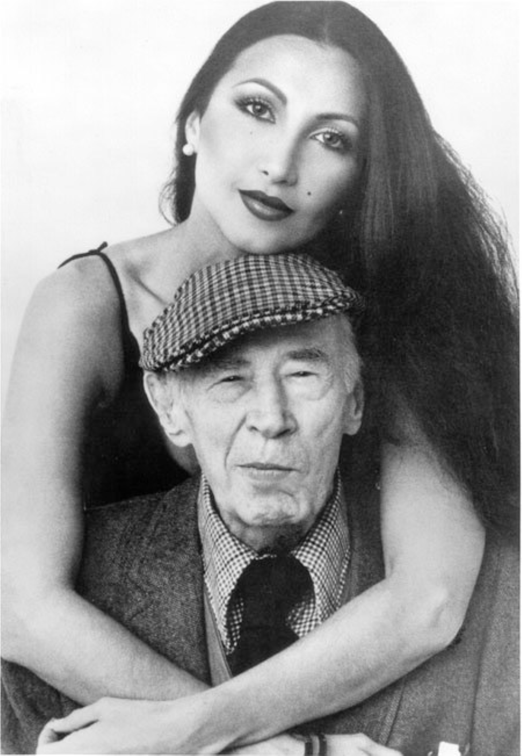

Creative Death, Henry Miller

Creative Death

“I DON’T WANT my Fate or Providence to treat me well. I am essentially a fighter.” It was towards the end of his life that Lawrence wrote this, but at the very threshold of his career he was saying: “We have to hate our immediate predecessors to get free of their authority.”

The men to whom he owed everything, the great spirits on whom he fed and nourished himself, whom he had to reject in order to assert his own power, his own vision, were they not like himself men who went to the source? Were they not all animated by that same idea which Lawrence voiced over and over again—that the sun itself will never become stale, nor the earth barren? Were they not, all of them, in their search for God, for that “clue which is missing inside men,” victims of the Holy Ghost?

Who were his predecessors? To whom, time and again before ridiculing and exposing them, did he acknowledge his indebtedness? Jesus certainly, and Nietzsche, and Whitman and Dostoievski. All the poets of life, the mystics, who in denouncing civilization contributed most heavily to the lie of civilization.

Lawrence was tremendously influenced by Dostoievski. Of all his forerunners, Jesus included, it was Dostoievski whom he had most difficulty in shaking off, in surpassing, in “transcending.” Lawrence had always looked upon the sun as the source of life, and the moon as the symbol of non-being. Life and Death—like a mariner he kept before him constantly these two poles.

“He who gets nearer the sun,” he said, “is leader, the aristocrat of aristocrats. Or, he who like Dostoievski, gets nearer the moon of our non-being.” With the in-betweens he had no concern.

“But the most powerful being,” he concludes, “is that which moves towards the as-yet-unknown blossom!” He saw man as a seasonal phenomenon, a moon that waxes and wanes, a seed that emerges out of primal darkness to return again therein. Life brief, transitory, eternally fixed between the two poles of being and non-being. Without the clue, without the revelation no life, but being sacrificed to existence. Immortality he interpreted as this futile wish for endless existence. To him this living death was the Purgatory in which man ceaselessly struggles.

Strange as it may seem today to say, the aim of life is to live, and to live means to be aware, joyously, drunkenly, serenely, divinely aware. In this state of god-like awareness one sings; in this realm the world exists as poem.

No why or wherefore, no direction, no goal, no striving, no evolving. Like the enigmatic Chinaman one is rapt by the everchanging spectacle of passing phenomena. This is the sublime, the a-moral state of the artist, he who lives only in the moment, the visionary moment of utter, far-seeing lucidity.

Such clear, icy sanity that it seems like madness. By the force and power of the artist’s vision the static, synthetic whole which is called the world is destroyed. The artist gives back to us a vital, singing universe, alive in all its parts.

In a way the artist is always acting against the time-destiny movement. He is always a-historical. He accepts Time absolutely, as Whitman says, in the sense that any way he rolls (with tail in mouth) is direction; in the sense that any moment, every moment, may be the all; for the artist there is nothing but the present, the eternal here and now, the expanding infinite moment which is flame and song.

And when he succeeds in establishing this criterion of passionate experience (which is what Lawrence meant by “obeying the Holy Ghost”) then, and only then, is he asserting his humanness.

Then only does he live out his pattern as Man. Obedient to every urge—without distinction of morality, ethics, law, custom, etc. He opens himself to all influences—everything nourishes him. Everything is gravy to him, including what he does not understand—particularly what he does not understand.

This final reality which the artist comes to recognize in his maturity is that symbolic paradise of the womb, that “China” which the psychologists place somewhere between the conscious and the unconscious, that pre-natal security and immortality and union with nature from which he must wrest his freedom. Each time he is spiritually born he dreams of the impossible, the miraculous, dreams he can break the wheel of life and death, avoid the struggle and the drama, the pain and the suffering of life.

His poem is the legend wherein he buries himself, wherein he relates of the mysteries of birth and death—his reality, his experience. He buries himself in his tomb of poem in order to achieve that immortality which is denied him as a physical being.

China is a projection into the spiritual domain of his biologic condition of non-being. To be is to have mortal shape, mortal conditions, to struggle, to evolve. Paradise is, like the dream of the Buddhists, a Nirvana where there is no more personality and hence no conflict. It is the expression of man’s wish to triumph over reality, over becoming. The artist’s dream of the impossible, the miraculous, is simply the resultant of his inability to adapt himself to reality.

He creates, therefore, a reality of his own—in the poem—a reality which is suitable to him, a reality in which he can live out his unconscious desires, wishes, dreams. The poem is the dream made flesh, in a two-fold sense: as work of art, and as life, which is a work of art. When man becomes fully conscious of his powers, his role, his destiny, he is an artist and he ceases his struggle with reality. He becomes a traitor to the human race.

He creates war because he has become permanently out of step with the rest of humanity. He sits on the door-step of his mother’s womb with his race memories and his incestuous longings and he refuses to budge. He lives out his dream of Paradise. He transmutes his real experience of life into spiritual equations.

He scorns the ordinary alphabet, which yields at most only a grammar of thought, and adopts the symbol, the metaphor, the ideograph. He writes Chinese. He creates an impossible world out of an incomprehensible language, a lie that enchants and enslaves men.

It is not that he is incapable of living. On the contrary, his zest for life is so powerful, so voracious that it forces him to kill himself over and over. He dies many times in order to live innumerable lives. In this way he wreaks his revenge upon life and works his power over men. He creates the legend of himself, the lie wherein he establishes himself as hero and god, the lie wherein he triumphs over life.

Perhaps one of the chief difficulties in wrestling with the personality of a creative individual lies in the powerful obscurity in which, wittingly or unwittingly, he lodges himself. In the case of a man like Lawrence we are dealing with one who glorified the obscurity, a man who raised to the highest that source and manifestation of all life, the body.

All efforts to clarify his doctrine involve a return to, and a renewed wrestling with, the eternal, fundamental problems which confronted him. He is forever bringing one back to the source, to the very heart of the cosmos, through a mystic labyrinth.

His work is altogether one of symbol and metaphor. Phoenix, Crown, Rainbow, Plumed Serpent, all these symbols center about the same obsessive idea: the resolution of two opposites in the form of a mystery. Despite his progression from one plane of conflict to another, from one problem of life to another, the symbolic character of his work remains constant and unchanged. He is a man of one idea: that life has a symbolic significance. Which is to say that life and art are one.

In his choice of the Rainbow, for example, one sees how he attempted to glorify the eternal hope in man, the illusion on which his justification as artist rests. In all his symbols, the Phoenix and the Crown particularly, for they were his earliest and most potent symbols, we observe that he was but giving concrete form to his real nature, his artist being. For the artist in man is the undying symbol of the union between his warring selves.

Life has to be given a meaning because of the obvious fact that it has no meaning. Something has to be created, as a healing and goading intervention, between life and death, because the conclusion that life points to is death and to that conclusive fact man instinctively and persistently shuts his eyes. The sense of mystery, which is at the bottom of all art, is the amalgam of all the nameless terrors which the cruel reality of death inspires. Death then has to be defeated—or disguised, or transmogrified.

But in the attempt to defeat death man has been inevitably obliged to defeat life, for the two are inextricably related. Life moves on to death, and to deny one is to deny the other. The stern sense of destiny which every creative individual reveals lies in this awareness of the goal, this acceptance of the goal, this moving on towards a fatality, one with the inscrutable forces that animate him and drive him on.

All history is the record of man’s signal failure to thwart his destiny—the record, in other words, of the few men of destiny who, through the recognition of their symbolic role, made history. All the lies and evasions by which man has nourished himself—civilization, in a word—are the fruits of the creative artist.

It is the creative nature of man which has refused to let him lapse back into that unconscious unity with life which characterizes the animal world from which he made his escape. As man traces the stages of his physical evolution in his embryonic life, so, when ejected from the womb, he repeats, in the course of his development from childhood to old age, the spiritual evolution of man.

In the person of the artist the whole historical evolution of man is recapitulated. His work is one grand metaphor, revealing through image and symbol the whole cycle of cultural development through which man has passed from primitive to effete civilized being.

When we trace back the roots of the artist’s evolution, we rediscover in his being the various incarnations, or aspects of hero which man has always represented himself to be—king, warrior, saint, magician, priest, etc. The process is a long and devious one.

It is all a conquest of fear. The question why leads to the question whither and then how. Escape is the deepest wish. Escape from death, from the nameless terror.

And the way to escape death is to escape life. This the artist has always manifested through his creations. By living into his art he adopts for his world an intermediary realm in which he is all-powerful, a world which he dominates and rules.

This intermediary realm of art, this world in which he moves as hero, was made realizable only out of the deepest sense of frustration. It arises paradoxically out of lack of power, out of a sense of inability to thwart fate.

This, then, is the Rainbow—the bridge which the artist throws over the yawning gulf of reality. The radiance of the rainbow, the promise it bespeaks, is the reflection of his belief in eternal life, his belief in perpetual spring, in continuous youth, virility, power.

All his failures are but the reflection of his frail human encounters with inexorable reality. The mainspring is the dynamic impact of a will that leads to destruction. Because with each realistic failure he falls back with greater intensity on his creative illusions.

His whole art is the pathetic and heroic effort to deny his human defeat. He works out, in his art, an unreal triumph—since it is neither a triumph over life nor over death. It is a triumph over an imaginary world which he himself has created. The drama lies entirely in the realm of idea. His war with reality is a reflection of the war within himself.

Just as the individual, when he arrives at maturity, evinces his maturity by the acceptance of responsibility, so the artist, when he recognizes his real nature, his destined role, is obliged to accept the responsibility of leadership. He has invested himself with power and authority, and he must act accordingly. He can tolerate nothing but the dictates of his own conscience.

Thus, in accepting his destiny, he accepts the responsibility of fathering his ideas. And just as the problems which each individual encounters are unique for him, and must be lived out, so the ideas which germinate in the artist are unique and must be lived out.

He is the sign of Fate itself, the very symbol of destiny. For when, by living out his dream logic, he fulfills himself through the destruction of his own ego, he is incarnating for humanity the drama of individual life which, to be tasted and experienced, must embrace dissolution.

In order to accomplish his purpose, however, the artist is obliged to retire, to withdraw from life, utilizing just enough of experience to present the flavor of the real struggle. If he chooses to live he defeats his own nature.

He must live vicariously. Thus he is enabled to play the monstrous role of living and dying innumerable times, according to the measure of his capacity for life.

In each new work he re-enacts the spectacle of the sacrifice of the god. Because behind the idea of the sacrifice is the very substantial idea of the sacrament: the person incarnating the great power is killed, in order that his body may be consumed and the magic powers redistributed.

The hatred for the god is the underlying motive of the worship of the god: it is based on the primitive desire to obtain the mysterious power of the man-god. In this sense, then, the artist is always crucified—in order to be consumed, in order to be divested of the mystery, in order to be robbed of his power and magic. The need of god is this hunger for a greater life: it is one and the same as the hunger for death.

We may image man forth as a sacred tree of life and death and if, further, we also think of this tree as representing not only the individual man, but a whole people, a whole Culture, we may begin to perceive the intimate connection between the emergence of the Dionysian type of artist and the notion of the sacred body.

Pursuing the image of man as tree of life and death, we may well conceive how the life instincts, goading man on to ever greater and greater expression through his world of form and symbol, his ideology, cause him at last to overlook the purely human, relative, fundamental aspects of his being—his animal nature, his very human body.

Man rushes up the trunk of livingness to expand in a spiritual flowering. From an insignificant microcosm, but recently separated from the animal world, he eventually spreads himself over the heavens in the form of the great anthropos, the mythical man of the zodiac.

The very process of differentiating himself from the animal world to which he still belongs causes him to lose sight more and more of his utter humanness. It is only at the last limits of creativeness, when his form world can assume no further architectural dimensions, that he suddenly begins to realize his “limitations.” It is then that fear assails him. It is then that he tastes death truly—a foretaste, as it were.

Now the life instincts are converted into death instincts. That which before had seemed all libido, endless urge to creation, is now seen to contain another principle—the embrace of the death instincts.

Only at the full summit of creative expansion does he become truly humanized. Now he feels the deep roots of his being, in the earth. Rooted. The supremacy and the glory and the magnificence of the body finally asserts itself in full vigor.

Only now does the body assume its sacred character, its true role. The trinal division of body, mind and soul becomes a unity, a holy trinity. And with it the realization that one aspect of our nature cannot be exalted above another, except at the expense of one or the other.

What we call wisdom of life here attains its apogee—when this fundamental, rooted, sacred character of the body is divined. In the topmost branches of the tree of life thought withers.

The grand spiritual efflorescence, by virtue of which man had raised himself to god-like proportions so that he lost touch with reality—because he himself was reality—this great spiritual flowering of Idea is now converted into an ignorance which expresses itself as the mystery of the Soma.

Thought retraverses the religious trunk by which it had been supported and, digging into the very roots of being, rediscovers the enigma, the mystery of the body. Rediscovers the kinship between star, beast, ocean, man, flower, sky.

Once again it is perceived that the trunk of the tree, the very column of life itself, is religious faith, the acceptance of one’s tree-like nature—not a yearning for some other form of being. It is this acceptance of the laws of one’s being which preserves the vital instincts of life, even in death.

In the rush upward the “individual” aspect of one’s being was the imperative, the only obsession. But at the summit, when the limits have been felt and perceived, there unfolds the grand perspective and one recognizes the similitude of surrounding beings, the inter-relationship of all forms and laws of being—the organic relatedness, the wholeness, the oneness of life.

And so the most creative type—the individual artist type—which had shot up highest and with the greatest variety of expression, so much so as to seem “divine,” this creative type of man must now, in order to preserve the very elements of creation in him, convert the doctrine, or the obsession of individuality, into a common, collective ideology.

This is the real meaning of the Master-Exemplar, of the great religious figures who have dominated human life from the beginning. At their furthest peak of blossoming they have but emphasized their common humanity, their innate, rooted, inescapable humanness. Their isolation, in the heavens of thought, is what brings about their death.

When we look at an Olympian figure like Goethe we see a gigantic human tree that declared no “goal” except to unfold its proper being, no goal except to obey the deep organic laws of nature.

That is wisdom, the wisdom of a ripe mind at the height of a great Culture. It is what Nietzsche described as the fusion in one being of two divergent streams—the Apollonian dreamer type and the ecstatic Dionysian. In Goethe we have the image of man incarnate, with head in the clouds and feet deeply rooted in the soil of race, culture, history.

The past, represented by the historical, cultural soil; and the present, represented by the varying conditions of weather that compose his mental climate, both the past and the present nourished him. He was deeply religious without the necessity of worshipping a god.

He had made himself a god. In this image of a Man there is no longer any question of conflict. He neither sacrifices himself to art, nor does he sacrifice art to life. Goethe’s work, which was a grand confession—“life’s traces,” he called it—is the poetic expression of his wisdom, and it fell from him like ripe fruit from a tree.

No station was too noble for his aspirations, no detail too insignificant for his attention. His life and work assumed grandiose proportions, an architectonic amplitude and majesty, for in both his life and his work there was the same organic foundation.

He is the nearest, with the exception of da Vinci, to the god-man ideal of the Greeks. In him soil and climate were at their most favorable. He had blood, race, culture, time—everything with him. Everything nourished him!

At this lofty point when Goethe appears, when man and culture are both at peak, the whole of past and future spreads out. The end is now in sight, the road henceforth is downward.

After the Olympian Goethe the Dionysian race of artists sets in, the men of the “tragic age” which Nietzsche prophesied and of which he himself was a superb example. The tragic age, when all that which is forever denied us makes itself felt with nostalgic force. Once again the cult of Mystery is revived.

Once again man must re-enact the mystery of the god, the god whose fertilizing death is to redeem and to purify man from guilt and sin, to free him from the wheel of birth and becoming. Sin, guilt, neurosis—they are one and the same, the fruit of the tree of knowledge.

The tree of life now becomes the tree of death. But it is always the same tree. And it is from this tree of death that life must spring forth again, that life must be reborn. Which, as all the myths of the tree testify, is precisely what happens.

“At the moment of the destruction of the world,” says Jung, referring to Ygdrasil, the world-ash, “this tree becomes the guardian mother, the tree of death and life, one ‘pregnant.’ ”

It is at this point in the cultural cycle of history that the “transvaluation of all values” must set in. It is the reversal of the spiritual values, of a whole complex of reigning ideological values. The tree of life now knows its death.

The Dionysian art of ecstasies now reasserts its claims. The drama intervenes. The tragic reappears. Through madness and ecstasy the mystery of the god is enacted and the drunken revellers acquire the will to die—to die creatively.

It is the conversion of that same life instinct which urged the tree of man to fullest expression. It is to save man from the fear of death, so that he may be able to die!

To go forward into death! Not backward into the womb. Out of the quicksands, out of the stagnant flux!

This is the winter of life, and our drama is to secure a foothold so that life may go forward once again.

But this foothold can only be gained on the dead bodies of those who are willing to die.\*

\* Fragment from an unfinished book; The World of Lawrence.

The end