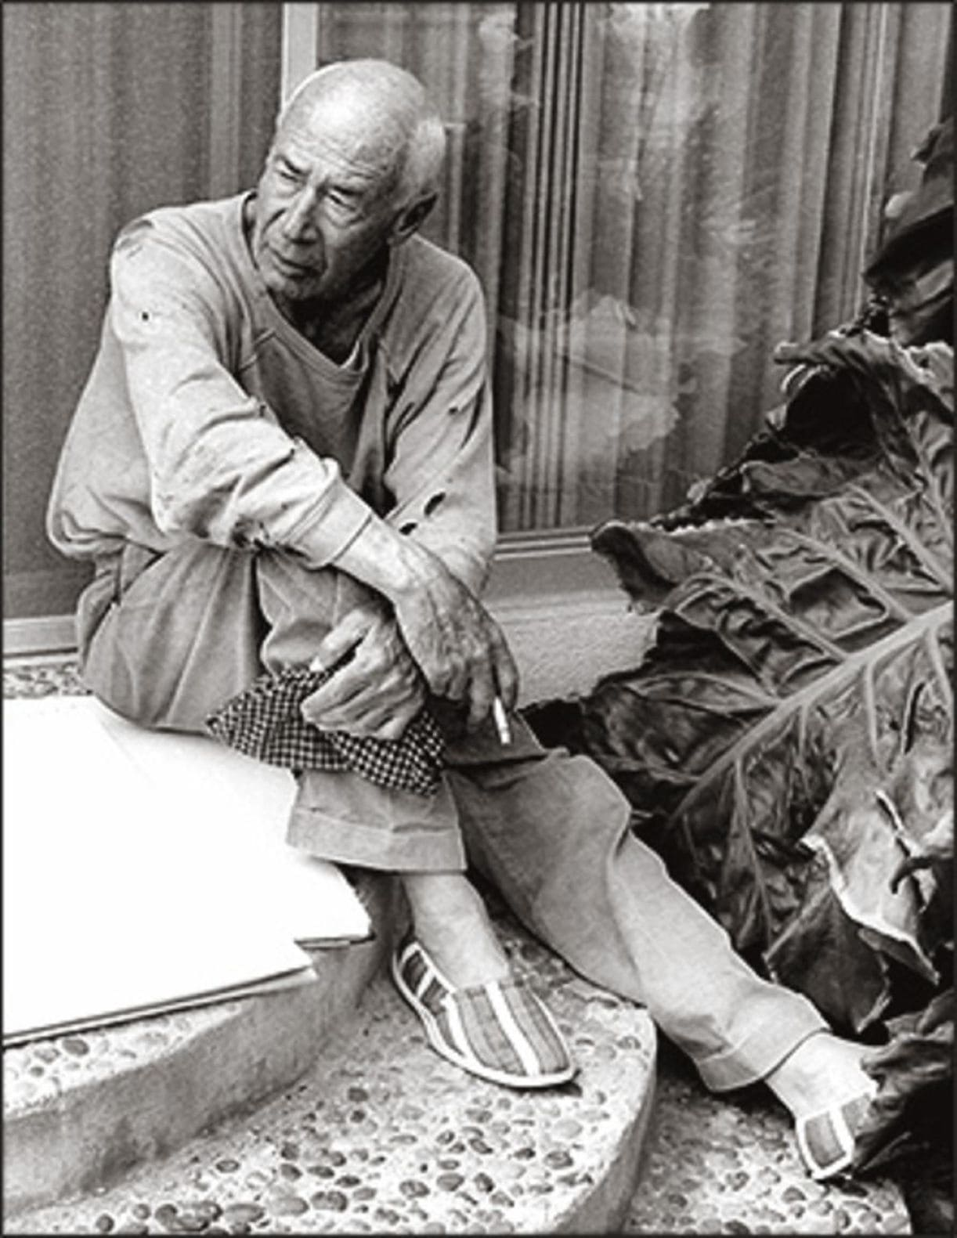

Mademoiselle Claude, Henry Miller

Mademoiselle Claude

PREVIOUSLY, WHEN I began to write this tale, I set out by saying that Mlle. Claude was a whore. She is a whore, of course, and I’m not trying to deny it, but what I say now is—if Mlle.

Claude is a whore then what name shall I find for the other women I know? Somehow the word whore isn’t big enough. Mlle. Claude is more than a whore. I don’t know what to call her. Maybe just Mlle. Claude. Soit.

There was the aunt who waited up for her every night. Frankly, I couldn’t swallow that story. Aunt hell! More likely it was her maquereau. But then that was nobody’s business but her own. . . . Nevertheless, it used to gall me—that pimp waiting up for her, getting ready perhaps to clout her if she didn’t come across.

And no matter how loving she was (I mean that Claude really knew how to love) there was always in the back of my head the image of that blood-sucking, low-browed bastard who was getting all the gravy.

No use kidding yourself about a whore—even when they’re most generous and yielding, even if you’ve slipped them a thousand francs (who would, of course?)—there’s always a guy waiting somewhere and what you’ve had is only a taste. He gets the gravy, be sure of that!

But then, all this, as I afterwards discovered, was just so much wasted emotion. There was no maquereau—not in Claude’s case. I’m the first maquereau Claude has ever had. And I don’t call myself a maquereau either. Pimp’s the word. I’m her pimp now. O. K.

I remember distinctly the first time I brought her to my room,—what an ass I made of myself. Where women are concerned I always make an ass of myself. The trouble is I worship them and women don’t want to be worshiped.

They want . . . well, anyway, about that first night, believe it or not, I behaved just as if I had never slept with a woman before. I don’t understand to this day why it should have been so. But that’s how it was.

Before she even attempted to remove her things, I remember, she stood beside the bed looking up at me, waiting for me to do something, I suppose. I was trembling. I had been trembling ever since we left the café. I gave her a peck—on the lips, I think.

I don’t know—maybe I kissed her brow—I’m just the guy to do that sort of thing . . . with a woman I don’t know. Somehow I had the feeling that she was doing me a tremendous favor. Even a whore can make a guy feel that way sometimes. But then, Claude isn’t just a whore, as I said.

Before she had even removed her hat she went to the window, closed it, and drew the curtains to. Then she gave me a sort of sidelong look, smiled, and murmured something about getting undressed. While she fooled around with the bidet I went through the business of stripping down.

As a matter of fact, I was nervous. I thought perhaps she’d be embarrassed if I watched her, so I fiddled around with the papers on my table, made a few meaningless notes, and threw the cover over the typewriter. When I turned she was standing in her chemise, near the sink, wiping her legs.

“Hurry! Get in bed!” she said. “Warm it up!’’ And with this she gave herself a few extra dabs.

Everything was so damned natural that I began to lose my uneasiness, my nervousness. I saw that her stockings were rolled down carefully, and from her waist there dangled some sort of harness which she flung presently over the back of the chair.

The room was chilly all right. We snuggled up and lay silently for a while, a long while, warming each other. I had one arm around her neck and with the other I held her close. She kept staring into my eyes with that same expectant look that I had observed when we first entered the room. I began to tremble again. My French was fading away.

I don’t remember now whether I told her then and there that I loved her. Probably I did. Anyway, if I did, she probably forgot it immediately. As she was leaving I handed her a copy of Aphrodite, which she said she’d never read, and a pair of silk stockings that I had bought for some one else. I could see she liked the stockings.

When I saw her again I had changed my hotel. She looked about in her quick, eager way and saw at a glance that things weren’t going so well. She asked very naively if I was getting enough to eat.

“You mustn’t remain here long,” she said. “It’s very sad here.” Maybe she didn’t say sad, but that’s what she meant, I’m sure.

It was sad all right. The furniture was falling apart, the windowpanes were broken, the carpet was torn and dirty, and there was no running water. The light too was dim, a dim, yellow light that gave the bedspread a gray, mildewed look.

That night, for some reason or other, she pretended to be jealous. “There is somebody else whom you love,” she said.

“No, there’s nobody else,” I answered.

“Kiss me, then,” she said, and she clung to me affectionately, her body warm and tingling. I seemed to be swimming in the warmth of her flesh . . . not swimming either, but drowning, drowning in bliss.

Afterwards we talked about Pierre Loti, and about Stamboul. She said she’d like to go to Stamboul some day. I said I’d like to go too. And then suddenly she said—I think this was it—“you’re a man with a soul.” I didn’t try to deny it—I was too happy, I guess. When a whore tells you you’ve got a soul it means more somehow. Whores don’t usually talk about souls.

Then another strange thing happened. She refused to take any money.

“You mustn’t think about money,” she said. “We are comrades now. And you are very poor. . . .”

She wouldn’t let me get out of bed to see her to the landing. She spilled a few cigarettes out of her bag and laid them on the table beside the bed; she put one in my mouth and lit it for me with the little bronze lighter that some one had given her as a gift. She leaned over to kiss me good-night.

I held her arm. “Claude,” I said, “vous êtes presque un ange.”

“Ah non!” she replied, quickly, and there was almost a look of pain in her eyes, or terror.

That “presque” was really the undoing of Claude, I do believe. I sensed it almost immediately. And then the letter which I handed her soon after—the best letter I ever wrote in my life, though the French was execrable. We read it together, in the café where we usually met.

As I say, the French was atrocious, except for a paragraph or two which I lifted from Paul Valéry. She paused a moment or two when she came to these passages. “Very well expressed!” she exclaimed. “Very well, indeed!” And then she looked at me rather quizzically and passed on. Oh, it wasn’t Valéry that got her. Not at all. I could have done without him. No, it was the angel stuff that got her.

I had pulled it again—and this time I embroidered it, as subtly and suasively as I knew how. By the time we had reached the end, though, I was feeling pretty uncomfortable. It was pretty cheap, taking advantage of her like that. I don’t mean to say that it wasn’t sincere, what I wrote, but after that first spontaneous gesture—I don’t know, it was just literature.

And then, too, it seemed shabbier than ever when, a little later, sitting on the bed together, she insisted on reading it over again, this time calling my attention to the grammatical errors. I became a little impatient with her and she was offended. But she was very happy just the same. She said she’d always keep the letter.

About dawn she slipped out. The aunt again. I was getting reconciled to the aunt business. Besides, if it wasn’t an aunt I’d soon know now. Claude wasn’t very good at dissembling—and then that angel stuff . . . that sank in deep.

I lay awake thinking about her. She certainly had been swell to me. The maquereau! I thought about him, too, but not for long, I wasn’t worrying about him any more. Claude—I thought only about her and how I could make her happy. Spain . . . Capri . . . Stamboul. . . .

I could see her moving languidly in the sunshine, throwing crumbs to the pigeons or watching them bathe, or else lying back in a hammock with a book in her hands, a book that I would recommend to her.

Poor kid, she probably had never been further than Versailles in her life. I could see the expression on her face as we boarded the train, and later, standing beside a fountain somewhere. . . . Madrid or Seville. I could feel her marching beside me, close, always close, because she wouldn’t know what to do with herself alone and even if it was dumb I liked the idea.

Better a damned sight than having some god-damned flapper with you, some lightheaded little bastard who’s always figuring out a way of ditching you even when she’s lying with you. No, I could feel sure of Claude. Later it might get tiresome—later . . . later. I was glad I had picked a whore. A faithful whore! Jesus, I know people who’d laugh like hell if I ever said that.

I was planning it all out in detail: the places we’d stop at, the clothes she’d wear, what we’d talk about . . . everything . . . everything. She was Catholic, I supposed, but that didn’t matter a damn to me. In fact, I rather liked it. It was lots better going to church to hear mass than to study architecture and all that crap.

If she wanted, I’d become a Catholic too . . . what the hell I’d do anything she asked me to—if it gave her a kick. I began to wonder if she had a kid somewhere, as most of them have. Imagine, Claude’s kid!

Why I’d love that kid more than if it were my own. Yes, she must have a kid, Claude—I’m going to see about it. There’d be times, I knew, when we’d have a big room with a balcony, a room looking out on a river, and flowers on the windowsill and birds singing. (I could see myself coming back with a bird-cage on my arm. O. K. So long as it made her happy!) But the river—there must be rivers once in a while. I’m nuts about rivers.

Once, in Rotterdam, I remember— — —. The idea, though, of waking up in the morning, the sun streaming in the windows and a good, faithful whore beside you who loves you, who loves the guts out of you, the birds singing and the table all spread, and while she’s washing up and combing her hair all the men she’s been with and now you, just you, and barges going by, masts and hulls, the whole damned current of life flowing through you, through her, through all the guys before you and maybe after, the flowers and the birds and the sun streaming in and the fragrance of it choking you, annihilating you. O Christ! Give me a whore always, all the time!

I’ve asked Claude to live with me and she’s refused. This is a blow. I know it’s not because I’m poor—Claude knows all about my finances, about the book I’m writing, etc. No, there must be some other, deeper reason. But she won’t come out with it.

And then there’s another thing—I’ve begun to act like a saint. I take long walks alone, and what I’m writing now has nothing to do with my book. It seems as if I were alone in the universe, that my life is complete and separate, like a statue’s.

I have even forgotten the name of my creator. And I feel as if all my actions are inspired, as if I were meant to do nothing but good in this world. I ask for nobody’s approval.

I refuse to take any charity from Claude any more. I keep track of everything I owe her. She looks sad these days, Claude. Sometimes, when I pass her on the terrasse, I could swear that there are tears in her eyes.

She’s in love with me now, I know it. She loves me desperately. For hours and hours she sits there on the terrasse. I go with her sometimes because I can’t bear to see her miserable, to see her waiting, waiting, waiting. . . .

I have even spoken to some of my friends about her, tipped them off, as it were. Yes, anything is better than to see Claude sitting there waiting, waiting. What does she think about when she sits there all by herself?

I wonder what she would say if I walked up to her one day and slipped her a thousand franc note. Just walk up to her, when she’s got that melancholy look in her eyes, and say: “Voici quelque chose que j’ai oublié l’autre jour.”

Sometimes, when we lie together and there come those long brimming silences, she says to me: “Que pensez-vous maintenant?” And I always answer “Rien!” But what I’m really thinking to myself is—“Voici quelque chose que. . . .” This is the beautiful part of l’amour à credit.

When she takes leave of me the bells ring out wildly. She makes everything so right inside me. I lie back on the pillow and luxuriously enjoy the weak cigarette which she has left me. I don’t have to stir for a thing.

If I had a plate in my mouth I’m sure she wouldn’t forget to put it in the tumbler on the table beside my bed, together with the matches and the alarm clock and all the other junk. My trousers are carefully folded and my hat and coat are hanging on a peg near the door. Everything in its place. Marvelous! When you get a whore you get a jewel. . . .

And the best of it is, the fine feeling endures. A mystic feeling it is, and to become mystic is to feel the unity of life. I don’t care particularly any more whether I am a saint or not. A saint struggles too much. There is no struggle in me any longer.

I have become a mystic. I impart good, peace, serenity. I am getting more and more customers for Claude and she no longer has that sad look in her eyes when I pass her. We eat together most every day. She insists on taking me to expensive places, and I no longer demur. I enjoy every phase of life—the expensive places as well as the inexpensive places. If it makes Claude happy— — —.

Pourtant je pense à quelque chose. A little thing, to be sure, but lately it has grown more and more important in my mind. The first time I said nothing about it. An unwonted touch of delicacy, I thought to myself. Charming, in fact. The second time—was it delicacy, or just carelessness? However, rien à dire.

Between the second and third times I was unfaithful, so to speak. Yes, I was up on the Grands Boulevards one night, a little tight. After running the gauntlet all the way from the Place de la République to Le Matin, a big, scabby buzzard whom I ordinarily wouldn’t have pissed on grabbed me off.

A droll affair. Visitors knocking at our door every few minutes. Poor little ex-Folies girls who begged the kind monsieur to give them a little tip—thirty francs or so. For what, pray? Pour rien . . . . pour le plaisir. A very strange, and very funny night. A day or so later irritation. Worries. Hurried trip to the American Hospital. Visions of Ehrlich and his black cigars. Nothing wrong, however. Just worry.

When I broach the subject to Claude she looks at me in astonishment. “I know you have every confidence in me, Claude, but. . . .” Claude refuses to waste any time on such a subject. A man who would consciously, deliberately give a woman a disease is a criminal.

That’s how Claude looks upon it. “C’est vrai, n’est-ce pas?” she asks. It’s vrai all right. However. . . . But the subject is closed. Any man who would do that is a criminal.

Every morning now, when I take my paraffin oil—I always take it with an orange—I get to thinking about these criminals who give women diseases. The paraffin oil makes the spoon very sticky. It is necessary to wash it well.

I wash the knife and the spoon very carefully. I do everything carefully—it is my nature. After I have washed my face I look at the towel. The patron never gives out more than three towels a week; by Tuesday they are all soiled. I dry the knife and the spoon with a towel; for my face I use the bedspread. I don’t rub my face—I pat it gently with the edge of the bedspread, near the feet.

The Rue Hippolyte Mandron looks vile to me. I detest all the dirty, narrow, crooked streets with romantic names hereabouts. Paris looks to me like a big, ugly chancre. The streets are gangrened. Everybody has it—if it isn’t clap it’s syphilis.

All Europe is diseased, and it’s France who’s made it diseased. This is what comes of admiring Voltaire and Rabdais! I should have gone to Moscow, as I intended. Even if there are no Sundays in Russia, what difference does it make? Sunday is like any other day now, only the streets are more crowded, more victims walking about contaminating one another.

Mind you, it’s not Claude I’m raving against. Claude is a jewel, un ange, and no presque about it. There’s the bird-cage hanging outside the window, and flowers too—though it ain’t Madrid or Seville, no fountains, no pigeons.

No, it’s the clinic every day. She goes in one door and I in the other. No more expensive restaurants. Go to the movies every night and try to stop squirming. Can’t bear the sight of the Dôme or the Coupole any more. These bastards sitting around on the terrasse, looking so clean and healthy with their coats of tan, their starched shirts and their eau-de-cologne.

It wasn’t entirely Claude’s fault. I tried to warn her about these suave looking bastards. She was so damned confident of herself—the injections and all that business. And then, any man who would. . . . Well, that’s just how it happened.

Living with a whore—even the best whore in the world—isn’t a bed of roses. It isn’t the numbers of men, though that too gets under your skin sometimes, it’s the everlasting sanitation, the precautions, the irrigations, the examinations, the worry, the dread.

And then, in spite of it all— — —. I told Claude . . . I told her repeatedly—“watch out for the swell guys!”

No, I blame myself for everything that’s happened. Not content with being a saint I had to prove that I was a saint. Once a man realizes that he’s a saint he should stop there. Trying to pull the saint on a little whore is like climbing into heaven by the back stairs.

When she cuddles up to me—she loves me now more than ever—it seems to me that I’m just some damned microbe that’s wormed its way into her soul. I feel that even if I am living with an angel I ought to try to make a man of myself.

We ought to get out of this filthy hole and live somewhere in the sunshine, a room with a balcony overlooking a river, birds, flowers, life streaming by, just she and me and nothing else.

The end