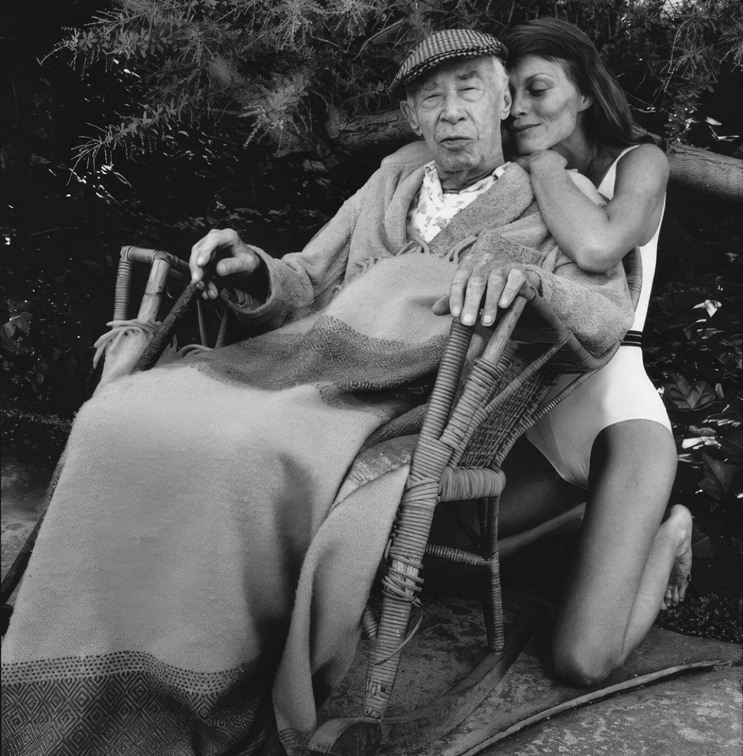

Raimu, Henry Miller

Raimu

IT IS as an American living in France, who has seen practically all the important films produced by Russia, Germany, France and America, that I write this tribute to Raimu whom I consider the most human figure on the screen today.

Though it seems that the French films have at last won the recognition which they deserve, in America, from the titles which I see discussed I realize that these films which my countrymen are beginning to appreciate, ten years too late, are by no means the best which the French have to offer.

America is always twenty to fifty years behind time in accepting the true genius of Europe. Even today, for example, they are still discovering, through their avant-garde reviews, such writers as Jean Cocteau and Leon Paul Fargue. Recently an American who came to visit me had the naïveté to ask me if I did not consider the author of Hommes de Bonne Volonté the Dos Passos of Europe!

The fundamental difference between the French and American films, as everybody knows, lies in the understanding of what is human. A French film, when it is good, is unsurpassable, not only because it is more true to life but because this conception of life strikes a deeper note than anything conceived by Russians, Germans, or Americans.

A fact often commented upon by foreigners is that French actors, male and female, are usually well advanced in years, usually quite unprepossessing, if not downright homely, and, when given the opportunity (which is not often enough), are capable of assuming the most diverse roles, including the comic as well as the tragic.

In the American films, on the other hand, it is highly noticeable that there is not one great serious actor, unless it be the clown, Charlie Chaplin. (Men like Paul Muni and Edward Robinson, capable in their way, are always actors rather than men.) Anything verging on the tragic, in the American film, quickens into melodrama and sticky sentimentality.

In the better French films (the poor ones are below every level!) there is always a sense of reality, of the tragicomedy of life. Where the French film fails is in the realm of imagination, of phantasy.

It is the inherent weakness of the French character, the blind spot which accounts perhaps for the popularity of such a feeble masterpiece, in literature, as Le Grand Meaulnes. Among the French, one often hears it said that the American film, even if bad, is at any rate amusing. They are never thoroughly bored by a bad American film—so they say, at least.

Myself, I am bored to tears often, even by the “great” American films. This attitude of the French is explicable only because they do not expect too much of anything American. A man would be an imbecile, for example, to be disappointed in a work of Maurice Dekobra’s. Somehow, much is expected of a good French film, even by the French.

In Raimu, whose rise I have watched now for several years, the French people, the soul quality, I might say, makes itself manifest. Raimu is the one truly human figure on the screen today, and whether he be considered a good actor or a bad one is relatively unimportant.

He represents something which is vitally missing in the cinema, and he represents it forcefully. To appreciate his contribution one has only to take a sidelong glance at his American counterpart, Wallace Beery.

The latter, together with Gary Cooper, represent the highest efforts of the American producers to give us a semblance of the human being and not the Hollywood figure in papier-mâché. But they are usually cast for adventure, for thrilling episodes, for action. Only once was Gary Cooper, for example, permitted to express anything like his real self—in Mr. Deeds Goes to Town.

Wallace Beery has never been given a role which would permit him to reveal his full stature—nor has Barbara Stanwyck, except for one film, Liliane, which was banned in America. To understand this deliberate deteriorization of character which Hollywood enforces one has only to reflect on what happens to the French actor whose services are impressed by Hollywood.

Any ordinary French film starring Charles Boyer or Daniele Darrieux, for example, seems infinitely better than the sensational ones created for them in America. What is the constant plaint of the French artist after his arrival in Hollywood? “They want to make us over!”

It is the American vice, the democratic disease which expresses its tyranny by reducing everything unique to the level of the herd. Think of “making over” the heroine of Mayerling! Think of what it would mean to make over a Gabin or a Jouvet!

I do not mean to imply by the foregoing that the French producers are animated only by lofty artistic ideals. I think, taking them by and large, that they are as guilty as the American producers of complicity in foisting upon the public anything and everything which will bring quick returns.

They are as bad as the French publishers who are deliberately, cold-bloodedly, ruining the taste for good literature by their shameless concentration on the till. They are as bad as the French politicians who, bar none, are the most corrupt in the world.

But there is something in the French character which, despite the lowest intentions, prevents them from completely betraying their heritage. The Frenchman is first and foremost a man. He is likeable often just because of his weaknesses, which are always thoroughly human, even if despicable.

As a rogue and a scoundrel he is more often than not misled by a perverted sense of reality which he calls realism. But even at his worst there always remains an area—of the soul, shall I say?—with which one can deal and hope for an ultimate understanding.

It is difficult for a Frenchman to wholly defeat the human being in himself. Race, tradition, culture—these speak out even when the mind has been traduced. And so, even with the worst motives, it often happens that a mediôcre French film offers something which the best films of other countries never take into account.

Study the faces of the American stars! Compare them with the French. At a glance one can spot the difference—the contrast between adolescence and maturity, between a fake idealism and a grim sense of reality, between puppets who will perform any insane stunt and individuals who cannot be trained to act like monkeys no matter what bait is held out to them. The American cannot help making an ass of himself, even when he is inspired; the Frenchman is always a human being, even when he caricatures himself.

The American ideal is youth—handsome, empty youth. Russia too idolizes youth, but what a difference between the two conceptions of youth! Russia is young in spirit, because the spirit is still vital; in America youth means simply athleticism, disrespect, gangsterism, or sickly idealism expressing itself through thinly disguised and badly digested social science theories acted out by idiots who are desperadoes at heart.

Think of the American idol, James Cagney; or of Robert Taylor, the matinee idol of the screen; or of Clark Gable, the symbol of American vigor and manliness! What do they bring to the screen besides good looks, a fast, pat lingo, the art of fisticuffs, or a suit of well-tailored clothes?

Think of Victor MacLaglen, for whose work in The Informer I have the highest admiration. Think, however, what it is America truly admires in him! They have made him the symbol of their own brutish nature.

Let us get back to the human, to Raimu. . . . One of the things which impresses me most about Raimu is his habit of going about in shirt sleeves and suspenders, his struggles to lace his boots or to tie his cravat.

He is always sweating (not perspiring!), always trying to unburden himself of his clothes, to give his body light and air. It is a quality which one almost never observes in an American actor. Raimu sweats, weeps, laughs, yells with pain.

Raimu flies into a rage, an unholy rage, in which he is not ashamed to strike his wife or son, if deserving of his wrath. Wrath! Here again is something which is usually absent from the American’s repertoire of emotions.

The wrath of Raimu is magnificent; there is something Biblical, something godlike about it. It springs up from that sense of justice which is never entirely stifled in the French and which, when roused, permits them to accomplish superhuman feats of strength and daring.

When the American strikes it is really a reflex action. (Hie Englishman, be it noted, seldom resorts to violence; when he is sufficiently goaded he simply opens up, like the oyster, and devours his adversary.

Yet the most sadistic picture I have ever seen, the only picture which I think should be banned, is the British production of Broken Blossom.) No, the American scarcely knows what anger is, nor joy, for that matter.

He oscillates between cold-blooded murder, as depicted by the gangsters or those who are punishing them, and a bright, hard gaiety devoid of all sensitivity, all respect and consideration for the personality of the other. He is quick to kill or to laugh, but both his laughter and his murderousness are empty.

The “fraicheur” which the French pretend to see in the impossible American farces is a hoax. The Americans are not young and fresh in spirit, but senile; their humor is hysterical, a reaction born of panic, of a refusal to look life in the face.

The way they throw their bodies around, the way they pummel one another, the way they destroy themselves and the objects which they have created, what is it but a sort of ferocious nightmare activity?

If this is “life,” then life is absurd. If this is health and youthfulness, then give me old age and melancholy. The crimes they commit in their sleep outdo the atrocities perpetrated by the most tyrannical despots.

In Raimu I see the opposite of all this. In Raimu I see a heavy, sluggish figure, a man who is certainly not “refined,” a man who is not a “heart-breaker,” nor a “hero.” Everything he says and does is human and understandable, even his crimes.

He never tries to be more than he is, or other than he is; he is never ridiculous, even when he inspires laughter. He is touching, an old-fashioned word, but one that suits him well.

It is not an actor one watches in his films, but a man living his life: he breathes, sleeps, snores, sweats, chews, spits, curses, and so on. He is unlovely to look at, and yet he is far from being ugly. He redeems the human figure by stripping it of its superfluities, its external paraphernalia.

Think of his emotions and compare them with the frowsy bag of tricks employed by that broken-down hack, Lionel Barrymore, who is about the only old man America can rustle up to enact anything resembling tragedy.

What a farce, the Barrymore tradition! For John, the great matinee idol of twenty-five years ago, is even worse than Lionel. What empty words and gestures! What drivel! Even an avowedly bad actor, such as Jules Berry, puts him to shame. Even Victor Francen, who is about as stagey and unreal as any French actor can hope to be, is infinitely superior to this antiquated tragedian.

It is when Raimu becomes violent that I like him best. His violence is slow in accumulating; it gathers like a storm-cloud and breaks with devastating fury, only to clear as quickly as it came. It is a purge, a creative purge, even to observe it as a spectator. This, I maintain, no American actor ever gives us. He can’t, because his theory of dynamics is all wrong.

Everything, including metabolism, is sacrificed to speed and effect. Everything moves like lightning—but nothing ever happens. There is no drama—there is only the heat of frenzy in a void of the mind.

Raimu, on the other hand, when he saunters slowly down a street or through the corridor of a hotel, when he lowers himself into a seat or leans against a wall to tell a story, is like a refreshing bath. He allows time for what is human in the individual to gather and grow, to express itself finally, when the moment is ripe, by an appropriate gesture, by a gush of words or by an act of silence.

He makes no attempt to conceal his tears—he weeps openly and unashamedly. When an American weeps—and usually no one but a silly young virgin or a stereotyped old mother ever weeps in the films!—no emotion whatever is aroused.

They are all trained “tear-jerkers,” to use an American expression. The tears do not well up from the feelings, but are pumped up by the will, or by the economic demands of the film director who values them at so much the ounce, like perfume. Why do the Americans envy and hate Garbo so?

Because she is really a “tragic” figure, and because she has never concealed her scorn and contempt for their theories of art. To the American, Garbo, when she is not “grand” or “magnificent,” is melodramatic—or else an anaemic, flat-footed, tired Swede. But they are proud to have given her to the world, and however much they ridicule and malign her, they want the credit for discovering her talent.

As to learning anything from her, no, absolutely impossible. She represents another world, another mode of life, not only alien but hostile to theirs. They boast about absorbing the best from the world, but actually they take only what suits their own low level of life and then impose it on the world as their creation.

Only the other night I saw another Raimu film—The Hero of the Marne. Even without Raimu this picture would be the greatest of its genre ever produced. What a chasm between this quiet, moving spectacle and the false, trashy war films, such as those based on Remarque’s books, for example, from America!

Who can believe in these fabricated celluloid horrors of war? What silly, empty, hundred per cent American imbeciles they try to palm off as Germans!

What a literary air of unreality about these films! In the Hero of the Marne the war is made out to be what every sensitive man knows it to be—a fateful horror, a butchery which nobody is responsible for, unless it be the statesmen and financiers.

It is a mess in which both sides appear guilty and equally responsible, and for our colossal ignorance and sinfulness the innocent, as well as the guilty, are made to perish. What is heroic in man, as this film seems to indicate, is not born out of a sense of “righteousness” but of the power of endurance, of the courage which arises from accepting the worst in our nature.

It is the common, undenominated man who, almost against his will, it would appear, rises to the heights of heroism. The deep resignation, the acceptance of that which is revolting and unbearable, is here revealed as of the very essence of heroism.

In Raimu’s portrayal of the dilemma one can see the spirit of the whole French people. He is a man of peace who is obliged to kill, and to offer his own flesh and blood to be killed too. He is not a patriot, but something far greater, far more inspiring: he is a man, and he acts like one.

In his weakness he moves us even more than in his courageousness. He is what we all are, a mixture of good and bad, of wisdom and stupidity, of nobility and narrow-mindedness. He is not a paste-board figure pulled by the strings of an idealistic despot to prove the truth of an empty theory of life derived from a cheap Saturday Evening Post story which not even the editors themselves believe in.

In the French figures on the screen today, those who best know how to portray human emotions, there is that curious mixture, practically unheard of in the American, of tenderness and brutality combined.

The American can give us one or the other, both in a more extreme degree, but never the two combined in the one personality. Wallace Beery and Victor MacLaglen come closest to it, perhaps, but they are rather crude specimens, types rather than human beings. In Emil Jannings we had the closest approximation to this great French quality, but marred by a hidebound German theatricality.

Only once, to my recollection, was Jannings above criticism, and that was in an early silent film which was called in English The Last Laugh. Here he almost reached Dostoievskian proportions. But to achieve it he had to rely on burlesque, of which the French are altogether ignorant.

As I say, this quality of brutality and tenderness combined is the special characteristic of the French actor, and through it he reveals the meaning which the French give to the word “human.” It is something passionate, and not the expression of a blind, senseless activity, of reflex muscular rage.

It is something slumbering and capable of infinite mutations, destructive and creative, always dramatic because always expressive of the inherent antagonism in things. In a film such as Geuele d’Amour even the atmosphere reflects this quality.

The street scene, in Orange I believe it was, when night is coming on and there is just the flapping of the awning in the breeze, so much is contained in this moment that it is like an act of poetry.

In a trifling touch a whole world of feeling is conveyed. So it is too with Gabin’s studied restraint, his abortive gestures, his muttering silences, his quick, dull look, which comes like a hammer-blow.

Raimu and Jouvet also have this terrifying look at times; it is like a thick curtain of blood suddenly veiling the eye. They brood, they wait, they endure; but when they move, when they reach for their victim, it is like Fate itself striking, and nothing can hinder.

In the American films murder is committed negligently, recklessly, unthinkingly: a button is touched and the sawed-off shot-guns squirt their fire. It matters little who gets in the way—women, children, priests, anybody who comes within range is mowed down.

I remember the shock of a Parisian audience when in an American film a priest was shown as being struck down by a blow of the fist. But it might just as well have been a kick in the rear which he had received. Or he might have been boiled in oil.

To the American, as their films well reveal, nothing is sacred, nothing taboo—except perhaps the act of going to bed with a woman. That is immoral, though it happens everywhere all the time, even in America.

But it must never be openly shown—it must be imagined only. Thus, too, the dead are portrayed as drinking cocktails, something which is not altogether inconceivable, but which, if true, is only a minor virtue in the life of the dead.

But the real key to the American sense of grandeur lies in the glorification of catastrophes. Nature is the hero, not man! If it is not an earthquake it is a hurricane or a landslide or a flood, dramatic incidents which have their human counterpart in battle scenes, prison riots and so on. When it is really a grandiose theme, such as in Lost Horizon, for example, it is muffled with clowning and sensationalism.

The Grand Lama spouts the Christian doctrine through the mouth of a Jewish actor. The French, who were as divided as the rest of the world about the merits of this film, reduced the theme to a comfortable bourgeois ideal with a little foreword containing some such clap-trap as this—“who has not dreamed of retiring some day to his little home in the country!’’ What rubbish!

What a woeful depreciation of a grand theme! However . . . in the film based on that splendid human document, The Good Earth, the really important feature seems to have been the invasion of the locusts.

In San Francisco it is the earthquake, an episode which requires about three minutes to render, and the rest of the film is sheer drivel, absolutely insupportable, especially Jeanette MacDonald. (The same is true for The Charge of the Light Brigade and Gunga Din; only the destructive scenes have value—the rest is hogwash.) Even when the film is a restoration film the street scenes are unconvincing.

Whole corps of men and women are mobilized to study the history, costumes, architecture, furniture of a period—and yet the result is nil. The money spent on research, which is colossal, is sheer waste. The same for characters.

In a Chinese film, when America of all countries is full of available types, Paul Muni, a Viennese Jew, is made a Chinese, and Luise Rainer, after her adorable portrayal of Anna Held in The Great Ziegfeld, is converted into a Chinese peasant woman who speaks English with an Austrian accent. A Frenchman or a Hindu is always a caricature of the type.

No country in the world has such a variety of racial types as America; no acting is required, because in the American film everybody is supposed “to be just himself.” Yet in their frantic attempts at realism, at producing a semblance of something life-like, something authentic, they will choose, as if blindfolded, the very man or woman most unlike the one they are attempting to portray. When it comes to reciting the Gettysburg address an Englishman is chosen, because he is undoubtedly the most expert in the use of the English language.

Charles Laughton’s recital of the Gettysburg address was a memorable moment in the history of the cinema, but what a travesty of the homely diction Lincoln must have employed! When they admire good acting in a foreign film they choose an innocuous museum piece like La Kermesse Héroique or such a sham as La Grande Illusion, with that linguistic, physiognomic monstrosity, Eric von Stroheim, who is neither fish nor fowl.

The French, in turn, are capable of applauding a fifth rate film such as Back Street, which was based upon the work of probably the worst writer in America, Fanny Hurst. They even fall so far, in their critical acumen, as to present it to the public through a little speech of pure asininity, by Henri Duvernois, one of their own bad writers.

Of the two films which seem to be most frequently revived here—Million Dollar Legs and The Whole Town’s Talking—the one is a burlesque-fantasy and the other a study of the “double.” Robinson is a capable actor, in the old style, histrionic through and through.

The film is excellent, and he is largely responsible for its excellence, but better films of this genre have been produced in Europe. As for Million Dollar Legs, with Jack Oakie, whom the French seem to adore, especially the intellectuals, it is hard to see what they so admire in this film which is put together in slapdash fashion and creaks with wheezy old gags that fill up the holes in a hollow scenario.

The element of fantasy\* in it perhaps appeals to the French, because they have none themselves, but the burlesque is shoddy and emasculated. What is called “burlesque” by French film fans is only the weak dregs, the coffee grounds, as it were, of a once strong brew.

Real burlesque, as it was known in America before the Catholic Church intervened, would shock the French to death. The sexual element, which was its chief characteristic, has been eliminated; what remains is horse-play, wise-cracks, mountebank tricks of the carnival variety.

This bastardized version of burlesque, which the American films now present, the French intelligentsia accept as a sort of American Surrealism, the spice of life in the great cultural desert. But they are mistaken. What is truly surrealistic the Americans understand nothing of, nor do the French themselves for that matter, excepting the pontificators and mystagogues.

What is truly American usually misses fire here, as I have noticed time and again. The really excellent things which America offers— in weak pills usually, I must confess—make no appeal to the French spirit.

They fail to come within the scope of the Frenchman’s understanding of reality. (What is truly Irish is similarly misunderstood or ignored, I notice, despite the Celtic bond. Poetry, when it is lived, is simply another form of insanity to the French.) The films I have in mind, when I speak of representative American themes, have to do with a “message.”

And this message has to do with the common man, with the great hope which Whitman gives sublime expression to throughout his works. This hope the American is blindly trying to give body to.

It is something which the cultured European understands with his mind only; it never affects his behavior. But in America, despite the crass ignorance, despite the corruption in every walk of life, despite the seemingly permanent air of unreality in which everybody bathes, even when “up against it,” as the saying goes, this message is nevertheless understood by the lowest man, is in his blood, so to speak.

It marks the gulf between the New and the Old World, and all the blithe exchanges of fraternity and solidarity by the cunning politicians fail to hide it. The American is a different animal, and he is primarily a non-political, non-cultural animal.

In his most Utopian dreams he is most truly himself. He is, despite all outward signs of practicality, a dreamer, one, unfortunately, who is capable of committing the most heinous crimes in his sleep.

In Mr. Deeds Goes to Town we have the American par excellence in the person of Gary Cooper who, interpreting in his own original way a thin story by a hack writer, permits the French to visualize the common man whose homely, shrewd common sense is very close to the wisdom of the cultured man.

Between such a type as this and Raimu, who represents an ordinary man of the Midi, also a sound and solid type, though a “relapsed” one, there is a world of difference. Raimu symbolizes the tragedy of the common man of Europe who is forever being sacrificed to the political machinations of unscrupulous seekers after power. He is not a fool, but helpless, a pawn in a game which is beyond him.

In Gary Cooper, as pure type of American, one feels that perhaps one day the common man will win out over the undeserving leaders, over the despots in every guise who lure him to death. Americans, though denying it in practice, have always clung to the belief in such a possibility.

The European, on the other hand, does not believe, not deep down, even when he is a revolutionary. He is always thinking politically, strategically, ambitiously; he is animated more by envy and hatred than by any chimerical thought of real brotherhood.

The peasant always wins out over the city man, and the peasant is at heart selfish and uninspired. The American is a born anarchist; he has no genuine concern with the ideals of the European.

If, as an unwilling ally, he makes common cause with the European it is more out of a spirit of adventure, out of sheer love of fight, fight for its own sake. I speak of the man in the street, to be sure, and not those who “represent” America in official capacities by manipulating the passions of the mob.

When I see a character such as Raimu, I realize how solitary, how lonely, is the real man of Europe. In every gesture he makes Raimu enacts the tragedy of a life which has been imposed upon the common man of Europe and which, as an individual, he is powerless to alter because he cannot free himself from the mesh of national intrigues in which he is born and nurtured.

But if this man has little or no hope, and it is that which I read in the faces of Europeans everywhere, he at least has grandeur and dignity, sometimes the noblesse which is born of sheer desperation.

In all his roles, however, I have the feeling that it is not his own fight which I am witnessing; I feel that he has forfeited from birth the privilege of the pursuit of life and happiness which is theoretically, if not actually, supposed to be due every man. He lives on, as part of a group soul, a hero who is never recognized, except anonymously.

The American, while moving with the herd, is instinctively a traitor—to group, country, race, tradition. He does not know clearly what he is striving for, but he does know that he wants a chance, and he means to grab that chance, when he can, even if it involves the destruction of the world.

He is an unconscious Nihilist. Any real connection with the man of Europe is vague and tenuous, imagined rather than felt. He is far closer, in spirit, to the German and the Japanese than to the French. He is not democratic, not libertarian—he is a human bomb for the time being carefully wrapped like a mummy in swathes of idealistic bandages.

For me Raimu stands out as the symbol of the lone European who is doomed to disappear in the convulsions of internecine strife because he has never dared to believe in his destiny as an individual. He is the blood-brother whom the American left in the lurch in order to open up a New World.

\* (P.S.) How explain the mysterious disappearance from the programs of the recent French attempt at fantasy—“Monsieur Coccinelle”? There is something louche about this!

The end