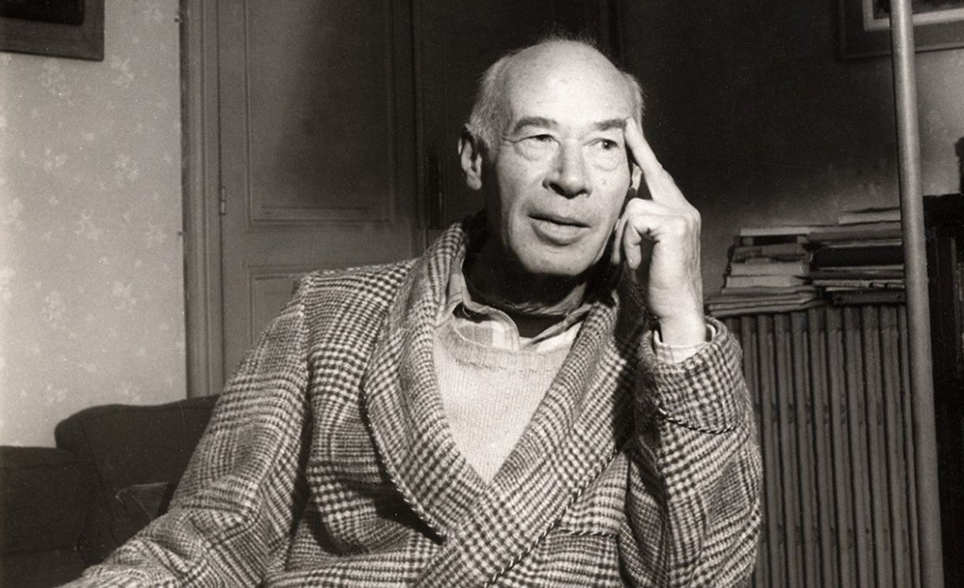

Reflections on Writing, Henry Miller

Reflections on Writing

KNUT HAMSUN once said, in response to a questionnaire, that he wrote to kill time. I think that even if he were sincere in stating it thus he was deluding himself. Writing, like life itself, is a voyage of discovery.

The adventure is a metaphysical one: it is a way of approaching life indirectly, of acquiring a total rather than a partial view of the universe. The writer lives between the upper and lower worlds: he takes the path in order eventually to become that path himself.

I began in absolute chaos and darkness, in a bog or swamp of ideas and emotions and experiences. Even now I do not consider myself a writer, in the ordinary sense of the word. I am a man telling the story of his life, a process which appears more and more inexhaustible as I go on.

Like the world-evolution, it is endless. It is a turning inside out, a voyaging through X dimensions, with the result that somewhere along the way one discovers that what one has to tell is not nearly so important as the telling itself.

It is this quality about all art which gives it a metaphysical hue, which lifts it out of time and space and centers or integrates it to the whole cosmic process. It is this about art which is “therapeutic”: significance, purposelessness, infinitude.

From the very beginning almost I was deeply aware that there is no goal. I never hope to embrace the whole, but merely to give in each separate fragment, each work, the feeling of the whole as I go on, because I am digging deeper and deeper into life, digging deeper and deeper into past and future.

With the endless burrowing a certitude develops which is greater than faith or belief. I become more and more indifferent to my fate, as writer, and more and more certain of my destiny as man.

I began assiduously examining the style and technique of those whom I once admired and worshipped: Nietzsche, Dostoievski, Hamsun, even Thomas Mann, whom today I discard as being a skillful fabricator, a brick-maker, an inspired jackass or draught-horse.

I imitated every style in the hope of finding the clue to the gnawing secret of how to write. Finally I came to a dead end, to a despair and desperation which few men have known, because there was no divorce between myself as writer and myself as man: to fail as a writer meant to fail as a man.

And I failed. I realized that I was nothing—less than nothing—a minus quantity. It was at this point, in the midst of the dead Sargasso Sea, so to speak, that I really began to write. I began from scratch, throwing everything overboard, even those whom I most loved.

Immediately I heard my own voice I was enchanted: the fact that it was a separate, distinct, unique voice sustained me. It didn’t matter to me if what I wrote should be considered bad. Good and bad dropped out of my vocabulary.

I jumped with two feet into the realm of aesthetics, the non-moral, non-ethical, non-utilitarian realm of art. My life itself became a work of art. I had found a voice, I was whole again.

The experience was very much like what we read of in connection with the lives of Zen initiates. My huge failure was like the recapitulation of the experience of the race: I had to grow foul with knowledge, realize the futility of everything, smash everything, grow desperate, then humble, then sponge myself off the slate, as it were, in order to recover my authenticity. I had to arrive at the brink and then take a leap in the dark.

I talk now about Reality, but I know there is no getting at it, leastwise by writing. I learn less and realize more: I learn in some different, more subterranean way. I acquire more and more the gift of immediacy.

I am developing the ability to perceive, apprehend, analyze, synthesize, categorize, inform, articulate—all at once. The structural element of things reveals itself more readily to my eye. I eschew all clear cut interpretations: with increasing simplification the mystery heightens. What I know tends to become more and more unstatable.

I live in certitude, a certitude which is not dependent upon proofs or faith. I live completely for myself, without the least egotism or selfishness. I am living out my share of life and thus abetting the scheme of things.

I further the development, the enrichment, the evolution and the devolution of the cosmos, every day in every way. I give all I have to give, voluntarily, and take as much as I can possibly ingest. I am a prince and a pirate at the same time.

I am the equals sign, the spiritual counterpart of the sign Libra which was wedged into the original Zodiac by separating Virgo from Scorpio. I find that there is plenty of room in the world for everybody—great interspatial depths, great ego universes, great islands of repair, for whoever attains to individuality.

On the surface, where the historical battles rage, where everything is interpreted in terms of money and power, there may be crowding, but life only begins when one drops below the surface, when one gives up the struggle, sinks and disappears from sight.

Now I can as easily not write as write: there is no longer any compulsion, no longer any therapeutic aspect to it. Whatever I do is done out of sheer joy: I drop my fruits like a ripe tree. What the general reader or the critic makes of it is not my concern. I am not establishing values: I defecate and nourish. There is nothing more to it.

This condition of sublime indifference is a logical development of the egocentric life. I lived out the social problem by dying: the real problem is not one of getting on with one’s neighbor or of contributing to the development of one’s country, but of discovering one’s destiny, of making a life in accord with the deep-centered rhythm of the cosmos.

To be able to use the word cosmos boldly, to use the word soul, to deal in things “spiritual”—and to shun definitions, alibis, proofs, duties. Paradise is everywhere and every road, if one continues along it far enough, leads to it.

One can only go forward by going backward and then sideways and then up and then down. There is no progress: there is perpetual movement, displacement, which is circular, spiral, endless. Every man has his own destiny: the only imperative is to follow it, to accept it, no matter where it lead him.

I haven’t the slightest idea what my future books will be like, even the one immediately to follow. My charts and plans are the slenderest sort of guides: I scrap them at will, I invent, distort, deform, lie, inflate, exaggerate, confound and confuse as the mood seizes me. I obey only my own instincts and intuitions. I know nothing in advance. Often I put down things which I do not understand myself, secure in the knowledge that later they will become clear and meaningful to me.

I have faith in the man who is writing, who is myself, the writer. I do not believe in words, no matter if strung together by the most skillful man: I believe in language, which is something beyond words, something which words give only an inadequate illusion of.

Words do not exist separately, except in the minds of scholars, etymologists, philologists, etc. Words divorced from language are dead things, and yield no secrets. A man is revealed in his style, the language which he has created for himself.

To the man who is pure at heart I believe that everything is as clear as a bell, even the most esoteric scripts. For such a man there is always mystery, but the mystery is not mysterious, it is logical, natural, ordained, and implicitly accepted. Understanding is not a piercing of the mystery, but an acceptance of it, a living blissfully with it, in it, through and by it.

I would like my words to flow along in the same way that the world flows along, a serpentine movement through incalculable dimensions, axes, latitudes, climates, conditions. I accept a priori my inability to realize such an ideal. It does not bother me in the least.

In the ultimate sense, the world itself is pregnant with failure, is the perfect manifestation of imperfection, of the consciousness of failure. In the realization of this, failure is itself eliminated. Like the primal spirit of the universe, like the unshakable Absolute, the One, the All, the creator, i.e., the artist, expresses himself by and through imperfection.

It is the stuff of life, the very sign of livingness. One gets nearer to the heart of truth, which I suppose is the ultimate aim of the writer, in the measure that he ceases to struggle, in the measure that he abandons the will.

The great writer is the very symbol of life, of the non-perfect. He moves effortlessly, giving the illusion of perfection, from some unknown center which is certainly not the brain center but which is definitely a center, a center connected with the rhythm of the whole universe and consequently as sound, solid, unshakable, as durable, defiant, anarchic, purposeless, as the universe itself. Art teaches nothing, except the significance of life.

The great work must inevitably be obscure, except to the very few, to those who like the author himself are initiated into the mysteries. Communication then is secondary: it is perpetuation which is important. For this only one good reader is necessary.

If I am a revolutionary, as has been said, it is unconsciously. I am not in revolt against the world order. “I revolutionize,” as Blaise Cendrars said of himself. There is a difference. I can as well live on the minus side of the fence as on the plus side.

Actually I believe myself to be just above these two signs, providing a ratio between them which expresses itself plastically, non-ethically, in writing. I believe that one has to pass beyond the sphere and influence of art. Art is only a means to life, to the life more abundant. It is not in itself the life more abundant.

It merely points the way, something which is overlooked not only by the public, but very often by the artist himself. In becoming an end it defeats itself. Most artists are defeating life by their very attempt to grapple with it. They have split the egg in two.

All art, I firmly believe, will one day disappear. But the artist will remain, and life itself will become not “an art,” but art, i.e., will definitely and for all time usurp the field.

In any true sense we are certainly not yet alive. We are no longer animals, but we are certainly not yet men. Since the dawn of art every great artist has been dinning that into us, but few are they who have understood it.

Once art is really accepted it will cease to be. It is only a substitute, a symbol-language, for something which can be seized directly. But for that to become possible man must become thoroughly religious, not a believer, but a prime mover, a god in fact and deed. He will become that inevitably.

And of all the detours along this path art is the most glorious, the most fecund, the most instructive. The artist who becomes thoroughly aware consequently ceases to be one. And the trend is towards awareness, towards that blinding consciousness in which no present form of life can possibly flourish, not even art.

To some this will sound like mystification, but it is an honest statement of my present convictions. It should be borne in mind, of course, that there is an inevitable discrepancy between the truth of the matter and what one thinks, even about himself: but it should also be borne in mind that there exists an equal discrepancy between the judgment of another and this same truth. Between subjective and objective there is no vital difference. Everything is illusive and more or less transparent.

All phenomena, including man and his thoughts about himself, are nothing more than a movable, changeable alphabet. There are no solid facts to get hold of. Thus, in writing, even if my distortions and deformations be deliberate, they are not necessarily less near to the truth of things.

One can be absolutely truthful and sincere even though admittedly the most outrageous liar. Fiction and invention are of the very fabric of life. The truth is no way disturbed by the violent perturbations of the spirit.

Thus, whatever effects I may obtain by technical device are never the mere results of technique, but the very accurate registering by my seismographic needle of the tumultuous, manifold, mysterious and incomprehensible experiences which I have lived through and which, in the process of writing, are lived through again, differently, perhaps even more tumultuously, more mysteriously, more incomprehensibly.

The so-called core of solid fact, which forms the point of departure as well as repair, is deeply embedded in me: I could not possibly lose it, alter it, disguise it, try as I may. And yet it is altered, just as the face of the world is altered, with each moment that we breathe.

To record it then, one must give a double illusion—one of arrestation and one of flow. It is this dual trick, so to speak, which gives the illusion of falsity: it is this lie, this fleeting, metamorphic mask, which is of the very essence of art. One anchors oneself in the flow: one adopts the lying mask in order to reveal the truth.

I have often thought that I should like one day to write a book explaining how I wrote certain passages in my books, or perhaps just one passage. I believe I could write a good-sized book on just one small paragraph selected at random from my work.

A book about its inception, its genesis, its metamorphosis, its accouchement, of the time which elapsed between the birth of the idea and its recording, the time it took to write it, the thoughts I had between times while writing it, the day of the week, the state of my health, the condition of my nerves, the interruptions that occurred, those of my own volition and those which were forced upon me, the multifarious varieties of expression which occurred to me in the process of writing, the alterations, the point where I left off and in returning, completely altered the original trend, or the point where I skillfully left off, like a surgeon making the best of a bad job, intending to return and resume some time later, but never doing so, or else returning and continuing the trend unconsciously some few books later when the memory of it had completely vanished.

Or I might take one passage against another, passages which the cold eye of the critic seizes on as examples of this or that, and utterly confound them, the analytical-minded critics, by demonstrating how a seemingly effortless piece of writing was achieved under great duress whereas another difficult, labyrinthian passage was written like a breeze, like a geyser erupting.

Or I could show how a passage originally shaped itself when in bed, how it became transformed upon arising, and again transformed at the moment of sitting down to record it. Or I could produce my scratch pad to show how the most remote, the most artificial stimulus produced a warm, life-like human flower.

I could produce certain words discovered by hazard while riffling the pages of a book, show how they set me off—but who on earth could ever guess how, in what manner, they were to set me off?

All that the critics write about a work of art, even at the best, even when most sound, convincing, plausible, even when done with love, which is seldom, is as nothing compared to the actual mechanics, the real genetics of a work of art.

I remember my work, not word for word, to be sure, but in some more accurate, trustworthy way; my whole work has come to resemble a terrain of which I have made a thorough, geodetic survey, not from a desk, with pen and ruler, but by touch, by getting down on all fours, on my stomach, and crawling over the ground inch by inch, and this over an endless period of time in all conditions of weather.

In short, I am as close to the work now as when I was in the act of executing it—closer perhaps. The conclusion of a book was never anything more than a shift of bodily position. It might have ended in a thousand different ways.

No single part of it is finished off: I could resume the narrative at any point, carry on, lay canals, tunnels, bridges, houses, factories, stud it with other inhabitants, other fauna and flora, all equally true to fact. I have no beginning and no ending, actually. Just as life begins at any moment, through an act of realization, so the work.

But each beginning, whether of book, page, paragraph, sentence or phrase, marks a vital connection, and it is in the vitality, the durability, the timelessness and changelessness of the thoughts and events that I plunge anew each time.

Every line and word is vitally connected with my life, my life only, be it in the form of deed, event, fact, thought, emotion, desire, evasion, frustration, dream, revery, vagary, even the unfinished nothings which float listlessly in the brain like the snapped filaments of a spider’s web.

There is nothing really vague or tenuous—even the nothingnesses are sharp, tough, definite, durable. Like the spider I return again and again to the task, conscious that the web I am spinning is made of my own substance, that it will never fail me, never run dry.

In the beginning I had dreams of rivaling Dostoievski. I hoped to give to the world huge, labyrinthian soul struggles which would devastate the world. But before very far along I realized that we had evolved to a point far beyond that of Dostoievski—beyond in the sense of degeneration. With us the soul problem has disappeared, or rather presents itself in some strangely distorted chemical guise.

We are dealing with crystalline elements of the dispersed and shattered soul. The modern painters express this state or condition perhaps even more forcibly than the writer: Picasso is the perfect example of what I mean. It was quite impossible for me, therefore, to think of writing novels; equally unthinkable to follow the various blind alleys represented by the various literary movements in England, France and America.

I felt compelled, in all honesty, to take the disparate and dispersed elements of our life—the soul life, not the cultural life—and manipulate them through my own personal mode, using my own shattered and dispersed ego as heartlessly and recklessly as I would the flotsam and jetsam of the surrounding phenomenal world.

I have never felt any antagonism for or anxiety over the anarchy represented by the prevailing forms of art; on the contrary, I have always welcomed the dissolving influences. In an age marked by dissolution, liquidation seems to me a virtue, nay a moral imperative. Not only have I never felt the least desire to conserve, bolster up or buttress anything, but I might say that I have always looked upon decay as being just as wonderful and rich an expression of life as growth.

I think I should also confess that I was driven to write because it proved to be the only outlet open to me, the only task worthy of my powers. I had honestly tried all the other roads to freedom.

I was a self-willed failure in the so-called world of reality, not a failure because of lack of ability. Writing was not an “escape,” a means of evading the every day reality: on the contrary, it meant a still deeper plunge into the brackish pool—a plunge to the source where the waters were constantly being renewed, where there was perpetual movement and stir.

Looking back upon my career, I see myself as a person capable of undertaking almost any task, any vocation. It was the monotony and sterility of the other outlets which drove me to desperation.

I demanded a realm in which I should be both master and slave at the same time: the world of art is the only such realm. I entered it without any apparent talent, a thorough novice, incapable, awkward, tongue-tied, almost paralyzed by fear and apprehensiveness.

I had to lay one brick on another, set millions of words to paper before writing one real, authentic word dragged up from my own guts. The facility of speech which I possessed was a handicap; I had all the vices of the educated man. I had to learn to think, fed and see in a totally new fashion, in an uneducated way, in my own way, which is the hardest thing in the world. I had to throw myself into the current, knowing that I would probably sink.

The great majority of artists are throwing themselves in with life-preservers around their necks, and more often than not it is the life-preserver which sinks them. Nobody can drown in the ocean of reality who voluntarily gives himself up to the experience. Whatever there be of progress in life comes not through adaptation but through daring, through obeying the blind urge.

“No daring is fatal,” said René Crevel, a phrase which I shall never forget. The whole logic of the universe is contained in daring, i.e., in creating from the flimsiest, slenderest support.

In the beginning this daring is mistaken for will, but with time the will drops away and the automatic process takes its place, which again has to be broken or dropped and a new certitude established which has nothing to do with knowledge, skill, technique or faith.

By daring one arrives at this mysterious X position of the artist, and it is this anchorage which no one can describe in words but yet subsists and exudes from every line that is written.

The end