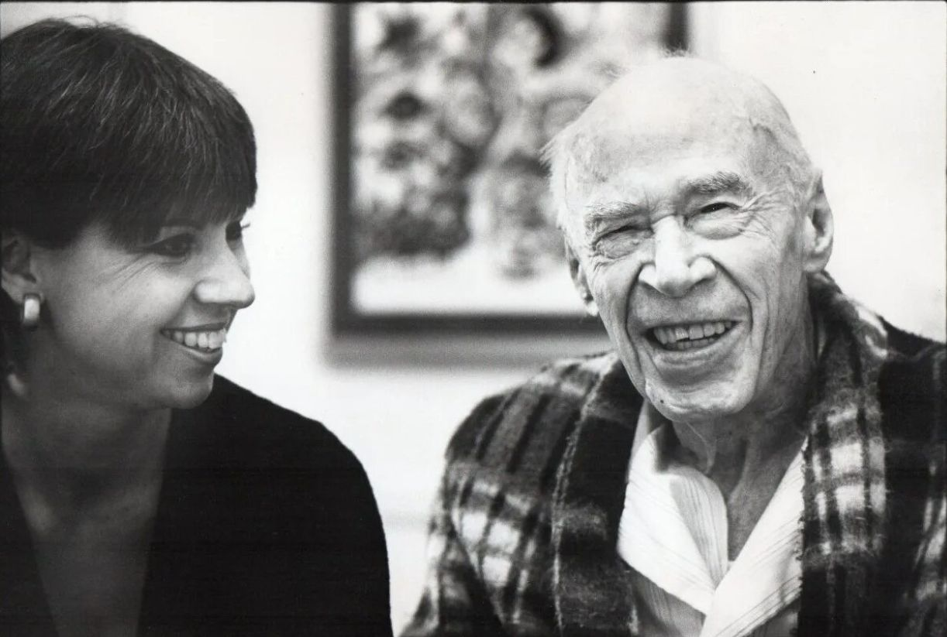

The Cosmological Eye, Henry Miller

The Cosmological Eye

MY FRIEND Reichel is just a pretext to enable me to talk about the world, the world of art and the world of men, and the confusion and eternal misunderstanding between the two. When I talk about Reichel I mean any good artist who finds himself alone, ignored, unappreciated.

The Reichels of this world are being killed off like flies. It will always be so; the penalty for being different, for being an artist, is a cruel one.

Nothing will change this state of affairs. If you read carefully the history of our great and glorious civilization, if you read the biographies of the great, you will see that it has always been so; and if you read still more closely you will see that these exceptional men have themselves explained why it must be so, though often complaining bitterly of their lot.

Every artist is a human being as well as painter, writer or musician; and never more so than when he is trying to justify himself as artist.

As a human being Reichel almost brings tears to my eyes. Not merely because he is unrecognized (while thousands of lesser men are wallowing in fame), but first of all because when you enter his room, which is in a cheap hotel where he does his work, the sanctity of the place breaks you down. It is not quite a hovel, his little den, but it is perilously close to being one.

You cast your eye about the room and you see that the walls are covered with his paintings. The paintings themselves are holy. This is a man, you cannot help thinking, who has never done anything for gain. This man had to do these things or die.

This is a man who is desperate, and at the same time full of love. He is trying desperately to embrace the world with this love which nobody appreciates. And, finding himself alone, always alone and unacknowledged, he is filled with a black sorrow.

He was trying to explain it to me the other day as we stood at a bar. It’s true, he was a little under the weather and so it was even more difficult to explain than normally. He was trying to say that what he felt was worse than sorrow, a sort of sub-human black pain which was in the spinal column and not in the heart or brain.

This gnawing black pain, though he didn’t say so, I realized at once was the reverse of his great love: it was the black unending curtain against which his gleaming pictures stand out and glow with a holy phosphorescence.

He says to me, standing in his little hotel room: “I want that the pictures should look back at me; if I look at them and they don’t look at me too then they are no good.” The remark came about because some one had observed that in all his pictures there was an eye, the cosmological eye, this person said.

As I walked away from the hotel I was thinking that perhaps this ubiquitous eye was the vestigial organ of his love so deeply implanted into everything he looked at that it shone back at him out of the darkness of human insensitivity.

More, that this eye had to be in everything he did or he would go mad. This eye had to be there in order to gnaw into men’s vitals, to get hold of them like a crab, and make them realize that Hans Reichel exists.

This cosmological eye is sunk deep within his body. Everything he looks at and seizes must be brought below the threshold of consciousness, brought deep into the entrails where there reigns an absolute night and where also the tender little mouths with which he absorbs his vision eat away until only the quintessence remains.

Here, in the warm bowels, the metamorphosis takes place. In the absolute night, in the black pain hidden away in the backbone, the substance of things is dissolved until only the essence shines forth.

The objects of his love, as they swim up to the light to arrange themselves on his canvases, marry one another in strange mystic unions which are indissoluble. But the real ceremony goes on below, in the dark, according to the inscrutable atomic laws of wedlock.

There are no witnesses, no solemn oaths. Phenomenon weds phenomenon in the way that atomic elements marry to make the miraculous substance of living matter. There are polygamous marriages and polyandrous marriages, but no morganatic marriages.

There are monstrous unions too, just as in nature, and they are as inviolable, as indissoluble as the others. Caprice rules, but it is the stern caprice of nature, and so divine.

There is a picture which he calls “The Stillborn Twins.” It is an ensemble of miniature panels in which there is not only the embryonic flavor but the hieroglyphic as well. If he likes you, Reichel will show you in one of the panels the little shirt which the mother of the stillborn twins was probably thinking of in her agony. He says it so simply and honestly that you feel like weeping.

The little shirt embedded in a cold pre-natal green is indeed the sort of shirt which only a woman in travail could summon up. You feel that with the freezing torture of birth, at the moment when the mind seems ready to snap, the mother’s eye inwardly turning gropes frantically towards some tender, known object which will attach her, if only for a moment, to the world of human entities.

In this quick, agonized clutch the mother sinks back, through worlds unknown to man, to planets long since disappeared, where perhaps there were no baby’s shirts but where there was the warmth, the tenderness, the mossy envelope of a love beyond love, of a love for the disparate elements which metamorphose through the mother, through her pain, through her death, so that life may go on.

Each panel, if you read it with the cosmological eye, is a throw-back to an undecipherable script of life. The whole cosmos is moving back and forth through the sluice of time and the stillborn twins are embedded there in the cold pre-natal green with the shirt that was never worn.

When I see him sitting in the armchair in a garden without bounds I see him dreaming backward with the stillborn twins. I see him as he looks to himself when there is no mirror anywhere in the world: when he is caught in a stone trance and has to imagine the mirror which is not there.

The little white bird in the corner near his feet is talking to him, but he is deaf and the voice of the bird is inside him and he does not know whether he is talking to himself or whether he has become the little white bird itself.

Caught like that, in the stony trance, the bird is plucked to the quick. It is as though the idea, bird, was suddenly arrested in the act of passing through the brain. The bird and the trance and the bird in the trance are transfixed. It shows in the expression on his face. The face is Reichel’s, but it is a Reichel that has passed into a cataleptic state.

A fleeting wonder hovers over the stone mask. Neither fear nor terror is registered in his expression—only an inexpressible wonder, as though he were the last witness of a world sliding down into darkness. And in this last minute vision the little white bird comes to speak to him—but he is already deaf.

The most miraculous words are being uttered inside him, this bird language which no one has ever understood; he has it now, deep inside him. But it is at this moment when everything is clear that he sees with stony vision the world slipping away into the black pit of nothingness.

There is another self-portrait—a bust which is smothered in a mass of green foliage. It’s extraordinary how he bobs up out of the still ferns, with a more human look now, but still drunk with wonder, still amazed, bedazzled and overwhelmed by the feast of the eye.

He seems to be floating up from the paleozoic ooze and, as if he had caught the distant roar of the Flood, there is in his face the premonition of impending catastrophe. He seems to be anticipating the destruction of the great forests, the annihilation of countless living trees and the lush green foliage of a spring which will never happen again.

Every variety of leaf, every shade of green seems to be packed into this small canvas. It is a sort of bath in the vernal equinox, and man is happily absent from his preoccupations. Only Reichel is there, with his big round eyes, and the wonder is on him and this great indwelling wonder saturates the impending doom and casts a searchlight into the unknown.

In every cataclysm Reichel is present. Sometimes he is a fish hanging in the sky beneath a triple-ringed sun. He hangs there like a God of Vengeance raining down his maledictions upon man. He is the God who destroys the fishermen’s nets, the God who brings down thunder and lightning so that the fishermen may be drowned.

Sometimes he appeals incarnated as a snail, and you may see him at work building his own monument. Sometimes he is a gay and happy snail crawling about on the sands of Spain. Sometimes he is only the dream of a snail, and then his world already phantasmagorical becomes musical and diaphanous.

You are there in his dream at the precise moment when everything is melting, when only the barest suggestion of form remains to give a last fleeting due to the appearance of things. Swift as flame, elusive, perpetually on the wing, nevertheless there is always in his pictures the iron claw which grasps the unseizable and imprisons it without hurt or damage.

It is the dexterity of the master, the visionary clutch which holds firm and secure its prey without ruffling a feather.

There are moments when he gives you the impression of being seated on another planet making his inventory of the world. Conjunctions are recorded such as no astronomer has noted. I am thinking now of a picture which he calls “Almost Full Moon.” The almost is characteristic of Reichel.

This almost full is not the almost full with which we are familiar. It is the almost-full-moon which a man would see from Mars, let us say. For when it will be full, this moon, it will throw a green, spectral light reflected from a planet just bursting into life.

This is a moon which has somehow strayed from its orbit. It belongs to a night studded with strange configurations and it hangs there taut as an anchor in an ocean of pitchblende.

So finely balanced is it in this unfamiliar sky that the addition of a thread would destroy its equilibrium. This is one of the moons which the poets are constantly charting and concerning which, fortunately, there is no scientific knowledge.

Under these new moons the destiny of the race will one day be determined. They are the anarchic moons which swim in the latent protoplasm of the race, which bring about baffling disturbances, angoisse, hallucinations.

Everything that happens now and has been happening for the last twenty thousand years or so is put in the balance against this weird, prophetic cusp of a moon which is traveling towards its optimum.

The moon and the sea! What cold, clean attractions obsess him! That warm, cosy fire out of which men build their petty emotions seems almost unknown to Reichel. He inhabits the depths, of ocean and of sky. Only in the depths is he content and in his element.

Once he described to me a Medusa he had seen in the waters of Spain. It came swimming towards him like a sea-organ playing a mysterious oceanic music. I thought, as he was describing the Medusa, of another painting for which he could not find words.

I saw him make the motion with his arms, that helpless, fluttering stammer of the man who has not yet named everything. He was almost on the point of describing it when suddenly he stopped, as if paralyzed by the dread of naming it.

But while he was stuttering and stammering I heard the music playing; I knew that the old woman with the white hair was only another creature from the depths, a Medusa in female guise who was playing for him the music of eternal sorrow.

I knew that she was the woman who inhabited “The Haunted House” where in hot somber tones the little white bird is perched, warbling the pre-ideological language unknown to man. I knew that she was there in the “Remembrance of a Stained Glass Window,” the being which inhabits the window, revealing herself in silence only to those who have opened their hearts.

I knew that she was in the wall on which he had painted a verse of Rilke’s, this gloomy, desolate wall over which a smothered sun casts a wan ray of light. I knew that what he could not name was in everything, like his black sorrow, and that he had chosen a language as fluid as music in order not to be broken on the sharp spokes of the intellect.

In everything he does color is the predominant note. By the choice and blend of his tones you know that he is a musician, that he is preoccupied with what is unseizable and untranslatable. His colors are like the dark melodies of César Franck. They are all weighted with black, a live black, like the heart of chaos itself.

This black might also be said to correspond to a kind of beneficent ignorance which permits him to resuscitate the powers of magic. Everything he portrays has a symbolic and contagious quality: the subject is but the means for conveying a significance which is deeper than form or language.

When I think, for example, of the picture which he calls “The Holy Place,” one of his strikingly unobtrusive subjects, I have to fall back on the word enigmatic. There is nothing in this work which bears resemblance to other holy places that we know of.

It is made up of entirely new elements which through form and color suggest all that is called up by the title. And yet, by some strange alchemy, this little canvas, which might also have been called “Urim and Thummim,” revives the memory of that which was lost to the Jews upon the destruction of the Holy Temple.

It suggests the fact that in the consciousness of the race nothing which is sacred has been lost, that on the contrary it is we who are lost and vainly seeking, and that we shall go on vainly seeking until we learn to see with other eyes.

In this black out of which his rich colors are born there is not only the transcendental but the despotic. His black is not oppressive, but profound, producing a fruitful disquietude. It gives one to believe that there is no rock bottom any more than there is eternal truth.

Nor even God, in the sense of the Absolute, for to create God one would first have to describe a circle. No, there is no God in these paintings, unless it be Reichel himself.

There is no need for a God because it is all one creative substance born out of darkness and relapsing into darkness again.

The end