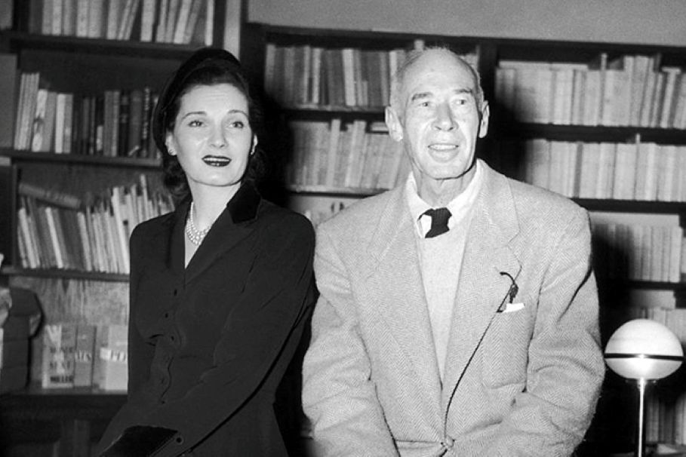

The Enormous Womb, Henry Miller

The Enormous Womb

AS THE dictionary says, the womb is the place where anything is engendered or brought to life. As far as I can make out, there is never anything but womb.

First and last there is the womb of Nature; then there is the mother’s womb; and finally there is the womb in which we have our life and being and which we call the world.

It is the failure to recognize the world as womb which is the cause of our misery, in large part.

We think of the child unborn as living in a state of bliss; we think of death as an escape from life’s ills; but life itself we still refuse to regard as bliss and security. And yet, in this world about is not everything being engendered and brought to life?

Perhaps it is only another of our illusions that the grave be regarded as a refuge and the nine months preceding birth as bliss. Who knows anything about the uterine life or the life hereafter?

Yet somehow the idea has caught hold, and probably it will never perish, that these two states of unconsciousness mean freedom from pain and struggle, and hence bliss. On the other hand we know from experience that there are people alive and moving about who live in what is called a state of bliss.

Are they more unconscious than the rest, or less so? I think most of us would agree that they are less unconscious. Wherein are their lives different then from that of the ordinary run of mankind?

To my way of thinking the difference lies in their attitude towards the world, lies in the supreme fact that they have accepted the world as a womb, and not a tomb. For they seem neither to regret what has passed nor to fear what is to come. They live in an intense state of awareness and yet are apparently without fear.

It has been said that fear, which plays such a dominant role in our lives, was once a vague, nameless thing, an echo, one might almost say, of the life instinct. It has been said that with the development of civilization this nameless fear gradually crystallized into a fear of death.

And that in the highest reaches of civilization this fear of death becomes a fear of life, as exemplified by the behavior of the neurotic. Now there is nothing strange about fear: no matter in what guise it presents itself it is something with which we are all so familiar that when a man appears who is without it we are at once enslaved by him.

There have been less than a handful of such men in the history of man. Whether they were forces for good or evil matters little: the fear which they awaken is the fear of the monster.

In truth they were all monsters, whether they be called Tamerlane, Buddha, Christ or Napoleon. They were heroic figures, and the hero, according to myths was always born supernaturally. The hero, in short, is one who was spared the shock of birth.

The hero then is a sort of monster who is immune to pain and suffering: he is on the side of life. The world is for him a place where things are engendered, brought to life. Life reveals itself to him as art, and not as an ordeal.

He enjoys life by rearranging it according to his own needs. He may say that he is doing it for others, for humanity, but we know that he is also a liar. The hero is a man who says to himself—this is where things happen, not somewhere else. He acts as if he were at home in the world.

Such behavior, of course, brings about a terrific confusion, for as you may have noticed, people are seldom at home, always somewhere else, always “absent.” Life, as it is called, is for most of us one long postponement. And the simple reason for it is: FEAR.

As we see whenever a war breaks out, the fear of war is overcome the moment one is really in it. If war were really as terrible as people imagine it to be it would have been wiped out long ago.

To make war is as natural for human beings as to make love. Love can make cowards of men just as much as the fear of war. But once desperately in love a man will commit any crime and not only feel justified, but feel good about it. It is in the order of things.

The wisest men are those who speak of illusion: MAYA. Illusion is the antidote to fear. In harness they render life absurdly illogical. But it is just this antinomian quality of life which keeps us going, which sends us shuttling back and forth from one womb to another.

The world, which is not just the human world, is the womb of all, of birth and of life and of death.

It is this third and all-inclusive womb, THE WORLD, which man is perpetually striving to make himself a part of. It is the original chaos, the seat of creation itself. No man ever fully attains it. It is a condition of IS known neither to the foetus nor to the corpse. But it is known to the soul, and if it be unrealizable it is none the less true.

Curiously enough the verb which expresses being is in our language an intransitive verb. Most people think it quite natural that the verb to be should be an intransitive one. And yet there are languages, as we know, which make no distinction between transitive and intransitive. The spirit of these languages is more deeply rooted in symbol.

Since it is only through symbolism that we apprehend anything profoundly, the more precise and conceptual a language becomes the more sterile does it become. The modern tongues, all of them, reflect more and more the death in us.

They reflect only too clearly the fact that we regard life itself as a vestibule, whether to heaven or to hell makes little difference. It was against this stagnant automatism which Lawrence fought all his life; it is this surrender to the death instincts which enrages a man like Céline.

Real death is not a source of terror for the ordinary, intelligent, sensitive being. It is living death which is the great nightmare. Living death means the interruption of the current of life, the forestalling of a natural death process.

It is a negative way of recognizing that the world is really nothing but a great womb, the place where everything is brought to life.

Everything that lives has will, that is, creativeness. Will is in the verb, which is the most important adjunct of our speech: a verb is ipso facto transitive. A verb, however, can be made intransitive, as the will can be rendered powerless, by the mind.

But by its nature a verb is the symbol of action, regardless of whether the action be doing, having, breathing, or being.

Actually there is nothing but a steady stream of activity, a movement towards or away from life. This activity continues even in death, therein proving often to be the most fructifying of all activity. We have no real language for death, since we know nothing of it, have never experienced it; we have only thought concepts, counter-symbols which are expressive of life in a negative fashion.

All that we really know is becoming, the endless change and transformation. Things are constantly being recreated. The real fear, the real terror, lies in the idea of arrest. It is a living idea of death.

Some people are born dead. Some people impress us as only half-alive. Others again seem radiant with energy. Whether one is on the side of life or on the side of death makes no difference. Life is just as wonderful on the minus side as on the plus side.

The real miracle is to stand still. That would mean becoming God, or dead-alive. That is the only possible escape from the womb, and that of course is why the notion of God is so ingrained in the human consciousness. God is summation, which is the same as saying cessation. God does not represent life, but fulfillment, which is the only legitimate form of death.

In this legitimate form of death, which I say lies behind the notion of fulfillment, there is the completest subservience to the life instinct. This is the idea which has obsessed all the religious maniacs, the very sensible one that only in living a thing out to the full can there be an end. It is a wholly unmoral idea, a thoroughly artistic one.

The greatest artists have been the immoralists, that is, the ones who have been in favor of living it out. Of course they were immediately misunderstood by their disciples, by those who go about preaching in their name, disseminating the gospel of this or that. The idea with which these great religious figures were imbued is that of bringing things to an end. They were all ridden with an obsession about suffering.

The idea that the womb might be a place of torture or punishment is a fairly recent one. I mean by that only a few thousand years old. It goes hand in hand with the loss of innocence. All ideas of Paradise involve the conquest of fear. Paradise is always a condition that is earned or won through struggle. The elimination of struggle is the greatest struggle of all—the struggle not to struggle.

For struggle, whether erroneously or not, has to do with birth. But there was a time when birth was easy. That time is now as much as then.

To get beyond pain and suffering, beyond struggle, one must learn the equilibrist’s art. (“God does not want men to overtax themselves,” said Nijinsky. “He wants men to be happy.”) In walking the slack wire above the opposites one becomes thoroughly and keenly aware—perilously aware.

The consciousness expands to embrace the apparently conflicting opposites. To be supremely aware, which means accepting life for what it is, eliminates the tenors of life and kills false hopes. I should say rather, kills hope, for seen from a beyond hope appears as an evil rather than a good.

I say nothing about being happy. When one really understands what happiness is one goes out like a light. (Vide Kirillov!) All arrangements for a better life here on earth mean increased suffering and misery. Everything that is being planned for tomorrow means the destruction of that which now exists.

The best world is that which is now this very moment. It is the best because it is absolutely just—which does not mean that it has anything to do with justice. If we wish something better or worse we have only to want it and we shall damned well have it.

The world is a dream which is being realized from moment to moment, only man is sound asleep in the midst of his creation. Birth and rebirth, and the monsters as much a part of the process as the angels.

The world becomes interesting and livable only when we accept it in toto with eyes wide open, only when we live it out as the foetus lives out its uterine life. Apropos, has any one ever heard of an “immoral” foetus?

Or a “cowardly” corpse? Can any one say whether the Bushmen in Australia are leading the right life, the good life? And the flowers, do they make for progress and invention? These are little questions which often disturb the philosophers. Intellectual sabotage. But it is good to ask unanswerable questions now and then—it makes life more livable.

I remember a phrase which haunted me when I was younger: “man on his way to ordination.” I didn’t know what it meant precisely, but it fascinated me. I believed. Today, though I am frank to say I don’t know what such a phrase means, I believe more than ever. I believe everything, good and bad. I believe more and less than what is true.

I believe beyond the whole corpus of man’s thinking. I believe everything. I believe in a collective life and in the individual life also. I believe in the life of the world, the uterus which it is. I believe in the contradictions of the uterine life of this world.

I believe in having money and in not having money too. And whether I believe or don’t believe I always act. I act first and inquire afterwards. For nothing seems more certain to me than that everything which exists, exists by fiat. If the world is anything it is an act.

Thinking too is an act. The world is not a thought, but it may well be an act of thought. Those who act create reactions, as we say. In the throes of giving birth the mother is only reacting: it is the foetus which acts. And whether the mother lives or dies is one and the same to the foetus. For a foetus the important thing is birth.

Similarly for man, the important thing is to get born, born into the world-as-is, not some imaginary, wished for world, not some better, brighter world, but this, the only world, the world of NOW.

There are many people today who imagine that the way to do this is to pay another man to permit them to lie down on a couch and have him listen to their tale of woe. Others again think that the midwives who perform this task ought themselves pay to be born again.

There are always Saviours and somehow the Saviours always get it in the neck. Nobody has yet found out how to save those who refuse to save themselves. And then again—a little uterine question —do we really want to be saved? And if so, for what, why, what is there to save?

We see how the banks spend the money which we save for them; we see how governments spend the taxes which they compel us to pay, in order, as they say, to “protect” us. We see how the philosophers dispense of their wisdom, and how prodigal the artist is of his strength. And do we not know that God is constantly giving us of his boundless love? In the highest places there is giving and spending galore.

Why then do we not give ourselves—recklessly, abundantly, completely? If we realized that we were part of an endless process, that we had neither to lose nor to gain, but only to live it out, would we behave as we do? I can imagine the man of the year 5,000 A. D. opening the door of his home and stepping out into a world infinitely better than this; I can also imagine him stepping out into a world infinitely worse than ours.

But for him, Mr. John Doe personally, I believe in the bottom of my heart that it will be exactly the same world as this which we now inhabit. The fauna and flora may be different, the climate may be different, the ideologies may be different, God may be different, everything may be different—but John Doe will himself be different and so it will be the same.

I feel as close to John Doe of the year 5,000 A. D. as I do to John Doe of the year 5,000 B. C. I would be incapable of choosing between them. Each has his own world to which he belongs. Whoever does not realize what a wonderful world it is, tant pis for him. The world is the world, and the world is more interested in its own birth and death than in the opinion which Mr. John Doe may have about it.

Most of the active workers of the world today look upon our life on earth as a Purgatory or a Hell. They are sweating and struggling to make it a Heaven for the man to come. Or if they refuse to put it quite that way to themselves, then they say that it is to make a Heaven for themselves—a little later.

Time passes. Five Year Plans. Ten Year Plans. (Dinosaurs, dynasties, dynamos.) Meanwhile the teeth decay, rheumatism comes, then death. (Death never fails.) But it’s never Heaven. Somehow Heaven is always in the offing, always just around the corner. Tomorrow, tomorrow, tomorrow. . . .

IT’S BEEN GOING ON THAT WAY FOR A MILLION YEARS OR SO. In the midst of this crazy treadmill I refuse to budge an inch. I stand still. Stock still. Now or never! I say. Peace brothers, it’s wonderful! Meanwhile the big guns are booming, in Abyssinia, in China, in Spain, and besides the usual routine slaughter of harmless animals, birds, fish, insects, snails, oysters et cetera, man is slaughtering man to pave the way for the millennium.

Tomorrow the guns may be roaring here in Paris, or in New York, or in Timbuctoo. They may even roar in Scandinavia, in Holland, in Switzerland, where all is sleep and contentment whilst the cows silently chew the cud. But they will soon roar and belch their fire, that is sure.

Still I will not budge. I will stand stock still and shout: Peace! It’s wonderful! I have nothing to lose, nothing to gain. Even though I did not make the cannon with my own hands, nevertheless I assisted at their birth. The cannons belong, like everything else. Everything belongs. It’s the world, comrades—the world of birth and rebirth, and long may it wave!

The end