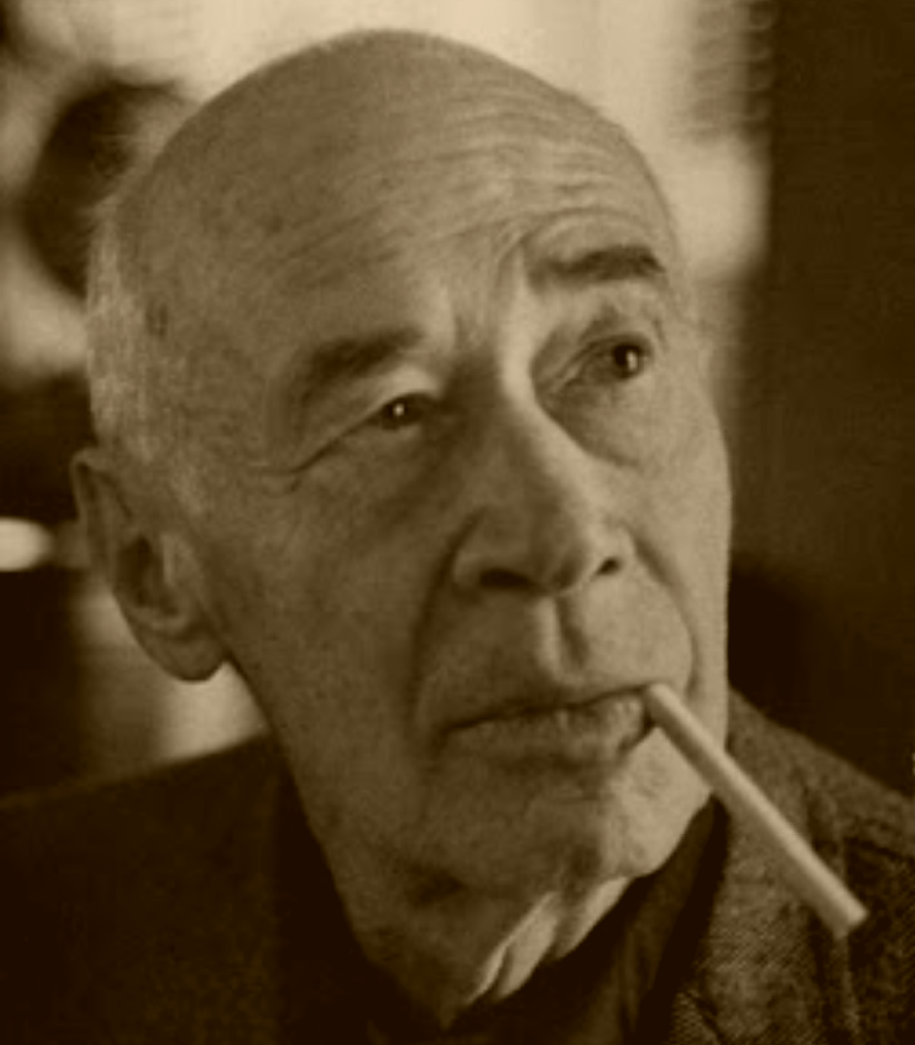The Eye of Paris, Henry Miller

The Eye of Paris

BRASSAI HAS that rare gift which so many artists despise—normal vision. He has no need to distort or deform, no need to lie or to preach.

He would not alter the living arrangement of the world by one iota; he sees the world precisely as it is and as few men in the world see it because seldom do we encounter a human being endowed with normal vision.

Everything to which his eye attaches itself acquires value and significance, a value and significance, I might say, heretofore avoided or ignored. The fragment, the defect, the commonplace—he detects in them what there is of novelty or perfection.

He explores with equal patience, equal interest, a crack in the wall or the panorama of a city. Seeing becomes an end in itself. For Brassai is an eye, a living eye.

When you meet the man you see at once that he is equipped with no ordinary eyes. His eyes have that perfect, limpid sphericity, that all-embracing voracity which makes the falcon or the shark a shuddering sentinel of reality.

He has the eyeball of the insect which, hypnotized by its myopic scrutiny of the world, raises its two huge orbs from their sockets in order to acquire a still greater flexibility.

Eye to eye with this man you have the sensation of a razor operating on your own eyeball, a razor which moves with such delicacy and precision that you are suddenly in a ball room in which the act of undressing follows upon the wish.

His gaze pierces the retina like those marvelous probes which penetrate the labyrinth of the ear in order to sound for dead bone, which tap at the base of the skull like the dull tick of a watch in moments of complete silence.

I have felt the penetration of his gaze like the gleam of a searchlight invading the hidden recesses of the eye, pushing open the sliding doors of the brain. Under that keen, steady gaze I have felt the seat of my skull glowing like an asbestos grill, glowing with short, violet waves which no living matter can resist.

I have felt the cool, dull tremors in every vertebra, each socket, each nodule, cushion and fiber vibrating at such a speed that the whole backbone together with my rudimentary tail is thrown into incandescent relief.

My spine becomes a barometer of light registering the pressure and deflection of all the waves which escape the heavy, fluid substance of matter. I feel the feathery, jubilant weight of his eye rising from its matrix to brush the prisms of light.

Not the eye of a shark, nor a horse, nor a fly, not any known flexible eye, but the eye of a coccus newborn, a coccus travelling on the wave of an epidemic, always a millimeter in advance of the crest. The eye that gloats and ravages.

The eye that precedes doom. The waiting, lurking eye of the ghoul, the torpid, monstrously indifferent eye of the leper, the still, all-inclusive eye of the Buddha which never closes. The insatiable eye.

It is with this eye that I see him walking through the wings of the Folies-Bergère, walking across the ceiling with sticky, clinging feet, crawling on all fours over candelabras, warm breasts, crinolines, training that huge, cold searchlight on the inner organs of a Venus, on the foam of a wave of lace, on the cicatrices that are dyed with ink in the satin throat of a puppet, on the pulleys that will hoist a Babylon in paint and papier-mâché, on the empty seats which rise tier upon tier like layers of sharks’ teeth.

I see him walking across the proscenium with his beautiful suede gloves, see him peeling them off and tossing them to the inky squib which has swallowed the seats and the glass chandeliers, the fake marble, the brass posts, the thick velvet cords and the chipped plaster.

I see the world of behind the scenes upside down, each fragment a new universe, each human body or puppet or pulley framed in its own inconceivable niche. I see the lovely Venus prone and full athwart her strange axis, her hair dipped in laudanum, her mouth bright with asphodels; she lies in the neap of the tide, taut with starry sap, her toes tinctured with light, her eyes transfixed.

He does not wait for the curtain to rise; he waits for it to fall. He waits for that moment when all the conglomerations artificially produced resolve back into their natural component entities, when the nymphs and the dryads strewing themselves like flowers over the floor of the stage gaze vacantly into the mirror of the tank where a moment ago, tesselated with spotlights, they swam like goldfish.

Deprived of the miracle of color, registering everything in degrees of black and white, Brassai nevertheless seems to convey by the purity and quality of his tones all the effects of sunlight, and even more impressively the effects of night light.

A man of the city, he limits himself to that spectacular feast which only such a city as Paris can offer. No phase of cosmopolitan life has escaped his eye. His albums of black and white comprise a vast encyclopaedia of the city’s architecture, its growth, its history, its origins.

Whatever aspect of the city his eye seizes upon the result is a vast metaphor whose brilliant arc, studded with incalculable vistas backward and forward, glistens now like a drop of dew suspended in the morning light.

The Cemetery Montmartre, for example, shot from the bridge at night is a phantasmagoric creation of death flowering in electricity, the intense patches of night lie upon the tombs and crosses in a crazy patchwork of steel girders which fade with the sunlight into bright green lawns and flower beds and graveled walks.

Brassai strikes at the accidental modulations, the illogical syntax, the mythical juxtaposition of things, at that anomalous, sporadic form of growth which a walk through the streets or a glance at a map or a scene in a film conveys to the sleeping portion of the brain. What is most familiar to the eye, what has become stale and commonplace, acquires through the flick of his magic lens the properties of the unique.

Just as a thousand diverse types may write automatically and yet only one of them will bear the signature of André Breton, so a thousand men may photograph the Cemetery Montmartre but one of them will stand out triumphantly as Brassai’s.

No matter how perfect the machine, no matter how little of human guidance is involved, the mark of personality is always there. The photograph seems to carry with it the same degree of personality as any other form or expression of art.

Brassai is Brassai and Man Ray is Man Ray. One man may try to interfere as little as possible with the apparatus, or the results obtained from the apparatus; the other may endeavor to subjugate it to his will, to dominate it, control it, use it like an artist. But no matter what the approach or the technique involved the thing that registers is the stamp of individuality.

Perhaps the difference which I observe between the work of Brassai and that of other photographers lies in this—that Brassai seems overwhelmed by the fullness of life. How else are we to explain that a chicken bone, under the optical alchemy of Brassai, acquires the attributes of the marvelous, whereas the most fantastic inventions of other men often leave us with a sense of unfulfillment?

The man who looked at the chicken bone transferred his whole personality to it in looking at it; he transmitted to an insignificant phenomenon the fullness of his knowledge of life, the experience acquired from looking at millions of other objects and participating in the wisdom which their relationships one to another inspired.

The desire which Brassai so strongly evinces, a desire not to tamper with the object but regard it as it is, was this not provoked by a profound humility, a respect and reverence for the object itself?

The more the man detached from his view of life, from the objects and identities that make life, all intrusion of individual will and ego, the more readily and easily he entered into the multitudinous identities which ordinarily remain alien and closed to us. By depersonalizing himself, as it were, he was enabled to discover his personality everywhere in everything.

Perhaps this is not the method of art. Perhaps art demands the wholly personal, the catalytic power of will. Perhaps.

All I know is that when I look at these photographs which seem to have been taken at random by a man loath to assert any values except what were inherent in the phenomena, I am impressed by their authority.

I realize in looking at his photos that by looking at things aesthetically, just as much as by looking at things moralistically or pragmatically, we are destroying their value, their significance.

Objects do not fade away with time: they are destroyed! From the moment that we cease to regard them awesomely they die. They may carry on an existence for thousands of years, but as dead matter, as fossil, as archaeologic data.

What once inspired an artist or a people can, after a certain moment, fail to elicit even the interest of a scientist. Objects die in proportion as the vision of things dies. The object and the vision are one. Nothing flourishes after the vital flow is broken, neither the thing seen, nor the one who sees.

It happens that the man who introduced me to Brassai is a man who has no understanding of him at all, a sort of human cockroach living out his dream of the 18th ccntury.

He knows all the Metro stations by heart, can recite them backwards for you, line by line; he can give you the history of each arrondissement, can tell you precisely where and how one street intersects another, can give you the genesis of every statue and monument in Paris.

But he has absolutely no feeling for the streets, no wanderlust, no curiosity, no reverence. He secretes himself in his room and lives out in imagination the hermeneutic life of the 18th century.

I mention this only as an example of the strange fatality by which two men of kindred spirit are sometimes brought together. I mention it by way of showing that even the despised cockroach serves a purpose in life. I see that the cockroach living out its dream of the 18th century can serve as a link to bind the living. It was this same cockroach, I must also confess, who revealed to me the glamor of the 13th arrondissement.

In the very heart of it, like a spider luring me to its lair, there lived all the while this man Brassai whom I was destined to meet. I remember vividly how, when I first came to Paris, I wandered one day to his hotel looking for a painter. The man who received me was not the man I had expected to see. He was a petty, niggardly, querulous soul who had once painted a knife and fork and rested there.

I had to return to America, come back to France once again, starve, roam the streets, listen to silly, idiotic theories of life and art, take up with this failure and that, and finally surrender to the cockroach before it was possible to know the man who like myself had taken in Paris without effort of will, the man who, without my knowing it, was silently slaving away at the illustrations for my books.

And when one day the door was finally thrust open I beheld to my astonishment a thousand replicas of all the scenes, all the streets, all the walls, all the fragments of that Paris wherein I died and was born again. There on his bed, in myriad pieces and arrangements, lay the cross to which I had been nailed and crucified, the cross on which I was resurrected to live again and forever in the spirit.

How then am I to describe these morsels of black and white, how refer to them as photographs or specimens of art? Here on this man’s bed, drained of all blood and suffering, radiant now with only the life of the sun, I saw my own sacred body exposed, the body that I have written into every stone, every tree, every monument, park, fountain, statue, bridge, and dwelling of Paris.

I see now that I am leaving behind me a record of Paris which I have written in blood—but also in peace and good will. The whole city—every arrondissement, every carrefour, every impasse, every enchanted street. Through me Paris will live again, a little more, a little brighter.

Tenderly, reverently, as if I were gathering to my breast the most sentient morsels of myself, I pick up these fragments which lie on the bed. Once again I traverse the road that led me to the present, to this high, cool plateau whence I can look about me in serenity. What a procession passes before my eyes! What a throng of men and women! What strange cities—and situations stranger still!

The mendicant sitting on the public bench, thirsting for a glimmer of sun, the butcher standing in a pool of blood with knife upraised, the scows and barges dreaming in the shadows of the bridges, the pimp standing against a wall with cigarette in hand, the street cleaner with her broom of reddish twigs, her thick, gnarled fingers, her high stomach draped in black, a shroud over her womb, rinsing away the vomit of the night before so that when I pass over the cobblestones my feet will gleam with the light of morning stars.

I see the old hats, the sombreros and fedoras, the velours and Panamas that I painted with a clutching fury; I see the corners of walls eroded by time and weather which I passed in the night and in passing felt the erosion going on in myself, corners of my own walls crumbling away, blown down, dispersed, reintegrated elsewhere in mysterious shape and essence.

I see the old tin urinals where, standing in the dead silence of the night, I dreamed so violently that the past sprang up like a white horse and carried me out of the body.

Looking for an instant into the eyes of this man I see therein the image of myself. Two enormous eyes I see, two glowing discs which look up at the sun from the bottom of a pool; two round, wondrous orbs that have pushed back the heavy, opaque lids in order to swim up to the surface of the light and drink with unslakeable thirst.

Heavy tortoise eyes that have drunk from every stratum; soft, viscous eyes that have burrowed into the mud sinks, tracked the worm and shell; hard, sclerotic gems, bead and nugget, over which the heel of man has passed and left no imprint.

Eye that lurks in the primal ooze, lord and master of all it surveys; not waiting on history, not waiting on time. The cosmologic eye, persisting through wrack and doom, impervious, inchoate, seeing only what is.

Now and then, in wandering through the streets, suddenly one comes awake, perceives with a strange exultation that he is moving through an absolutely fresh slice of reality. Everything has the quality of the marvelous—the murky windows, the rain-sodden vegetables, the contours of the houses, the bill-posters, the slumping figures of men and women, the tin soldiers in the stationery shops, the colors of the walls—everything written down in an unfamiliar script.

After the moment of ecstasy has passed what is one’s amazement but to discover that the street through which he is walking with eyes popping is the street on which he lives. He has simply come upon it unaware, from the wrong end perhaps. Or, moving out of the confines of an unknown region, the sense of wonder and mystery prolonged itself in defiance of reality.

It is as if the eye itself had been freshened, as if it had forgotten all that it had been taught. In this condition it happens that one really does see things he had never seen before—not the fantastic, harrowing, hallucinating objects of dream or drug, but the most banal, the most commonplace things, seen as it were for the first time.

Walking one night along a dark, abandoned street of Levallois-Perret suddenly across the way I notice a window lit up. As I approach the reddish glow of the room awakens something in me, some obscure memory which stirs sleepily, only to be drowned again in deeper memories.

The hideous pattern of the wallpaper, which I can only vaguely decipher, seems as familiar to me as if I had lived with it all my life. The weird, infernal glow of the room throws the pattern of the wallpaper into violent relief; it leaps out from the wall like the frantic gesture of a madman. My heart is in my throat. My step quickens. I have the sensation of being about to look into the privacy of a room such as no man has seen before.

As I come abreast of the window I notice the glass bells suspended from the chandelier—three glass bells such as are manufactured by the million and which are the pride of every poverty-stricken home wherever there are progress and invention.

Under this modern, universal whatnot are gathered three of the most ordinary people that could possibly be grouped together—a tintype of honest toil snapped on the threshold of Utopia.

Everything in the room is familiar to me, nauseatingly familiar: the cupboard, the chain, the table, the tablecloth, the rubber plant, the bird cage, the alarm dock, the calendar on the wall, the Sunday it registers and the saint who rules it.

And yet never have I seen such a tintype as this. This is so ordinary, so familiar, so stale, so commonplace, that I have never really noticed it before.

The group is composed of two men and a woman. They are standing around the cheap, polished walnut table—the table that is not yet paid for. One man is in his shirt sleeves and wears a cap; the other man is wearing a pair of striped flannel pajamas and has a black derby tilted on the back of his head.

The woman is in a dressing sack and one of her titties is falling out. A large juicy teat with a dark, mulberry nipple swimming in a deep coffee stain full of fine wrinkles. On the table is a large dishpan filled with boiling water.

The man with cap and shirt sleeves has just doused something in the pan; the other man stands with his hands in his pockets and quietly puffs a cigarette, allowing the ash to fall on his pajama coat and from there to the table.

Suddenly the woman grabs the queer-looking object from the man with the cap and, holding it somewhat above her head, she commences plucking at it with lean, tenacious fingers. It is a dead chicken with black and red feathers and a bright red-toothed comb.

While she holds the legs of the chicken with one hand the man with the cap holds the neck; at intervals they lower the dead chicken into the pan of boiling water. The feathers come out easily, leaving the slightly yellowish skin full of black splinters. They stand there facing each other without uttering a word.

The woman’s fingers move nimbly from one area of the chicken to another—until she comes to the little triangular flap over the vent when with one gleeful clutch she rips out all the tail feathers at once and flinging them on the floor drops the chicken on the table.

Strike me pink if I have ever seen anything more grotesque! Taken in combination, under that light, at that hour of the night, the three tintypes, the peculiar deadness of the chicken, the scene remains unique in my memory.

Every other chicken, dressed or undressed, is scalded from my memory. Henceforth whenever I say chicken there will always come to mind two kinds—this chicken, whose name I do not know, and all other chickens. Chicken prime, let us say, so as to distinguish it from all other chicken integers that were and will be tomorrow, henceforth and forevermore.

And so it is, when I look at the photographs of Brassai, that I say to myself—chicken prime, table prime, chair prime, Venus prime, etc. That which constitutes the uniqueness of an object, the first, the original, the imperishable vision of things. When Shakespeare painted a horse, said a friend of mine once, it was a horse for all time.

I must confess that I am largely unfamiliar with the horses of Shakespeare, but knowing as I do certain of his human characters, and knowing also that they have endured throughout several centuries, I am quite willing to concede that his horses too, whoever and wherever they are, will have a long and abiding life.

I know that there are men and women who belong just as distinctly and inexpugnably to Rembrandt’s world, or Giotto’s, or Renoir’s.

I know that there are sleeping giants who belong to the Grimm family or to Michelangelo, and dwarfs who belong to Velasquez or Hieronymus Bosch, or to Toulouse-Lautrec. I know that there are physiognomic maps and relics of the human body which is all that we possess of buried epochs, all that is personal and understandable to us, and that these maps and relics bear the distinguished imprimatur of Dante, da Vinci, Petronius and such like.

I know too that even when the human body has been disintegrated and made an inhuman part of a fragmented world—such as the one we now inhabit—I mean that when the human body, having lost its distinction and kingship, serves the painter with no more inspiration, no more reverence than a table or chair or discarded newspaper, still it is possible to recognize one sort of hocus-pocus from another, to say this is Braque, that is Picasso, the other Chirico.

We have reached the point where we do not want to know any longer whose work it is, whose seal is affixed, whose stamp is upon it; what we want, and what at last we are about to get, are individual masterpieces which triumph in such a way as to completely subordinate the accidental artists who are responsible for them.

Every man today who is really an artist is trying to kill the artist in himself—and he must, if there is to be any art in the future. We are suffering from a plethora of art. We are art-ridden.

Which is to say that instead of a truly personal, truly creative vision of things, we have merely an aesthetic view. Empty as we are, it is impossible for us to look at an object without annexing it to our collection.

We have not a single chair, for example, in the sweep and memory of our retina, that does not bear a label; if, for the space of a week, a man working in absolute secrecy were to turn out chairs unique and unrecognizable, the world would go mad. And yet every chair that is brought into existence is howling for recognition as chair, as chair in its own right, unique and perdurable.

I think of chair because among all the objects which Brassai has photographed his chair with the wire legs stands out with a majesty that is singular and disquieting. It is a chair of the lowest denomination, a chair which has been sat on by beggars and by royalty, by little trot-about whores and by queenly opera divas.

It is a chair which the municipality rents daily to any and every one who wishes to pay fifty centimes for sitting down in the open air. A chair with little holes in the seat and wire legs which come to a loop at the bottom.

The most unostentatious, the most inexpensive, the most ridiculous chair, if a chair can be ridiculous, which could be devised. Brassai chose precisely this insignificant chair and, snapping it where he found it, unearthed what there was in it of dignity and veracity. THIS IS A CHAIR. Nothing more.

No sentimentalism about the lovely backsides which once graced it, no romanticism about the lunatics who fabricated it, no statistics about the hours of sweat and anguish that went into the creation of it, no sarcasm about the era which produced it, no odious comparisons with chairs of other days, no humbug about the dreams of the idlers who monopolize it, no scorn for the nakedness of it, no gratitude either. Walking along a path of the Jardin des Tuileries one day he saw this chair standing on the edge of a grating.

He saw at once chair, grating, tree, clouds, sun, people. He saw that the chair was as much a part of that fine spring day as the tree, the clouds, the sun, the people. He took it as it was, with its honest little holes, its slender wire legs.

Perhaps the Prince of Wales once sat on it, perhaps a holy man, perhaps a leper, perhaps a murderer or an idiot. Who sat on it did not interest Brassai in the least. It was a spring day and the foliage was greening; the earth was in a ferment, the roots convulsed with sap.

On such a day, if one is alive, one can well believe that out of the dead body of the earth there will spring forth a race of men immortal in their splendor. On such a day there is visible in the stalest object a promise, a hope, a possibility. Nothing is dead, except in the imagination.

Animate or inanimate, all bodies under the sun give expression to their vitality. Especially on a fine day in spring!

And so on that day, in that glorious hour, the homely, inexpensive chair belonging to the municipality of Paris became the empty throne which is always beseeching the restless spirit of man to end his fear and longing and proclaim the kingdom of man.

The end