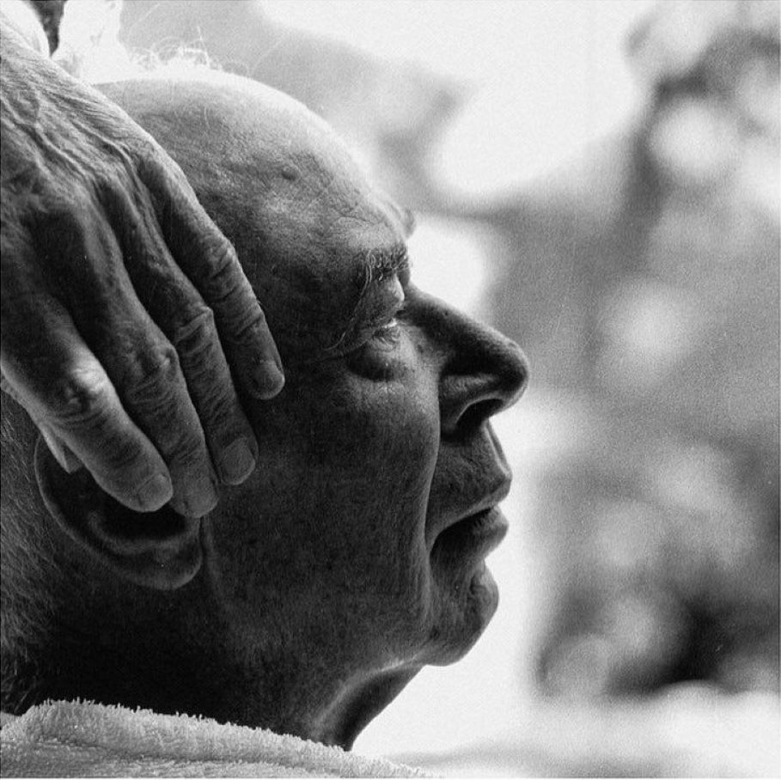

Tribute To Blaise Cendrars, Henry Miller

Tribute To Blaise Cendrars

Je suis un homme inquiet, dur vis à vis de soi-même, comme tous les solitaires. From Une Nuit dans la Forêt.

THE REASON I always think of Cendrars with affection and admiration is that he resembles so closely that Chinese rock-bottom man of my imagination whom I have probably invented because of my hatred and contempt for the men I see about me in the world today.

Cendrars himself gives the clue to his enigmatic character in an autobiographical fragment, a little book called Une Nuit dans la Forêt. “De plus en plus, je me rends compte que j’ai toujours pratiqué la vie contemplative.”

Turbulent and chaotic though his writing seems, the meaning nevertheless is always crystal clear. Cendrars anchors himself in the very heart of things. He is the most active of men and yet serene as a lama.

To bemoan the contradictoriness of his nature is to misjudge him. The man is all of a piece, one inexhaustible creative substance which enjoys a continuous fulfillment through giving. Many people would say that he is generous to a fault. I would not use the word generous in connection with Cendrars.

He is beyond that. He is a vital force, a blind and pitiless urge, closer to nature than to man. He is tender and ruthless at the same time. He is antinomian. And always uniquely himself, always uniquely Blaise Cendrars.

If you will look at a list of his works you will see that more than half of them are exhausted. And if you study the titles of his works you will see that the man himself is inexhaustible. He is the most contemporary of contemporaries, dated and undated at the same time.

He is so well informed that he is absolutely oblivious of what is going on. Cendrars is the crude ore of which the finest metals are made.

He can tell the most monstrous lies and remain absolutely truthful. In every yarn he spins there is more of vital substance and genuine fact than you can find in the whole panorama, for example, of Jules Romains’ magnum opus. In every book he gives us Cendrars seems to be making the gesture of bending down and picking up a handful of earth with his good left hand.

In every book he seems to be embracing us with that mutilated arm through which the blood still courses warm and red. Cendrars knows only the reality and honesty of the heart.

His gestures, often rough and awkward, are nevertheless manly gestures. He never tries to please or to conciliate. He is the worst diplomat in the world, and consequently the best. He is not a realist, but real.

In his peculiar inhuman way he does only what is human, responds only to what is human. If sometimes he seems like a charge of dynamite it is because his sincerity, his integrity, is incorruptible.

Cendrars is a voyager. There is hardly a corner of the globe whereon he has not set foot. He has not only voyaged about the world, but beyond the world. He has been to the moon, to Man, to Neptune, Vega, Saturn, Pluto, Uranus.

He is a visionary who does not spurn the ordinary means of travel, of locomotion. Usually he travels incognito, adopting the manners and the speech of the people he is visiting.

He carries no passport and no letters of credit, neither letters of introduction, to be sure. He knows that wherever he lands it is the same rigmarole. It is not a question of confidence in himself, nor even of faith in his lucky star—it is a question of accuracy.

When he describes his celestial voyages he proceeds simply and honestly, as if he were describing a trip to Formosa or Patagonia. The world is one, the same in dream as in waking life. One plasma and one magma. Frontiers exist only for the timid ones, for the poor and mean at heart. Cendrars never uses the word “frontier”: he speaks of latitude and longitude.

He inquires about the climate, or the nature of the soil, what do you use for food, and so on. He is almost frighteningly natural, almost inhumanly human. “L’action seule libère. Elle dénoue tout.”

He has friends everywhere, even among the Hottentots. And yet he is the most solitary of men. Of all the men I have ever met he is the most liberated—yet thoroughly earthbound. To use the word “cosmic” with reference to him would be to insult him; it would imply that he accepted life. Cendrars does not accept.

He accepts nothing. He says neither “Yes” nor “No.” He walks over such questions rough-shod. He becomes terrifyingly silent. And that is why perhaps he is the most marvellous talker I have ever listened to. His talk is not of loneliness, as with most men—it is of the absolute moment, of nothingness, of evanescence and metamorphosis.

And so it is fecund, magical, toxic. His talk is pure destruction to everything that is not of the moment; it is a mirage born of the peculiar spiritual atmosphere which he has created about him and in which he lives. He follows it thirstily, like the wanderer in the desert.

But he is never lost, nor is he ever deceived. Nor does he ever leave his body, as do those strange seekers of wisdom in Tibet. Wherever Cendrars goes his body accompanies him—and his hunger and his thirst.

If it has been a tight squeeze he returns looking emaciated; if it was plain sailing he comes back with ruddy face and that sort of starry gleam in his eyes which is unforgettable. One is tempted to say of him that he is hallucinating. Cendrars not only creates longing, he answers it too.

His talk is that of a man ceaselessly emptying his pockets. He does not talk words; he talks things, facts, deeds, experiences. He needs no adjectives, just verbs and nouns—and conjunctions and conjunctions and conjunctions.

His nationality is obscure. He is a melting-pot of all races, all peoples. Once I was going to dedicate a book to him—“To Blaise Cendrars, the first Frenchman to make me a royal gesture!”—but I realized as I wrote the phrase that it would be an injustice to Cendrars to call him a Frenchman.

No, he is, as I said before, the Chinese rock-bottom man of my imagination, the man that D. H. Lawrence would like to have been, the man of the cosmos who remains forever unidentified, the man who renews the race by putting humanity back into the crucible. “Je méprise tout ce qui est. J’agis. Je revolutionne,” says Cendrars.

I remember reading Moravagine, one of my very first attempts to read French. It was like reading a phosphorescent text through smoked glasses. I had to divine what he was saying, Cendrars, but I got it. If he had written it in Tegalic I would have gotten it. Even in such a work as L’Eubage one gets it, gets it quick in the guts—or never.

Everything is written in blood, but a blood that is saturated with starlight. Cendrars is like a transparent fish swimming in a planetary sperm; you can see his backbone, his lungs, his heart, his kidneys, his intestines; you can see the red corpuscles moving in the blood-stream.

You can look clean through him and see the planets wheeling. The silence he creates is deafening. It takes you back to the beginning of the world, to that hush which is engraved on the face of mystery.

I always see him there in the hub of the universe, slowly revolving with the vortex. I see his slouch hat and battered mug beneath it. I see him “revolutionizing,” because there is no help for it, because there is nothing else to do.

Yes he is a sort of Brahman à rebours, as he says of himself, a Brahman who is the envoy plenipotentiary of the active principle itself. He is the man of the dream which he is dreaming, and he will be that until the dream ends. There is no subject and object.

There is. A transitive mode which is expressed by the intransitive; action which is the negation of activity. Cendrars is the eye of the navel, the face in the mirror which remains after you have turned your back on it.

Another interesting thing about him—he does as little as possible. It is not that he is lazy—far from it!—nor that he is gripped by the futility of things. It is rather because he is a piece of human radium buried in the maggot pile of humanity.

At the very bottom of the pile he can still assert his full strength. He does not need to get up and walk or shout; he has only to be, only to radiate his inexhaustible vitality. He is the incarnation of the very opposite principle which governs the world, like the lie which reveals the truth. He is all those things which we know only by contrast, and so he has not even to move his little finger.

The slightest voluntary movement and he would be done for, he would explode. And Cendrars knows it. He has an almost geologic wisdom, which is why he is never logical, never ruthful, never serious, never hopeful, never confident, never trustful, never anything. He is never, never, never. He is.

You reach to him by leaning backward, by receding, by putting minus in front of you. You can never meet him face to face, never seize him by putting your arms out. You must relinquish, sink back, close your eyes.

He is at the beginning of the road, not at the end. Meet me yesterday, he says, or the day before yesterday. It is no use setting the alarm—you will never get up early enough to meet him.

If he had wanted to be anything he could have been it most successfully. He does not want He is like the sage in the Chinese story who, when asked why he never performed the miracles attributed to his disciple, replied; “The Master is able to do these things, but he is also able to refrain from doing them.” His disinterestedness is always a positive, active quality. He is not inactive—he refuses, he rejects.

It is this instinctive, ordained defiance in Cendrars which makes the word “rebel” sound ridiculous when applied to him. He is not a rebel, he is an absolute traitor to the race, and as such I salute him. The salute is wasted, of course, because Cendrars doesn’t give a damn whether you salute him or not.

Would you salute a tree for spreading its foliage? Whether you are at the bottom or the top is all the same to Cendrars. He doesn’t care to know what you are trying to do; he is only interested in what you are. He looks you through and through, pitilessly. If you are meat for the gristle, fine! he devours you.

If you are just suet, then down the sewer you go—unless that day he happens to be in need of a little fat. He is the epitome of injustice, which is why he appears so magnanimous. He does not forgive, or pardon, or condemn, or condone. He puts you in the scales and weighs you. He says nothing.

He lets you do the talking. With himself he is equally rigorous. “Moi, l’homme le plus libre du monde, je reconnais que l’on est toujours lié par quelque chose, et que la liberté, l’indépendance n’existe pas, et je me méprise autant que je peux, tout en rejouissant de mon impuissance.”

He has been accused of writing trash. It is true that he does not always write on the same level—but Cendrars never writes trash. He is incapable of writing trash. His problem is not whether to write well or badly, but whether to write or not write. Writing is almost a violation of his way of living.

He writes against the grain, more and more so as the years go on. If, on the impulse of the moment, or through dire necessity, he takes the notion to do a piece of reportage, he goes through with it with good grace.

He goes about even the most trivial task with pains, because fundamentally he does not recognize that one thing is trivial and another important. If it is not anti-human, his attitude, it is certainly anti-moral. He is as much ashamed of being disgusted or revolted as of being exalted or inspired. He has known what it is to struggle, but he despises struggle too.

His writing, like his life, is on different levels. It changes color, substance, tempo, just as his life changes rhythm and equilibrium. He goes through metamorphoses, without however surrendering his identity. His behavior seems to be governed not merely by internal changes—psychic, chemical, physiologic—but by external ones also, chiefly by interstellar configurations.

He is tremendously susceptible to changes of weather—the spiritual weather. He experiences in his soul genuine eclipses; he knows what it means to fly off at a tangent, or to sweep across the sky like a flaming comet. He has been put on the rack, drawn and quartered; he has pursued his own shadow, tasted madness.

It seems to me that his greatest tribulation has been to accept the quality of the grandiose which is written in his destiny. His struggle has been with his own fate, with the grandeur which for some reason he has never wholly accepted. Out of desperation and humility he has created for himself the more human role of the antagonist.

But his destiny was laid down in royal colors. He does not fit in anywhere because his whole life has been lived in defiance of the pattern which was ordained. And desperate and tragic, even foolish as such a course may seem, it is the very inmost virtue of Cendrars, the link which binds him to the human family, which makes him the wonderful copain he is, the marvellous man among men whom even the unseeing recognize immediately.

It is this challenge which he carries around in him, which he hurls now and then in his mad, drunken moments; it is this which really sustains those about him, those who have had even the least contact with him.

It is not the blustering, heroic attitude, but the blind, tragic defiance of the Greeks. It is the resistance to fate which is always aroused by a super-endowment of strength, by a super-wisdom.

It is the Dionysian element which is created at the moment of greatest lucidity: the frail, human voice denying the god-impulse because to accept it would mean the death of all that is creative, all that is truly human.

It is on this wheel of creation and destruction that Cendrars turns, as the globe itself turns. It is this which isolates him, makes him a solitary.

He refuses to spread himself thin over an illusory pattern of grandeur; he muscles deeper and deeper into the hub, into the everlasting no-principle of the universe.

The end