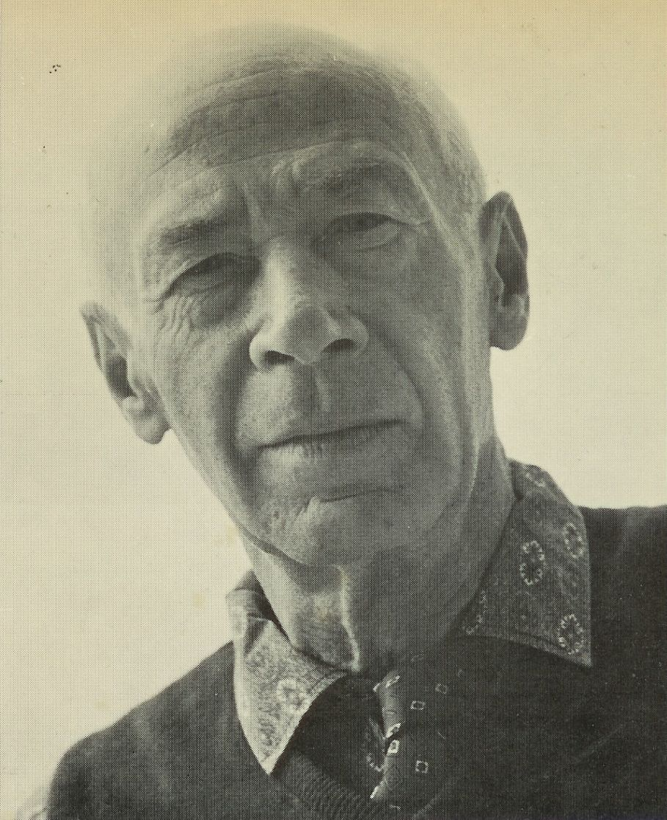Uterine Hunger, Henry Miller

Uterine Hunger

I WAS BORN too soon. In the seventh month I ripped and clawed my way out of the womb. I fell out on the street head first, with full grown nails, cloven hoofs and a double set of teeth.

They swaddled me in cotton wool and shoved me back in an incubator where under glass I enjoyed an artificial birth. It cost a dime to have a look at me, and for the same dime one could also examine the three-legged cow, the embryo with two heads and other interesting monsters. Near by was a shooting gallery. It was in Dreamland, Coney Island.

Exposed to the light too soon I developed hypertrophy of the end organs. I react to color violently. My two months in the incubator were like a prison term. By the time I was handed my birth certificate my criminal instincts were already fully developed.

It was only natural that I should become a rebel, an outlaw, a desperado. I blame my parents, I blame society, I blame God. I accuse. I go through life with finger lifted accusingly. I have the prophetic itch. I curse and blaspheme. I tell the bitter truth.

From the very beginning it seems as if the world were an artificial womb, a prison, seems as though everybody and everything were conspiring to pull me back to the womb from which I broke loose too soon. I go through life raw, exposed, twisting, writhing, squirming.

The light stabs me like a million needles. I dance such a violent jig inside that my articulation is thrown completely out of gear. I am always turning inside out, to protect myself with my bones. The light whistles through my bones; I glow like a skeleton under the X-ray.

And always I am hungry, voraciously hungry. I am insatiable. It is a hunger on all fronts: alimentary, sexual, spiritual. I don’t eat—I attach myself, like the amoeba, to whatever morsel of food presents itself.

Once I have ingested it I split—double, triple, multiple selves floating off in search of fresh morsels of food. It goes on like that ad nauseam. Women—they too seem like morsels of food. After I attach myself to them I devour them. I fuck my way through body, brain and soul, and then I split again. Parthogenic marriage.

The women I have loved are only bare bones now—the armature which refused to be masticated, even though I was equipped with a double set of teeth. With ideas the same: I swallowed them boiling hot and scorched my gizzards.

What remains is the pure crystalline essence, the atomic structure which refused to pass through the intestines of the brain. It’s like continual fireworks going on in the upper story—an explosion that never comes off.

I suppose I am a reflection of the times, of this feverish agitation, this mad tempo, this inability to hold it in until the germ is ready to blossom. Nothing but short waves, nothing but clash, stridency, a brief meteoric flash and then extinction. Something is struggling to be born, that’s evident.

But the toll is frightful—the toll of stillbirths. The walls of the womb are weak, and the weak womb has a tenacious clutch. The clamor inside has the same hysterical pitch as that outside: the born and the unborn are doing the St. Vitus dance.

The modern womb is like a rectum full of haemorrhoids; the child has either to be yanked out by the forceps or cut away like an ulcer. Usually the womb is turned inside out, and after that it has to be scraped and cauterized. Then a dose of alum—so that it will shrink back to normalcy.

The worst is that this spawn which comes out of the womb stinks of the womb for the rest of its life. And not only that, but a continual turning and twisting, as if they were trying to turn themselves inside out.

As a matter of fact, the world is turning itself inside out. One can see the skeletal bones everywhere, like umbrella ribs lying in the gutter after a violent storm. Everything stands out nakedly—the grinning skeleton for any one who has an eye. The artist who is born of these times is the living symbol of this squirming nakedness.

He is looking for meat to cover his bare bones, for a little flesh to hide the blood which was spilled at his birth. He wants to get out of the strait jacket which was slipped over him before he had the strength to raise his arms. He wants to get rid of the blinders which were put over his eyes before he had even a chance to look at the world.

Whatever the artist does now is in short wave lengths—uterine vibrations which are scarcely perceptible. He works in nascent images, straggling to reveal through his colors the hidden form of things.

He sees everything in terms of phylogeny and ontogeny. He is incestuous, perverted at the roots. The father is displaced, murdered by the son, because he has not asserted his power over life and death. The mother, like Osiris, searches frantically for the missing genitals.

When the body of life is wasted away there is nothing for it but to take the bare bones to our bosom and hug them and warm them. Life beats through the skeleton in some miraculous way. At the last ditch this which we imagine to be useless and an abomination gets up and walks, gets up and takes on flesh, gets up and sings.

This which we carry around inside us, which took form and substance out of the irreducible elements, is the final inspiration. When we wear away to this we touch the node, the ultimate link between life and death. At that farthest extreme of life which is called death we recover the simplicity of the organic unities.

With the ebb-tide there is no consciousness of anything save atomic structure. At the last point of livingness thought spreads itself so thin that the structural element expresses itself finitely. The chemistry of the mind becomes the alchemy of the spirit. The multiverse is made a universe. Through form significance is restored.

The world is always dying and always coming back to life. Tide and pulse, and with the turn of the tide a touch of mystery. At thought’s deadmost reach the miraculous seeps back and throws a glow over the wan cadaver of despair.

The taut, stretched world which the mind inhabited grows smaller and smaller and more and more awe-inspiring. The feeling for life rises as the forms and symbols become illuminated. The stars gather direction in the same way that the foetus moves towards birth.

The mystery is never revealed, but with birth attention is focused on creation. Once the sacred character of the body is recognized the cosmos wheels into line. Once the cosmic accent is identified the whole edifice of life bursts into melody.

When the individual is wholly creative, one with destiny, there is neither time nor space, nor birth and death. The god-feeling becomes so intense that everything, organic and inorganic, beats with a divine rhythm.

At the moment of supreme individuation, when the identity of all things is sensed and one is at the same time utterly and blissfully alone, the umbilical cord is at last cut. There is neither a longing for the womb nor a longing for the beyond.

The sure feeling of eternality. Beyond this there is no evolution, only a perpetual movement from creation to creation. The personality itself becomes a creation. From symbolizing himself in his works man symbolizes himself in his being.

At this stage he utters miracles and produces miracles. He speaks in a language so clear that it penetrates the densest matter. The word becomes magic, it produces a contagion.

And it is through this miraculous virus that the world is poisoned and dies. It is the miracle of miracles. The world dies over and over again, but the skeleton always gets up and walks.

The end