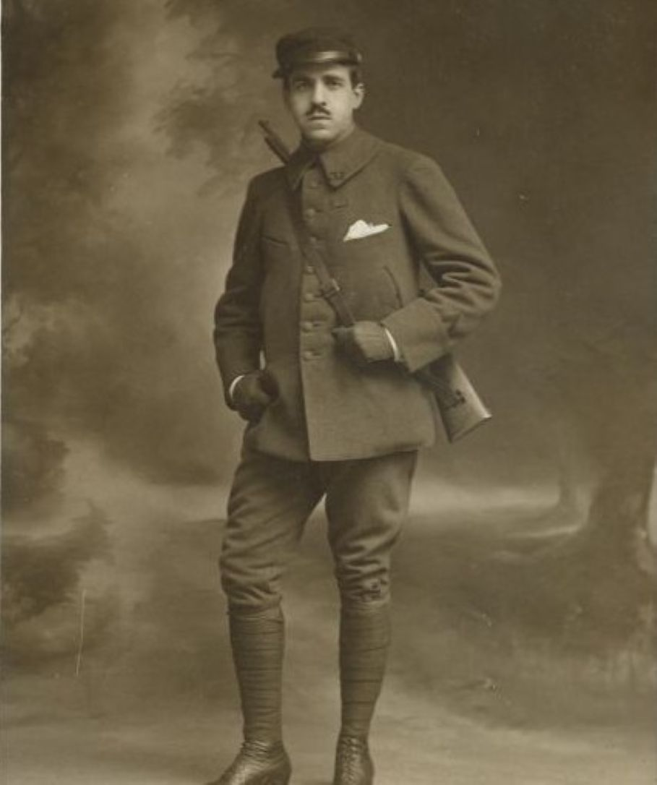

A Dinner in High Society, Marcel Proust

A Dinner in High Society

But Fundianus, who shared the happiness of that banquet with you? I’m dying to know.

—HORACE: SATIRES

Honoré was late; he greeted his host and hostess and the people he knew, he was introduced to the rest, and they all went in to dinner. Several moments later, his neighbor, a very young man, asked him to name the others and tell him something about them. Honoré had never met him in society.

He was very handsome. The mistress of the house kept darting ardent glances at him, which sufficiently indicated why she had invited him and that he would soon become part of her circle. Honoré saw him as a future power; but with no envy and out of kindness and courtesy, he set about answering him.

He looked around. Two diners across from him were not on speaking terms: with good but clumsy intentions, they had been invited and placed side by side because they were both involved in literature. But to this foremost reason for mutual hatred they added a more personal one.

The older man, as a relative—doubly hypnotized—of Monsieur Paul Desjardins and Monsieur de Vogüé, affected a scornful silence toward the younger man, who, as a favorite disciple of Monsieur Maurice Barrès, maintained a stance of irony toward his neighbor. Moreover, each man’s malevolence quite involuntarily exaggerated the other’s importance, as if the chief of villains were confronting the king of imbeciles.

Further away, a superb Spanish woman was eating ravenously. That evening, serious person that she was, she had unhesitatingly sacrificed a rendezvous to the probability of advancing her social career by dining in a fashionable home. And indeed, she had every prospect of success with her calculations.

Madame Fremer’s snobbery was, for her female friends, and that of her female friends was, for her, like mutual insurance against sinking into the bourgeoisie. But as luck would have it, on this particular evening Madame Fremer was ridding herself of a stock of people whom she had been unable to invite to her dinners, but to whom she insisted on being polite for various reasons and whom she had gathered almost higgledy-piggledy.

The event was crowned by a duchess, but the Spanish woman had already met her and could get nothing more out of her. So she exchanged irritated glances with her husband, whose guttural voice could perpetually be heard at soirées, asking at five-minute intervals that were quite filled with other kettles of fish: “Would you present me to the duke?” “Monsieur le duc, would you present me to the duchess?” “Madame la duchesse, may I present my wife?”

Fuming at having to waste his time, he was nevertheless resigned to starting a conversation with his neighbor, the host’s business partner. For over a year now Fremer had been begging his wife to invite him.

She had finally yielded and had tucked him away between the señora’s husband and a humanist. The humanist, who read too much, ate too much. He quoted and burped, and these two complaints were equally repugnant to his neighbor, a self-made aristocrat, Madame Lenoir.

Having quickly turned the conversation to the Prince de Buivres’s victories at Dahomey, she said in a deeply moved voice: “The dear boy, how delighted I am that he is honoring our family.”

She was indeed a cousin of the de Buivres, who, all of them younger than she, treated her with the deference that was due her age, her allegiance to the royal family, her massive fortune, and the unfailing barrenness of her three marriages.

She had transferred to all the de Buivres whatever family sentiments she might possess. She felt personally ashamed of the de Buivres whose vile deeds had earned him a court-appointed guardianship, and around her right-minded brow, on monarchist bandeaux, she naturally wore the laurels of the de Buivres who was a general. An intruder in this previously closed family, she had become its head and virtually its dowager.

She felt truly exiled in modern society and she always spoke tearfully about the “elderly noblemen of the old days.” Her snobbery was all imagination and, moreover, was all the imagination she had. With names rich in history and glory exerting a singular power over her sensitive soul, she felt the same unbiased pleasure whether dining with princes or reading memoirs of the Old Regime.

Always sporting the same grapevines, her coiffure was as steadfast as her principles. Her eyes sparkled with stupidity. Her smiling face was noble, her gesticulation excessive and meaningless. Putting her trust in God, she displayed the same optimistic excitement on the eve of a garden party or on the eve of a revolution, whereby her hasty gestures seemed to exorcise radicalism or inclement weather.

Her neighbor, the humanist, was speaking to her with a fatiguing elegance and a dreadful glibness; he kept quoting Homer in order to excuse his own bouts of gluttony and drunkenness in other people’s eyes and to poeticize them in his own eyes. His narrow brow was wreathed with invisible roses, ancient and yet fresh.

But with an equable politesse, which came easily to Madame Lenoir (since she viewed it as the exercise of her power and the respect, so rare today, for old traditions), she spoke to Monsieur Fremer’s associate every five minutes. Still, the associate had nothing to complain about: at the opposite end of the table, Madame Fremer accorded him the most charming flattery.

She wanted this dinner to count for several years and, determined not to dig up this spoilsport for a long time, she buried him under flowers.

As for Monsieur Fremer: working at his bank all day, dragged into society by his wife every evening or kept at home when they entertained, always ready to bite anyone’s head off, always muzzled, he eventually developed, even in the most trivial circumstances, an expression that blended stifled annoyance, sullen resignation, pent-up exasperation, and profound brutishness. Tonight, however, the financier’s usual expression gave way to a cordial satisfaction whenever his eyes met his associate’s.

Even though he could not stand him in everyday life, he felt fleeting but sincere affection for him, not because he could easily dazzle him with his wealth, but because he felt the same vague fraternity that we experience at the sight of even an odious Frenchman in a foreign country.

So violently torn from his habits every evening, so unjustly deprived of the relaxation that he deserved, so cruelly uprooted, Monsieur Fremer felt a normally despised yet powerful bond, which finally linked him to someone, drawing him out of his unapproachable and desperate isolation.

Across from him, Madame Fremer mirrored her blond beauty in the charmed eyes of the guests. The twofold reputation surrounding her was a deceptive prism through which everyone tried to fathom her real traits.

Ambitious, conniving, almost an adventuress, according to the financial world, which she had abandoned for a more brilliant destiny, she was nevertheless regarded as a superior being, an angel of sweetness and virtue, by the aristocracy and the royal family, both of whom she had conquered.

Nor had she forgotten her old and humbler friends, and she remembered them particularly when they were sick or in mourning—poignant circumstances, in which, moreover, one cannot complain of not being invited because one does not go out anyway. That was how she indulged her fits of charity, and in conversations with kinsmen or priests at deathbeds she wept honest tears, gradually deadening one by one the pangs of conscience that her all-too-frivolous life inspired in her scrupulous heart.

But the most amiable guest was the young Duchess de D., whose alert and lucid mind, never anxious or uneasy, contrasted so strangely with the incurable melancholy of her beautiful eyes, the pessimism of her lips, the infinite and noble weariness of her hands.

This powerful lover of life in all its forms—kindness, literature, theater, action, friendship—chewed her beautiful red lips like disdained flowers, though not withering them, while a disenchanted smile barely raised the corners of her mouth. Her eyes seemed to promise a spirit forever capsized in the diseased waters of regret.

How often, in the street, at the theater, had dreamy passersby kindled their dreams on those twinkling stars! Now the duchess, while recalling some farce or thinking up a wardrobe, kept sadly twisting her noble, resigned, and wistful phalanges and casting about deep and desperate glances that inundated the impressionable diners in torrents of melancholy. Her exquisite conversation was casually adorned with the faded and charming elegance of an already ancient skepticism.

The company had just had a discussion, and this person, who was so absolute in life and who believed that there was only one way of dressing, repeated to each interlocutor: “But why can’t one say everything, think everything? I could be right, so could you. It’s so terrible and narrow-minded to have only one opinion.”

Unlike her body, her mind was not clad in the latest fashion, and she readily poked fun at symbolists and believers. Indeed her mind was like those charming women who are lovely enough and vivacious enough to be attractive even when wearing old-fashioned garments. It may, incidentally, have been deliberate coquetry. Certain all-too-crude ideas might have snuffed out her mind the way certain colors, which she banned from herself, would have obliterated her complexion.

Honoré had sketched these various figures rapidly for his handsome neighbor, and so good-naturedly that despite their profound differences, they all seemed alike: the brilliant Señora de Torreno, the witty Duchess de D., the beautiful Madame Lenoir.

He had neglected their sole common trait, or rather the same collective madness, the same prevalent epidemic with which all of them were stricken: snobbery. Of course, depending on the given character, it differed greatly with each person, so that it was a far cry from the imaginative and poetic snobbery of Madame Lenoir to the conquering snobbery of Señora de Torreno, who was as greedy as a functionary trying to climb to the top.

And yet that terrible woman was capable of rehumanizing herself. Her neighbor at the dinner had just told her that he had admired her little daughter at the Parc Monceau. She had instantly broken her indignant silence. This obscure bookkeeper had aroused her pure and grateful liking, which she might have been incapable of feeling for a prince, and now they were chatting away like old friends.

Madame Fremer presided over the conversations with a visible satisfaction brought on by her sense of the lofty mission she was performing. Accustomed to introducing great writers to duchesses, she viewed herself as a sort of omnipotent foreign minister, who displays a sovereign spirit even in ceremonial etiquette.

In the same way, a spectator at the theater, while digesting his dinner, judges, and therefore looks down at, the performers, the audience, the author, the rules of dramatic art, and genius.

The conversation, incidentally, was taking a rather harmonious course. The dinner had reached the point at which the men touch the knees of the women or question them about their literary preferences according to their temperament and education, according, above all, to the individual lady.

For an instant a snag seemed unavoidable. When, with the imprudence of youth, Honoré’s handsome neighbor attempted to insinuate that Heredia’s oeuvre might contain more substance than was generally claimed, the diners, whose habits of thinking were upset, grew surly.

But since Madame Fremer promptly exclaimed, “On the contrary, those things are nothing but admirable cameos, gorgeous enamels, flawless goldsmithery,” vivacity and contentment returned to all faces.

A discussion about anarchists was more serious. But Madame Fremer, as if resigned and bowing to a fateful law of nature, slowly said: “What good does it all do? There will always be rich people and poor people.” And, struck by this truth and delivered from their scruples, all these people, of whom the poorest had a private annual income of at least a hundred thousand francs, drained their final flutes of champagne with hearty cheerfulness.

After Dinner

Honoré, sensing that the melange of wines was making his head spin, left without saying goodbye, picked up his coat downstairs, and walked along the Champs-Élysées. He was extremely joyful. The barriers of impossibility, which close off the field of reality to our dreams and desires, were shattered, and his thoughts drifted exuberantly through the unattainable, fired by their own movement.

He was drawn by the mysterious avenues that stretch between all human beings and at the ends of which an unsuspected sun of delight or desolation goes down every evening. He instantly and irresistibly liked each person he thought about, and one by one he entered the streets where he might hope to encounter them, and had his expectations come true, he would have gone up to the unknown or indifferent person without fear and with a delicious thrill.

With the collapse of a stage set that had stood too nearby, life spread out far away in all the magic of its novelty and mystery, across friendly, beckoning landscapes. And the regret that this was the mirage or reality of only a single evening filled him with despair; he would never again do anything but dine and drink so well in order to see such beautiful things.

He suffered only for being unable to immediately reach all the sites that were scattered here and there in the infinity of the faraway perspective. Then he was struck by the noise of his slightly threatening and exaggerated voice, which for the last quarter hour had kept repeating: “Life is sad, it’s idiotic” (that last word was underlined by a sharp gesture of his right arm, and he noticed the brusque movement of his cane).

He mournfully told himself that those mechanically spoken words were a rather banal translation of similar visions, which, he thought, might not perhaps be expressed.

“Alas! It’s probably only the intensity of my pleasure or regret that’s increased a hundredfold, but the intellectual content has remained as is. My happiness is skittish, personal, untranslatable for others, and if I were writing at this moment, my style would have the same qualities, the same defects, alas, and the same mediocrity as always.” However, the physical well-being he felt kept him from pursuing those thoughts and immediately granted him the supreme consolation: oblivion.

He had reached the boulevards. People were passing to and fro, and he offered them his friendship, certain of their reciprocity.

He felt like their glorious center of attention; he opened his overcoat to show them the so very becoming whiteness of his shirt and the dark-red carnation in his buttonhole.

That was how he offered himself to the admiration of the passersby, to the affection he so voluptuously shared with them.

The end