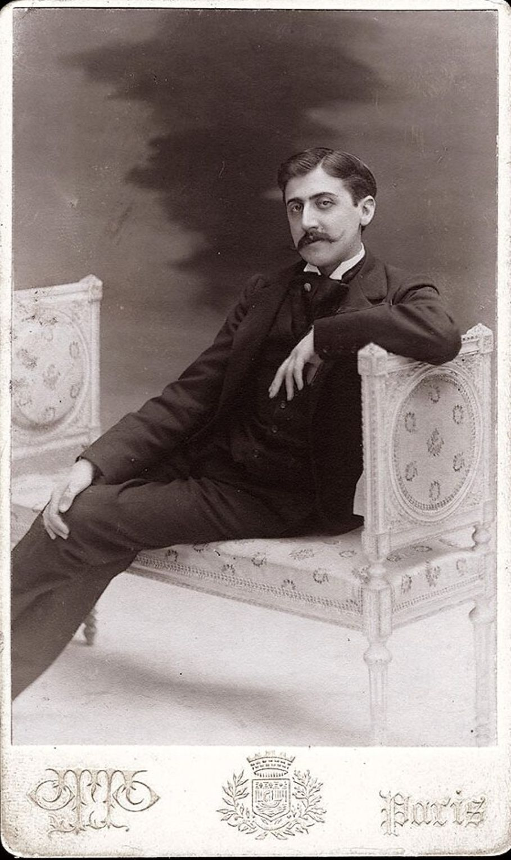

A Dinner in Town, Marcel Proust

A Dinner in Town

But, Fundanius, who shared with you the pleasures of that meal? I am longing to know.

– Horace

1

Honoré was late; he said hello to the hosts, to the guests he knew, was introduced to the others, and went to sit down at table. After a few moments, his neighbour, a very young man, asked him to name the guests and tell him something about them. Honoré had never met him in society until now. He was very handsome. The hostess kept gazing at him with burning eyes that indicated quite well enough why she had invited him, and showed that he would soon be part of her circle. Honoré sensed within him the potential for future greatness, but, without any envy, out of polite benevolence, he decided it was his duty to reply.

He looked around. Opposite, two neighbours were not talking to each other; they had been invited together, out of clumsy good intentions, and placed next to each other because they were both active in literature. But on top of this initial reason for hating each other, they had a more specific one. The older, a kinsman – doubly hypnotized – of M. Paul Desjardins and M. de Vogüé, affected a scornful silence towards the younger man, the favourite disciple of M. Maurice Barrès,\* who considered him in turn with a certain irony. Furthermore, the ill will each of them felt exaggerated – greatly against their respective desires – the importance of the other, as if the chief of rogues had been forced to confront the king of imbeciles.

Further along, a superb Spanish woman was eating in a furious temper. She had unhesitatingly – being a serious kind of person – sacrificed a lovers’ tryst this evening to the probability that she might advance her social career by coming to dinner in an elegant household. And indeed, there was every likelihood that she had made the right choice. The snobbery of Mme Fremer was for her lady friends, and the snobbery of her lady friends was for Mme Fremer, like a mutual insurance against becoming commonplace and bourgeois.

But chance had so willed it that Mme Fremer was going through, on just this very evening, a stock of people she hadn’t had time to invite to her dinners before – people to whom, for different reasons, she really wanted to be polite, and whom she had assembled almost at random. The whole gathering was suitably crowned by a duchess, but one whom the Spanish woman already knew and who was of no further interest to her.

And so she kept exchanging angry glances with her husband, whose guttural voice could always be heard at these evening receptions saying successively (leaving between each request an interval of five minutes suitably filled with other little tasks), “Would you please introduce me to the Duke?” And, to the Duke, “Monsieur, would you please introduce me to the Duchess?” And, to the Duchess, “Madame, may I introduce my wife to you?”

Exasperated at having to waste his time, he had nonetheless resigned himself to striking up a conversation with his neighbour, the associate of the master of the house. For over a year, Fremer had been begging his wife to invite this man. She had finally yielded and had hidden him away between the Spanish woman’s husband and a humanist. The humanist, an omnivorous reader, was also an omnivorous eater.

Quotations and burps kept welling from his lips, and these two disagreeable characteristics were equally repugnant to the woman next to him, a noble commoner, Mme Lenoir. She had soon brought the conversation round to the victories of the Prince de Buivres in Dahomey\* and said in a voice tremulous with emotion, “Dear boy, how delighted I am to see him honouring his family!” She was indeed a cousin of the Buivres, who, all being younger than she was, treated her with the deference due to her age, her attachment to the royal family, her huge fortune and the unfailing sterility of her three marriages.

She had transferred to the entire Buivres clan all the family feelings of which she was capable. She took personal umbrage when any of them so misbehaved that he had to be put under legal guardianship; and, around her right-thinking brow, on the parting in her Orleanist hair, she naturally wore the laurels of the family member who happened to be a general. Initially an intruder into that hitherto so exclusive family, she had become its head and, as it were, its dowager.

She felt really exiled in modern society, and always spoke with nostalgic affection of the “gentlemen of bygone days”. Her snobbery was all in her imagination: indeed, her imagination contained nothing else. Names rich in history and glory exerted a singular influence on her sensitive mind, and she took great delight, quite devoid of self-interest, in dining with princes or reading memoirs from the Ancien Régime. She always wore the same grape-bedecked hats, which were as invariable as her principles. Her eyes sparkled with inanity. Her smiling face was noble, her affected gestures exaggerated and meaningless. Thanks to her trust in God, she was in a similarly optimistic flutter on the eve of a garden party or a revolution, and made darting little gestures that seemed designed to ward off radicalism or bad weather.

Her neighbour the humanist was talking to her with wearisome eloquence and a dreadfully facile gift for the right formula; he kept quoting Horace to excuse his gluttony and drunkenness in the eyes of others, and to add a poetic sheen to those failings in his own. Invisible, ancient and yet freshly plucked roses wreathed his narrow brow. But with an equal politeness, which came to her easily since she found in it a way of exerting her influence and showing her respect – nowadays rare – for old traditions, Mme Lenoir turned every five minutes or so to talk to M. Fremer’s associate.

The latter had, in any case, no cause for complaint. From the other end of the table, Mme Fremer was addressing to him the most charming flatteries. She wanted this dinner to count for several years’ worth and, resolved not to have to invite this wet blanket for a long time to come, she was burying him under garlands of praise. As for M. Fremer, who worked all day at his bank and then in the evening found himself being dragged out into society by his wife, or forced to stay at home if they were giving a reception, he was always ready to eat anyone alive, but always muzzled, so that he had ended up by putting on, in the most everyday circumstances, an expression compounded of muted irritation, sulky resignation, barely contained exasperation and profound brutishness.

However, on this particular evening, this expression on the financier’s face had given way to a cordial satisfaction every time that his eyes met those of his associate. Although he couldn’t stand him in the ordinary course of things, he had discovered in himself feelings of fleeting but sincere affection for him, not because he found it easy to dazzle him with his opulence, but because of that same vague fellow feeling that overcomes us when we are abroad and see a Frenchman, even an odious one.

He, so violently torn away every evening from his habits, so unjustly deprived of the rest he had deserved, so cruelly uprooted, at last felt a bond, one that usually filled him with violent resentment, but strong nonetheless, which made him feel close to someone and meant that he could emerge and even escape from his fierce and desperate isolation.

Opposite him, Mme Fremer allowed the enchanted eyes of her fellow diners to reflect her blond beauty. The double reputation which surrounded her like an aura was a deceiving prism through which everyone tried to distinguish her true features. An ambitious woman, an intriguer, almost an adventurer – or so it was said in the world of finance that she had abandoned for a more brilliant destiny – she appeared, on the contrary, in the eyes of the faubourg and the royal family (whom she had quite won over with her superior intelligence), an angel of gentleness and virtue.

In addition, she had not forgotten her old and humbler friends, and remembered them in particular when they were ill or bereaved – those touching circumstances which had the added advantage that, since they then of course stayed at home instead of going out into society, they could not complain about not being invited anywhere. Hence she gave full rein to her charitable impulses, and in her conversations with relatives or priests at the bedside of the dying, she shed sincere tears, killing little by little the remorse that her excessively easy life inspired in her scrupulous heart.

But the most likeable guest was the young Duchess of D\*\*\*, whose clear, alert mind, never anxious or confused, contrasted so strangely with the incurable melancholy of her lovely eyes, the pessimism of her lips, the boundless and noble weariness of her hands. This energetic lover of life in every shape and form – kindness, literature, theatre, action and friendship – kept biting, without spoiling them, like a flower cast aside, her beautiful red lips, whose corners a disenchanted smile barely raised.

Her eyes seemed to indicate a mind that had foundered once and for all on the sickly waters of regret. How many times, in the street, at the theatre, had wistful passers-by allowed those variable stars to illumine their dreams! Just now the Duchess, who was busy remembering a vaudeville show, or inventing a new outfit, continued nonetheless to stretch out the joints of her noble fingers, looking resigned and pensive, and gazing around her with a deep and desperate expression in her eyes, drowning the impressionable guests in the torrents of their melancholy.

Her exquisite conversation negligently decked itself out in the faded and perfectly charming elegance of an already old-fashioned scepticism. There had just been a heated discussion, and this woman, so absolute in life, convinced that there was only one way of dressing, would repeat to all and sundry, “But why can’t one say and think everything? I might be right, and so might you.

How dreadful and narrow-minded it is to have an opinion.” Her mind was not like her body, dressed in the latest fashion, and she found it easy to tease symbolists and enthusiasts. But her mind rather resembled those charming women who are beautiful and vivacious enough to look good even when they are wearing old clothes. In any case, it was perhaps a deliberate coquetry. Certain excessively crude opinions would have paralysed her mind in the same way that, she was convinced, certain colours would have clashed with her complexion.

To his handsome neighbour, Honoré had given a rapid sketch of these different figures, and one which was so good-natured that, despite the profound differences between them, they all seemed alike – the brilliant Mme de Torreno, the witty Duchess of D\*\*\*, the beautiful Mme Lenoir. He had neglected the only feature they all shared, or rather the same collective madness, the same prevalent epidemic by which they were all affected: snobbery.

True, this snobbery assumed very different shapes in accordance with their very different natures, and there was a world of difference between the imaginative and poetic snobbery of Mme Lenoir and the all-conquering snobbery of Mme de Torreno, who was as avid as a civil servant desperate to reach the highest positions. And yet, that terrible woman was quite capable of rehumanizing herself. Her neighbour had just told her that he had been admiring her daughter in the Parc Monceau. Immediately she had broken her angry silence. She had felt for this obscure accountant a pure and friendly gratitude that she would have been incapable of feeling for a prince, and now they were chatting away like old friends.

Mme Fremer was presiding over the conversations with the visible satisfaction that sprang from the sentiment of the lofty mission she was performing. Used to introducing great writers to duchesses, she seemed, in her own eyes, a sort of omnipotent Minister of Foreign Affairs, who even in matters of protocol displayed great elevation of mind.

In the same way, a spectator digesting his dinner in the theatre can see below him, as he sits in judgement over them, artists, audience, the rules of dramatic art and genius. The conversation was in any case going with a real swing. They had reached that moment at dinner when gentlemen start touching the knees of the ladies next to them, or questioning them about their literary preferences: it depended on their different temperaments and education, and above all it depended on the ladies in question. One minute, a faux pas seemed inevitable.

Honoré’s handsome neighbour had tried with all the imprudence of youth to insinuate that in the work of Heredia\* there were perhaps more ideas than people were prepared to admit. The guests, seeing their habitual opinions being thrown into question, started to look morose. But Mme Fremer immediately exclaimed, “On the contrary, they are merely admirable cameos, sumptuous enamels, flawless pieces of jewellery,” whereupon vivacity and satisfaction reappeared on every face.

A discussion of the anarchists was a more serious matter. But Mme Fremer, as if bowing resignedly before some fateful and natural law, said slowly, “What’s the use of all that? Rich and poor will be always with us.” And all those people, the poorest of whom had an income of at least a hundred thousand pounds, struck by the truth of this remark, and freed from their scruples, emptied with buoyant gaiety their last glass of champagne.

2

After Dinner

Honoré, aware that the mixture of different wines had left him feeling giddy, went off without saying goodbye, picked up his overcoat downstairs and started to walk down the Champs-Élysées. He was filled with great joy. The barriers of impossibility which separate our desires and our dreams from the realm of reality had been broken down, and his thoughts, filled with exaltation at their own momentum, circulated exuberantly through the domain of the unattainable.

The mysterious avenues that extend between one human being and another, and at the far end of which, every evening, there perhaps sets some unsuspected sun of joy or desolation, were starting to draw him down them.

Each person he thought of immediately struck him as irresistibly likeable, and he turned successively down each street in which he might hope to meet them in turn; and if his expectations had been realized, he would have gone up and greeted strangers or indifferent passers-by fearlessly, gently and with a quiver of anticipation. Now that a stage set positioned too close to him had fallen away, life stretched out into the distance ahead of him, in all the charm of its novelty and its mystery, in friendly landscapes that beckoned him on.

And the regret that it might be the mirage or the reality of a single evening filled him with despair; he would make sure he always dined and drank as well as he just had, so that he could again see things as lovely as these. He was simply pained at his inability to reach all the scenes dotted here and there in the infinite prospect that stretched away into the far distance.

Then he was struck by the sound of his voice, somewhat rough and forced, that had been repeating for a quarter of an hour, “Life is sad, how stupid!” (This last word was underlined by the abrupt gesture he made with his right arm, and he noticed the sudden jerk of his walking stick.) He told himself sadly that these mechanical words were an altogether banal translation of similar visions which, he thought, were perhaps not amenable to expression.

“Alas! No doubt the intensity of my pleasure or my regret is multiplied a hundredfold, but even so, its intellectual content remains the same. My happiness is edgy, personal, untranslatable to anyone else, and if I were to write now, my style would have the same qualities, the same defects – alas! – and the same commonplace tenor as usual.” But the physical well-being he was feeling prevented him from thinking about it at any greater length and immediately gave him that supreme consolation, oblivion.

He had come out onto the boulevards. People were going by, to whom he extended his warm feelings, certain that they would be reciprocated. He felt that he was their glorious role model; he opened his overcoat so that they could see the dazzling whiteness of his evening jacket, which so suited him, and the dark-red carnation in his buttonhole. Thus he offered himself to the admiration of the passers-by and the affection which he so voluptuously exchanged with them.

The end