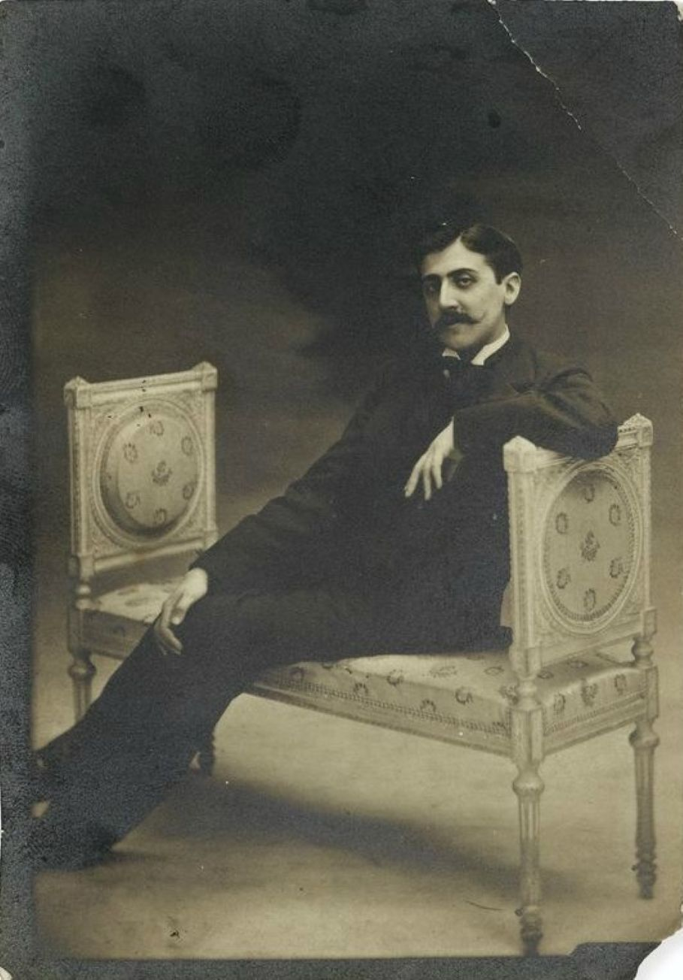

A Young Girl’s Confession, Marcel Proust

A Young Girl’s Confession

The cravings of the senses carry us hither and yon, but once the hour is past, what do you bring back? Remorse and spiritual dissipation.

You go out in joy and you often return in sadness, so that the pleasures of the evening cast a gloom on the morning.

Thus, the delight of the senses flatters us at first, but in the end it wounds and it kills.

—THOMAS À KEMPIS: IMITATION OF CHRIST, BOOK I, CHAPTER 18

Amid the oblivion we seek in false

delights,

The sweet and melancholy scent of lilac

blossoms

Wafts back more virginal through our

intoxications.

—HENRI DE RÉGNIER: SITES, POEM 8 (1887)

At last my deliverance is approaching. Of course I was clumsy, my aim was poor, I almost missed myself. Of course it would have been better to die from the first shot; but in the end the bullet could not be extracted, and then the complications with my heart set in. It will not be very long now. But still, a whole week! It can last for a whole week more!—during which I can do nothing but struggle to recapture the horrible chain of events.

If I were not so weak, if I had enough willpower to get up, to leave, I would go and die at Les Oublis, in the park where I spent all my summers until the age of fifteen. No other place is more deeply imbued with my mother, so thoroughly has it been permeated with her presence, and even more so her absence. To a person who loves, is not absence the most certain, the most effective, the most durable, the most indestructible, the most faithful of presences?

My mother would always bring me to Les Oublis at the end of April, leave two days later, visit for another two days in mid-May, then come to take me home during the last week of June. Her ever so brief visits were the sweetest thing in the world and the cruelest. During those two days she showered me with affection, while normally quite chary with it in order to inure me and calm my morbid sensitivity.

On both evenings she spent at Les Oublis she would come to my bed and say good night, an old habit that she had cast off because it gave me too much pleasure and too much pain, so that, instead of falling asleep, I kept calling her back to say good night to me again, until I no longer dared to do so even though I felt the passionate need all the more, and I kept inventing new pretexts: my burning pillow, which had to be turned over, my frozen feet, which she alone could warm by rubbing them. . . .

So many lovely moments were lovelier still because I sensed that my mother was truly herself at such times and that her usual coldness must have cost her dearly. On the day she left, a day of despair, when I clung to her dress all the way to the train, begging her to take me back to Paris, I could easily glimpse the truth amid her pretense, sift out her sadness, which infected all her cheerful and exasperated reproaches for my “silly and ridiculous” sadness, which she wanted to teach me to control, but which she shared.

I can still feel my agitation during one of those days of her departures (just that intact agitation not adulterated by today’s painful remembrance), when I made the sweet discovery of her affection, so similar to and so superior to my own. Like all discoveries, it had been foreseen, foreshadowed, but so many facts seemed to contradict it!

My sweetest impressions are of the years when she returned to Les Oublis, summoned by my illness. Not only was she paying me an extra visit, on which I had not counted, but she was all sweetness and tenderness, pouring them out, on and on, without disguise or constraint.

Even in those times when they were not yet sweetened and softened by the thought that they would someday be lacking, her sweetness and tenderness meant so much to me that the joys of convalescence always saddened me to death: the day was coming when I would be sound enough for my mother to leave, and until then, I was no longer sick enough to keep her from reviving her severity, her unlenient justice.

One day, the uncles I stayed with at Les Oublis had failed to tell me that my mother would be arriving; they had concealed the news because my second cousin had dropped by to spend a few hours with me, and they had feared I might neglect him in my joyful anguish of looking forward to my mother’s visit.

That ruse may have been the first of the circumstances that, independent of my will, were the accomplices of all the dispositions for evil that I bore inside myself, like all children of my age, though to no higher degree.

That second cousin, who was fifteen (I was fourteen), was already quite depraved, and he taught me things that instantly gave me thrills of remorse and delight. Listening to him, letting his hands caress mine, I reveled in a joy that was poisoned at its very source; soon I mustered the strength to get away from him and I fled into the park with a wild need for my mother, who I knew was, alas, in Paris, and against my will I kept calling to her along the garden trails.

All at once, while passing an arbor, I spotted her sitting on a bench, smiling and holding out her arms to me. She lifted her veil to kiss me, I flung myself against her cheeks and burst into tears; I wept and wept, telling her all those ugly things that required the ignorance of my age to be told, and that she knew how to listen to divinely, though failing to grasp them and softening their significance with a goodness that eased the weight on my conscience. This weight kept easing and easing; my crushed and humiliated soul kept rising lighter and lighter, more and more powerful, overflowing—I was all soul.

A divine sweetness was emanating from my mother and from my recovered innocence. My nostrils soon inhaled an equally fresh and equally pure fragrance. It came from a lilac bush, on which a branch hidden by my mother’s parasol was already in blossom, suffusing the air with an invisible perfume. High up in the trees the birds were singing with all their might. Higher still, among the green tops, the sky was so profoundly blue that it almost resembled the entrance to a heaven in which you could ascend forever.

I kissed my mother. Never have I recaptured the sweetness of that kiss. She left the next day, and that departure was crueler than all the ones preceding it. Having once sinned, I felt forsaken not only by joy but also by the necessary strength and support.

All these separations were preparing me, in spite of myself, for what the irrevocable separation would be someday, even if, back then, I never seriously envisaged the possibility of surviving my mother. I had resolved to kill myself within a minute after her death. Later on, absence taught me far more bitter lessons: that you get accustomed to absence, that the greatest abatement of the self, the most humiliating torment is to feel that you are no longer tormented by absence. However, those lessons were to be contradicted in the aftermath.

I now think back mainly to the small garden where I breakfasted with my mother amid countless pansies. They had always seemed a bit sad, as grave as coats-of-arms, but soft and velvety, often mauve, sometimes violet, almost black, with graceful and mysterious yellow patterns, a few utterly white and of a frail innocence. I now pick them all in my memory, those pansies; their sadness has increased because they have been understood, their velvety sweetness has vanished forever.

How could all this fresh water of memories have spurted once again and flowed through my impure soul of today without getting soiled? What virtue does this morning scent of lilacs have that it can pass through so many foul vapors without mingling and weakening? Alas!—my soul of fourteen reawakens not only inside me but, at the same time, far away from me, outside me. I do know that it is no longer my soul and that it does not depend on me to become my soul again. Yet back then it never occurred to me that I would someday regret its loss.

It was nothing but pure; I had to make it strong and able to perform the highest tasks in the future. At Les Oublis, after my mother and I, during the hot hours of the day, visited the pond with its flashes of sunlight and sparkling fish, or strolled through the fields in the morning or the evening, I confidently dreamed about that future, which was never beautiful enough for her love or my desire to please her.

And if not my willpower, then at least the forces of my imagination and my emotion were stirred up inside me, tumultuously calling for the destiny in which they would be realized, and repeatedly striking the wall of my heart as if to open it and dash outside myself, into life.

If, then, I jumped with all my strength, if I kissed my mother a thousand times, running far ahead like a young dog or indefinitely lagging behind to pick cornflowers and red poppies, which I brought her, whooping loudly—if I did all those things, it was less for the pleasure of strolling and gathering flowers than for the joy of pouring out the happiness of feeling all this life within me about to gush forth, to spread out infinitely, in more immense and more enchanting vistas than the far horizon of the woods and the sky, a horizon that I yearned to reach in a single leap. Bouquets of clover, of poppies, of cornflowers—if I carried you away with blazing eyes, with quivering ecstasy, if you made me laugh and cry, it was because I entwined you with all my hopes, which now, like you, have dried, have decayed, and, without blossoming like you, have returned to dust.

What distressed my mother was my lack of will. I always acted on the impulse of the moment. So long as the impulse came from my mind or my heart, my life, though not perfect, was not truly bad.

My mother and I were preoccupied chiefly with the realization of all my fine projects for work, calm, and reflection, because we felt—she more distinctly, I confusedly but intensely—that this realization would only be an image projected into my life, the image of the creation, by me and in me, of the willpower that she had conceived and nurtured. However, I always kept putting it off until tomorrow. I gave myself time, I occasionally grieved at watching time pass, but so much time still lay before me!

Yet I was a bit scared, and I obscurely felt that my habit of doing without willpower was starting to weigh down on me more and more strongly as the years accumulated; and I sadly suspected that there would be no sudden change, and that I could scarcely count on an utterly effortless miracle to transform my life and create my will. Desiring a will was not enough. I would have needed precisely what I could not have without willpower: a will.

And the furious wind of concupiscence

Makes your flesh flap like an old flag.

—CHARLES BAUDELAIRE

During my sixteenth year I suffered a crisis that left me sickly. To divert me, my family had me debut in society. Young men got into the habit of calling on me. One of them was perverse and wicked. His manners were both gentle and brash. He was the one I fell in love with. My parents found out, but to keep me from suffering all too much, they did not force his hand.

Spending all my time thinking about him when I did not see him, I finally lowered myself by imitating him as much as was possible for me. He beguiled me almost by surprise into doing wrong, then he got me accustomed to having bad thoughts which I had no will to resist—willpower being the only force capable of driving them back to the infernal darkness from which they emerged.

When love was gone, habit took its place, and there was no lack of immoral young men to exploit it. As accessories to my sins, they also justified them to my conscience. Initially I felt atrocious remorse; I made confessions that were not understood.

My friends talked me out of dwelling on the matter with my father. They gradually persuaded me that all girls were doing the same and that parents were simply feigning ignorance. As for the lies I was incessantly obliged to tell, my imagination soon embellished them as silences that I had to maintain about an ineluctable necessity. At this time, I no longer really lived; I still dreamed, still thought, still felt.

To divert and expel all those evil desires, I began socializing rather intensely. The dessicating pleasure of high society accustomed me to living in perpetual company, and, together with my taste for solitude, I lost the secret of the joys that I had previously been given by nature and art. Never have I attended so many concerts as during those years.

Never have I felt music less profoundly, engrossed as I was in my desire to be admired in an elegant box. I listened and I heard nothing. If I did happen to hear something, I no longer saw everything that music can unveil. My outings were likewise virtually stricken with sterility.

The things that had once sufficed to make me happy all day long—a bit of sunshine yellowing the grass, the fragrance that wet leaves emit with the final drops of rain—all these things had, like myself, lost their sweetness and gaiety. Woods, skies, water seemed to turn away from me, and if, alone with them and face to face, I questioned them uneasily; they no longer murmured those vague responses that had once delighted me. The divine guests announced by the voices of water, foliage, and sky deign to visit only those hearts that are purified by living in themselves.

Because I was seeking an inverse remedy and because I did not have the courage to want the real remedy, which was so close and, alas, so far from me, inside me, I again yielded to sinful pleasures, believing that I could thereby rekindle the flame that had been extinguished by society. My efforts were useless.

Held back by the pleasure of pleasing, I kept putting off, from day to day, the final decision, the choice, the truly free act, the option for solitude. I did not renounce either of those two vices in favor of the other. I combined them. What am I saying? Intent on smashing through all the barriers of thinking and feeling that would have stopped the next vice, each vice also appeared to summon it. I would go into society to calm down after committing a sin, and I sinned again the instant I was calm.

It was at that terrible moment, after my loss of innocence and before my remorse of today, at that moment, when I was less worthy than at any other moment of my life, that I was most appreciated by everybody. I had been shrugged off as a silly, pretentious girl; now, on the contrary, the ashes of my imagination were fancied by society, which reveled in them.

While I kept committing the worst crime against my mother, people viewed me as a model daughter because of my tender and respectful conduct with her. After the suicide of my thoughts, they admired my intelligence; they doted on my mind.

My parched imagination, my dried-up sensitivity were enough for the people who were the thirstiest for an intellectual life—their thirst being as artificial and mendacious as the source from which they believed they were quenching it! Yet no one suspected the secret crime of my life, and everyone regarded me as an ideal girl.

How many parents told my mother that if I had had a lesser standing, and if they could have dared to consider me, they would have desired no other wife for their sons! Nonetheless, in the depths of my obliterated conscience, I felt desperately ashamed of those undeserved praises; but my shame never reached the surface, and I had fallen so low that I was indecent enough to repeat them to and laugh at them with the accomplices of my crimes.

To anyone who has lost what he will regain

Never . . . Never!

—CHARLES BAUDELAIRE: “THE SWAN” (THE FLOWERS OF EVIL)

In the winter of my twentieth year, my mother’s health, which had never been vigorous, was deeply shaken. I learned that she had a weak heart, and while her condition was not serious, she had to avoid any excitement. One of my uncles told me that my mother wanted to see me get married.

I was thus presented with a clear and important task. Now I could show my mother how much I loved her. I accepted the first proposal that she transmitted to me with her approval, so that my life would be changed by necessity rather than by will.

My fiancé was precisely the kind of young man who, by his extreme intelligence, his gentleness and energy, could exert the finest influence on me. Furthermore he was determined that we would live with my mother. I would not be separated from her, which would have been the cruelest pain for me.

Now I had the courage to admit all my sins to my father confessor. I asked him if I owed the same avowal to my fiancé. My confessor was compassionate enough to talk me out of it, but he made me swear to turn over a new leaf and he gave me absolution. The late blossoms that joy opened in my heart, which I thought forever sterile, bore fruits.

I was cured by the grace of God, the grace of youth—an age that heals so many wounds with its vitality. If, as Saint Augustine says, it is more difficult to regain chastity than to have been chaste, I got to know a difficult virtue.

No one suspected that I was infinitely worthier than before, and my mother kissed my forehead every day, having never stopped believing it was pure and not realizing it was regenerated. Moreover I was unjustly rebuked for my absent-mindedness, my silence, and my melancholy in society. But I was not angry: I drew enough pleasure from the secret that existed between me and my satisfied conscience.

The convalescence of my soul (which now smiled endlessly at me with a face like my mother’s and gazed at me with an air of tender reproach through my drying tears) was infinitely appealing and languorous. Yes, my soul was reborn to life. I myself failed to understand how I could have maltreated my soul, made it suffer, nearly killed it. And I effusively thanked God for having saved it in time.

It was the harmony of that deep and pure joy with the fresh serenity of the sky that I savored on the evening when everything was consummated. The absence of my fiancé, who had gone to spend a few days with his sister, the presence at dinner of the young man who had had the greatest responsibility for my past sins, did not cast even the faintest pall on that limpid evening in May.

No cloud in the sky was reflected precisely in my heart. My mother, however, as if a mysterious solidarity existed between us despite her absolute ignorance of my sins, was very nearly cured.

“She must be treated with care for two weeks,” the doctor had said. “After that there’s no chance of a relapse.”

Those words alone were for me the promise of a happy future so rapturous that I burst into tears. That evening, my mother’s gown was more elegant than customary, and for the first time since my father’s death, which, still and all, had occurred ten years ago, she had added a touch of mauve to her habitual black.

Quite embarrassed to be dressed like that, as in her younger days, she was sad and happy to violate her pain and her grief in order to bring me pleasure and celebrate my joy. I approached her waist with a pink carnation, which she initially refused, but which, because it came from me, she then pinned on with a slightly hesitant and sheepish hand.

As the company headed for the table, I drew her over to the window and passionately kissed her face, which had delicately recovered from its past suffering. I was wrong to say that I have never recaptured the sweetness of that kiss at Les Oublis.

The kiss on this evening was as sweet as no other. Or rather, it was the kiss of Les Oublis, which, evoked by the allure of a similar minute, slipped gently from the depths of the past and settled between my mother’s still vaguely pale cheeks and my lips.

We toasted my coming marriage. I never drank anything but water since wine overagitated my nerves. My uncle declared that I could make an exception at a moment like this. I can vividly picture his cheerful face as he uttered those stupid words. . . .

My God! My God! I have confessed everything so calmly—will I be forced to stop here? I can no longer see anything! Now I can. . . . My uncle said that I could certainly make an exception at a moment like this. As he spoke, he looked at me and laughed; I drank quickly before glancing at my mother; I was afraid she might object.

She murmured: “One must never allow evil the tiniest nook.”

But the champagne was so cool that I drank two more flutes. My head grew very heavy; I needed both to rest and to expend my nervous energy. We rose from the table. Jacques came over and, staring at me, he said: “Would you like to join me? I want to show you some of my poems.”

His lovely eyes shone softly over his fresh cheeks; he slowly twisted his moustache. I realized I was doomed and I had no strength to resist. I said, shivering:

“Yes, I’d enjoy that.”

It was when saying those words, perhaps even earlier, when drinking my second glass of champagne, that I committed the truly responsible act, the abominable act. After that, I merely let myself go. We locked both doors, and he embraced me, breathing on my cheeks and fondling my entire body. Then, while pleasure gripped me tighter and tighter, I felt an infinite sadness and desolation awakening at the bottom of my heart; I seemed to be causing my mother’s soul to weep, the soul of my guardian angel, the soul of God.

I had always shuddered in horror when reading those accounts of the tortures that villains inflict on animals, on their own wives, their children; it now confusedly struck me that in every lustful and sinful act there is as much ferocity in the bodily part that is delighting in the pleasure, and that we have as many good intentions and, in us, as many pure angels are martyred and are weeping.

Soon my uncles would be finishing their card game and coming back. We had to anticipate them; I would never stumble again, it was the last time. . . . Then I saw myself in the mirror above the fireplace.

All that hazy anguish of my soul was painted not on my features, but on my entire face, from my sparkling eyes to my blazing cheeks and my parted lips, exhaled a stupid and brutal sensual pleasure.

I then thought of the horror that anyone who had just watched me kissing my mother with melancholy tenderness would now see me transformed into a beast. But in the mirror, Jacques’s mouth, covetous under his moustache, instantly arose against my face.

Shaken in my innermost being, I leaned my head against his, when, in front of me, I saw my mother (yes, I am telling you what happened—listen to me because I can tell you), on the balcony outside the window; I saw my mother gaping at me. I do not know if she cried out, I heard nothing; but she fell back, catching her head between the two bars of the railing.

This is not the last time I am telling you this; I have told you: I almost missed, my aim was good but my shot was clumsy. However, the bullet could not be extracted, and the complications in my heart began.

Still I can remain like this for one more week and I will not be able to stop mulling over the beginning and to see the end. I would rather my mother had seen me commit other crimes, including this one, so long as she had not seen my joyous expression in the mirror. No, she could not have seen it. . . . It was a coincidence. . . . She had suffered a stroke a minute before seeing me. . . . She had not seen my joy. . . . That is out of the question! God, who knew everything, would not have wanted it.

The end