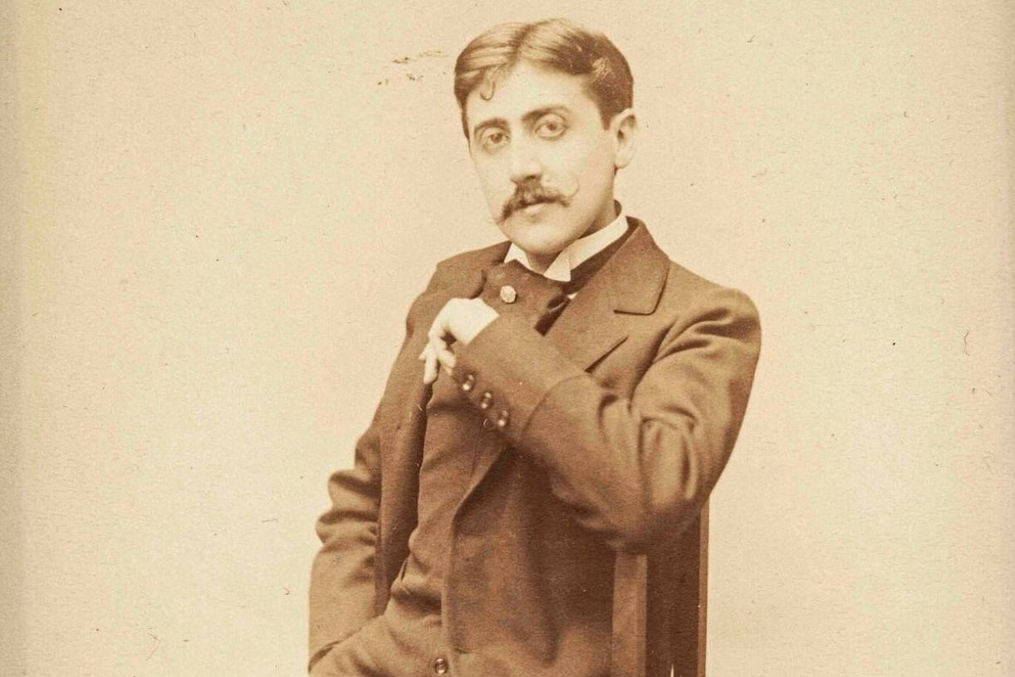

Another Memory, Marcel Proust

Another Memory

To M. Winter
Last year I spent some time in T., at the Grand Hôtel, which, standing at the far end of the beach, faces the sea.

Because of the rancid fumes coming from the kitchens and from the waste water, the luxurious banality of the tapestries, which offered the sole variation on the grayish nudity of the walls and complemented this exile decoration, I was almost morbidly depressed; then one day, with a gust that threatened to become a tempest, I was walking along a corridor to my room, when I was stopped short by a rare and delectable scent.

I found it impossible to analyze, but it was so richly and so complexly floral that someone must have denuded whole fields, Florentine fields, I assumed, merely to produce a few drops of that fragrance.

The sensual bliss was so powerful that I lingered there for a very long time without moving on; beyond the crack of a barely open door, which was the only one through which the perfume could have wafted, I discovered a room that, despite my limited glimpse, hinted at the presence of the most exquisite personality.

How could a guest, at the very heart of this nauseating hotel, have managed to sanctify such a pure chapel, perfect such a refined boudoir, erect an isolated tower of ivory and fragrance? The sound of footsteps, invisible from the hallway, and, moreover, an almost religious reverence prevented me from nudging the door any further.

All at once, the furious wind tore open a poorly attached corridor window, and a salty blast swept through in broad and rapid waves, diluting, without drowning, the concentrated floral perfume.

Never will I forget the fine persistence of the original scent adding its tonality to the aroma of that vast wind. The draft had closed the door, and so I went downstairs. But as my utterly annoying luck would have it: when I inquired about the inhabitants of room 47 (for those chosen beings had a number just like anyone else), all that the hotel director could provide were obvious pseudonyms.

Only once did I hear a grave and trembling, solemn and gentle male voice calling “Violet,” and a supernaturally enchanting female voice answering “Clarence.” Despite those two British names, they normally seemed, according to the hotel domestics, to speak French—and without a foreign accent.

Since they took their meals in a private room, I was unable to see them. One single time, in vanishing lines so spiritually expressive, so uniquely distinct that they remain for me one of the loftiest revelations of beauty, I saw a tall woman disappearing, her face averted, her shape elusive in a long brown and pink woolen coat.

Several days later, while ascending a staircase that was quite remote from the mysterious corridor, I smelled a faint, delicious fragrance, definitely the same as the first time. I headed toward that hallway and, upon reaching that door, I was numbed by the violence of fragrances, which boomed like organs, growing measurably more intense by the minute.

Through the wide-open door the unfurnished room looked virtually disemboweled. Some twenty small, broken phials lay on the parquet floor, which was soiled by wet stains. “They left this morning,” said the domestic, who was wiping the floor, “and they smashed the flagons so that nobody could use their perfumes, since they couldn’t fit them in their trunks, which were crammed with all the stuff they bought here. What a mess!” I pounced on a flagon that had a few final drops. Unbeknown to the mysterious travelers, those drops still perfume my room.

In my humdrum life I was exalted one day by perfumes exhaled by a world that had been so bland. They were the troubling heralds of love. Suddenly love itself had come, with its roses and its flutes, sculpting, papering, closing, perfuming everything around it. Love had blended with the most immense breath of the thoughts themselves, the respiration that, without weakening love, had made it infinite.

But what did I know about love itself? Did I, in any way, clarify its mystery, and did I know anything about it other than the fragrance of its sadness and the smell of its fragrances?

Then, love went away, and the perfumes, from shattered flagons, were exhaled with a purer intensity. The scent of a weakened drop still impregnates my life.

The end

