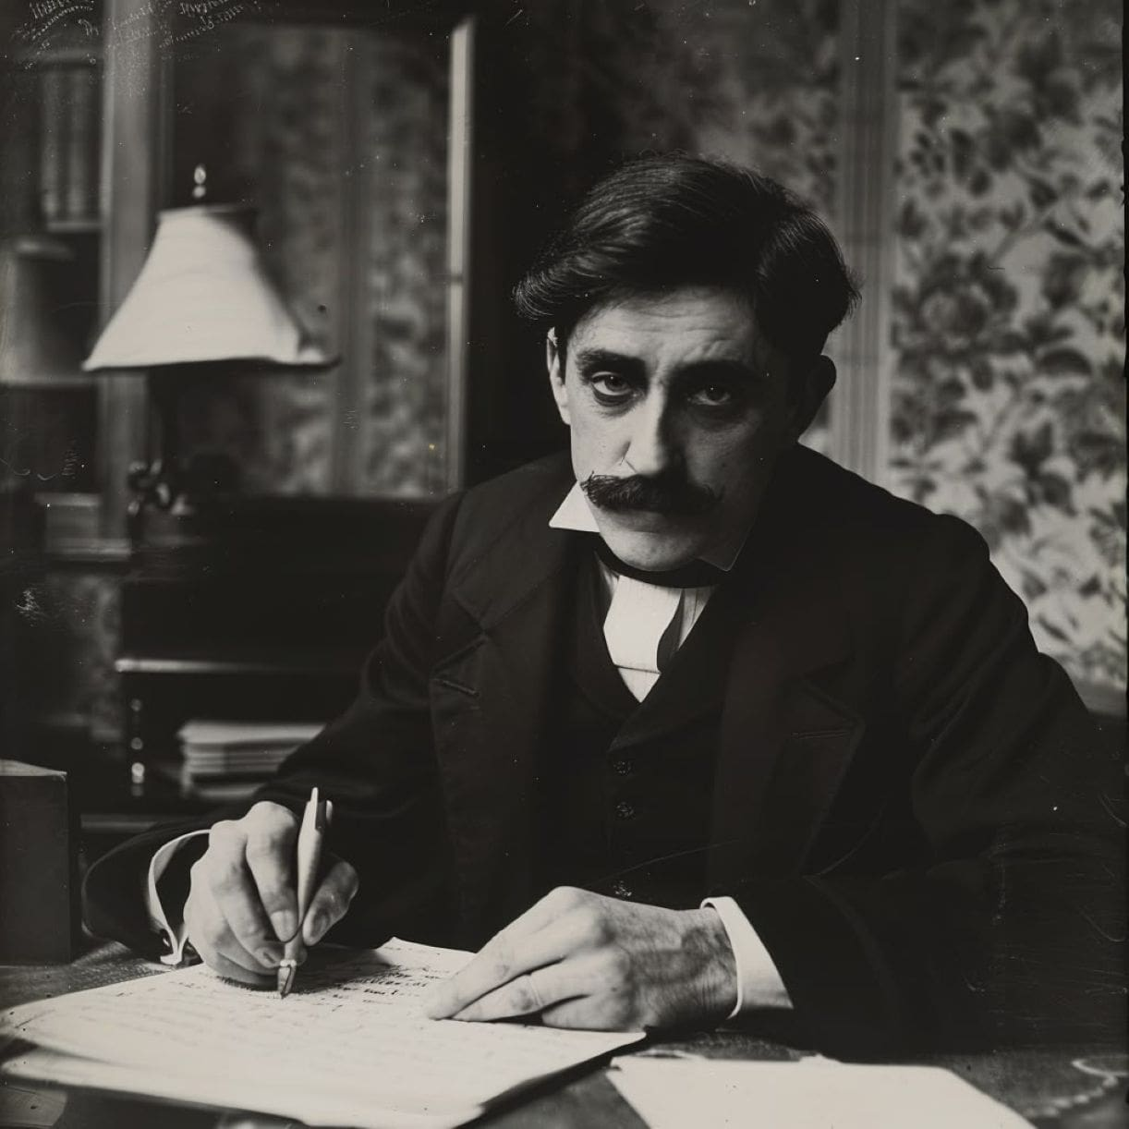

Before the Night, Marcel Proust

Before the Night

“Even though I’m still quite strong, you know” (she spoke with a more intimate sweetness, the way accentuation can mellow the overly harsh things that one must say to the people one loves), “you know I could die any day now—even though I may just as easily live another few months.

So I can no longer wait to reveal to you something that has been weighing on my conscience; afterwards you will understand how painful it was to tell you.”

Her pupils, symbolic blue flowers, discolored as if they were fading. I thought she was about to cry, but she did nothing of the kind. “I’m quite sad about intentionally destroying my hope of still being esteemed by my best friend after my death, about tarnishing and shattering his memory of me, in terms of which I often imagine my own life in order to see it as more beautiful and more harmonious.

But my concern about an aesthetic arrangement” (she smiled while pronouncing that epithet with the slightly ironic exaggeration accompanying her extremely rare use of such words in conversation) “cannot repress the imperious need for truth that forces me to speak. Listen, Leslie, I have to tell you this.

But first, hand me my coat. This terrace is a bit chilly, and the doctor forbade me to get up if it’s not necessary.” I handed her the coat. The sun was already gone, and the sea, which could be spotted through the apple trees, was mauve.

As airy as pale, withered wreaths and as persistent as regrets, blue and pink cloudlets floated on the horizon. A melancholy row of poplars sank into the darkness, leaving their submissive crowns in churchlike rosiness; the final rays, without grazing their trunks, stained their branches, hanging festoons of light on these balustrades of darkness.

The breeze blended the three smells of sea, wet leaves, and milk. Never had the Norman countryside more voluptuously softened the melancholy of evening, but I barely savored it—deeply agitated as I was by my friend’s mysterious words.

“I loved you very much, but I’ve given you little, my poor friend.”

Forgive me for defying the rules of this literary genre by interrupting a confession to which I should listen in silence,” I cried out, trying to use humor to calm her down, but in reality mortally sad.

“What do you mean you’ve given me little? And the less I’ve asked for, the more you’ve given me, indeed far more than if our senses had played any part in our affection. You were as supernatural as a Madonna and as tender as a wet nurse; I worshiped you, and you nurtured me. I loved you with an affection whose tangible prudence was not disturbed by any hope for carnal pleasure.

Did you not requite my feelings with incomparable friendship, exquisite tea, naturally embellished conversation, and how many bunches of fresh roses? You alone, with your maternal and expressive hands, could cool my feverish brow, drip honey between my withered lips, put noble images into my life. Dear friend, I do not want to hear that absurd confession. Give me your hands so I may kiss them: it’s cold, why don’t we go inside and talk about something else.”

“Leslie, you must listen to me all the same, my poor dear. It’s crucial. Have you never wondered whether I, after becoming a widow at twenty, have remained one . . . ?”

“I’m certain of it, but it’s none of my business. You are a creature so superior to anyone else that any weakness of yours would have a nobility and beauty that are not to be found in other people’s good deeds. You’ve acted as you’ve seen fit, and I’m certain that you’ve never done anything that wasn’t pure and delicate.”

“Pure! Leslie, your trust grieves me like an anticipated reproach. Listen . . . I don’t know how to tell you this. It’s far worse than if I had loved you, say, or someone else, yes, truly, anyone else.”

I turned as white as a sheet, as white as she, alas, and, terrified that she might notice it, I tried to laugh and I repeated without really knowing what I was saying: “Ah! Ah! Anyone else—how strange you are.”

“I said far worse, Leslie, I can’t decide at this moment, however luminous it may be. In the evening one sees things more calmly, but I don’t see this clearly, and there are enormous shadows on my life. Still, if, in the depths of my conscience, I believe that it was not worse, why be ashamed to tell you?”

“Was it worse?” I did not understand; but, prey to a horrible agitation that was impossible to disguise, I started trembling in terror as in a nightmare. I did not dare look at the garden path, which, now filled with night and dread, opened before us, nor did I dare to close my eyes.

Her voice, which, broken by deeper and deeper sadness, had faded, suddenly grew louder, and, in a clear and natural tone, she said to me:

“Do you remember when my poor friend Dorothy was caught with a soprano, whose name I’ve forgotten?” (I was delighted with this diversion, which, I hoped, would definitively lead us away from the tale of her sufferings.) “Do you recall explaining to me that we could not despise her?

I remember your exact words: ‘How can we wax indignant about habits that Socrates (it involved men, but isn’t that the same thing?), who drank the hemlock rather than commit an injustice, cheerfully approved of among his closest friends?

If fruitful love, meant to perpetuate the race, noble as a familial, social, human duty, is superior to purely sensual love, then there is no hierarchy of sterile loves, and such a love is no less moral—or, rather, it is no more immoral for a woman to find pleasure with another woman than with a person of the opposite sex.

The cause of such love is a nervous impairment which is too exclusively nervous to have any moral content. One cannot say that, because most people see as red the objects qualified as red, those people who see them as violet are mistaken.

Furthermore,’ you added, ‘if we refine sensuality to the point of making it aesthetic, then, just as male and female bodies can be equally beautiful, there is no reason why a truly artistic woman might not fall in love with another woman.

In a truly artistic nature, physical attraction and repulsion are modified by the contemplation of beauty. Most people are repelled by a jellyfish. Michelet, who appreciated the delicacy of their hues, gathered them with delight.

I was revolted by oysters, but after musing’ (you went on) ‘about their voyages through the sea, which their taste would now evoke for me, they have become a suggestive treat, especially when I am far from the sea. Thus, physical aptitudes, the pleasure of contact, the enjoyment of food, the pleasures of the senses are all grafted to where our taste for beauty has taken root.’

“Don’t you think that these arguments could help a woman physically predisposed to this kind of love to come to terms with her vague curiosity, particularly if, for example, certain statuettes of Rodin’s have triumphed—artistically—over her repugnance; don’t you think that these arguments would excuse her in her own eyes, appease her conscience—and that this might be a great misfortune?”

I don’t know how I managed to stifle my cry: a sudden flash of lightning illuminated the drift of her confession, and I simultaneously felt the brunt of my dreadful responsibility.

But, letting myself be blindly led by one of those loftier inspirations that tear off our masks and recite our roles extempore when we fail to do justice to ourselves, when we are too inadequate to play our roles in life, I calmly said: “I can assure you that I would have no remorse whatsoever, for I truly feel no scorn, not even pity, for those women.”

She said mysteriously, with an infinite sweetness of gratitude: “You are generous.” She then quickly murmured with an air of boredom, the way one disdains commonplace details even while expressing them: “You know, despite everyone’s secrecy, it dawned on me that you’ve all been anxiously trying to determine who fired the bullet, which couldn’t be extracted and which brought on my illness.

I’ve always hoped that this bullet wouldn’t be discovered. Fine, now that the doctor appears certain, and you might suspect innocent people, I’ll make a clean breast of it. Indeed, I prefer to tell you the truth.”

With the tenderness she had shown when starting to speak about her imminent death, so that her tone of voice might ease the pain that her words would cause, she added: “In one of those moments of despair that are quite natural in any truly living person, it was I who . . . wounded myself.”

I wanted to go over and embrace her, but much as I tried to control myself, when I reached her, my throat felt strangled by an irresistible force, my eyes filled with tears, and I began sobbing.

She, at first, dried my tears, laughed a bit, consoled me gently as in the past with a thousand lovely words and gestures. But from deep inside her an immense pity for herself and for me came welling up, spurting toward her eyes—and flowed down in burning tears. We wept together. The accord of a sad and vast harmony.

Her pity and mine, blending into one, now had a larger object than ourselves, and we wept about it, voluntarily, unrestrainedly. I tried to drink her poor tears from her hands.

But more tears kept streaming, and she let them benumb her. Her hand froze through like the pale leaves that have fallen into the basins of fountains. And never had we known so much grief and so much joy.

The end