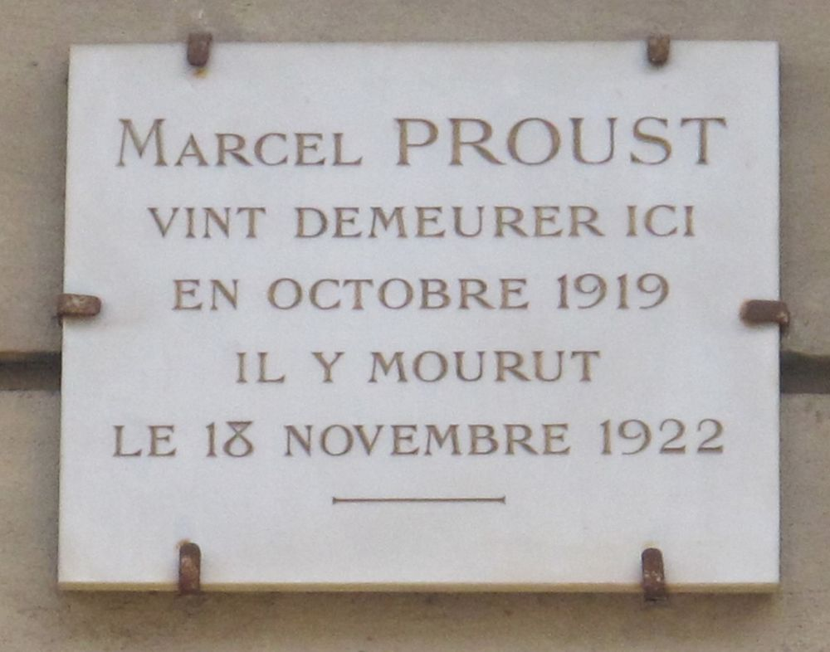

Bouvard and Pécuchet on Society and Music, Marcel Proust

Bouvard and Pécuchet on Society and Music

1

Society\*

“Now that we have a position,” said Bouvard, “why shouldn’t we go out into society like everyone else?”

This was also Pécuchet’s view; but they would need to shine in society, and to do that, they should study the subjects which people talk about.

Contemporary literature is of the highest importance.

They took out a subscription to the various journals which publish contemporary literature; they read them aloud, and endeavoured to write reviews, seeking above all a light and fluent style, in view of the aim they had set themselves.

Bouvard objected that the style of literary criticism, even when it is written in a light-hearted tone, does not suit social gatherings. And they practised making conversation about what they had read in the manner of society people.

Bouvard would lean against the fireplace, and fiddle cautiously – so as not to get them dirty – with a pair of buff-coloured gloves brought out expressly for the occasion, addressing Pécuchet as “Madame” or “General”, so as to make the illusion complete.

But often, this was as far as they would get; or, when one of them started to wax enthusiastic about an author, the other would try in vain in stop him. In any case, they disparaged everything. Leconte de Lisle\* was too devoid of passion, Verlaine was too sensitive. They dreamt of a golden mean, but never found it.

“Why does Loti\* always sound the same?”

“His novels always follow the same old tune.”

“He has only one string to his bow,” concluded Bouvard.

“But André Laurie\* isn’t any more satisfying – every year he takes us off to a different place and confuses literature with geography. It’s only his style that makes it any good. As for Henri de Régnier,\* he’s a either charlatan or a madman, there are no two ways about it.”

“If you can get beyond that, old fellow,” said Bouvard, “you’ll help contemporary literature to escape from the dreadful dead end it’s reached.”

“Why force them?” said Pécuchet in lordly but avuncular tones. “Perhaps those young colts have some spunk in them. Let’s give them free rein; the only danger is that they might be so hot-blooded that they overshoot the mark; but such extravagance is in itself the proof of a rich nature.”

“And meanwhile, barriers will be broken down!” cried Pécuchet; and, filling the echoing room with his counter-arguments, he became heated: “And you can keep telling me till you’re blue in the face that these unequal lines are poetry: I refuse to see anything other than prose in them, and meaningless prose at that!”

Mallarmé is no more talented than the rest, but he’s a brilliant conversationalist. What a misfortune it is that such a gifted man should go quite mad each time he picks up his pen. This is a singular malady, and it seemed to them quite inexplicable. Maeterlinck\* can shock, but he uses material means that are unworthy of the theatre; his art affects you as powerfully as a crime, it’s horrible! Anyway, his syntax is awful.

They conducted a spirited critique of his style, parodying his dialogue in the form of a conjugation:

“I said the woman had come in.”

“You said the woman had come in.”

“We said the woman had come in.”

“Why did they say that the woman had come in?”

Pécuchet wanted to send this little piece to the Revue des Deux Mondes,\* but it would be a better idea, countered Bouvard, to keep it to themselves and then trot it out in some fashionable salon. They would be immediately judged on their merits. They could easily send it to a review later. And the first beneficiaries of this witty sally, on reading it subsequently, would be retrospectively flattered at having attended its premiere.

Lemaître,\* for all his wit, struck them as inconsequential, irreverent, sometimes pedantic and sometimes bourgeois; he kept withdrawing his views. His style in particular was too lax, but the difficulty of improvising to strict and frequent deadlines could serve to excuse him. As for France, he is a good writer, but a poor thinker, as opposed to Bourget,\* who is deep, but has a dismal sense of form. The scarcity of an all-round talent filled them with melancholy.

But it shouldn’t be all that difficult – Bouvard would reflect – to express your ideas clearly. But clarity is not enough: you need grace (combined with force), vivacity, elevation, and logic. And irony too, added Bouvard. But according to Pécuchet, irony is not indispensable; it is often wearisome, and it is an unnecessary complication for the reader. In short, everybody writes badly. The fault lay, according to Bouvard, in an excessive quest for originality; and according to Pécuchet, in the decadence of contemporary life.

“Let us be brave enough to keep our conclusions to ourselves in social circles,” said Bouvard. “We would appear as carping critics and, by alarming everyone, we would displease them all. Let us provide reassurance rather than anxiety. Our originality will be enough of a drawback for us as it is. We should even try to conceal it. We don’t have to talk about literature.”

But other things really are important.

“How should you bow to someone? With your whole body or just your head, slowly or quickly, as you are standing or clicking your heels together, moving closer or staying put, tucking in your lower back or transforming it into a pivot? Should your hands hang down your sides, or hold on to your hat, or wear gloves? Should your face remain serious or smile throughout the duration of your bow? But how can one immediately resume one’s gravity once one has finished bowing?”

Introducing someone is difficult too.

Whose name should you begin with? Should you indicate the person you are naming with a wave of the hand, or a nod of the head, or should you remain motionless and look indifferent? Should you bow in the same way to an old man and a young man, a locksmith and a prince, an actor and an academician? An affirmative response satisfied Pécuchet’s egalitarian ideas, but shocked Bouvard’s common sense.

How could you give everyone their correct title?

You say “hello” to a baron, a viscount and a count; but “hello, my lord” seemed to them too pedestrian, and “hello, marquess” too cavalier, given their age. So they resigned themselves to saying “prince” to a prince and “my lord” to a duke, even though this latter usage struck them as revolting. When they got as far as the Highnesses, they became perplexed; Bouvard, flattered at the idea of his future acquaintances, imagined a thousand sentences in which this form of address appeared in every shape and size; he would accompany it with a bashful little smile, bowing his head slightly, and hopping from foot to foot. But Pécuchet declared that he’d get confused and keep muddling them up, or would burst out laughing in the prince’s face. In short, to simplify things, they just wouldn’t go into the Faubourg Saint-Germain.

But the Faubourg extends everywhere, and only from a distance does it look like a compact and isolated whole!… In any case, titles are even more respected in the upper echelons of the banking world, and as for the titles of foreign parvenus, you just can’t keep count of them. But in Pécuchet’s view, you should be intransigent when it came to fake nobles, and make a point of not giving them their full titles, even on the envelopes of letters or when talking to their servants.

Bouvard, more of a sceptic, saw their obsession with titles as merely a more recent fad, but one just as respectable as that of the great lords of old. In any case, in their opinion, the nobility had ceased to exist ever since it had lost its privileges. The nobility supports the clergy, is backward, doesn’t read books, does nothing, just has a good time, just as the bourgeoisie does; they found it absurd to respect it. It was only possible to frequent it because you could still express your contempt while doing so.

Bouvard declared that in order to know where they would pay their social calls, to which suburbs they would venture once a year, and where the arenas of their habits and vices would be located, they first of all needed to draw up an exact plan of Parisian society. It included, in his view, the Faubourg Saint-Germain, the world of finance, that of foreign parvenus, Protestant society, the world of the arts and the theatre, and the official and scholarly world.

The Faubourg, in Pécuchet’s view, concealed beneath its rigid exterior all the libertinage of the Ancien Régime. Every noble has mistresses and a sister who is a nun, and conspires with the clergy. They are brave, run up debts, ruin and abuse moneylenders, and are inevitably the champions of honour. They reign through their elegance, invent extravagant fashions, are exemplary sons, affectionate towards the common people, and hard on bankers. They always have a sword in their hand, or a woman riding behind them; they dream of the restoration of the monarchy, and are dreadfully lazy, but not haughty with ordinary folk; they cause traitors to flee and they insult cowards, and they deserve, thanks to a certain chivalric aura, our unwavering affection.

On the other hand, high finance, dignified and dour, inspires respect but also aversion. The financier is consumed by worries even at the wildest ball. One of his countless clerks is always turning up to bring him the latest news from the Stock Exchange, even at four in the morning; he hides his greatest triumphs and his worst disasters from his wife. No one even knows if he is a potentate or a crook; he is both of them in turn, quite unpredictably, and in spite of his vast fortune, he pitilessly throws out his small tenant when the latter gets behind with his rent, not even giving him an extension unless he wants to use him as a spy or sleep with his daughter. In any case, he is always in his carriage, dresses without elegance and habitually wears a pince-nez.

They did not feel any more warmly towards Protestant society; it is frigid, stuck up, gives money only to its own poor, and is exclusively composed of pastors. Protestant churches look too much like their homes, and their homes are as gloomy as their churches. They always have a pastor round for lunch; the servants remonstrate with their masters by quoting chapter and verse from the Bible; they are too afraid of gaiety to have anything to hide, and when conversing with Catholics they keep alluding to their perpetual grudge over the Revocation of the Edict of Nantes and the Massacre of St Bartholomew.\*

The world of the arts, while just as homogeneous, is quite different; every artist is a practical joker who has quarrelled with his family, never wears a top hat and speaks a special language. They spend their lives dodging the bailiffs who come to distrain their goods, and inventing grotesque disguises for masked balls.

Nonetheless, they produce a constant stream of masterpieces, and for most of them the abuse of alcohol and women is the very condition of their inspiration, if not of their genius; they sleep during the day, go out for a walk at night, work Heaven knows when, with their heads thrown back, letting their loosely knotted cravats float in the wind while they perpetually roll cigarettes.

The world of the theatre is hardly distinguishable from the world of artists; family life is never paid its proper respect; theatre people are eccentric and inexhaustibly generous. Actors, despite being vain and jealous, always help out their comrades, applaud their successes, adopt the children of actresses suffering from tuberculosis or misfortune, and are inclined to be affected in society, even though, never having received any education, they are often devout and always superstitious.

Those who work in the subsidized theatres are a case apart, entirely worthy of our admiration, and they would deserve to be seated at table before a general or a prince; their souls are filled with the sentiments expressed in the masterpieces they perform in our great playhouses. Their memories are prodigious and they are always immaculately turned out.

As for the Jews, Bouvard and Pécuchet, without entirely proscribing them (you have to be a liberal, after all), admitted that they hated finding themselves in their company; they had all sold pince-nez in Germany in their youth, and even in Paris they insisted on preserving – with a piety which, as impartial spectators, our heroes handsomely acknowledged – special practices, an unintelligible vocabulary and butchers from their own race.

They all have hooked noses, an exceptional intelligence and base souls intent only on seeking their own advantage; their women, on the other hand, are beautiful, a little on the flabby side, but capable of the deepest feelings. How many Catholics ought to imitate them! But why are their fortunes always incalculable and hidden? In addition, they formed a sort of vast secret society, like the Jesuits and the Freemasons. They had inexhaustible treasures stowed away, nobody knew where, at the service of unspecified enemies, always available for some terrible and mysterious purpose.

2

Music

Already tired of cycling and painting, Bouvard and Pécuchet set out to make a serious study of music. But whereas Pécuchet, that eternal friend of tradition and order, allowed himself to be hailed as the last devotee of bawdy songs and the Domino noir,\* Bouvard, a revolutionary if ever there was one, showed himself to be, we have to confess, “a staunch Wagnerian”. In point of fact, he did not know a single score by the “Berlin bawler” (as Pécuchet, always patriotic and ill-informed, cruelly nicknamed him),\* since they could not be heard in France, where the Conservatory stagnates in its routine, between Colonne who stammers and Lamoureux\* who stutters, nor in Munich, where the tradition has not been preserved, nor in Bayreuth, which has been overrun by snobs to an intolerable degree. It’s nonsensical to try and play them on the piano: the illusion of the stage is necessary, as is putting the orchestra in a buried pit and insisting on darkness in the auditorium. However, always on view to make visitors reel with surprise, the prelude to Parsifal\* lay permanently open on the music stand of his piano, between the photographs of César Franck’s penholder and the Primavera of Botticelli.

From the score of The Valkyrie, the “spring scene” had been carefully ripped out. In the table of contents of Wagner’s operas, on the first page, an indignant stroke of red pencil had struck out Lohengrin and Tannhäuser. Rienzi alone of the first operas still survived. To deny its merits was commonplace, and the time had come – Bouvard sensed with his subtle flair – to start promoting the opposite view. Gounod made him laugh, and Verdi made him scream. He was less good, admittedly, than Erik Satie\* – who could deny it? Beethoven, however, seemed to him as considerable a figure as some Messiah. Bouvard himself could, without undue false modesty, salute Bach as a precursor. Saint-Saëns has no content and Massenet\* no form, he kept saying to Pécuchet, in whose eyes, on the contrary, Saint-Saëns was all content and Massenet all form.

“That’s the reason why the one educates us and the other delights us, but without elevating us,” insisted Pécuchet.

For Bouvard, both of them were equally contemptible. Massenet could come up with a few ideas, but they were vulgar ones – anyway, we’ve had quite enough of ideas. Saint-Saëns had some sense of shape, but it was old-fashioned. They did not know very much about Gaston Lemaire, but they enjoyed making comparisons from time to time, and so they eloquently contrasted Chausson with Chaminade.\* Pécuchet, in any case, despite the reticence dictated by his aesthetic code, and even Bouvard himself (for every Frenchman is chivalrous and always puts women first) gallantly awarded to the latter the first place among the composers of the day.

In Bouvard, it was the democrat even more than the musician who condemned the music of Charles Levadé; lingering over the poetry of Mme de Girardin\* in the century of steam, universal suffrage and the bicycle is surely tantamount to opposing progress? In any case, since he was a proponent of art for art’s sake, of playing without nuance and singing without inflexion, Bouvard declared that he could not bear to hear him sing. He found that he looked like a musketeer, with mockingly flamboyant manners and the facile elegance of a superannuated sentimentality.

But the subject of their liveliest debates was Reynaldo Hahn.\* While his close friendship with Massenet, bringing the cruel and unremitting sarcasm of Bouvard down on his head, also marked him out as a prey to the passionate predilections of Pécuchet, he nonetheless contrived to exasperate the latter through his admiration for Verlaine, an admiration which Bouvard shared. “Set Jacques Normand to music, or Sully Prudhomme, or the Vicomte de Borelli!\*

Thank God, in the land of the troubadours, there is no lack of poets,” he would add patriotically. And, torn between the Teutonic sonorities of the name of Hahn and the southern ending of his first name Reynaldo, preferring to condemn him out of hatred for Wagner rather than to absolve him because of Verdi, he would conclude, with perfect logic, as he turned to Bouvard:

“Despite the effort of all your fine gentlemen, our lovely land of France is a land of clarity, and French music will be clear or will not be at all,” whereupon he emphasized his verdict by banging on the table to give extra force to his words.

“I pour scorn on your eccentricities from beyond the English Channel and your mists from beyond the Rhine – stop looking to the other side of the Vosges!” he added, gazing at Bouvard with a stern and fixed expression filled with unspoken implications – “Unless it is for the defence of our fatherland! That the Valkyrie can ever give pleasure even in Germany, I very much doubt… But for French ears, it will always be the most infernal torment – and the most cacophonous, not to say the most humiliating for our national pride! Anyway, doesn’t that opera combine the most revolting kind of incest with the most atrocious forms of dissonance?

Your music, Monsieur, is full of monsters, and you never know what people will dream up next! Even in nature – even though she is the mother of simplicity – only what is horrible gives you any pleasure. Doesn’t Monsieur Delafosse\* write songs about bats, in which the composer’s extravagance is bound to compromise the pianist’s long-standing reputation? Why couldn’t he choose some nice little bird?

Songs about sparrows would at least be perfectly Parisian; the swallow has lightness and grace, and the lark is so thoroughly French that Caesar, they say, had his soldiers roast them and stick them on their helmets. But bats!!! The French, always athirst for openness and clarity, will always detest that animal of darkness. In the poetry of Monsieur de Montesquiou, maybe… we can just about allow him that: it’s the whim of a rather blasé grand seigneur – but in music! It won’t be long before someone writes a Requiem for Kangaroos!…” This jest smoothed the wrinkles from Bouvard’s brow.

“Admit that I’ve made you laugh,” said Pécuchet (without any reprehensible fatuousness – we can allow men of wit a certain awareness of their own merits). “Let’s shake on it: you are quite disarmed!”

The end