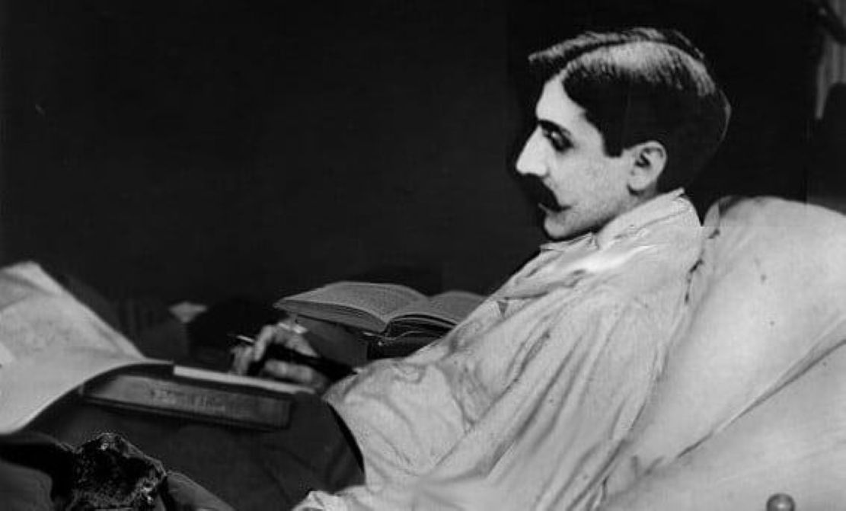

Memory, Marcel Proust

Memory

A servant in brown livery and gold buttons opened the door quite promptly and showed me to a small drawing room that had pine paneling, walls hung with cretonne, and a view of the sea.

When I entered, a young man, rather handsome indeed, stood up, greeted me coldly, then sat back down in his easy chair and continued reading his newspaper while smoking his pipe. I remained standing, a bit embarrassed, I might say even preoccupied with the reception I would be given here.

Was I doing the right thing after so many years, coming to this house, where they might have forgotten me long ago?—this once hospitable house, where I had spent profoundly tender hours, the happiest of my life?

The garden surrounding the house and forming a terrace at one end, the house itself with its two red-brick turrets encrusted with diversely colored faiences, the long, rectangular vestibule, where we had spent our rainy days, and even the furnishings of the small drawing room to which I had just been led—nothing had changed.

Several moments later an old man with a white beard shuffled in; he was short and very bent. His indecisive gaze lent him a highly indifferent expression. I instantly recognized Monsieur de N. But he could not place me. I repeated my name several times: it evoked no memory in him. I felt more and more embarrassed. Our eyes locked without our really knowing what to say.

I vainly struggled to give him clues: he had totally forgotten me. I was a stranger to him. Just as I was about to leave, the door flew open: “My sister Odette,” said a pretty girl of ten or twelve in a soft, melodious voice, “my sister has just found out that you’re here.

Would you like to come and see her? It would make her so happy!” I followed the little girl, and we went down into the garden. And there, indeed, I found Odette reclining on a chaise longue and wrapped in a large plaid blanket.

She had changed so greatly that I would not, as it were, have recognized her. Her features had lengthened, and her dark-ringed eyes seemed to perforate her wan face. She had once been so pretty, but this was no longer the case at all. In a somewhat constrained manner she asked me to sit at her side.

We were alone. “You must be quite surprised to find me in this state,” she said after several moments. “Well, since my terrible illness I’ve been condemned, as you can see, to remain lying without budging. I live on feelings and sufferings.

I stare deep into that blue sea, whose apparently infinite grandeur is so enchanting for me. The waves, breaking on the beach, are so many sad thoughts that cross my mind, so many hopes that I have to abandon. I read, I even read a lot.

The music of poetry evokes my sweetest memories and makes my entire being vibrate. How nice of you not to have forgotten me after so many years and to come and see me! It does me good! I already feel much better. I can say so—can’t I?—since we were such good friends.

Do you remember the tennis games we used to play here, on this very spot? I was agile back then; I was merry. Today I can no longer be agile; I can no longer be merry. When I watch the sea ebbing far out, very far, I often think of our solitary strolls at low tide. My enchanting memory of them could suffice to keep me happy, if I were not so selfish, so wicked.

But, you know, I can hardly resign myself, and, from time to time, in spite of myself, I rebel against my fate. I’m bored all alone, for I’ve been alone since Mama died.

As for Papa, he’s too sick and too old to concern himself with me. My brother suffered a terrible blow from a woman who deceived him horrendously. Since then, he’s been living alone; nothing can console him or even distract him. My little sister is so young, and besides, we have to let her live happily, to the extent that she can.”

As she spoke to me, her eyes livened up; her cadaverous pallor disappeared. She resumed her sweet expression of long ago. She was pretty again. My goodness, how beautiful she was! I would have liked to clasp her in my arms: I would have liked to tell her that I loved her. . . . We remained together for a long time. Then she was moved indoors, since the evening was growing cool. I now had to say goodbye to her.

My tears choked me. I walked through that long vestibule, that delightful garden, where the graveled paths would never, alas, grind under my feet again. I went down to the beach; it was deserted.

Thinking about Odette, I strolled, pensive, along the water, which was ebbing, tranquil and indifferent. The sun had disappeared behind the horizon; but its purple rays still splattered the sky.

Pierre de Touche

The end