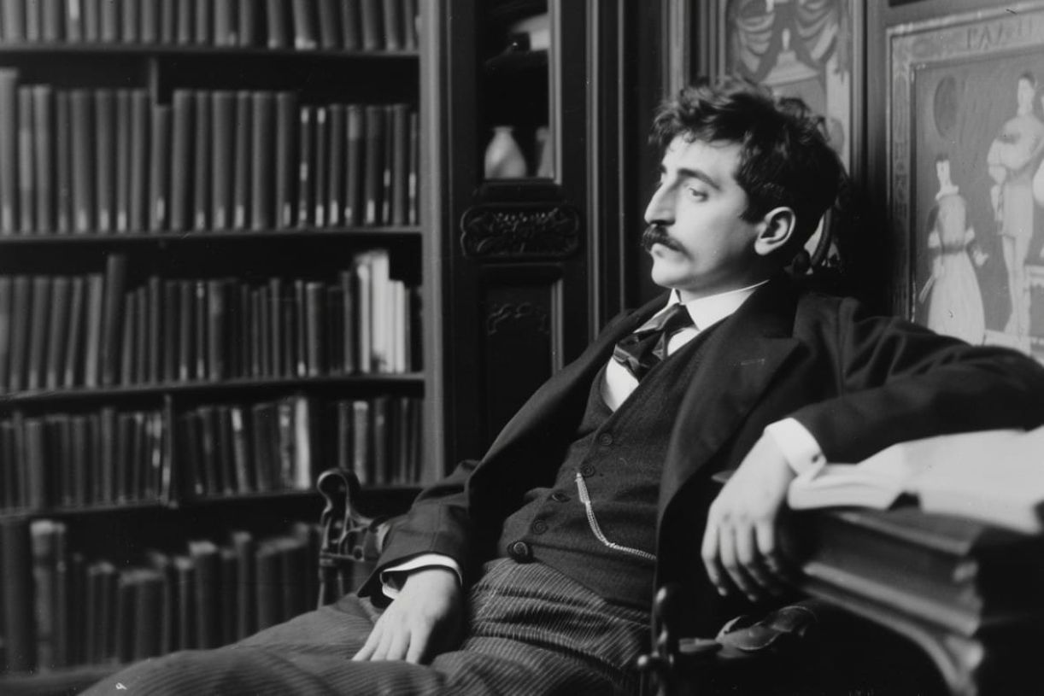

Portrait of Madame X. Marcel Proust

Portrait of Madame X.

Nicole combines Italian grace with the mystery of northern women. She has their blond hair, their eyes as clear as the transparency of the sky in a lake, their lofty bearing.

However, she breathes a knowing softness that has virtually ripened in that Tuscan sun, which inundates the eyes of women, lengthens their arms, raises the corners of their mouths, and rhythmically scans their gait, ultimately making all their beauty divinely languorous.

And not for nothing have the charms of both climates and both races fused together to make up Nicole’s charm, for she is the perfect courtesan, if this simply means that in her the art of pleasing has reached a truly unique degree, that it is composed of both talents and efforts, that it is both natural and refined.

Thus, the tiniest flower between her breasts or in her hand, the most ordinary compliment on her lips, the most banal act, like offering her arm to whoever escorts her to the table—all these things, when she does them, are imbued with a grace as poignant as an artistic emotion. Everything softens around her in a delightful harmony that is summed up in the folds of her gown.

But Nicole is unconcerned about the artistic pleasure that she provides, and as for her eyes, which seem to promise so much bliss, she barely knows for certain on whom her gaze has fallen—barely knows for no other reason most likely than that its fall was lovely.

She is concerned only about good, loves it enough to do it, loves it too much to be content with just doing it, without trying to grasp what—in doing it—she does. One cannot say that she is pedantic in her magnanimity, for it appeals to her too sincerely.

Let us say rather that she is erudite about it, an enchanting erudition that places only the agreeable names of the Virtues in her mind and on her lips. This makes her charm all the sweeter, as if it were perfumed with a saintly fragrance. One can seldom admire what one loves.

Hence, it is all the more exquisite to understand the seductions, the fecundity of a great heart in Nicole’s soft and rich beauty, in her lactea ubertas [her milky abundance], in her whole alluring person.

The end