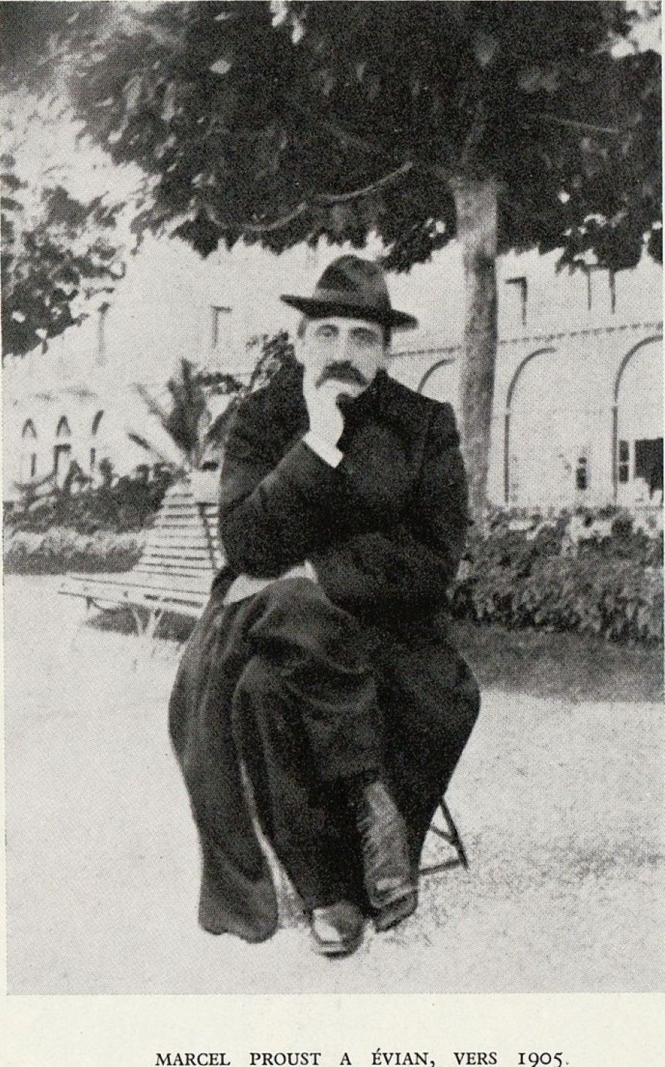

Portraits of Painters and Composers, Marcel Proust

Portraits of Painters and Composers

Portraits of Painters

ALFRED CUYP

Cuyp, the setting sun dissolving in limpid air,

Which is dimmed like water by a flight of gray doves,

Golden moisture, halo on a bull or a birch,

Blue incense of lovely days, smoking on the hillside,

Or marsh of brightness stagnating in the empty sky.

Horsemen are ready, a pink plume on each hat,

A hand on the hip; the tangy air, turning their skin rosy,

Lightly swells their fine blond curls,

And, tempted by the hot fields, the cool waves,

Without disturbing the herd of cattle

Dreaming in a fog of pale gold and repose,

They ride off to breathe those profound minutes.

PAULUS POTTER

Somber grief of skies uniformly gray,

Sadder for being blue during rare bright intervals,

And which allow the warm tears of a misunderstood sun

To filter down upon the paralyzed plains;

Potter, melancholy mood of the somber plains,

Which stretch out, endless, joyless, colorless;

The trees, the hamlet cast no shadows,

The tiny, meager gardens have no flowers.

A plowman lugs buckets home, and his puny mare

Resigned, anxious, and dreamy,

Uneasily listening to her pensive brain,

Inhales in small gulps the strong breath of the wind.

ANTOINE WATTEAU

Twilight putting makeup on faces and trees,

With its blue mantle, under its uncertain mask;

Dust of kisses around weary lips. . . .

Vagueness becomes tender, and nearness distance.

The masquerade, another melancholy distance,

Makes the gestures of love, unreal, mournful and bewitching.

A poet’s caprice—or a lover’s prudence,

For love needs skillful adornment—

Boats and picnics are here, silence and music.

ANTHONY VAN DYCK

Gentle pride of hearts, noble grace of things

That shine in the eyes, velvets and woods,

Lovely elevated language of bearing and poses

(The hereditary pride of women and kings!),

You triumph, van Dyck, you prince of calm gestures,

In all the lovely creatures soon to die,

In every lovely hand that still can open;

Suspecting nothing (what does it matter?),

That hand gives you the palm fronds!

The halting of horsemen, under pines, near water,

Calm like them—like them so close to sobs—

Royal children, already grave and magnificent,

Resigned in their garments, brave in their plumed hats,

With jewels that weep (like flaming waves)

The bitterness of tears that fill the souls,

Too proud to let them ascend to the eyes;

And you above them all, a precious stroller,

In a pale-blue shirt, one hand on your hip,

The other hand holding a leafy fruit picked from its branch,

I dream, uncomprehending, before your eyes and gestures:

Standing, but relaxed, in this shadowy haven,

Duke of Richmond, oh, young sage!—or charming madman?—

I keep returning to you; a sapphire at your neck

Has fires as sweet as your tranquil gaze.

Portraits of Composers

CHOPIN

Chopin, sea of sighs, of tears, of sobs,

Which a swarm of butterflies crosses without alighting,

And they play over the sadness or dance over the waves.

Dream, love, suffer, shout, soothe, charm, or cradle,

You always let the sweet and dizzying oblivion

Of your caprice run in between your sorrows

Like butterflies flitting from flower to flower;

Your joy is the accomplice of your grief;

The ardor of the whirlwind increases the thirst for tears.

The pale and gentle comrade of the moon,

The prince of despair or the betrayed grand lord,

You are exalted, more handsome for being pallid,

By the sunlight flooding your sickroom, tearfully smiling

At the patient and suffering at seeing him. . . .

A smile of regret and tears of Hope!

GLUCK

A temple to love, to friendship, a temple to courage,

Which a marquise had built in her English

Garden, where many a putto, with Watteau bending his bow,

Chooses glorious hearts as the targets of his rage.

But the German artist—whom she would have dreamed for

Knidos!—graver and deeper, sculpted without affectation

The lovers and the gods whom you see on this frieze:

Hercules has his funeral pyre in Armides’ gardens!

The heels, when dancing, no longer strike the path,

Where the ashes of extinguished eyes and smiles

Deaden our slow steps and turn the distances blue;

The voices of the harpsichords are silent or broken.

But your mute cry, Admetes and Iphigenia,

Still terrifies us, proffered in a gesture

And, swayed by Orpheus or braved by Alcestes,

The Styx—without masts or sky—where your genius cast anchor.

With love, Gluck, like Alcestes, conquered death,

Inevitable for the whims of an era;

He stands, an august temple to courage,

On the ruins of the small temple to Love.

SCHUMANN

From the old garden, where friendship welcomed you,

Hear boys and nests that whistle in the hedges,

You lover, weary of so many marches and wounds,

Schumann, dreamy soldier disappointed by war.

The happy breeze imbues the shadow of the huge walnut tree

With the scent of jasmine, where the doves fly past;

The child reads the future in the flames of the hearth,

The cloud or the wind speaks to your heart about graves.

Your tears used to run at the shouts of the carnival,

Or they blended their sweetness with the bitter victory

Whose insane enthusiasm still quivers in your memory;

You can weep without end: your rival has won.

The Rhine rolls its sacred water toward Cologne.

Ah! How gaily you sang on its shores

On holidays! But, shattered by grief, you fall asleep. . . .

Tears are raining in your illuminated darkness.

Dream where the dead woman lives, where you are true

To the ingrate, your hopes blossom and the crime is dust. . . .

Then, the shredding lightning of awakening, in which thunder

Strikes you again for the very first time.

Flow, emit fragrance, march to the drumbeat or be lovely!

Schumann, oh, confidant of souls and of flowers,

Between your joyous banks holy river of sorrows,

Pensive garden, tender, fresh, and faithful.

Where the lyres, the moon, and the swallow kiss one another,

A marching army, a dreaming child, a weeping woman!

MOZART

Italian woman on the arm of a Bavarian prince,

Whose sad, frozen eyes delight in her languor!

In his frosty gardens he holds to his heart

Her shadow-ripened breasts, to drink the light.

Her tender, German soul—a sigh so profound!—

Finally tastes the ardent laziness of being loved;

To hands too weak to hold it he delivers

The radiant hope of his enchanted head.

Cherubino! Don Giovanni! Far from fading oblivion,

You stand in the scents of so many trampled flowers

That the wind dispersed without drying their tears,

From the Andalusian gardens to the graves of Tuscany!

In the German park, where grief is hazy,

The Italian woman is still queen of the night.

Her breath makes the air sweet and spiritual,

And her Magic Flute lovingly drips

The coolness of sherbets, of kisses and skies,

In the still hot shadow of a lovely day’s farewell.

The end