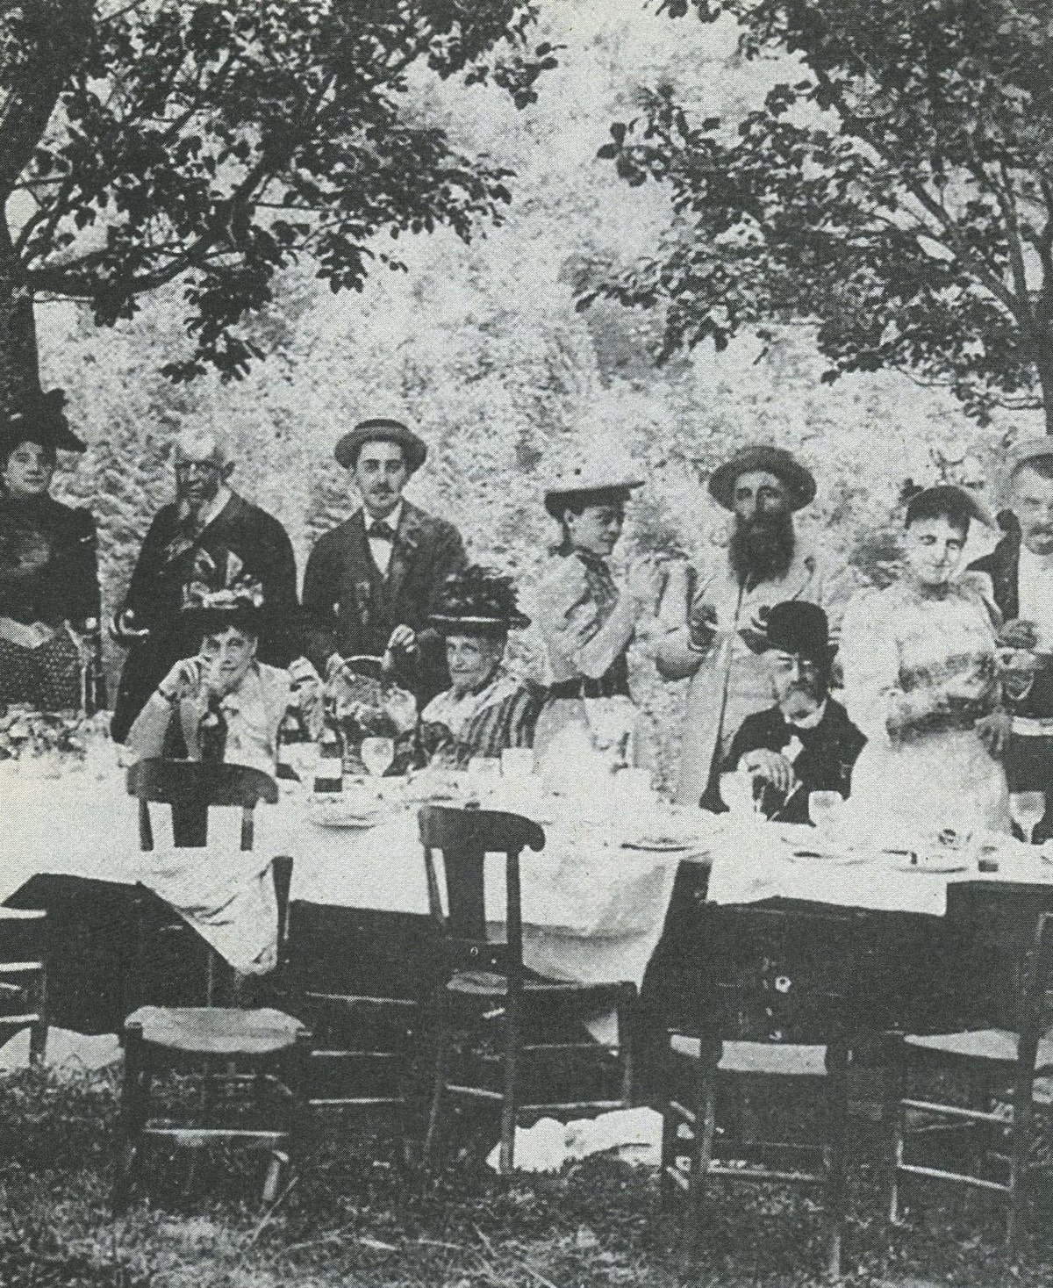

Portraits of Painters and Musicians, Marcel Proust

Portraits of Painters and Musicians

Portraits of Painters

Aelbert Cuyp

Cuyp, a setting sun dissolved in limpid air –

A ripple of grey wood pigeons, as if through water –

A damp golden haze, a halo for ox or birch,

Blue incense of fine days – smoke on the slopes –

Or gleam of stagnant marsh in the empty sky.

Cavaliers are ready, a pink plume in their hats;

Hands dangle down; the chill air makes their skin

Turn pink, and gently lifts their fine blond curls,

And, tempted by the hot fields and cool rills –

Their noise leaves undisturbed the herd of oxen

Dreaming in the mist of pale gold and repose –

They trot off, to breathe in those deep moments.

Paulus Potter

The mournful gloom of skies a uniform grey,

Made even sadder by rare patches of blue –

Filtering down onto the frozen plains

The warm tears of a foreign-seeming sun…

Potter, melancholy mood of sombre plains

That stretch out endlessly, joyless and dull,

The hamlet and the trees that shed no shade,

The scrubby gardens where no flower grows.

A ploughman drags his buckets home; his mare,

Sickly, resigned, disquieted, full of dreams

And anxious thoughts, lifting her thoughtful head,

Snuffles and sniffs and smells the whistling wind.

Antoine Watteau

The dusk applies make-up to trees and faces,

In its blue coat, beneath its dubious mask;

A scatter of kisses falls on weary lips…

The vague grows fond now, and the near grows far.

The masquerade is sad and distant too,

Love’s movements now seem forced, with their sad charm.

A poet’s whim – or lover’s wise precaution,

Since love must be adorned with expert skill –

Behold: a ship, a picnic, silence, song.

Anthony Van Dyck

Heart’s gentle pride, and noble grace of things

That shine in eyes, in velvet and in woods,

The lofty language of a posture’s pose

– Hereditary pride of kings and ladies! –

You triumph, Van Dyck, prince of tranquil gestures,

In all the lovely things that will soon die,

In every lovely hand that can still open,

And unawares – who cares? – gives you the palm!

The horsemen halt, beneath the pines and near

The waves equally calm and near to tears –

Such royal children, grave already and splendid,

Resigned in dress, with brave-plumed hats and jewels

In which there weeps – as water through the flames –

The bitterness of tears that fill their souls

Too haughty to shed tears from open eyes;

And you, oh precious stroller, above all,

In pale-blue shirt, one hand perched on your hip

(The other holds a fruit just plucked and leafy),

I dream, but do not grasp, your eyes and gestures:

Standing in alert repose in that dark shelter,

Oh wise young Richmond\* – charming madman too?

I come to you again: around your neck

A sapphire shines as quietly as your gaze.

Portraits of Musicians

Chopin

O Chopin, sea of sighs and tears and sobs,

The butterflies wing their restless way across you,

Playing on sadness, or dancing on the waves.

You dream, love, suffer, cry, console and charm

And cradle, and between each pain you bring

Dizzy and sweet oblivion at your whim

Like butterflies that dart from flower to flower;

Your joy is then in league with all your sorrow:

The torrid pain leaves us athirst for tears.

O pale and gentle friend of moon and waves,

Prince of despair or grand seigneur betrayed,

Your exultation grows, more palely beautiful,

As the sunlight floods into your sickroom, which

Weeps through its smiles and grieves to see the sun

Smile with regret and shed its tears for Hope!

Gluck

Temple to love, to friendship and to courage

Which a marquise erected in her English

Gardens, where many a Watteau cupid bends

Its bow and takes wild aim at noble hearts.

But the German artist – she would have dreamt of him

On Cnidus!\* – grave and deep sculpted the gods

And lovers, plain and bold, there on the frieze:

Hercules has his pyre in Armida’s gardens!\*

The dancers’ heels no longer kick the path

Where eyes now dust and smiles now blotted out

Muffle our steps and make the distance blue;

The harpsichord is cracked or silent now.

But your mute cry, Admetus, Iphigenia,

Still terrifies us, proffered by your body

And, vanquished by Orpheus, scorned by Alcestis too,\*

The Styx without masts or sky – where your genius anchored.

And Gluck like Alcestis has overcome by Love

The death that conquers every age’s foibles;

He stands erect, august temple to courage

On the ruins of the little shrine to Love.

Schumann

From the old friendly garden where you are made welcome,

You hear boys and nests whistling in the hedgerows,

Lovers weary of long journeys and wounds.

Schumann, wistful soldier, unsatisfied by war.

The cheerful breeze – a flock of doves goes by –

Fills the great walnut’s shade with jasmine sweet,

The child reads the future from the flickering flames,

The cloud or wind speaks to your heart of tombs.

Once your tears flowed to the cries of the carnival

Or mingled gently with the bitter victory

Whose crazed momentum still shudders in your memory;

You may as well weep for good – she has betrayed you.

Towards Cologne the Rhine’s sacred waters flow.

Ah, how gaily you sang on its banks, on holidays!

But now, broken and sorrowful, you sleep…

Tears rain down in the fitful gleam of darkness.

A dream (she lives, though dead, and the ingrate

Keeps faith); your hopes bloom fresh, his crime has crumbled

To dust… A lightning flash sears you awake:

Again its lash, as if for the first time…

Flow on, give balm, parading to the drums,

Be lovely… Schumann! Friend of souls and flowers,

Between the banks of joy, the waves of pain,

O holy river, garden fond, fresh, faithful,

Where moon and lilies kiss, and swallows too:

Army arrayed; dream, child; and, woman, weep.

Mozart

There’s an Italian girl in the Bavarian prince’s arms

(His sad and frozen eyes gleam at her softness!).

In his chilly gardens he holds tight to his heart

Her darkness-ripened breasts whose light he sucks.

His tender German soul – how deep its sigh! –

Enjoys at last the lazy pleasures of love,

And he grants to hands too weak to hold it fast

The radiant hope of his enchanted head.

Cherubino, Don Giovanni!\* Remember to forget

The flowers and sweet perfumes, all trampled, scattered

(But the tears flow on) from the gardens of Andalusia

To the tombs of Tuscany – blown by the winds!

In the German park where the mists gather like problems,

The Italian girl is still Queen of the Night.\*

Her breathing is a sweet and witty aria

And her Magic Flute lovingly tongues,

In the shadow still warm from the fine day’s farewell,

The cool of sherbet, kisses and the sky.

The end