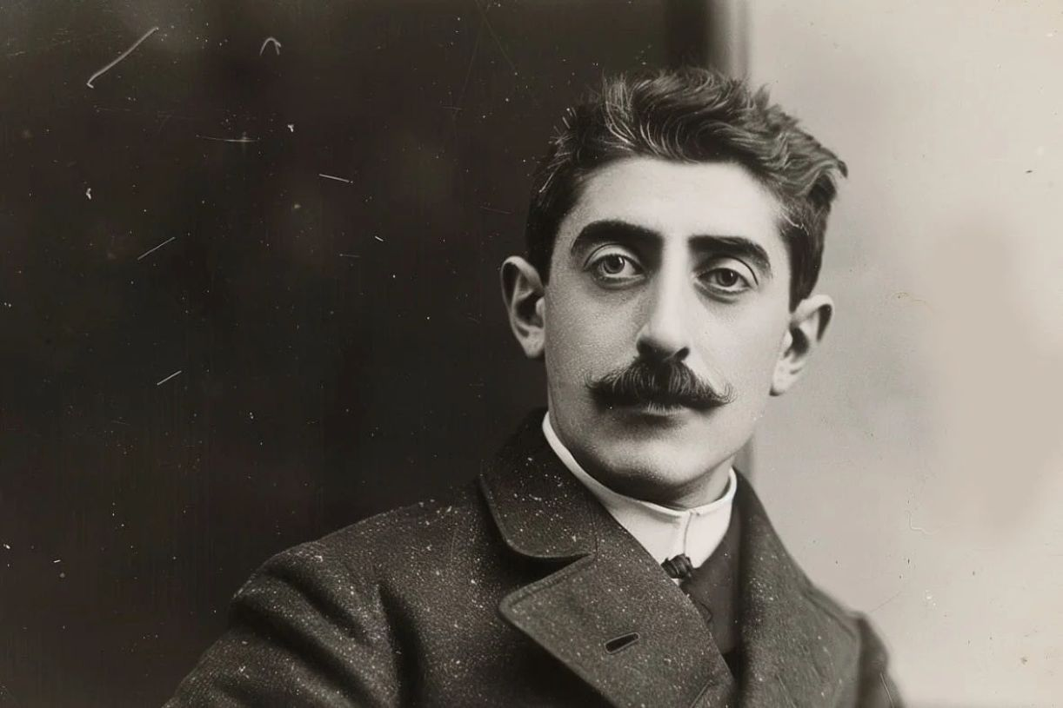

Social Ambitions and Musical Tastes of Bouvard and Pécuchet, Marcel Proust

Social Ambitions and Musical Tastes of Bouvard and Pécuchet\*

\*Needless to say, the opinions ascribed here to Flaubert’s two famous characters are by no means those of the author.

Social Ambitions

“Now that we have positions,” said Bouvard, “why shouldn’t we live a life of high society?”

Pécuchet could not have agreed with him more; but they would have to shine, and to do so they would have to study the subjects dealt with in society.

Contemporary literature is of prime importance.

They subscribed to the various journals that disseminate it; they read them aloud and attempted to write reviews, whereby, mindful of their goal, they aimed chiefly at an ease and lightness of style.

Bouvard objected that the style of reviews, even if playful, is not suitable in high society. And they began conversing about their readings in the manner of men of the world.

Bouvard would lean against the mantelpiece and, handling them cautiously to avoid soiling them, he would toy with a pair of light-colored gloves that were brought out specifically for the occasion, and he would address Pécuchet as “Madame” or “General” to complete the illusion.

Often, however, they would get no further; or else, if one of them would gush on about an author, the other would try in vain to stop him. Beyond that, they pooh-poohed everything. Leconte de Lisle was too impassive, Verlaine too sensitive. They dreamed about a happy medium but never found one.

“Why does Loti keep striking the same note?”

“His novels are all written in the same key.”

“His lyre has only one string,” Bouvard concluded.

“But André Laurie is no more satisfying; he takes us somewhere else every year, confusing literature with geography. Only his style is worth something. As for Henri de Regné, he’s either a fraud or a lunatic; there’s no other alternative.”

“Get around that, my good man,” said Bouvard, “and you’ll help contemporary literature out of an awful bottleneck.”

“Why rein them in?” said Pécuchet, an indulgent king. “Those colts may be blooded. Loosen their reins, let them have their way; our sole worry is that once they spurt off, they may gallop beyond the finish line. But immoderateness per se is proof of a rich nature.

“Meanwhile the barriers will be smashed,” Pécuchet cried out; hot and bothered, he filled the empty room with his negative retorts: “Anyway, you can claim all you like that these uneven lines are poetry—I refuse to see them as anything but prose, and meaningless prose at that!”

Mallarmé is equally untalented, but he is a brilliant talker. What a pity that such a gifted man should lose his mind the instant he picks up his pen. A bizarre illness that struck them as inexplicable. Maeterlinck frightens us, but only with material devices that are unworthy of the theater; art inflames us like a crime—it’s horrible! Besides, his syntax is dreadful.

They then applied a witty critique to his syntax, parodying his dialogue style in the form of a conjugation:

I said that the woman had come in.

You said that the woman had come in.

He said that the woman had come in.

Why did someone say that the woman had come in?

Pécuchet wanted to submit this piece to the Revue des Deux Mondes; but it would be wiser, in Bouvard’s opinion, to save it until it could be recited in a fashionable salon. They would instantly be classified according to their talent. They could easily send the piece to a journal later on. And when the earliest private admirers of this flash of wit read it in print, they would be retrospectively flattered to have been the first to enjoy it.

Lemaitre, for all his cleverness, struck them as scatterbrained, irreverent, sometimes pedantic and sometimes bourgeois; he retracted too often. Above all, his style was slipshod; but he should be forgiven since he had to write extempore under the pressure of regular and so frequent deadlines. As for Anatole France, he wrote well but thought poorly, unlike Bourget, who was profound but whose style was hopeless. Bouvard and Pécuchet greatly deplored the dearth of a complete talent.

“Yet it can’t be very difficult,” Bouvard thought, “to express one’s ideas clearly. Clarity is not enough, though; you need grace (allied with strength), vivacity, nobility, and logic.” Bouvard then added irony. According to Pécuchet irony was not indispensable; it was often tiring and it baffled the reader without benefiting him. In short, all writers were bad. The fault, according to Bouvard, lay with the excessive pursuit of originality; according to Pécuchet, with the decline of mores.

“Let us have the courage to hide our conclusions from the fashionable world: otherwise we would be viewed as nitpickers, we would frighten everyone, and they would all dislike us. Let us be reassuring rather than unnerving. Our originality would do us enough harm as it is. We should even conceal it. In society we can also not talk about literature.”

But other things are important there.

“How do we greet people? With a deep bow or simply a nod, slowly or quickly, just as we are or bringing our heels together, walking over or standing still, pulling in the small of the back or transforming it into a pivot? Should the hands drop alongside the body, should they hold your hat, should they be gloved? Should the face remain earnest or should you smile for the length of the greeting? And how do you immediately recover your gravity once the greeting is done?”

Introductions were also difficult.

With whose name should you start? Should you gesture toward the person you are naming or should you merely nod at him or should you remain motionless with an air of indifference? Should you greet an old man and a young man in the same way, a locksmith and a prince, an actor and an academician? The affirmative answer satisfied Pécuchet’s egalitarian ideas, but shocked Bouvard’s common sense.

And what about correct titles?

You said “monsieur” to a baron, a viscount, or a count; however, “Good day, monsieur le marquis” sounded groveling and “Good day, marquis” too free and easy—given their age. They would resign themselves to saying “prince” and “monsieur le duc,” even though they found the latter usage revolting. When it came to the highnesses, they floundered. Bouvard, gratified by the thought of his future connections, imagined a thousand sentences in which this appellation would appear in all its forms; he accompanied it with a faint and blushing smile, inclining his head slightly and hopping about. But Pécuchet declared that he would lose the thread, get more and more confused, or else laugh in the prince’s face. In short, to avoid embarrassment, they would steer clear of the Faubourg Saint-Germain, that bastion of aristocracy. However, the Faubourg seeps in everywhere and looks like a compact and isolated whole purely from a distance! . . .

Besides, titles are respected even more in the world of high finance, and as for the foreign adventurers, their titles are legion. But according to Pécuchet, one should be intransigent with pseudo-noblemen and make sure not to address them with a “de” even on envelopes or when speaking to their domestics. Bouvard, more skeptical, saw this as a more recent mania that was nevertheless as respectable as that of the ancient lords. Furthermore, according to Bouvard and Pécuchet, the nobility had stopped existing when it had lost its privileges. Its members were clerical, backward, read nothing, did nothing, and were as pleasure-seeking as the bourgeoisie; Bouvard and Pécuchet found it absurd to respect them. Frequenting them was possible only because it did not exclude contempt.

Bouvard declared that in order to know where they would socialize, toward which suburbs they would venture once a year, where their habits and their vices could be found, they would first have to draw up an exact plan of Parisian society. The plan, said Bouvard, would include Faubourg Saint-Germain, financiers, foreign adventurers, Protestant society, the world of art and theater, the official world, and the learned world.

The Faubourg Saint-Germain, in Pécuchet’s opinion, concealed the libertinage of the Old Regime under the guise of rigidity. Every nobleman had mistresses, plus a sister who was a nun, and he conspired with the clergy. They were brave, debt-ridden; they ruined and scourged usurers and they were inevitably the champions of honor. They reigned by dint of elegance, invented preposterous fashions, were exemplary sons, gracious to commoners and harsh toward bankers. Always clutching a sword or with a woman in pillion, they dreamed of restoring the monarchy, were terribly idle, but not haughty with decent people, sent traitors packing, insulted cowards, and with a certain air of chivalry they merited our unshakable affection.

On the other hand, the eminent and sullen world of finance inspires respect but also aversion. The financier remains careworn even at the wildest ball. One of his numberless clerks keeps coming to report the latest news from the stock exchange even at four in the morning; the financier conceals his most successful coups and his most horrible disasters from his wife. You never know whether he is a mogul or a swindler: he switches to and fro without warning; and despite his immense fortune, he ruthlessly evicts a poor tenant for being in arrears with his rent and refuses to grant him an extension unless he wants to use the tenant as a spy or sleep with his daughter. Moreover, the financier is always in his carriage, dresses without taste, and habitually wears a pince-nez.

Nor did Bouvard and Pécuchet feel any keener love for Protestant society: it is cold, starchy, gives solely to its own poor, and is made up exclusively of pastors. Their temples look too much like their homes, and a home is as dreary as a temple. There is always a pastor for lunch; the servants admonish their employers with biblical verses; Protestants fear merriment too deeply not to have something to hide; and when conversing with Catholics, they reveal their undying grudge about the Revocation of the Edict of Nantes and the Massacre of Saint Bartholomew.

The art world, equally homogeneous, is quite different; every artist is a humbug, estranged from his family, never wears a top hat, and speaks a special language. He spends his life outsmarting bailiffs who try to dispossess him and finding grotesque disguises for masked balls. Nevertheless artists constantly produce masterpieces, and for most of them their overindulgence in wine and women is the sine qua non of their inspiration if not their genius; they sleep all day, go out all night, work God knows when, and, with their heads always flung back, their limp scarves fluttering in the wind, they perpetually roll cigarettes.

The theater world is barely distinct from the art world: there is no family life on any level; theater people are eccentric and inexhaustibly generous. Actors, while vain and jealous, help their fellow players endlessly, applaud their successes, adopt the children of consumptive or down-on-their-luck actresses, and are precious in society, although, being uneducated, they are often sanctimonious and always superstitious. Actors at subsidized theaters are in a class of their own; entirely worthy of our admiration, they would deserve a more honorable place at the table than a general or a prince; they nurture feelings expressed in the masterpieces they perform on our great stages. Their memory is prodigious and their bearing perfect.

As for the Jews, Bouvard and Pécuchet, though unwilling to banish them (for one must be liberal), admitted that they hated being with them; in their younger days Jews had all sold opera glasses in Germany; in Paris (with a piety that, incidentally, both men, as impartial observers, felt was all to their credit) the Jews zealously maintained special practices, an unintelligible vocabulary, and butchers of their own race. All Jews had hooked noses, exceptional intelligence, and vile souls devoted purely to self-interest; their women, on the contrary, were beautiful, a bit flabby, but capable of the loftiest sentiments. How many Catholics ought to emulate them! But why were their fortunes always incalculable and concealed?

Furthermore they formed a kind of vast secret society, like the Jesuits and the Freemasons. They had—no one knew where—inexhaustible treasures in the service of some enemies or other, with a dreadful and mysterious goal.

Musical Tastes

Already disgusted with bicycles and paintings, Bouvard and Pécuchet now seriously took up music. But, although the everlasting champion of tradition and order, Pécuchet let himself be hailed as the utmost enthusiast of off-color songs and Le Domino noir; on the other hand, Bouvard, a revolutionary if ever there was one, turned out to be—it must be admitted—a resolute Wagnerian.

Truth to tell, he had never laid eyes on a single score by the “Berlin brawler” (as he was cruelly nicknamed by Pécuchet, always patriotic and uninformed); after all, one cannot hear Wagner’s scores in France, where the Conservatory is dying of its own routine, between Colonne, who babbles, and Lamoureux, who spells out everything; nor were those scores played in Munich, which did not maintain tradition, or in Bayreuth, which had been unendurably contaminated by snobs.

It was nonsense trying to play a Wagnerian score on the piano: the theatrical illusion was necessary, as were the lowering of the orchestra and the darkness of the auditorium. Nevertheless, the prelude to Parsifal, ready to dumbfound visitors, was perpetually open on the music stand of Bouvard’s piano, between the photographs of César Franck’s penholder and Botticelli’s Primavera.

The “Song of Spring” had been carefully torn out from the Valkyrie. On the first page of the roster of Wagner’s operas, Lohengrin and Tannhäuser had been indignantly crossed out by a red pencil. Of the early operas Rienzi alone prevailed. Disavowing Rienzi had become banal; it was time—Bouvard keenly sensed—to establish the opposite view.

Gounod made him laugh and Verdi shout. Less, assuredly, than Erik Satie—who could disagree? Beethoven, however, struck Bouvard as momentous, like a Messiah. Bouvard himself, without stooping, could salute Bach as a forerunner. Saint-Saëns lacks substance and Massenet form, he endlessly repeated to Pécuchet, in whose eyes, quite the contrary, Saint-Saëns had nothing but substance and Massenet nothing but form.

“That is why one of them instructs us and the other charms us, but without elevating us,” Pécuchet insisted.

For Bouvard both composers were equally despicable. Massenet had a few ideas, but they were coarse, and besides, ideas had had their day. Saint-Saëns revealed some craftsmanship, but it was old-fashioned.

Uninstructed about Gaston Lemaire, but playing with contrasts in their lessons, they eloquently pitted Chausson and Cécile Chaminade against one another. Moreover, Pécuchet and, though it was repugnant to his aesthetics, Bouvard himself gallantly yielded to Madame Chaminade the first place among composers of the day, for every Frenchman is chivalrous and always lets women go first.

It was the democrat in Bouvard even more than the musician who proscribed the music of Charles Levadé; was it not an obstruction of progress to linger over Madame de Girardin’s poems in the age of steam, universal suffrage, and the bicycle? Furthermore, as an advocate for the theory of art for art’s sake, for playing without nuances and singing without modulation, Bouvard declared that he could not stand hearing Levadé sing: he was too much the musketeer, the jokester, with the facile elegance of an antiquated sentimentalism.

However, the topic of their liveliest debates was Reynaldo Hahn. While his close friendship with Massenet, endlessly eliciting Bouvard’s cruel sarcasm, pitilessly marked Hahn as the victim of Pécuchet’s passionate predilections, Hahn had the knack of exasperating Pécuchet by his reverence for Verlaine, an admiration shared, incidentally, by Bouvard. “Set Jacques Normand to music, Sully Prudhomme, the Viscount of Borrelli.

There is, thank goodness, no shortage of poets in the land of the troubadours,” he added patriotically. And, divided between the Teutonic sonority of Hahn’s last name and the southern ending of Reynaldo, his first name, and preferring to execute him out of hatred for Wagner rather than absolving him on behalf of Verdi, Pécuchet, turning to Bouvard, rigorously concluded:

“Despite the efforts of all your fine gentlemen, our beautiful land of France is a land of clarity, and French music will be clear or it will not be,” Pécuchet stated, pounding on the table for emphasis.

“A plague on your eccentricities from across the Channel and on your mists from across the Rhine—do not always look beyond the Vosges,” he added, his glare bristling with hints, “unless you are defending our fatherland. I doubt whether the Valkyrie can be liked even in Germany. . . .

But for French ears it will always be the most hellish of tortures—and the most cacophonous!—plus the most humiliating for our national pride. Moreover, doesn’t this opera combine the most atrocious dissonance with the most revolting incest?

Your music, sir, is full of monsters, and all one can do is keep inventing. In nature herself—the mother of simplicity, after all—you like only the horrible. Doesn’t Monsieur Delafosse write melodies on bats, so that the composer’s aberration will compromise his old reputation as a pianist?

Why didn’t he choose some nice bird? Melodies on sparrows would at least be quite Parisian; the swallow has lightness and grace, and the lark is so eminently French that Caesar, they say, placed roasted larks on the helmets of his soldiers.

But bats!!! The Frenchman, ever thirsty for openness and clarity, will always detest this sinister animal. Let it pass in Monsieur Montesquiou’s verses—as the fantasy of a blasé aristocrat, which we can allow him in a pinch. But in music! What’s next—a Requiem for Kangaroos? . . .” This good joke brightened Bouvard up.

“Admit that I’ve made you laugh,” said Pécuchet (with no reprehensible smugness, for an awareness of its merit is permissible in a good mind). “Let’s shake, you’re disarmed!”

The end