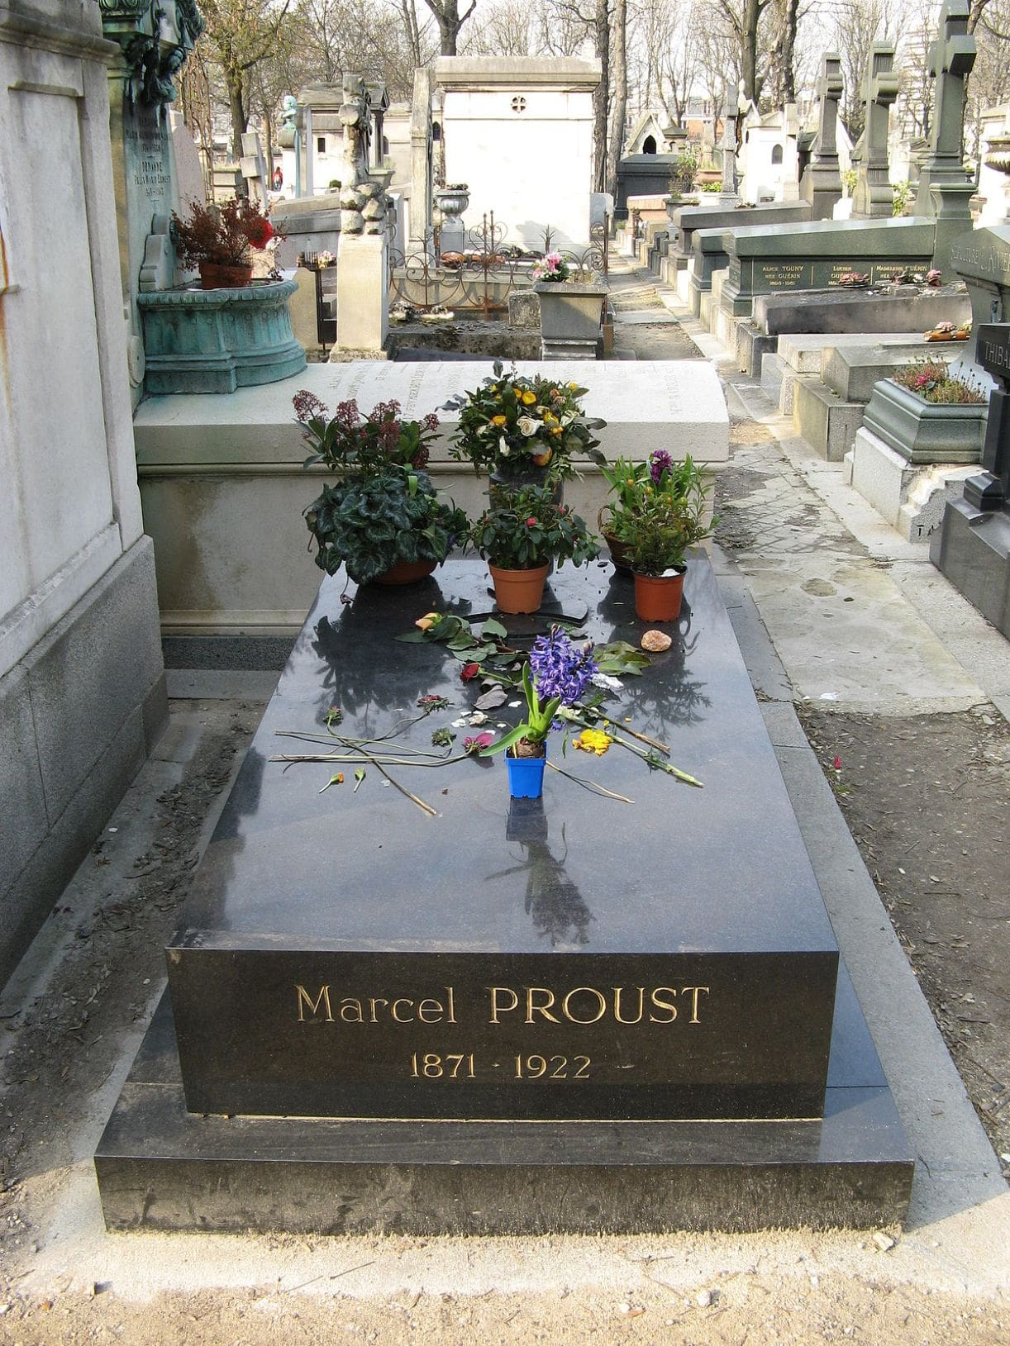

The Confession of a Young Woman, Marcel Proust

The Confession of a Young Woman

The desires of the senses drag you hither and thither, but once their hour is past, what do you bring back? Remorse of conscience and dissipation of spirit. You set out in joy and you often return in sadness, and the pleasures of evening sadden the next morning. Thus the joys of the senses caress us at first, but in the end they wound and kill.

– The Imitation of Christ, I, 18

1

Through the oblivion sought in drunken pleasures

There wafts, more sweet and virginal, heaven-sent,

The lilac with its melancholy scent.\*

– Henri de Régnier

At last my deliverance is drawing near. I admit it: I was clumsy, I didn’t shoot straight, I almost missed myself. Of course, it would have been better to die at the first shot, but in any case they weren’t able to extract the bullet and then my heart started to behave erratically. It can’t be long now. And yet – a week! It might last a whole week! And during that time I won’t be able to do anything but strive to grasp the whole horrible chain of circumstances. If I were not so weak, if I had enough willpower to get out of bed and go away, I would like to die at Les Oublis, in the grounds where I spent all my summers until the age of fifteen. No place is more full of my mother, so much did her presence, and even more her absence, impregnate it with her whole person.

Is not absence, for anyone who loves, the most certain, the most efficacious, the most vivacious, the most indestructible and the most faithful of presences?

My mother would take me to Les Oublis at the end of April, leaving after two days, spending another two days there in the middle of May, then coming to fetch me in the last week in June. Her stays, so short, were the sweetest and yet cruellest things.

During those two days she would lavish on me an affection of which she was usually very chary, as she was trying to make me tougher and to calm my unhealthy over-sensitivity. On the two evenings she spent at Les Oublis, she would come and say goodnight to me in my bed, an old habit she had otherwise given up, since it gave me too much pleasure and too much pain; I wouldn’t be able to get to sleep, since I kept calling her back to say goodnight to me all over again, eventually not daring to do so any more, but feeling all the more passionately my need for her, and constantly inventing new pretexts – my burning pillow that needed turning over, my frozen feet that she alone would be able to warm up in her hands…

So many sweet moments were made even sweeter because I felt these were the moments at which my mother was really herself, and that her habitual frigidity must be something she imposed on herself with an effort. The day on which she set off again – a day of despair when I would cling to her skirts all the way to the train compartment, begging her to take me with her to Paris – I could clearly distinguish what was sincere from what was feigned: the sadness evident behind her cheerful, cross rebukes at my “silly, ridiculous” sadness that she was trying to teach me to overcome, but which she shared.

I can still feel the emotion I felt on one of those days of departure (that precise emotion, intact and unaffected by its painful return today), one of those days of departure when I made the welcome discovery of her tenderness, so similar and superior to mine. As with all discoveries, I had had an inkling of it before, but the facts seemed so often to tell against it! My sweetest impressions are those of the years when she returned to Les Oublis, having been summoned there because I was ill.

Not only was she paying me an extra visit that I had not been expecting, but, above all, on those occasions she was nothing but the gentleness and tenderness that she lavished on me at length, without dissimulation or constraint. Even then, when that gentleness and tenderness had not been made even more gentle and tender by the thought that one day they would no longer be there for me, they counted for so much that the charm of convalescence always filled me with mortal sadness: the day approached on which I would again be well enough for my mother to leave, and until then I was not poorly enough for her to reassume the sternness and unyielding sense of justice that she had previously shown.

One day, the uncles with whom I lived at Les Oublis had kept concealed from me the fact that my mother was about to arrive, since a young cousin had come to spend a few hours with me, and I would not have paid him enough attention if I had been filled with the joyful anguish of that expectation. This little secret was perhaps the first of the circumstances independent of my will that helped to foster all the predispositions towards evil that, like all children of my age (and in those days no more than them), I bore within me.

This young cousin who was fifteen – I was fourteen – was already extremely prone to vice and taught me things that immediately made me shudder with remorse and pleasure. In listening to him, in letting his hands stroke mine, I tasted a joy poisoned at its very source; soon I found the strength to leave him, and I ran off into the grounds filled with a mad desire for my mother, whom I knew to be – alas! – in Paris; I called out to her everywhere, in spite of myself, up and down the paths of the park. Suddenly, walking past an arbour, I spotted her on a bench, smiling and opening her arms for me.

She lifted her veil to kiss me, I flung myself at her cheeks, bursting into tears; I wept for a long time, telling her all those nasty things that only the ignorance of my age could allow me to tell her and that she contrived to listen to with divine patience, without understanding them, but diminishing their importance with her kindness and thereby taking a load off my conscience. It grew lighter and lighter, this load; my crushed, humiliated soul rose, ever lighter and ever more powerful, overflowing so much that I was pure soul.

A divine sweetness radiated from my mother and from my restored innocence. I immediately smelt under my nostrils an odour just as pure and just as fresh. It was a lilac tree, a branch of which, hidden by my mother’s parasol, had already blossomed and was invisibly filling the air with its balm. High in the trees, the birds were singing with all their strength.

Higher up, between the treetops, the sky was of a blue so deep that it seemed but the entrance of a heaven into which it would be possible endlessly to rise. I kissed my mother. Never again did I experience the sweetness I then found in that kiss. She left the next day, and that departure was crueller than all those which had preceded it. As well as joy, it seemed to me as if the strength and the support that I needed, now that I had sinned for the first time, were abandoning me.

All these separations taught me in spite of myself that one day the irreparable would happen, even though never at that time did I seriously envisage the possibility of surviving my mother. I was resolved to kill myself the minute she died. Later on, absence taught me even more bitter lessons: that one gets used to absence, and that the greatest diminishment of self, the most humiliating form of suffering, consists in realizing that it no longer causes you any suffering. These lessons were in any case to be shown as false by subsequent events. Above all, right now, I am thinking back to the little garden where I would have my breakfast with my mother and where there were innumerable pansies. They had always seemed somewhat sad to me, as grave as emblems, but gentle and velvety, often mauve, sometimes violet, almost black, with gracious and mysterious yellow images, some of them entirely white and frail in their innocence. I pick them all now, in my memory, those pansies; their sadness has increased the more I have come to understand it, and the gentleness of their velvety down has disappeared for good.

2

How has all that freshwater surge of memories managed to spring up again and flow into my soul, today so impure, without being sullied by it? What virtue is possessed by that morning odour of lilacs that enables it to make its way across so many fetid vapours without being affected and weakened by them? Alas! the soul I had at fourteen can still awaken within me, but at the same time it is far away from me and outside of me. I know full well it is no longer my soul and that it is no longer within my power to make it so again. And yet at that time I did not think I would one day look back on it with nostalgia. It was merely pure, and I needed to make it strong and capable of performing, one day, the highest tasks.

Often, at Les Oublis, after going with my mother to the edge of the pond filled with the playful glitter of the sunlight and the fish, in the heat of the day, or in the morning and evening walking with her out in the fields, I would trustingly dream of the future that was never beautiful enough to satisfy her love, nor my desire to please her; and the powers, if not of will, at least of imagination and feeling that were stirring within me, tumultuously summoned the destiny in which they could find fulfilment, and knocked repeatedly against the walls of my heart as if to burst through and rush out of me, into life.

If I then jumped up, filled with exuberance, if I kissed my mother a thousand times over, ran far ahead like a puppy dog or, having lingered behind her, picking poppies and cornflowers, brought them up to her with glad cries, it was less because of the joy of the walk itself and the pleasure of picking those flowers than it was a way of giving free rein to my happiness at sensing within me all the life ready to spring forth, to spread out infinitely, in vaster and more magical perspectives than those granted by the distant horizon of the forests and the sky that I wished I could reach at a single bound. Bouquets of cornflowers, clover and poppies, if I carried you off in such intoxication, my eyes burning, quivering all over – if you made me laugh and cry – the reason was that I made you part of all the hopes I then nursed, which now, like you, have withered and perished and, without having even blossomed like you, have returned to dust.

What made my mother so sad was my lack of willpower. I did everything on a momentary impulse. As long as my life drew its sustenance from my mind or my heart, it was, if not altogether good, at least not altogether bad. My mother and I were above all else preoccupied by the attempt to fulfil all my fine plans for work, tranquillity and reasonableness, since we sensed – she more distinctly, I confusedly, but with great force – that this fulfilment would only come about if I could create by myself and within myself that willpower that she had conceived and nursed into existence.

But each time I would put it off to the next day. I let myself take my time; I was sometimes sorry to see time passing, but there was still so much of it ahead of me! And yet I was rather afraid, and felt vaguely that the habit of abstaining from exercising my willpower was starting to weigh on me more and more heavily, the more the years went by, filled as I was with the melancholy suspicion that things would not change all of a sudden, and that I could hardly count, if my life were to be transformed and my willpower shaped, on some miracle that would cost me no effort at all. To desire strength of will was not enough. I would have needed to do just what I could not do without strength of will: will it.

3

And the crazed wind of concupiscence

Makes your flesh crack and flap like an old flag.\*

– Baudelaire

In the course of my sixteenth year, I suffered a breakdown that left me feeling ill. To take my mind off it, my parents decided to bring me out into society. Young men fell into the habit of coming to see me. One of them was perverse and spiteful. He had manners that were both gentle and over-bold. He was the one I fell in love with. My parents learnt of it, and didn’t do anything too hasty, in case they upset me too much.

Spending all the time I couldn’t see him thinking about him, I finally lowered myself to resemble him as much as I possibly could. He led me into evil ways almost by stealth, then got me into the habit of allowing bad thoughts to arise in me, thoughts which I had no strength of will to oppose – and will alone would have been the only power capable of forcing them back into the infernal shadow from which they had emerged. When my love for him faded, habit had taken its place, and there was no lack of immoral young men ready to exploit it.

They were partners in my crimes, and made themselves the apologists of my misdeeds before the tribunal of my conscience. At first I was filled with agonized remorse, I made confessions that were not understood. My comrades put me off the idea of persisting in trying to tell my father. They slowly persuaded me that all girls did the same and that parents merely pretended not to know. My imagination soon glossed over the lies that I was ceaselessly obliged to tell by keeping a silence that my imagination depicted as the necessary result of some ineluctable necessity. At this time I was no longer properly living; but I was still dreaming, thinking and feeling.

To take my mind off all these unwholesome desires and chase them away, I started to go out a great deal into society. Its desiccating pleasures accustomed me to living in company the whole time and, as I lost the taste for solitude, I lost the secret of the joys that nature and art had hitherto given me. Never did I go to concerts so frequently as I did in those years. Never, entirely preoccupied as I was with the desire of being admired as I sat in some elegant box, did I have less of a feeling for the music. I listened, but I heard nothing.

If by chance I did hear, I had ceased to see everything that music can reveal. My walks too had been, as it were, stricken with sterility. The things which had once sufficed to make me happy for a whole day – a ray of sunlight casting its yellow beams on the grass, the odour given off by damp leaves when the last drops of rain fell – had, like me, lost their sweetness and gaiety. The woods, the sky, the lakes and rivers seemed to turn away from me, and if, lingering alone with them face to face, I anxiously questioned them, they no longer murmured those vague replies that had once so ravished me. The divine guests that are announced by the voice of the waters, leaves and sky only ever deign to visit hearts which, by dwelling within themselves, have purified themselves.

It was at this point that, seeking an inverse remedy, and not being courageous enough to will the true remedy that lay so close to me, and – alas! – so far away from me, since it was within me, I again let myself go, succumbing to guilty pleasures, thinking thereby to revive the flame which society had extinguished. It was in vain. Held back by the pleasure I took in pleasing others, I kept putting off, day after day, the definitive decision, the choice, the really free act – namely, opting for solitude.

I did not give up one of these two vices for the other. I combined them. More than that: each vice assumed the responsibility of overcoming all the obstacles in thought and feeling that might have stood in the way of the other vice, and thus seemed actually to summon it into being. I would go out into society to calm myself after some misdemeanour, and I would commit another one the minute I was calm. It was at that terrible period, after the loss of innocence, and before the remorse I feel today, at that period when, of all the periods in my life, I was most worthless, that I was most highly esteemed by everyone else.

I had been considered as a pretentious and eccentric little girl; now, conversely, the ashes of my imagination were greatly to the taste of society, which delighted in them. Just when I was committing the greatest of crimes against my mother, I was viewed, because of my tenderly respectful manner towards her, as a model daughter. After the suicide of my mind, everyone admired my intelligence and doted on my spirited remarks.

My desiccated imagination, my choked sensibility were enough to quench the thirst of those who most craved spiritual life, so artificial was their thirst, and so mendacious – just like the source at which they all imagined they could slake it! In any case, no one suspected the secret crime of my life, and I seemed to everyone to be the ideal young girl. How many parents told my mother at that time that if I had not enjoyed such a high position and if they had been able to aspire to me, they would have wished for no other wife for their sons! In the depths of my obliterated conscience, I nonetheless felt at this undeserved praise a desperate sense of shame; this shame did not reach the surface, and I had fallen so low that I was vile enough to report their praise, sarcastically, to my partners in crime.

4

I think of all who have lost what can

Never, ever be found again!\*

– Baudelaire

In the winter of my twentieth year, my mother’s health, which had never been strong, was greatly impaired. I learnt that she had a heart disease, not a grave one, but one that still meant she needed to avoid any upset. One of my uncles told me that my mother wished to see me married. A specific and important duty presented itself to me. I would be able to prove to my mother how much I loved her. I accepted the first marriage request that she passed on to me, and, by agreeing to it, I charged necessity with the task which willpower had been unable to make me undertake: that of changing my life. My fiancé was exactly the man who, with his exceptional intelligence, his gentleness and his vigour, could have the most salutary influence on me. He was, in addition, resolved to live with us. I would no longer be separated from my mother, which would have been the cruellest of pains for me.

Then I plucked up the courage to tell my confessor of all my misdeeds. I asked him if I should admit them to my fiancé too. He was compassionate enough to dissuade me, but made me swear that I would never relapse into those errors, and gave me absolution. The belated flowers that joy made blossom in my heart – a heart that I had thought was for ever sterile – bore fruit. The grace of God, the grace of youth – in which we see so many wounds closing of themselves, thanks to the vitality of that time of life – had cured me. If, as St Augustine says, it is more difficult to become chaste once one has lost the habit of chastity, then I really experienced how difficult virtue can be.

No one suspected that I was an immeasurably better person now than I had been previously, and every day my mother would kiss my brow which she had never ceased to think of as pure without knowing that it was now regenerate. Indeed, I was at this period unjustly rebuked for my inattentiveness, my silence and my melancholy in society. But these rebukes did not annoy me: the secret that I shared with my satisfied conscience gave me a pleasure altogether sufficient. The convalescence of my soul – which now ceaselessly smiled on me with a face like that of my mother, and gazed at me with an expression of tender reproach through its drying tears – was imbued with boundless charm and languor. Yes, my soul was experiencing a rebirth. I myself could not understand how I had been able to mistreat it, make it suffer, almost kill it. And I effusively thanked God for having saved it in time.

It was the harmony between this pure and profound joy on the one hand, and the fresh serenity of the sky on the other, that I was busy enjoying on the evening when it all finally happened. The absence of my fiancé, who had gone to spend a couple of days with his sister, and the presence at dinner of the young man who bore the greatest share of responsibility for my former errors did not cast the slightest sadness over that limpid May evening.

There was not a cloud in the sky, which in all its perfect clarity was reflected in my heart. In addition, my mother, as if there had been a mysterious solidarity between her and my soul – despite her total ignorance of my misdeeds – was more or less fully cured. “She needs lots of tender loving care from you over the next fortnight,” the doctor had said, “and after that, she’s in no risk of a relapse!” These words alone were for me the promise of a future happiness whose sweetness made me burst into tears.

That evening, my mother was wearing a more elegant dress than usual, and, for the first time since my father’s death, even though that was now a good ten years ago, she had added a dash of mauve to her habitual black dress. She was quite abashed to have dressed like this, in the clothes she had worn when she was younger, and both sad and happy to have forced herself to do violence to her grief and mourning so as to give me pleasure and celebrate my joy.

I held up to her bodice a pink carnation which at first she brushed away, but then pinned to her clothing – since it came from me – albeit with a rather hesitant and embarrassed hand. Just as we were about to sit down at table, I pulled her face towards me, as we stood near the window – her face now fresh and rejuvenated after her past sufferings – and I passionately kissed her. I had been wrong to say that I had never again experienced the sweetness of our kiss at Les Oublis. The kiss I gave her on that evening was as sweet as any other. Or rather, it was the very same kiss as that at Les Oublis which, summoned by the attractive force of a similar moment, wafted gently up from the depths of the past and came to place itself between my mother’s still somewhat pallid cheeks and my lips.

A toast was raised to my forthcoming marriage. I only ever drank water because of the overexcitement that wine aroused in my nerves. My uncle declared that, at a moment like this, I could make an exception. I can see in front of my eyes his cheerful face as he uttered those stupid words… My God! My God! I have confessed everything so calmly, am I going to be obliged to stop here? I can no longer see straight!

Oh yes… my uncle said that I could, after all, make an exception at a moment like this. He looked at me laughingly as he said these words; I drank quickly, before glancing at my mother, in case she forbade me. She said gently, “One should never yield an inch to evil, however insignificant it seems.” But the champagne was so cool that I drank another two glasses. My head had become really heavy; I needed simultaneously to rest and to discharge my nervous tension. Everyone was getting up from table; Jacques came over to me and said, as he stared at me:

“Come with me, please; I’d like to show you some poetry I’ve written.”

His handsome eyes twinkled above his fresh young cheeks, and he was slowly twirling his moustache. I realized I was destroying myself and I had no strength to resist. Trembling all over, I said:

“Yes, I’d love to.”

It was in uttering these words, or even earlier, in drinking the second glass of champagne, that I committed the really deliberate act, the abominable act. After that, I merely let myself go. We had locked both doors, and he, his breath on my cheeks, held me tight, his hands wandering feverishly up and down my body. Then, as pleasure started to overwhelm me, I felt arising in the depths of my heart a boundless desolation and sadness; it seemed that I was making them all weep – the soul of my mother, the soul of my guardian angel, the soul of God. I had never been able to read without a shudder of horror the account of the torture that evildoers inflict on animals, on their own wives, on their children; it appeared to me now, indistinctly, that in every pleasurable and sinful action the body in thrall to rapture is just as fierce as they are; within us, just as many good intentions and just as many pure angels weep as they suffer martyrdom.

Soon my uncles would have finished their game of cards and would be coming back. We would do it before they returned, I would never again yield, this was the last time… Then, above the fireplace, I saw myself in the mirror. None of the diffuse anguish of my soul was painted on my face, but from my shining eyes to my burning cheeks and my proffered lips, everything in that face breathed a sensual, stupid and brutal joy. Then I thought of the horror anyone would feel who had seen me just now kissing my mother with melancholy tenderness, and could now see me thus transformed into a beast. But immediately there arose in the mirror, against my face, Jacques’s mouth, avid beneath his moustache. Shaken to my depths, I moved my head towards his, when opposite me I saw – yes, I am telling it to you just as it happened, listen to me since I can tell you – on the balcony, outside the window, I saw my mother gazing at me, horror-struck. I don’t know if she cried out, I heard nothing, but she fell backwards and remained with her head caught between the two bars of the railing…

This isn’t the last time I’ll be telling you my story: as I said, I almost missed myself; even though I’d taken careful aim, I did not shoot straight. But they were not able to extract the bullet and my heart has started to behave erratically. But I can linger on for a week in this state, and until then I’ll be constantly trying to understand how it all started, and seeing how it finished. I would have preferred my mother to see me commit yet other crimes – or even that particular one, but without her catching sight of the expression of joy that my face had in the mirror. No, she can’t possibly have seen it… It was a coincidence… She was struck down by apoplexy a minute before she saw me… She didn’t see that expression… It’s not possible! God, who knew everything, would never have allowed it.

The end