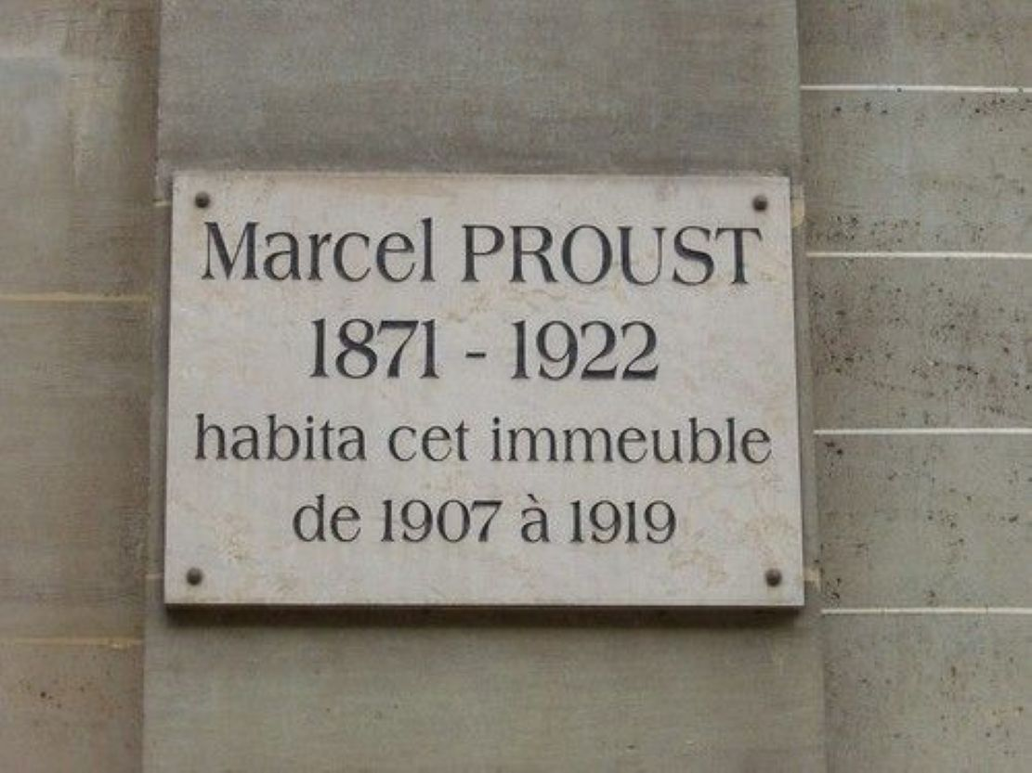

To My Friend Willie Heath, Marcel Proust

To My Friend Willie Heatha

Died in Paris 3rd October 1893\*

From the lap of God in which you rest… reveal to me those truths which conquer death, prevent us from fearing it and almost make us love it.\*

The ancient Greeks brought cakes, milk and wine for their dead. Seduced by a more refined illusion, if not by one that is any wiser, we offer them flowers and books. If I am giving you this one, it is first and foremost because it is a book of images.

Despite the “legends”, it will be, if not read, at least looked at by all the admirers of that great artist who has given me, without any affectation, this magnificent present, the woman of whom we might well say, adapting Dumas’s words, “that she is the one who has created the most roses after God”.\* M. Robert de Montesquiou\* has also celebrated her, in poems as yet unpublished, with that ingenious gravity, that sententious and subtle eloquence, that rigorous form which at times in his work recalls the seventeenth century. He tells her, speaking of flowers:

Posing for your paintbrush encourages them to bloom […]

You are their Vigée\* and you are Flora too,

Who brings them immortality, where she brings only doom!

Her admirers are an elite, and there is a host of them. It was my wish that on the first page they should see the name of the man they had no time to become acquainted with and whom they would have admired.

I myself, dear friend, knew you for only a very short time. It was in the Bois de Boulogne that I would often meet you in the mornings: you had spotted me coming and were waiting for me beneath the trees, erect but relaxed, like one of those great lords painted by Van Dyck,\* whose pensive elegance you shared. And indeed their elegance, like yours, resides less in clothes than in the body, and their bodies seem to have received it and to continue ceaselessly to receive it from their souls: it is a moral elegance.

And everything, moreover, helped to bring out that melancholy resemblance, even the background of foliage in whose shadow Van Dyck often caught and fixed a king taking a stroll; like so many of those who were his models, you were soon to die, and in your eyes as in their eyes one could see alternately the shades of presentiment and the gentle light of resignation.

But if the grace of your pride belonged by right to the art of a Van Dyck, you were much closer to Leonardo da Vinci by the mysterious intensity of your spiritual life. Often, your finger raised, your eyes impenetrable and smiling at the sight of the enigma you kept to yourself, you struck me as Leonardo’s John the Baptist.

Then we came up with the dream, almost the plan, of living more and more with each other, in a circle of magnanimous and well-chosen men and women, far enough from stupidity, vice and malice to feel safe from their vulgar arrows.

Your life, as you wished it to be, would comprise one of those works of art which require a lofty inspiration. Like faith and genius, we can receive this inspiration from the hands of love.

But it was death that would give it to you. In it too and even in its approach reside hidden strength, secret aid, a “grace” which is not found in life. Just like lovers when they start to love, like poets at the time when they sing, those who are ill feel closer to their souls. Life is hard when it wraps us in too tight an embrace, and perpetually hurts our souls. When we sense its bonds relaxing for a moment, we can experience gentle moments of lucidity and foresight.

When I was still a child, no other character in sacred history seemed to me to have such a wretched fate as Noah, because of the flood which kept him trapped in the ark for forty days. Later on, I was often ill, and for days on end I too was forced to stay in the “ark”. Then I realized that Noah was never able to see the world so clearly as from the ark, despite its being closed and the fact that it was night on earth. When my convalescence began, my mother, who had not left me, and would even, at night-time, remain by my side, “opened the window of the ark”, and went out. But, like the dove, “she came back in the evening”.

Then I was altogether cured, and like the dove “she returned not again”.\* I had to start to live once more, to turn away from myself, to listen to words harder than those my mother spoke; what was more, even her words, perpetually gentle until then, were no longer the same, but were imbued with the severity of life and of the duties she was obliged to teach me. Gentle dove of the flood, seeing you depart, how can one imagine that the patriarch did not feel a certain sadness mingling with his joy at the rebirth of the world? How gentle is that suspended animation, that veritable “Truce of God” which brings to a halt our labours and evil desires!

What “grace” there is in illness, which brings us closer to the realities beyond death – and its graces too, the graces of its “vain adornments and oppressive veils”, the hair that an importunate hand “has carefully gathered”,\* the soft mild acts of a mother’s or friend’s faithfulness that so often appeared to us wearing the very face of our sadness, or as the protective gesture that our weakness had implored, and which will stop on the threshold of convalescence; often I have suffered at feeling that you were so far away from me, all of you, the exiled descendants of the dove from the ark.

And who indeed has not experienced those moments, my dear Willie, in which he would like to be where you are? We assume so many responsibilities towards life that there comes a time when, discouraged at the impossibility of ever being able to fulfil them all, we turn towards the tombs, we call on death, “death who comes to the aid of destinies that are difficult to accomplish”.\* But if she unbinds us from the responsibilities we have assumed towards life, she cannot unbind us from those we have assumed towards ourselves, the first and foremost in particular – that of living so as to be worth something, and to gain merit.

More serious than any of us, you were also more childlike than anyone, not only in purity of heart, but in your innocent and delightful gaiety. Charles de Grancey had a gift which I envied him, that of being able, with memories of your schooldays, to arouse all of a sudden that laughter that never slumbered for long within you, and that we will hear no more.

If some of these pages were written at the age of twenty-three, many others (‘Violante’, almost all the ‘Fragments from Italian Comedy’, etc.) date from my twentieth year. All of them are merely the vain foam of a life that was agitated but is now calming down. May that life one day be limpid enough for the Muses to deign to gaze at themselves in it and for the reflection of their smiles and their dances to dart across its surface!

I am giving you this book. You are – alas! – the only one of my friends whose criticism it had nothing to fear from. I am at least confident that nowhere would its freedom of tone have shocked you. I have depicted immorality only in persons of a delicate conscience. Thus, as they are too weak to will the good, too noble to indulge with real enjoyment in evil, knowing nothing but suffering, I have managed to speak of them only with a pity too sincere for it not to purify these short essays.

May that true friend, and that illustrious and beloved Master,\* who have added the poetry of his music and the music of his incomparable poetry respectively, and may M. Darlu\* too, that great philosopher whose inspired spoken words, more assured of lasting life than anything written, have in me as in so many others engendered thought, forgive me for having reserved for you this last token of my affection, bearing in mind that no one living, however great he may be or however dear, must be honoured before one who is dead.

The end