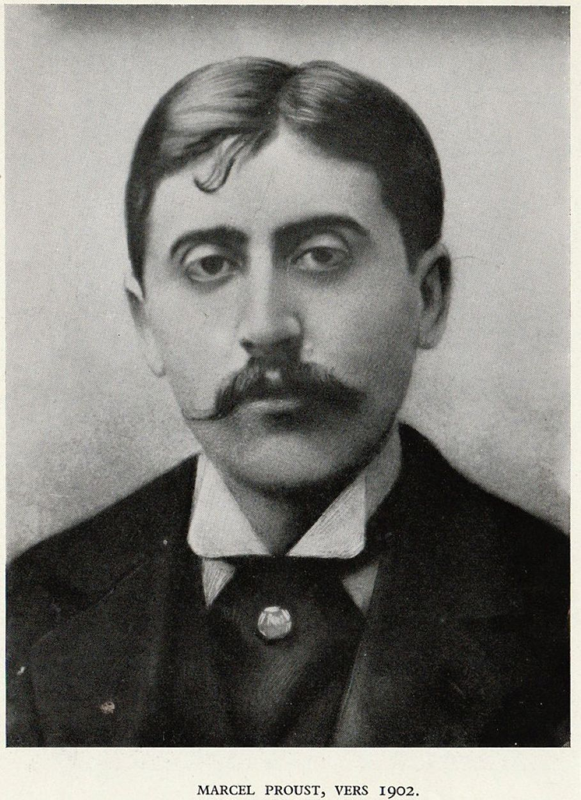

Violante or High Society, Marcel Proust

Violante or High Society

Have few dealings with young men and persons of the upper classes. . . . Do not desire to appear before the powerful.

—THOMAS À KEMPIS: IMITATION OF CHRIST, BOOK I, CHAPTER 8

Violante’s Meditative Childhood

The Viscountess of Styria was generous and affectionate and thoroughly imbued with an enchanting grace. Her husband the viscount had an extremely nimble mind, and his facial features were of an admirable regularity. But any grenadier was more sensitive than he and less vulgar. Far from society, they reared their daughter Violante at their rustic estate in Styria, and she, as lively and attractive as her father and as benevolent and mysteriously seductive as her mother, seemed to unite her parents’ qualities in a perfectly harmonious proportion.

However, the fickle strivings of her heart and her mind did not encounter a will in her that, without limiting them, could guide them and keep her from becoming their charming and fragile plaything. For her mother this lack of willpower inspired anxieties that might eventually have borne fruit if the viscountess and her husband had not been violently killed in a hunting accident, leaving Violante an orphan at fifteen.

Residing nearly alone, under the watchful but awkward supervision of old Augustin, her tutor and the steward of the Styrian castle, Violante, for lack of friends, dreamed up enchanting companions, promising to be faithful to them for the rest of her life. She took them strolling along the paths in the park and through the countryside, and she leaned with them on the balustrade of the terrace that, marking the boundary of the Styrian estate, faced the sea. Raised by her dream friends virtually above herself and initiated by them, Violante was sensitive to the visible world and had a slight inkling of the invisible world. Her joy was infinite, though broken by periods of sadness that were sweeter than her joy.

Sensuality

Do not lean on a wind-shaken reed and do not place your faith upon it, for all flesh is like grass, and its glory fades like the flower of the fields.

—THOMAS À KEMPIS: IMITATION OF CHRIST

Aside from Augustin and a few local children, Violante saw no one. Her sole guest from time to time was her mother’s younger sister, who lived in Julianges, a castle located several miles away. One day, when the aunt came to see her niece, she was accompanied by a friend. His name was Honoré, and he was sixteen years old. Violante did not care for him, but he visited her again.

Roaming along a path in the park, he taught her highly inappropriate things, whose existence she had never suspected. She experienced a very sweet pleasure, of which she was instantly ashamed. Then, since the sun was down, and they had walked and walked, they sat down on a bench, no doubt to gaze at the reflections with which the rosy sky was mellowing the sea.

Honoré drew closer to Violante so she would not feel cold; he fastened her fur coat around her throat, ingeniously drawing out his action, and he offered to help her try to practice the theories he had just been teaching her in the park. He wanted to whisper, his lips approached her ear, which she did not withdraw; but then they heard a rustling in the foliage.

“It’s nothing,” Honoré murmured tenderly.

“It’s my aunt,” said Violante.

It was the wind. But Violante, cooled just in time by the wind and now standing, refused to sit down again; she said goodbye to Honoré despite his pleading. She felt remorse, suffered a hysterical fit, and had a very hard time falling asleep during the next two nights. Her memory was a burning pillow which she kept turning and turning. Two days later Honoré asked to see her. She had her butler reply that she had gone for a walk. Honoré did not believe a word of it and did not dare come back.

The following summer she again thought about Honoré, with tenderness, but also with distress, for she knew that he was a sailor on some ship. After the sun had glided into the sea, Violante would sit on the bench to which he had brought her a year ago, and she would struggle to remember Honoré’s lips held out to her, his green eyes half-closed, his gazes sweeping like rays and focusing a little warm and vivid light upon her.

And on tender nights, on vast and secretive nights, when the certainty that no one could see her intensified her desire, she heard Honoré’s voice whispering the forbidden things into her ear. She conjured him up fully, and he obsessively offered himself to her like a temptation.

One evening at dinner, she sighed as she looked at the steward, who sat across from her.

“I feel very sad, dear Augustin,” said Violante. “No one loves me,” she added.

“And yet,” he countered, “a week ago, when I was straightening out the library at Julianges, I heard someone say about you: ‘How beautiful she is!’ ”

“Who said that?” Violante asked sadly.

A vague smile barely and very softly raised a corner of her mouth the way we try to lift a window curtain in order to admit the gaiety of daylight.

“It was that young man from last year, Monsieur Honoré. . . .”

“I thought he was at sea,” said Violante.

“He’s back,” said Augustin.

Violante promptly stood up and almost staggered into her bedroom in order to write Honoré, asking him to come and see her. Picking up her pen, she had a hitherto unknown feeling of happiness, of power: the feeling that she was arranging her life a bit according to her own whim and pleasure; the feeling that she could nudge along their two destinies, spur the intricate machinery that imprisoned them far apart; the feeling that he would appear at night, on the terrace, rather than in the cruel ecstasy of her unfulfilled desire; the feeling that, between her unheard expressions of tenderness (her perpetual inner romance) and real things, there were truly avenues of communication, along which she would hurry toward the impossible, making it viable by creating it.

The next day she received Honoré’s response, which she read, trembling, on the bench where he had kissed her.

Mademoiselle,

Your letter has reached me an hour before my ship is to sail. We have put into port for only a week, and I will not return for another four years. Be so kind as to keep the memory of

Your respectful and affectionate

Honoré.

Gazing now at that terrace to which he would no longer come, where no one could fulfill her desire, gazing also at that sea, which was tearing him away from her, exchanging him, in the girl’s imagination, for a bit of its grand, sad, and mysterious charm, the charm of things that do not belong to us, that reflect too many skies and wash too many shores; gazing and gazing, Violante burst into tears.

“My poor Augustin,” she said that evening. “Something awful has happened to me.”

Her initial need to confide in someone arose from the first disappointments of her sensuality, emerging as naturally as the first satisfactions of love normally emerge. She had not as yet known love. A short time later she suffered from it, which is the only manner in which we get to know it.

Pangs of Love

Violante was in love; that is, for several months a young Englishman named Laurence had been the object of her most trivial thoughts, the goal of her most important actions. She had gone hunting with him once and she failed to understand why the desire to see him again dominated her thoughts, drove her to roads where she would run into him, deprived her of sleep, and destroyed her peace of mind and her happiness.

Violante was smitten; she was spurned. Laurence loved high society; she loved it in order to follow him. But Laurence had no eyes for this twenty-year-old country girl. She fell ill with chagrin and jealousy and, to forget him, she went to take the waters at X.; but her pride was wounded because she had lost out to so many women who could not hold a candle to her; so, in order to triumph over them, she decided to beat them at their own game.

“I’m leaving you, my good Augustin,” she said, “I’m going to the Austrian court.”

“Heaven help us,” said Augustin. “The poor in our country will no longer be consoled by your charity once you’re in the midst of so many wicked people. You’ll no longer play with our children in the forest. Who’ll preside at the organ in church? We’ll no longer see you painting in the countryside, you’ll no longer compose any songs for us.”

“Don’t worry, Augustin,” said Violante, “just keep my castle and my Styrian peasants lovely and faithful. For me high society is only a means to an end. It offers vulgar but invincible weapons, and if I want to be loved someday, I have to possess them. I’m also prodded by curiosity and by a need to live a slightly more material and less meditative life than here.

I want both a holiday and an education. Once I gain my status, and my vacation ends, I’ll trade the sophisticated world for the country, for our good and simple people, and, what I prefer above everything else, my songs. On a certain and not all too distant day, I’ll stop on this slope, I’ll return to our Styria and live with you, dear Augustin.”

“Will you be able to?” said Augustin.

“One can if one wants to,” said Violante.

“But perhaps you won’t want the same thing as now,” said Augustin.

“Why won’t I?” asked Violante.

“Because you’ll have changed,” said Augustin.

The Sophisticated World

The members of high society are so mediocre that Violante merely had to deign to mingle with them in order to eclipse nearly all of them. The most unapproachable lords, the most uncivil artists sought her out and wooed her. She alone had a mind, had taste, and a bearing that was the epitome of all perfection. She launched plays, perfumes, and gowns. Writers, hairdressers, fashion designers begged for her patronage.

The most celebrated milliner in Austria requested her permission to call herself Violante’s personal modiste; the most illustrious prince in Europe requested her permission to call himself her lover. But she felt obliged to hold back these marks of esteem, which would have definitively consecrated their lofty standing in the fashionable world.

Among the young men who asked to be received by Violante, Laurence stood out because of his persistence. After causing her so much grief, he now aroused her disgust. And his base conduct alienated her more than all his earlier scorn.

“I have no right to be indignant,” she thought to herself. “I didn’t love him for his spiritual grandeur and I sensed very keenly, without daring to admit it to myself, that he was vile. This didn’t prevent me from loving him; it only kept me from loving spiritual grandeur to the same degree. I believed that a person could be both vile and lovable. But once you stop loving somebody, you prefer people with a heart. What a strange passion I had for that nasty man: it was all in my head; I had no excuse, I wasn’t swept away by sensual feelings. Platonic love is so meaningless.”

A bit later, as we shall see, Violante was to regard sensual love as even more meaningless.

Augustin came for a visit and tried to lure her back to Styria.

“You’ve conquered a veritable kingdom,” he said. “Isn’t that enough for you? Why not become the old Violante again?”

“I’ve only just conquered it, Augustin,” she retorted. “Let me at least exercise my power for a few months.”

An event, unforeseen by Augustin, temporarily exempted Violante from thinking about retirement. After rejecting marriage proposals from twenty most serene highnesses, as many sovereign princes, and one genius, she married the Duke of Bohemia, who had immense charm and five million ducats.

The announcement of Honoré’s return nearly broke up the marriage on the eve of the nuptials. But disfigured as he was by an illness, his attempts at familiarity were odious to Violante. She wept over the vanity of her desires, which had so ardently flown to the blossoming flesh that now had already withered forever.

The Duchess of Bohemia was as charming as Violante of Styria had been, and the duke’s immeasurable fortune served merely to provide a worthy frame for the artwork that she was. From an artwork she became a luxury article through that natural inclination of earthly things to slip lower if a noble effort does not maintain their center of gravity above them. Augustin was amazed at everything he heard from her.

“Why does the duchess,” he wrote her, “speak endlessly about things that Violante so thoroughly despised?”

“Because people who live in high society would not like me as much if I were preoccupied,” Violante answered, “with things that, being over their heads, are antipathetic to them and incomprehensible. But I’m so bored, my good Augustin.”

He came to see her and explained why she was bored:

“You no longer act on your taste in music, in reflection, in charity, in solitude, in rustic life. You’re absorbed in success, you’re held back by pleasure. But we can find happiness only in doing something we love with the deepest inclinations of the soul.”

“How can you know that?—you’ve never lived,” said Violante.

“I’ve thought, and thinking is living,” said Augustin. “I hope that you’ll soon be disgusted by this insipid life.”

Violante grew more and more bored; she was never cheerful now. Then, high society’s immorality, to which she had been indifferent, pounced on her, wounding her deeply, the way the harshness of the seasons beats down the bodies that illness renders incapable of struggling. One day, when she was strolling by herself along a nearly deserted avenue, a woman headed straight toward her after stepping down from a carriage that Violante had failed to notice.

The woman approached her and asked if she was Violante of Bohemia; she said that she had been her mother’s friend and that she desired to see little Violante, whom she had held in her lap.

The woman kissed her with intense emotion, put her arms around Violante’s waist, and kissed her so often that Violante dashed away without saying goodbye. The next evening, Violante attended a party in honor of the Princess of Miseno, whom she did not know. Violante recognized her: she was the abominable lady from yesterday. And a dowager, whom Violante had esteemed until now, asked her:

“Would you like me to introduce you to the Princess of Miseno?”

“No!” said Violante.

“Don’t be shy,” said the dowager. “I’m sure she’ll like you. She’s very fond of pretty women.”

From then on Violante had two mortal enemies, the Princess of Miseno and the dowager, both of whom depicted Violante everywhere as a monster of arrogance and perversity. Violante heard about it and wept for herself and for the wickedness of women. She had long since made up her mind about the wickedness of men. Soon she kept telling her husband every evening:

“The day after tomorrow we’re going back to my Styria and we will never leave it again.”

But then came a festivity that she might enjoy more than the others, a lovelier gown to show off. The profound need to imagine, to create, to live alone and through the mind, and also to sacrifice herself—those needs had lost too much strength, torturing her because they were not fulfilled, preventing her from finding even a particle of delight in high society; those needs were no longer urgent enough to make her change her way of life, to force her to renounce society and realize her true destiny.

She continued to present the sumptuous and woebegone image of a life made for infinity but gradually reduced to almost nothing and left with only the melancholy shadows of the noble destiny that she could have achieved but from which she was retreating more and more each day.

A great surge of far-reaching philanthropy that could have scoured her heart like a tide, leveling all the human inequalities that obstruct an aristocratic heart, was stemmed by the thousand dams of selfishness, coquetry, and ambition. She liked kindness now purely as an elegant gesture. She was still charitable with her money, with even her time and trouble; but a whole part of her had been put aside and was no longer hers.

She still spent each morning in bed, reading or dreaming, but with a distorted mind that now halted on the surface of things and contemplated itself, not to go deeper but to admire itself voluptuously and coquettishly as in a mirror.

And if visitors were announced, she did not have the willpower to send them away in order to continue dreaming or reading. She had reached the point at which she could enjoy nature solely with perverted senses, and the enchantment of the seasons existed for her merely to perfume her fashionable status and provide its tonality.

The charms of winter became the pleasure of being cold, and the gaiety of hunting closed her heart to the sorrows of autumn. Sometimes, by walking alone in the forest, she tried to rediscover the natural source of true joy. But she wore dazzling gowns under the shadowy foliage. And the delight of being fashionable corrupted her joy of being alone and dreaming.

“Are we leaving tomorrow?” the duke asked.

“The day after,” Violante replied.

Then the duke stopped asking her. In response to Augustin’s laments, she wrote him: “I’ll go back when I’m a bit older.”

“Ah!” Augustin answered. “You’re deliberately giving them your youth; you will never return to your Styria.”

She never returned. While young, she remained in high society to reign over the kingdom of elegance, which she had conquered while still practically a child. Growing old, she remained there to defend her power. It was useless. She lost it.

And when she died, she was still in the midst of trying to reconquer it. Augustin had counted on disgust. But he had reckoned without a force that, while nourished at first by vanity, overcomes disgust, contempt, even boredom: it is habit.

The end