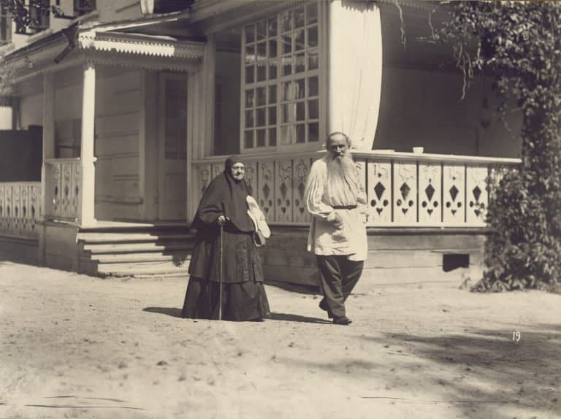

A Dialogue Among Clever People, Leo Tolstoy

A Dialogue Among Clever People

Translated by Nathan Haskell Dole 1892

ONCE SOME GUESTS were gathered in a rich man’s home, and it happened that a serious conversation about life arose.

They talked about persons absent and persons pres-ent, and they could not hit upon a single one contented with his life.

Not only did each one find something to complain of in his fortune, but there was not one who would consider that he was living as a Christian ought to live. All confessed that they were living worldly lives, concerned only about themselves and their families, thinking little about their neighbors, and still less about God.

Thus talked the guests, and all agreed in blaming themselves for their godless, unchristian lives.

“ Then why do we live so ? “ cried one youth. “ Why do we do what we ourselves do not approve ? Have we not the power over our own lives ? We ourselves are conscious that our luxury, our effeminacy, our wealth, and especially our pride our separation from our breth-ren are our ruin. In order to be important and rich we must deprive ourselves of everything that gives man joy in living; we crowd ourselves into cities, we make our-selves effeminate, we ruin our constitutions; and not-withstanding all our diversion, we die of ennui and of disgust because our lives are not what they ought to be.

“ Why live so ? Why destroy our lives so, and all the good which God has bestowed on us ? I mean to give up living as I have. I will give up the studies I have begun; for, don’t you see, they would lead me to no other than that tormenting life which all of us are now complaining of. I will renounce my property, and I will go and live with the poor in the country. I will work with them; I will learn to labor with my hands, and if my culture is necessary to the poor, I will share it with them, but not through institutions and books, but directly, living with them as if I were their brother. .... Yes, I have made up my mind,” he added, looking inquiringly at his father, who was also present.

“ Your desire is a worthy one,” said his father,-’but foolish and ill-considered. Everything seems to you quite easy because you don’t know life. How beautiful it seems to us ! But the truth is, the accomplishment of this beautiful ideal is very difficult and complicated. It is hard enough to go well on a beaten track, but still more to trace out new paths. They can be traced out only by men who have arrived at full maturity and have assimilated all that is in the power of man to absorb.

It seems to you easy to break out new paths in life, because, as yet, you have had no experience of life. This is all the heedlessness and pride of youth. We old people are needed to curb your impulses and to guide you by our experience, while you young people must obey us so as to profit by our experience. Your active life is still before you; now you are growing and developing. Get your education, and all the culture you can; stand on your own legs, have your own firm convictions, and then begin your new life, if you feel you have the strength for it. But now you must obey those that are guiding you for your own good, and you must not strike out into new paths in life ! “

The youth made no reply, and the older persons pres-ent agreed with what his father said.

“ You are right,” said a middle-aged, married man, ad-dressing the youth’s father. “It is true that a youth having no experience of life may blunder in trying new paths of life, and his resolution may not be deeply set-tled; but, you see, we are all agreed on this point, that our lives are contrary to our consciences, and do not make us happy. And so we can’t help regarding your desire to enter upon this new life as laudable.

“ The young man may adopt his ideal through reason, but I am not a young man, and I am going to speak to you about myself. As I listened to our talk this even-ing the same thought entered my mind. The life which I am leading, it is plain to me, cannot give me a serene conscience and happiness. Both experience and reason prove this. Then what am I waiting for ! You struggle from morning till night for your family, and the result is that both you and your family continue to live un-godly lives, and you are all the while worse and worse entangled in your sins.

You work for your family, and it seems your family are not better off or happier because you work for them. And so I often think it would be better if I changed my whole life and did exactly what this young man proposed ceased to bother about wife and children, and only thought about my soul. Not without reason does it say in St. Paul : ‘ He that is married takes thought about his wife, but he that is unmarried about God.’ ‘

Before this married man had finished his remarks, all the women present, including his wife, fell upon him :

“ You ought to have thought about all this earlier,” said one of the elderly ladies. “ ‘ Once harnessed, you must work.’ According to your plan every man will be saying, ‘ I want to be saved,’ when it seems to him hard to maintain and feed a family. It is all deception and basebess. No; a man ought to be able to live in a godly way even if he has a family. It is easy enough for him to save himself alone.

And then the main thing to act so is to act contrary to the teaching of Christ. God has commanded us to love others, but in this way you would offend others as if it were for God. No; a mar-ried man has his definite obligations, and he ought not to shirk them. It is another thing when your family has already been established. Then you may do as you please for yourself, but no one has any right to do vio-lence to his family.”

The married man did not agree with this. He said :” I have no wish to give up my family. All I say is that it is not necessary to maintain one’s family and children in a worldly fashion, or to teach them to live for their own pleasures as we were just saying; but we ought to train them so that children in their early days may be accustomed to poverty, to labor, to help others; and, above all, to lead a fraternal life with all men. And to do this it is necessary to renounce all wealth and distinc-tion.”

“ There is no sense in breaking in others while you yourself are not living a godly life,” retorted his wife, with some heat. “ Ever since your earliest youth you have lived for your own gratification. Why, then, should you wish to torment your children and family ? Let them grow up in peace, and then they will do as they themselves are inclined; but don’t you coerce them.”

The married man held his peace, but an elderly man who was present took up the cudgels in his defense :

“ Let us admit,” said he, “it is impossible for a married man who has accustomed his family to a certain degree of luxury, suddenly to deprive them of it all. It is true that if you have begun to educate your children, you had better carry out your plans than break them off. All the more, because the children, when they are grown up, will themselves choose the path which they think best.

I admit that it is difficult, if not impossible, for a family man to change his life without working injury. But to us old men God has given this as a command. I will say of myself, I am living now without any responsibili-ties. I am living, to tell the truth, merely for my belly. I eat, I drink, I take my ease, and it is disgusting and repulsive to my nature.

“ So then it is time for me to give up this life, to dis-tribute my property, and to live the rest of my days as God has commanded a Christian to live.”

The rest did not agree with the old man. His niece and goddaughter was present, all of whose children he had stood as sponsor for, always providing them with holiday gifts; and so was his son. All protested against his views.

“ No,” said his son, “you have worked hard in your day, you deserve to rest; and you have no right to tor-ment yourself. You have lived sixty years in your own habits; it would be impossible for you to change them. You would only torment yourself for nothing.”

“Yes, yes,” exclaimed his niece, in confirmation of this, “ you would be in want, you would be out of sorts, you would grumble, and you would commit worse sin. But God is merciful and pardons all sinners much more such a good kind uncle as you are ! “

“Yes, and why should we?” asked another old man, a contemporary of the old uncle. “ You and I may not have two days longer to live. So what is the use of beginning ? “

“What a marvelous thing!” exclaimed one of the guests he had not spoken before “ What a marvel-ous thing ! All of us confess that it is good to live a godly life, and that we live ill and suffer in soul and body; but as soon as it comes to the point, then it seems that it is impossible to break in the children, but they must be educated, not in the godlike way, but in the old-fashioned way.

It is impossible for a young man to es-cape from his parents’ will, but he must live, not in the godlike way, but in the old way. A married man can-not restrain his wife and children, but must live the ungodlike life, in the old way. The old men cannot begin, they are not accustomed to it; and besides this, they may not live two days longer. So the upshot is that it is impossible for any one to live well, but only to talk about it.”

The End