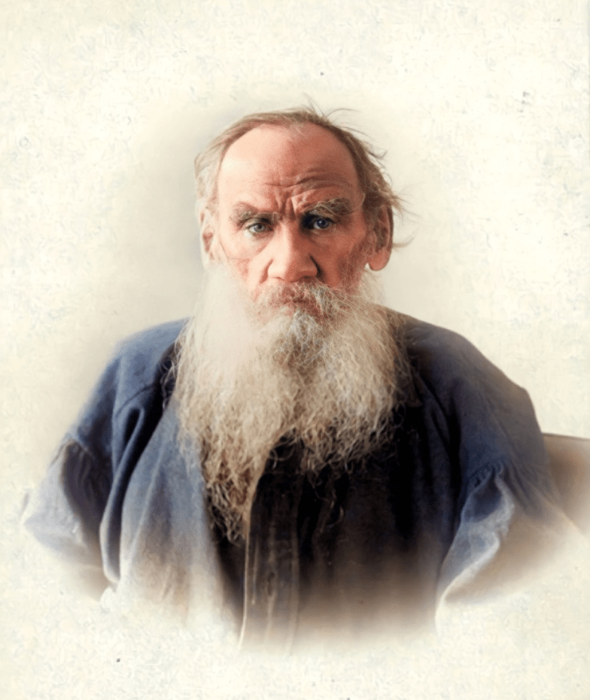

After The Dance, Leo Tolstoy

After The Dance (After the Ball)

"--AND you say that a man cannot, of himself, understand what is good and evil; that it is all environment, that the environment swamps the man. But I believe it is all chance. Take my own case . . ."

Thus spoke our excellent friend, Ivan Vasilievich, after a conversation between us on the impossibility of improving individual character without a change of the conditions under which men live. Nobody had actually said that one could not of oneself understand good and evil; but it was a habit of Ivan Vasilievich to answer in this way the thoughts aroused in his own mind by conversation, and to illustrate those thoughts by relating incidents in his own life. He often quite forgot the reason for his story in telling it; but he always told it with great sincerity and feeling.

He did so now.

"Take my own case. My whole life was moulded, not by environment, but by something quite different."

"By what, then?" we asked.

"Oh, that is a long story. I should have to tell you about a great many things to make you understand."

"Well, tell us then."

Ivan Vasilievich thought a little, and shook his head.

"My whole life," he said, "was changed in one night, or, rather, morning."

"Why, what happened?" one of us asked.

"What happened was that I was very much in love. I have been in love many times, but this was the most serious of all. It is a thing of the past; she has married daughters now. It was Varinka B----." Ivan Vasilievich mentioned her surname. "Even at fifty she is remarkably handsome; but in her youth, at eighteen, she was exquisite--tall, slender, graceful, and stately. Yes, stately is the word; she held herself very erect, by instinct as it were; and carried her head high, and that together with her beauty and height gave her a queenly air in spite of being thin, even bony one might say. It might indeed have been deterring had it not been for her smile, which was always gay and cordial, and for the charming light in her eyes and for her youthful sweetness."

"What an entrancing description you give, Ivan Vasilievich!"

"Description, indeed! I could not possibly describe her so that you could appreciate her. But that does not matter; what I am going to tell you happened in the forties. I was at that time a student in a provincial university. I don't know whether it was a good thing or no, but we had no political clubs, no theories in our universities then. We were simply young and spent our time as young men do, studying and amusing ourselves. I was a very gay, lively, careless fellow, and had plenty of money too. I had a fine horse, and used to go tobogganing with the young ladies. Skating had not yet come into fashion. I went to drinking parties with my comrades--in those days we drank nothing but champagne--if we had no champagne we drank nothing at all. We never drank vodka, as they do now. Evening parties and balls were my favourite amusements. I danced well, and was not an ugly fellow."

"Come, there is no need to be modest," interrupted a lady near him. "We have seen your photograph. Not ugly, indeed! You were a handsome fellow."

"Handsome, if you like. That does not matter. When my love for her was at its strongest, on the last day of the carnival, I was at a ball at the provincial marshal's, a good-natured old man, rich and hospitable, and a court chamberlain. The guests were welcomed by his wife, who was as good-natured as himself. She was dressed in puce-coloured velvet, and had a diamond diadem on her forehead, and her plump, old white shoulders and bosom were bare like the portraits of Empress Elizabeth, the daughter of Peter the Great.

"It was a delightful ball. It was a splendid room, with a gallery for the orchestra, which was famous at the time, and consisted of serfs belonging to a musical landowner. The refreshments were magnificent, and the champagne flowed in rivers. Though I was fond of champagne I did not drink that night, because without it I was drunk with love. But I made up for it by dancing waltzes and polkas till I was ready to drop--of course, whenever possible, with Varinka.

She wore a white dress with a pink sash, white shoes, and white kid gloves, which did not quite reach to her thin pointed elbows. A disgusting engineer named Anisimov robbed me of the mazurka with her--to this day I cannot forgive him. He asked her for the dance the minute she arrived, while I had driven to the hair-dresser's to get a pair of gloves, and was late. So I did not dance the mazurka with her, but with a German girl to whom I had previously paid a little attention; but I am afraid I did not behave very politely to her that evening.

I hardly spoke or looked at her, and saw nothing but the tall, slender figure in a white dress, with a pink sash, a flushed, beaming, dimpled face, and sweet, kind eyes. I was not alone; they were all looking at her with admiration, the men and women alike, although she outshone all of them. They could not help admiring her.

"Although I was not nominally her partner for the mazurka, I did as a matter of fact dance nearly the whole time with her. She always came forward boldly the whole length of the room to pick me out. I flew to meet her without waiting to be chosen, and she thanked me with a smile for my intuition. When I was brought up to her with somebody else, and she guessed wrongly, she took the other man's hand with a shrug of her slim shoulders, and smiled at me regretfully.

"Whenever there was a waltz figure in the mazurka, I waltzed with her for a long time, and breathing fast and smiling, she would say, 'Encore'; and I went on waltzing and waltzing, as though unconscious of any bodily existence."

"Come now, how could you be unconscious of it with your arm round her waist? You must have been conscious, not only of your own existence, but of hers," said one of the party.

Ivan Vasilievich cried out, almost shouting in anger: "There you are, moderns all over! Nowadays you think of nothing but the body. It was different in our day. The more I was in love the less corporeal was she in my eyes. Nowadays you think of nothing but the body. It was different in our day. The more I was in love the less corporeal was she in my eyes. Nowadays you set legs, ankles, and I don't know what. You undress the women you are in love with. In my eyes, as Alphonse Karr said--and he was a good writer--' the one I loved was always draped in robes of bronze.' We never thought of doing so; we tried to veil her nakedness, like Noah's good-natured son. Oh, well, you can't understand."

"Don't pay any attention to him. Go on," said one of them.

"Well, I danced for the most part with her, and did not notice how time was passing. The musicians kept playing the same mazurka tunes over and over again in desperate exhaustion--you know what it is towards the end of a ball. Papas and mammas were already getting up from the card-tables in the drawing-room in expectation of supper, the men-servants were running to and fro bringing in things. It was nearly three o'clock. I had to make the most of the last minutes. I chose her again for the mazurka, and for the hundredth time we danced across the room.

"'The quadrille after supper is mine,' I said, taking her to her place.

"'Of course, if I am not carried off home,' she said, with a smile.

"'I won't give you up,' I said.

"'Give me my fan, anyhow,' she answered.

"'I am so sorry to part with it,' I said, handing her a cheap white fan.

"'Well, here's something to console you,' she said, plucking a feather out of the fan, and giving it to me.

"I took the feather, and could only express my rapture and gratitude with my eyes. I was not only pleased and gay, I was happy, delighted; I was good, I was not myself but some being not of this earth, knowing nothing of evil. I hid the feather in my glove, and stood there unable to tear myself away from her.

"'Look, they are urging father to dance,' she said to me, pointing to the tall, stately figure of her father, a colonel with silver epaulettes, who was standing in the doorway with some ladies.

"'Varinka, come here!' exclaimed our hostess, the lady with the diamond ferronniere and with shoulders like Elizabeth, in a loud voice.

"'Varinka went to the door, and I followed her.

"'Persuade your father to dance the mazurka with you, ma chere.--Do, please, Peter Valdislavovich,' she said, turning to the colonel.

"Varinka's father was a very handsome, well-preserved old man. He had a good colour, moustaches curled in the style of Nicolas I., and white whiskers which met the moustaches. His hair was combed on to his forehead, and a bright smile, like his daughter's, was on his lips and in his eyes. He was splendidly set up, with a broad military chest, on which he wore some decorations, and he had powerful shoulders and long slim legs. He was that ultra-military type produced by the discipline of Emperor Nicolas I.

"When we approached the door the colonel was just refusing to dance, saying that he had quite forgotten how; but at that instant he smiled, swung his arm gracefully around to the left, drew his sword from its sheath, handed it to an obliging young man who stood near, and smoothed his suede glove on his right hand.

"'Everything must be done according to rule,' he said with a smile. He took the hand of his daughter, and stood one-quarter turned, waiting for the music.

"At the first sound of the mazurka, he stamped one foot smartly, threw the other forward, and, at first slowly and smoothly, then buoyantly and impetuously, with stamping of feet and clicking of boots, his tall, imposing figure moved the length of the room. Varinka swayed gracefully beside him, rhythmically and easily, making her steps short or long, with her little feet in their white satin slippers.

"All the people in the room followed every movement of the couple. As for me I not only admired, I regarded them with enraptured sympathy. I was particularly impressed with the old gentleman's boots. They were not the modern pointed affairs, but were made of cheap leather, squared-toed, and evidently built by the regimental cobbler. In order that his daughter might dress and go out in society, he did not buy fashionable boots, but wore home-made ones, I thought, and his square toes seemed to me most touching.

It was obvious that in his time he had been a good dancer; but now he was too heavy, and his legs had not spring enough for all the beautiful steps he tried to take. Still, he contrived to go twice round the room. When at the end, standing with legs apart, he suddenly clicked his feet together and fell on one knee, a bit heavily, and she danced gracefully around him, smiling and adjusting her skirt, the whole room applauded.

"Rising with an effort, he tenderly took his daughter's face between his hands. He kissed her on the forehead, and brought her to me, under the impression that I was her partner for the mazurka. I said I was not. 'Well, never mind. just go around the room once with her,' he said, smiling kindly, as he replaced his sword in the sheath.

"As the contents of a bottle flow readily when the first drop has been poured, so my love for Varinka seemed to set free the whole force of loving within me. In surrounding her it embraced the world. I loved the hostess with her diadem and her shoulders like Elizabeth, and her husband and her guests and her footmen, and even the engineer Anisimov who felt peevish towards me. As for Varinka's father, with his home-made boots and his kind smile, so like her own, I felt a sort of tenderness for him that was almost rapture.

"After supper I danced the promised quadrille with her, and though I had been infinitely happy before, I grew still happier every moment.

"We did not speak of love. I neither asked myself nor her whether she loved me. It was quite enough to know that I loved her. And I had only one fear--that something might come to interfere with my great joy.

"When I went home, and began to undress for the night, I found it quite out of the question. held the little feather out of her fan in my hand, and one of her gloves which she gave me when I helped her into the carriage after her mother. Looking at these things, and without closing my eyes I could see her before me as she was for an instant when she had to choose between two partners. She tried to guess what kind of person was represented in me, and I could hear her sweet voice as she said, 'Pride--am I right?' and merrily gave me her hand. At supper she took the first sip from my glass of champagne, looking at me over the rim with her caressing glance. But, plainest of all, I could see her as she danced with her father, gliding along beside him, and looking at the admiring observers with pride and happiness.

"He and she were united in my mind in one rush of pathetic tenderness.

"I was living then with my brother, who has since died. He disliked going out, and never went to dances; and besides, he was busy preparing for his last university examinations, and was leading a very regular life. He was asleep. I looked at him, his head buried in the pillow and half covered with the quilt; and I affectionately pitied him, pitied him for his ignorance of the bliss I was experiencing.

Our serf Petrusha had met me with a candle, ready to undress me, but I sent him away. His sleepy face and tousled hair seemed to me so touching. Trying not to make a noise, I went to my room on tiptoe and sat down on my bed. No, I was too happy; I could not sleep. Besides, it was too hot in the rooms. Without taking off my uniform, I went quietly into the hall, put on my overcoat, opened the front door and stepped out into the street.

"It was after four when I had left the ball; going home and stopping there a while had occupied two hours, so by the time I went out it was dawn. It was regular carnival weather--foggy, and the road full of water-soaked snow just melting, and water dripping from the eaves. Varinka's family lived on the edge of town near a large field, one end of which was a parade ground: at the other end was a boarding-school for young ladies.

I passed through our empty little street and came to the main thoroughfare, where I met pedestrians and sledges laden with wood, the runners grating the road. The horses swung with regular paces beneath their shining yokes, their backs covered with straw mats and their heads wet with rain; while the drivers, in enormous boots, splashed through the mud beside the sledges. All this, the very horses themselves, seemed to me stimulating and fascinating, full of suggestion.

"When I approached the field near their house, I saw at one end of it, in the direction of the parade ground, something very huge and black, and I heard sounds of fife and drum proceeding from it. My heart had been full of song, and I had heard in imagination the tune of the mazurka, but this was very harsh music. It was not pleasant.

"'What can that be?' I thought, and went towards the sound by a slippery path through the centre of the field. Walking about a hundred paces, I began to distinguish many black objects through the mist. They were evidently soldiers. 'It is probably a drill,' I thought.

"So I went along in that direction in company with a blacksmith, who wore a dirty coat and an apron, and was carrying something. He walked ahead of me as we approached the place. The soldiers in black uniforms stood in two rows, facing each other motionless, their guns at rest. Behind them stood the fifes and drums, incessantly repeating the same unpleasant tune.

"'What are they doing?' I asked the blacksmith, who halted at my side.

"'A Tartar is being beaten through the ranks for his attempt to desert,' said the blacksmith in an angry tone, as he looked intently at the far end of the line.

"I looked in the same direction, and saw between the files something horrid approaching me. The thing that approached was a man, stripped to the waist, fastened with cords to the guns of two soldiers who were leading him. At his side an officer in overcoat and cap was walking, whose figure had a familiar look. The victim advanced under the blows that rained upon him from both sides, his whole body plunging, his feet dragging through the snow. Now he threw himself backward, and the subalterns who led him thrust him forward. Now he fell forward, and they pulled him up short; while ever at his side marched the tall officer, with firm and nervous pace. It was Varinka's father, with his rosy face and white moustache.

"At each stroke the man, as if amazed, turned his face, grimacing with pain, towards the side whence the blow came, and showing his white teeth repeated the same words over and over. But I could only hear what the words were when he came quite near. He did not speak them, he sobbed them out,--"'Brothers, have mercy on me! Brothers, have mercy on me!' But the brothers had, no mercy, and when the procession came close to me, I saw how a soldier who stood opposite me took a firm step forward and lifting his stick with a whirr, brought it down upon the man's back.

The man plunged forward, but the subalterns pulled him back, and another blow came down from the other side, then from this side and then from the other. The colonel marched beside him, and looking now at his feet and now at the man, inhaled the air, puffed out his cheeks, and breathed it out between his protruded lips. When they passed the place where I stood, I caught a glimpse between the two files of the back of the man that was being punished. It was something so many-coloured, wet, red, unnatural, that I could hardly believe it was a human body.

"'My God!"' muttered the blacksmith.

The procession moved farther away. The blows continued to rain upon the writhing, falling creature; the fifes shrilled and the drums beat, and the tall imposing figure of the colonel moved along-side the man, just as before. Then, suddenly, the colonel stopped, and rapidly approached a man in the ranks.

"'I'll teach you to hit him gently,' I heard his furious voice say. 'Will you pat him like that? Will you?' and I saw how his strong hand in the suede glove struck the weak, bloodless, terrified soldier for not bringing down his stick with sufficient strength on the red neck of the Tartar.

"'Bring new sticks!' he cried, and looking round, he saw me. Assuming an air of not knowing me, and with a ferocious, angry frown, he hastily turned away. I felt so utterly ashamed that I didn't know where to look. It was as if I had been detected in a disgraceful act. I dropped my eyes, and quickly hurried home.

All the way I had the drums beating and the fifes whistling in my ears. And I heard the words, 'Brothers, have mercy on me!' or 'Will you pat him? Will you?' My heart was full of physical disgust that was almost sickness. So much so that I halted several times on my way, for I had the feeling that I was going to be really sick from all the horrors that possessed me at that sight. I do not remember how I got home and got to bed. But the moment I was about to fall asleep I heard and saw again all that had happened, and I sprang up.

"'Evidently he knows something I do not know,' I thought about the colonel. 'If I knew what he knows I should certainly grasp--understand--what I have just seen, and it would not cause me such suffering.'

"But however much I thought about it, I could not understand the thing that the colonel knew. It was evening before I could get to sleep, and then only after calling on a friend and drinking till I; was quite drunk.

"Do you think I had come to the conclusion that the deed I had witnessed was wicked? Oh, no. Since it was done with such assurance, and was recognised by every one as indispensable, they doubtless knew something which I did not know. So I thought, and tried to understand. But no matter, I could never understand it, then or afterwards. And not being able to grasp it, I could not enter the service as I had intended. I don't mean only the military service: I did not enter the Civil Service either. And so I have been of no use whatever, as you can see."

"Yes, we know how useless you've been," said one of us. "Tell us, rather, how many people would be of any use at all if it hadn't been for you."

"Oh, that's utter nonsense," said Ivan Vasilievich, with genuine annoyance.

"Well; and what about the love affair?

"My love? It decreased from that day. When, as often happened, she looked dreamy and meditative, I instantly recollected the colonel on the parade ground, and I felt so awkward and uncomfortable that I began to see her less frequently. So my love came to naught. Yes; such chances arise, and they alter and direct a man's whole life," he said in summing up. "And you say . . ."

The End