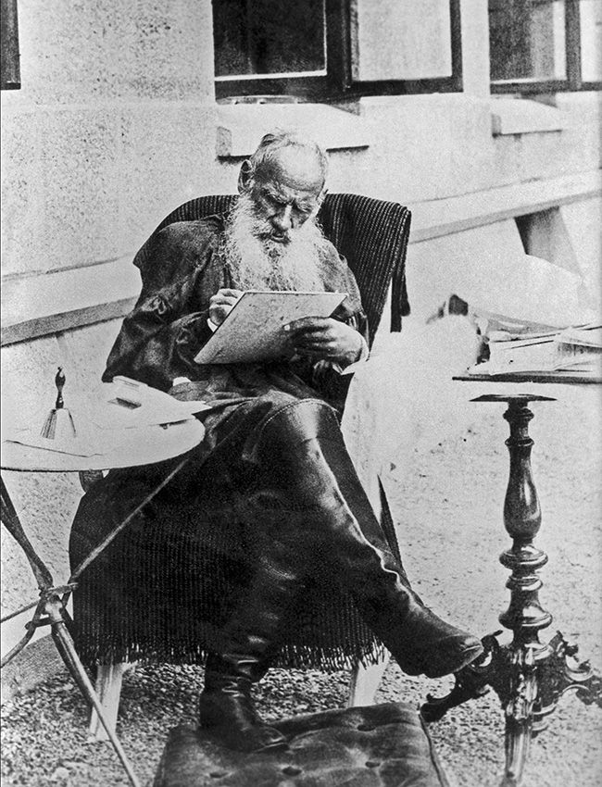

Esarhaddon, King Of Assyria, Leo Tolstoy

Esarhaddon, King Of Assyria

Translated by Louise and Aylmer Maude 1906

ASSYRIAN KING, ESARHADDON, had conquered the kingdom of King Lailie, had destroyed and burnt the towns, taken all the inhabitants captive to his own country, slaughtered the warriors, beheaded some chieftains and impaled or flayed others, and had confined King Lailie himself in a cage.

As he lay on his bed one night, King Esarhaddon was thinking how he should execute Lailie, when suddenly he heard a rustling near his bed, and opening his eyes saw an old man with a long gray beard and mild eyes.

‘You wish to execute Lailie?’ asked the old man.

‘Yes,’ answered the King. ‘But I cannot make up my mind how to do it.’

‘But you are Lailie,’ said the old man.

‘That’s not true,’ replied the King. ‘Lailie is Lailie, and I am I.’

‘You and Lailie are one,’ said the old man. ‘You only imagine you are not Lailie, and that Lailie is not you.’

‘What do you mean by that?’ said the King. ‘Here am I, lying on a soft bed; around me are obedient men-slaves and women-slaves, and to-morrow I shall feast with my friends as I did to-day; whereas Lailie is sitting like a bird in a cage, and to-morrow he will be impaled, and with his tongue hanging out will struggle till he dies, and his body will be torn in pieces by dogs.’

‘You cannot destroy his life,’ said the old man.

‘And how about the fourteen thousand warriors I killed, with whose bodies I built a mound?’ said the King. ‘I am alive, but they no longer exist. Does not that prove that I can destroy life?’

‘How do you know they no longer exist?’

‘Because I no longer see them. And, above all, they were tormented, but I was not. It was ill for them, but well for me.’

‘That, also, only seems so to you. You tortured yourself, but not them.’

‘I do not understand,’ said the King.

‘Do you wish to understand?’

‘Yes, I do.’

‘Then come here,’ said the old man, pointing to a large font full of water.

The King rose and approached the font.

‘Strip, and enter the font.’

Esarhaddon did as the old man bade him.

‘As soon as I begin to pour this water over you,’ said the old man, filling a pitcher with the water, ‘dip down your head.’

The old man tilted the pitcher over the King’s head and the King bent his head till it was under water.

And as soon as King Esarhaddon was under the water he felt that he was no longer Esarhaddon, but some one else. And, feeling himself to be that other man, he saw himself lying on a rich bed, beside a beautiful woman. He had never seen her before, but he knew she was his wife. The woman raised herself and said to him:

‘Dear husband, Lailie! You were wearied by yesterday’s work and have slept longer than usual, and I have guarded your rest, and have not roused you. But now the Princes await you in the Great Hall. Dress and go out to them.’

And Esarhaddon — understanding from these words that he was Lailie, and not feeling at all surprised at this, but only wondering that he did not know it before — rose, dressed, and went into the Great Hall where the Princes awaited him.

The Princes greeted Lailie, their King, bowing to the ground, and then they rose, and at his word sat down before him; and the eldest of the Princes began to speak, saying that it was impossible longer to endure the insults of the wicked King Esarhaddon, and that they must make war on him. But Lailie disagreed, and gave orders that envoys shall be sent to remonstrate with King Esarhaddon; and he dismissed the Princes from the audience.

Afterwards he appointed men of note to act as ambassadors, and impressed on them what they were to say to King Esarhaddon. Having finished this business, Esarhaddon-feeling himself to be Lailie-rode out to hunt wild asses. The hunt was successful. He killed two wild asses himself, and having returned home, feasted with his friends, and witnessed a dance of slave girls.

The next day he went to the Court, where he was awaited by petitioners, suitors, and prisoners brought for trial; and there as usual he decided the cases submitted to him. Having finished this business, he again rode out to his favourite amusement: the hunt. And again he was successful: this time killing with his own hand an old lioness, and capturing her two cubs. After the hunt he again feasted with his friends, and was entertained with music and dances, and the night he spent with the wife whom he loved.

So, dividing his time between kingly duties and pleasures, he lived for days and weeks, awaiting the return of the ambassadors he had sent to that King Esarhaddon who used to be himself. Not till a month had passed did the ambassadors return, and they returned with their noses and ears cut off.

King Esarhaddon had ordered them to tell Lailie that what had been done to them — the ambassadors — would be done to King Lailie himself also, unless he sent immediately a tribute of silver, gold, and cypress-wood, and came himself to pay homage to King Esarhaddon.

Lailie, formerly Esarhaddon, again assembled the Princes, and took counsel with them as to what he should do. They all with one accord said that war must be made against Esarhaddon, without waiting for him to attack them. The King agreed; and taking his place at the head of the army, started on the campaign. The campaign lasts seven days. Each day the King rode round the army to rouse the courage of his warriors.

On the eighth day his army met that of Esarhaddon in a broad valley through which a river flowed. Lailie’s army fought bravely, but Lailie, formerly Esarhaddon, saw the enemy swarming down from the mountains like ants, over-running the valley and overwhelming his army; and, in his chariot, he flung himself into the midst of the battle, hewing and felling the enemy. But the warriors of Lailie were but as hundreds, while those of Esarhaddon were as thousands; and Lailie felt himself wounded and taken prisoner. Nine days he journeyed with other captives, bound, and guarded by the warriors of Esarhaddon.

On the tenth day he reached Nineveh, and was placed in a cage. Lailie suffered not so much from hunger and from his wound as from shame and impotent rage. He felt how powerless he was to avenge himself on his enemy for all he was suffering. All he could do was to deprive his enemies of the pleasure of seeing his sufferings; and he firmly resolved to endure courageously without a murmur, all they could do to him. For twenty days he sat in his cage, awaiting execution.

He saw his relatives and friends led out to death; he heard the groans of those who were executed: some had their hands and feet cut off, others were flayed alive, but he showed neither disquietude, nor pity, nor fear. He saw the wife he loved, bound, and led by two black eunuchs. He knew she was being taken as a slave to Esarhaddon. That, too, he bore without a murmur.

But one of the guards placed to watch him said, ‘I pity you, Lailie; you were a king, but what are you now?’ And hearing these words, Lailie remembered all he had lost. He clutched the bars of his cage, and, wishing to kill himself, beat his head against them. But he had not the strength to do so and, groaning in despair, he fell upon the floor of his cage.

At last two executioners opened his cage door, and having strapped his arms tight behind him, led him to the place of execution, which was soaked with blood. Lailie saw a sharp stake dripping with blood, from which the corpse of one of his friends had just been torn, and he understood that this had been done that the stake might serve for his own execution. They stripped Lailie of his clothes. He was startled at the leanness of his once strong, handsome body. The two executioners seized that body by its lean thighs; they lifted him up and were about to let him fall upon the stake.

‘This is death, destruction!’ thought Lailie, and, forgetful of his resolve to remain bravely calm to the end, he sobbed and prayed for mercy. But no one listened to him.

‘But this cannot be,’ thought he. ‘Surely I am asleep. It is a dream.’ And he made an effort to rouse himself, and did indeed awake, to find himself neither Esarhaddon nor Lailie — but some kind of an animal. He was astonished that he was an animal, and astonished, also, at not having known this before.

He was grazing in a valley, tearing the tender grass with his teeth, and brushing away flies with his long tail. Around him was frolicking a long-legged, dark-gray ass-colt, striped down its back. Kicking up its hind legs, the colt galloped full speed to Esarhaddon, and poking him under the stomach with its smooth little muzzle, searched for the teat, and, finding it, quieted down, swallowing regularly. Esarhaddon understood that he was a she-ass, the colt’s mother, and this neither surprised nor grieved him, but rather gave him pleasure. He experienced a glad feeling of simultaneous life in himself and in his offspring.

But suddenly something flew near with a whistling sound and hit him in the side, and with its sharp point entered his skin and flesh. Feeling a burning pain, Esarhaddon — who was at the same time the ass — tore the udder from the colt’s teeth, and laying back his ears galloped to the herd from which he had strayed. The colt kept up with him, galloping by his side. They had already nearly reached the herd, which had started off, when another arrow in full flight struck the colt’s neck. It pierced the skin and quivered in its flesh. The colt sobbed piteously and fell upon its knees. Esarhaddon could not abandon it, and remained standing over it. The colt rose, tottered on its long, thin legs, and again fell. A fearful two-legged being-a man-ran up and cut its throat.

‘This cannot be; it is still a dream! thought Esarhaddon, and made a last effort to awake. ‘Surely I am not Lailie, nor the ass, but Esarhaddon!’

He cried out, and at the same instant lifted his head out of the font...The old man was standing by him, pouring over his head the last drops from the pitcher.

‘Oh, how terribly I have suffered! And for how long!’ said Esarhaddon.

‘Long?’ replied the old man, ‘you have only dipped your head under water and lifted it again; see, the water is not yet all out of the pitcher. Do you now understand?’

Esarhaddon did not reply, but only looked at the old man with terror.

‘Do you now understand,’ continued the old man, ‘that Lailie is you, and the warriors you put to death were you also? And not the warriors only, but the animals which you slew when hunting and ate at your feasts were also you. You thought life dwelt in you alone but I have drawn aside the veil of delusion, and have let you see that by doing evil to others you have done it to yourself also. Life is one in them all, and yours is but a portion of this same common life. And only in that one Part of life that is yours, can you make life better or worse-increasing or decreasing it.

‘You can only improve life in yourself by destroying the barriers that divide your life from that of others, and by considering others as yourself, and loving them. By so doing you increase your share of life. You injure your life when you think of it as the only life, and try to add to its welfare at the expense of other lives. By so doing you only lessen it. To destroy the life that dwells in others is beyond your power.

The life of those you have slain has vanished from your eyes, but is not destroyed. You thought to lengthen your own life and to shorten theirs, but you cannot do this. Life knows neither time nor space. The life of a moment, and the life of a thousand years: your life and the life of all the visible and invisible beings in the world, are equal. To destroy life, or to alter it, is impossible; for life is the one thing that exists. All else, but seems to us to be.’

Having said this the old man vanished.

Next morning King Esarhaddon gave orders that Lailie and all the prisoners should be set at liberty and that the executions should cease.

On the third day he called his son Assur-bani-pal, and gave the kingdom over into his hands; and he himself went into the desert to think over all he had learnt. Afterwards he went about as a wanderer through the towns and villages, preaching to the people that all life is one, and that when men wish to harm others, they really do evil to themselves.

The End