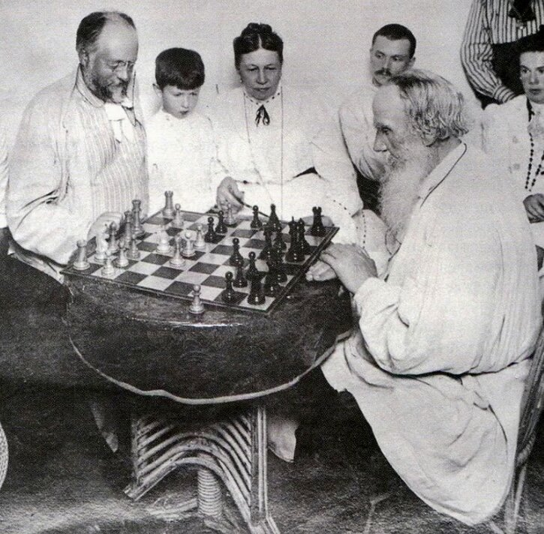

Evil Allures, But Good Endures, Leo Tolstoy

Evil Allures, But Good Endures

Translated by Louise and Aylmer Maude 1906

THERE LIVED IN olden times a good and kindly man. He had this world’s goods in abundance, and many slaves to serve him. And the slaves prided themselves on their master, saying:

‘There is no better lord than ours under the sun.

He feeds and clothes us well, and gives us work suited to our strength. He bears no malice and never speaks a harsh word to any one. He is not like other masters, who treat their slaves worse than cattle: punishing them whether they deserve it or not, and never giving them a friendly word. He wishes us well, does good, and speaks kindly to us. We do not wish for a better life.’

Thus the slaves praised their lord, and the Devil, seeing it, was vexed that slaves should live in such love and harmony with their master. So getting one of them, whose name was Aleb, into his power, the Devil ordered him to tempt the other slaves. And one day, when they were all sitting together resting and talking of their master’s goodness, Aleb raised his voice, and said:

‘It is stupid to make so much of our master’s goodness. The Devil himself would be kind to you, if you did what he wanted. We serve our master well, and humour him in all things. As soon as he thinks of anything, we do it: foreseeing all his wishes. What can he do but be kind to us? Just try how it will be if, instead of humouring him, we do him some harm instead. He will act like any one else, and will repay evil for evil, as the worst of masters do.

The other slaves began denying what Aleb had said and at last bet with him. Aleb undertook to make their master angry. If he failed, he was to lose his holiday garment; but if he succeeded, the other slaves were to give him theirs. Moreover, they promised to defend him against the master, and to set him free if he should be put in chains or imprisoned. Having arranged this bet, Aleb agreed to make his master angry next morning.

Aleb was a shepherd, and had in his charge a number of valuable, pure-bred sheep, of which his master was very fond. Next morning, when the master brought some visitors into the inclosure to show them the valuable sheep, Aleb winked at his companions, as if to say:

‘See, now, how angry I will make him.’

All the other slaves assembled, looking in at the gates or over the fence, and the Devil climbed a tree near by to see how his servant would do his work. The master walked about the inclosure, showing his guests the ewes and lambs, and presently he wished to show them his finest ram.

‘All the rams are valuable,’ said he, ‘but I have one with closely twisted horns, which is priceless. I prize him as the apple of my eye.’

Startled by the strangers, the sheep rushed about the inclosure, so that the visitors could not get a good look at the ram. As soon as it stood still, Aleb startled the sheep as if by accident, and they all got mixed up again. The visitors could not make out which was the priceless ram. At last the master got tired of it.

‘Aleb, dear friend,’ he said, ‘pray catch our best ram for me, the one with the tightly twisted horns. Catch him very carefully, and hold him still for a moment.’

Scarcely had the master said this, when Aleb rushed in among the sheep like a lion, and clutched the priceless ram. Holding him fast by the wool, he seized the left hind leg with one hand, and, before his master’s eyes, lifted it and jerked it so that it snapped like a dry branch. He had broken the ram’s leg and it fell bleating on to its knees. Then Aleb seized the right hind leg, while the left twisted round and hung quite limp. The visitors and the slaves exclaimed in dismay, and the Devil, sitting up in the tree, rejoiced that Aleb had done his task so cleverly. The master looked as black as thunder, frowned, bent his head, and did not say a word. The visitors and the slaves were silent, too, waiting to see what would follow. After remaining silent for a while, the master shook himself as if to throw off some burden.

Then he lifted his head, and raising his eyes heavenward, remained so for a short time. Presently the wrinkles passed from his face, and he looked down at Aleb with a smile saying:

‘Oh, Aleb, Aleb! Your master bade you anger me; but my master is stronger than yours. I am not angry with you, but I will make your master angry. You are afraid that I shall punish you, and you have been wishing for your freedom. Know, then, Aleb, that I shall not punish you; but, as you wish to be free, here, before my guests, I set you free. Go where you like, and take your holiday garment with you!’

And the kind master returned with his guests to the house; but the Devil, grinding his teeth, fell down from the tree, and sank through the ground.

The End