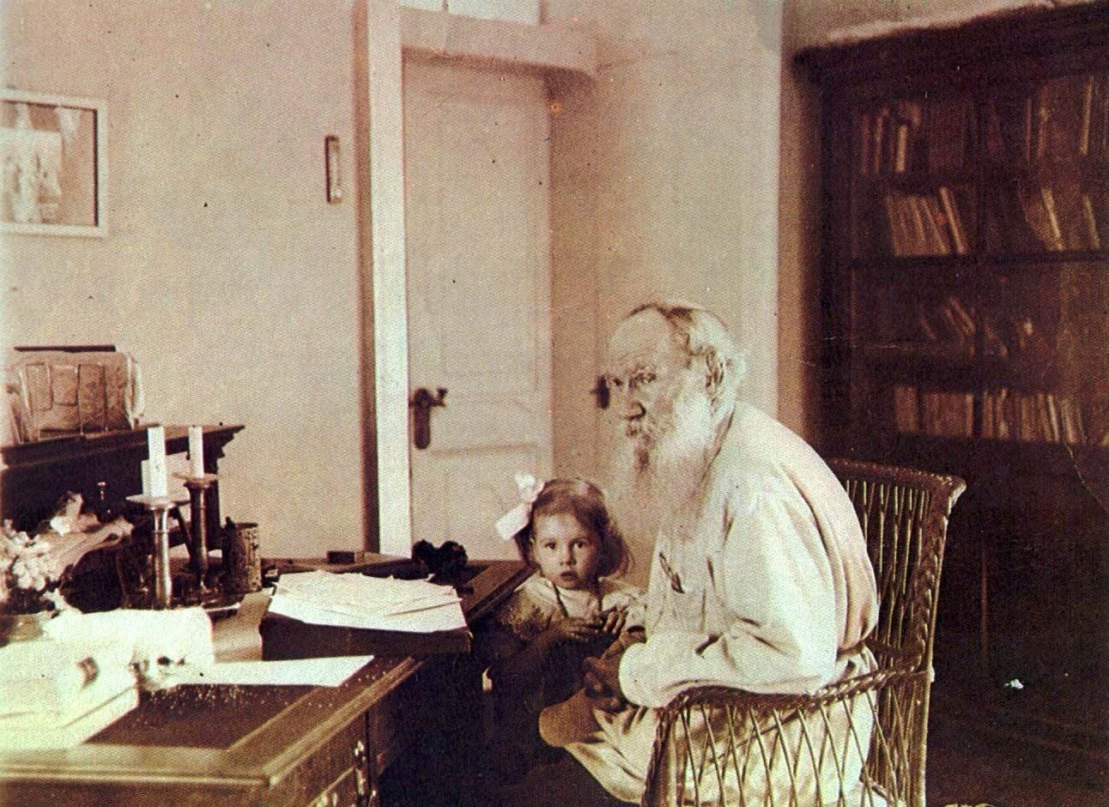

How The Little Devil Earned The Crust Of Bread, Leo Tolstoy

How The Little Devil Earned The Crust Of Bread Or Promoting The Devil

Translated by N. and A. C. Fifield 1910

A poor peasant went out to plough his field one morning, before breakfast, taking with him a crust of bread. He tipped the plough over took out the bar, and laid it under a bush with the crust, and spread his coat over all.

Presently the peasant got hungry, and the horse was tired. So he stuck the plough into the ground, unharnessed the horse and let her loose to graze, and went to the bush to have a bite and rest awhile. He lifted the coat: the crust had gone! He looked and looked, rummaged in the coat, shook it still no crust ! The peasant wondered. “ That’s strange,” he said; “ 1 saw no one, yet someone must have taken the bread.”

It was a little Devil who had taken the crust while the peasant was ploughing, and he now sat behind the bush to listen how the peasant would swear and call on his the devil’s name.

The peasant was sorry.

“ Oh, well,” he said; “ I shan’t die of hunger ! I suppose whoever took it was in need of it. Let him eat it, and may it give him health!”

And the peasant went to the well, drank some water, rested, caught the horse, harnessed her, and set to work again.

The little devil was disappointed that he had not led the peasant into sin, and he went to tell it to the big devil.

He came to the big devil and told how he had stolen the bread, and how the peasant instead of swearing, had wished him good health.

The big devil was very angry.

If the peasant has had the best of you in this matter,”

he said, “ it’s your own fault : you were a fool about it. If the peasants and then their women get into that sort of habit, we shall have nothing left to live by. The matter can’t be left like this ! Go to that peasant again, and earn your crust. If in three years you haven’t got the better of the peasant, I’ll throw you into holy water ! “

The little devil was frightened, and ran out on to the earth thinking how to redeem his error. He thought and thought, and at last found it.

He turned himself into a workman and hired himself out to the poor peasant. The following year was a dry summer, and the little devil told the peasant to sow his corn en marshy ground. All the other peasants’ corn was burned up by the sun; but the poor peasant’s corn grew tall and thick and full-eared.

The peasant lived on it till the next harvest and still had a lot left. Next summer the little devil told the peasant to sow his corn on the moun-tain. The summer was a rainy one : all the corn was beaten down, and rotted, and the grains died, but the peasant’s crops on the mountain side were splendid.

He had still more extra corn now, and didn’t know what to do with it.

And the little devil taught the peasant how to crush the grain and to make whisky out of it. And the peasant began to make whisky, to drink it himself, and to give it to others.

The little devil went to the big devil and began to boast that he had earned the crust. The big devil went to see.

He came to the peasant’s house and saw that the peasant had some guests and was treating them with whisky. His wife poured it out, but just as she. was about to carry it round she tripped against the table and let a glass fall.

The peasant was furious and shouted at her. “ You devil’s fool 1 “ he said; “ can’t you take care, you idiot, and not pour the spirit on the floor as if it were dirty water ! “

The little devil nudged the big one with his elbow, and said : “ What do you think he would do now if someone stole his crust? “

When the peasant had finished swearing, he began to carry the spirit round himself. Soon a poor peasant re-turning from his day’s work came in uninvited, and sat down. He saw the people drinking, and being very weary, he thought he would also like to have a drink. So he sat and sat, licking his lips, but the master didn’t offer him any, and only muttered under his breath : “ I don’t make whisky for all the vagrants that happen to want it.”

This pleased the big devil; but the little devil only boasted the more and said : “ You wait; you’ll see some more ! “

The rich peasants drank and the master drank also. Then they all began to toady to each other, and to flatter and speak oily and lying words to one another.

The big devil listened and listened, and praised the little devil. “ If,” said he, “ this drink can make them as full of lies and cunning as I have seen, then they are in our hands.

“Wait a bit,” said the little devil, “this is only the beginning; wait till they drink a little more. Now, like foxes, they are wagging their tails and trying to trick each other, but soon they’ll be as cruel as wolves.”

The peasants drank another glass each, and their talk grew louder and rougher. Instead of oily words, there was wrangling and curses, and soon they worked themselves into a fury and flew at eacb other and smashed each others noses in. The master also fought and got beaten.

The big devil looked on and was very pleased. “This is good,” he said.

But the little devil said : “ Wait a bit, there’s more to follow. Let them drink a little more. Now they rage like wolves, but soon they will wallow like swine.”

The peasants drank again, and soon were maudlin drunk. They shouted, and muttered they knew not what, unable to understand each other.

Presently they began to disperse and went slouching through the streets, alone or in twos and threes. The master went to see his guests off, but he fell into the if utter and lay covered with filth and grunting like a pig.

This pleased the big devil immensely. “ You have made a good drink,” he said, “ and you deserve your crust. Only tell me, what did you make it of? You must have mixed in it first the blood of the fox that was why they grew as cunning as foxes; then the blood of the wolf that was why they grew as cruel as wolves; then the blood of the swine that was why they grovelled like pigs.”

“ No,” said the little devil, “ I did none of those things. The only thing I did was to give him more bread than he needed. The blood of the beast is always in man but when he earns his bread with labour it hasn’t free scope. At first the man was willing to Part with his last crust, but when he began to have more bread than he needed, he began also to think how to provide for his pleasures. And I taught him a pleasure to drink whisky. And as soon as he began to turn God’s gift into spirit for his own pleasure, the blood of the fox and of the wolf and of the swine rose up within him. And as long as he continues to drink he will always remain a beast.”

The big devil praised the little devil and forgave him for losing the crust and appointed him chief among his servants.

The End