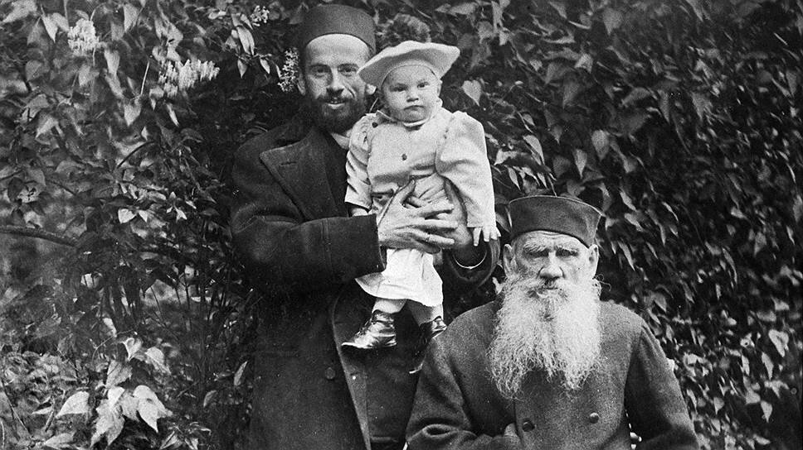

Ilyás, Leo Tolstoy

Ilyás

Translated by Louise and Aylmer Maude 1906

THERE ONCE LIVED, in the Government of Oufá a Bashkír named Ilyás. His father, who died a year after he had found his son a wife, did not leave him much property. Ilyás then had only seven mares, two cows, and about a score of sheep. He was a good manager, however, and soon began to acquire more. He and his wife worked from morn till night; rising earlier than others and going later to bed; and his possessions increased year by year. Living in this way, Ilyás little by little acquired great wealth. At the end of thirty-five years he had 200 horses, 150 head of cattle, and 1,200 sheep.

Hired labourers tended his flocks and herds, and hired women milked his mares and cows, and made kumiss (Kumiss (or more properly koumys) is a fermented drink prepared from mare’s milk), butter and cheese. Ilyás had abundance of everything, and every one in the district envied him. They said of him:

‘Ilyás is a fortunate man: he has plenty of everything. This world must be a pleasant place for him.’

People of position heard of Ilyás and sought his acquaintance. Visitors came to him from afar; and he welcomed every one, and gave them food and drink. Whoever might come, there was always kumiss, tea, sherbet, and mutton to set before them. Whenever visitors arrived a sheep would be killed, or sometimes two; and if many guests came he would even slaughter a mare for them.

Ilyás had three children: two sons and a daughter; and he married them all off. While he was poor, his sons worked with him, and looked after the flocks and herds themselves; but when he grew rich they got spoiled and one of them took to drink. The eldest was killed in a brawl; and the younger, who had married a self-willed woman, ceased to obey his father, and they could not live together any more.

So they Parted, and Ilyás gave his son a house and some of the cattle; and this diminished his wealth. Soon after that, a disease broke out among Ilyás’s sheep, and many died. Then followed a bad harvest, and the hay crop failed; and many cattle died that winter. Then the Kirghíz captured his best herd of horses; and Ilyás’s property dwindled away. It became smaller and smaller, while at the same time his strength grew less; till, by the time he was seventy years old, he had begun to sell his furs, carpets, saddles, and tents.

At last he had to Part with his remaining cattle, and found himself face to face with want. Before he knew how it had happened, he had lost everything, and in their old age he and his wife had to go into service. Ilyás had nothing left, except the clothes on his back, a fur cloak, a cup, his indoor shoes and overshoes, and his wife, Sham-Shemagi, who also was old by this time. The son who had Parted from him had gone into a far country, and his daughter was dead, so that there was no one to help the old couple.

Their neighbour, Muhammad-Shah, took pity on them. Muhammad-Shah was neither rich nor poor, but lived comfortably, and was a good man. He remembered Ilyás’s hospitality, and pitying him, said:

‘Come and live with me, Ilyás, you and your old woman. In summer you can work in my melon-garden as much as your strength allows, and in winter feed my cattle; and Sham-Shemagi shall milk my mares and make kumiss. I will feed and clothe you both. When you need anything, tell me, and you shall have it.’

Ilyás thanked his neighbour, and he and his wife took service with Muhammad-Shah as labourers. At first the position seemed hard to them, but they got used to it, and lived on, working as much as their strength allowed.

Muhammad-Shah found it was to his advantage to keep such people, because, having been masters themselves, they knew how to manage and were not lazy, but did all the work they could. Yet it grieved Muhammad-Shah to see people brought so low who had been of such high standing.

It happened once that some of Muhammad-Shah’s relatives came from a great distance to visit him, and a Mullah came too. Muhammad-Shah told Ilyás to catch a sheep and kill it. Ilyás skinned the sheep, and boiled it, and sent it in to the guests. The guests ate the mutton, had some tea, and then began drinking kumiss. As they were sitting with their host on down cushions on a carpet, conversing and sipping kumiss from their cups, Ilyás, having finished his work passed by the open door. Muhammad-Shah, seeing him pass, said to one of the guests:

‘Did you notice that old man who passed just now?’

‘Yes,’ said the visitor, ‘what is there remarkable about him?’

‘Only this — that he was once the richest man among us,’ replied the host. ‘His name is Ilyás. You may have heard of him.’

‘Of course I have heard of him,’ the guest answered ‘I never saw him before, but his fame has spread far and wide.’

‘Yes, and now he has nothing left,’ said Muhammad-Shah, ‘and he lives with me as my labourer, and his old woman is here too — she milks the mares.’

The guest was astonished: he clicked with his tongue, shook his head, and said:

‘Fortune turns like a wheel. One man it lifts, another it sets down! Does not the old man grieve over all he has lost?’

‘Who can tell. He lives quietly and peacefully, and works well.’

‘May I speak to him?’ asked the guest. ‘I should like to ask him about his life.’

‘Why not?’ replied the master, and he called from the kibítka (A kibitk is a movable dwelling, made up of detachable wooden frames, forming a round, and covered over with felt) in which they were sitting:

‘Babay;’ (which in the Bashkir tongue means ‘Grandfather ‘) ‘come in and have a cup of kumiss with us, and call your wife here also.’

Ilyás entered with his wife; and after exchanging greetings with his master and the guests, he repeated a prayer, and seated himself near the door. His wife passed in behind the curtain and sat down with her mistress.

A Cap of kumiss was handed to Ilyás; he wished the guests and his master good health, bowed, drank a little, and put down the cup.

‘Well, Daddy,’ said the guest who had wished to speak to him, ‘I suppose you feel rather sad at the sight of us. It must remind you of your former prosperity, and of your present sorrows.’

Ilyás smiled, and said:

‘If I were to tell you what is happiness and what is misfortune, you would not believe me. You had better ask my wife. She is a woman, and what is in her heart is on her tongue. She will tell you the whole truth.’

The guest turned towards the curtain.

‘Well, Granny,’ he cried, ‘tell me how your former happiness compares with your present misfortune.’

And Sham-Shemagi answered from behind the curtain:

‘This is what I think about it: My old man and I lived for fifty years seeking happiness and not finding it; and it is only now, these last two years, since we had nothing left and have lived as labourers, that we have found real happiness, and we wish for nothing better than our present lot.’

The guests were astonished, and so was the master; he even rose and drew the curtain back, so as to see the old woman’s face. There she stood with her arms folded, looking at her old husband, and smiling; and he smiled back at her. The old woman went on:

‘I speak the truth and do not jest. For half a century we sought for happiness, and as long as we were rich we never found it. Now that we have nothing left, and have taken service as labourers, we have found such happiness that we want nothing better.’

‘But in what does your happiness consist?’ asked the guest.

‘Why, in this,’ she replied, ‘when we were rich my husband and I had so many cares that we had no time to talk to one another, or to think of our souls, or to pray to God. Now we had visitors, and had to consider what food to set before them, and what presents to give them, lest they should speak ill of us. When they left, we had to look after our labourers who were always trying to shirk work and get the best food, while we wanted to get all we could out of them. So we sinned. Then we were in fear lest a wolf should kill a foal or a calf, or thieves steal our horses.

We lay awake at night, worrying lest the ewes should overlie their lambs, and we got up again and again to see that all was well. One thing attended to, another care would spring up: how, for instance, to get enough fodder for the winter. And besides that, my old man and I used to disagree. He would say we must do so and so, and I would differ from him; and then we disputed — sinning again. So we passed from one trouble to another, from one sin to another, and found no happiness.’

‘Well, and now?’

‘Now, when my husband and I wake in the morning, we always have a loving word for one another and we live peacefully, having nothing to quarrel about. We have no care but how best to serve our master. We work as much as our strength allows and do it with a will, that our master may not lose but profit by us. When we come in, dinner or supper is ready and there is kumiss to drink. We have fuel to burn when it is cold and we have our fur cloak. And we have time to talk, time to think of our souls, and time to pray. For fifty years we sought happiness, but only now at last have we found it.’

The guests laughed.

But Ilyás said:

‘Do not laugh, friends. It is not a matter for jesting — it is the truth of life. We also were foolish at first, and wept at the loss of our wealth; but now God has shown us the truth, and we tell it, not for our own consolation, but for your good.’

And the Mullah said:

‘That is a wise speech. Ilyás has spoken the exact truth. The same is said in Holy Writ.’

And the guests ceased laughing and became thoughtful.

The End