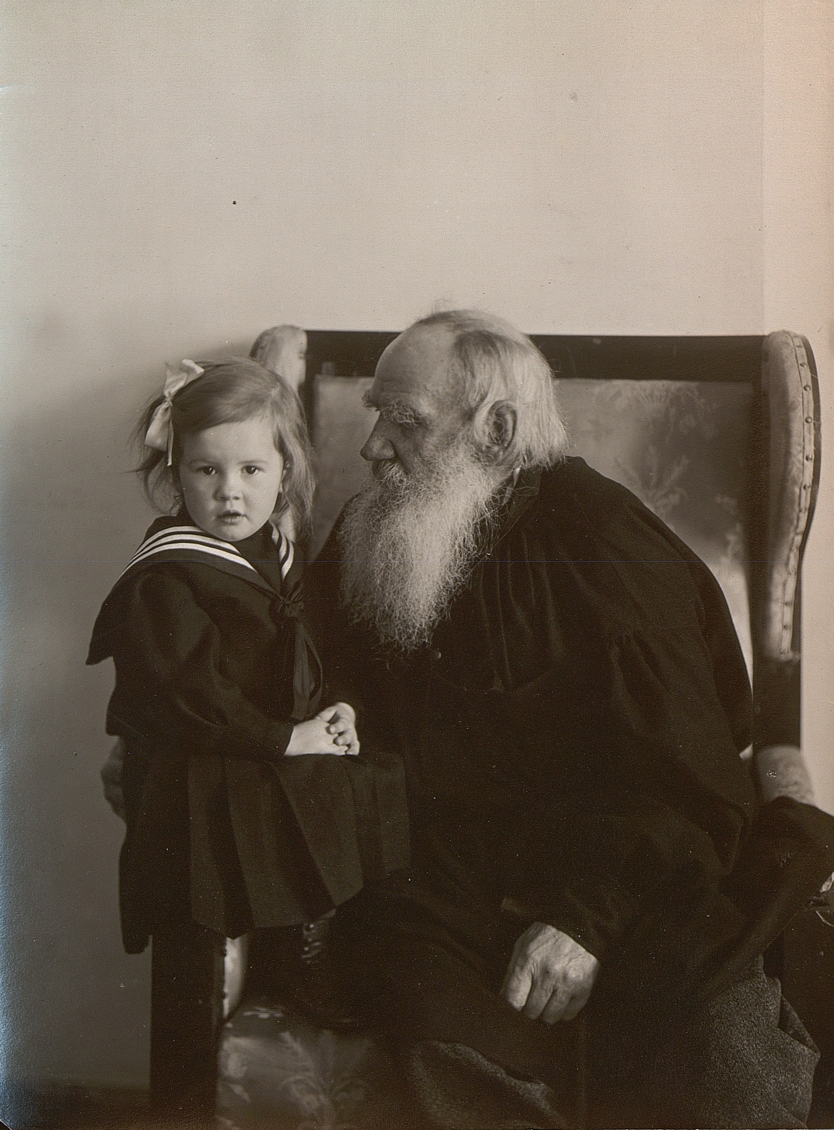

My Dream, Leo Tolstoy

My Dream

"As a daughter she no longer exists for me. Can't you understand? She simply doesn't exist. Still, I cannot possibly leave her to the charity of strangers. I will arrange things so that she can live as she pleases, but I do not wish to hear of her. Who would ever have thought . . . the horror of it, the horror of it."

He shrugged his shoulders, shook his head, and raised his eyes. These words were spoken by Prince Michael Ivanovich to his brother Peter, who was governor of a province in Central Russia. Prince Peter was a man of fifty, Michael's junior by ten years.

On discovering that his daughter, who had left his house a year before, had settled here with her child, the elder brother had come from St. Petersburg to the provincial town, where the above conversation took place.

Prince Michael Ivanovich was a tall, handsome, white-haired, fresh coloured man, proud and attractive in appearance and bearing. His family consisted of a vulgar, irritable wife, who wrangled with him continually over every petty detail, a son, a ne'er-do-well, spendthrift and roue--yet a "gentleman," according to his father's code, two daughters, of whom the elder had married well, and was living in St. Petersburg; and the younger, Lisa--his favourite, who had disappeared from home a year before. Only a short while ago he had found her with her child in this provincial town.

Prince Peter wanted to ask his brother how, and under what circumstances, Lisa had left home, and who could possibly be the father of her child. But he could not make up his mind to inquire.

That very morning, when his wife had attempted to condole with her brother-in-law, Prince Peter had observed a look of pain on his brother's face. The look had at once been masked by an expression of unapproachable pride, and he had begun to question her about their flat, and the price she paid. At luncheon, before the family and guests, he had been witty and sarcastic as usual. Towards every one, excepting the children, whom he treated with almost reverent tenderness, he adopted an attitude of distant hauteur. And yet it was so natural to him that every one somehow acknowledged his right to be haughty.

In the evening his brother arranged a game of whist. When he retired to the room which had been made ready for him, and was just beginning to take out his artificial teeth, some one tapped lightly on the door with two fingers.

"Who is that?"

"C'est moi, Michael."

Prince Michael Ivanovich recognised the voice of his sister-in-law, frowned, replaced his teeth, and said to himself, "What does she want?" Aloud he said, "Entrez."

His sister-in-law was a quiet, gentle creature, who bowed in submission to her husband's will. But to many she seemed a crank, and some did not hesitate to call her a fool. She was pretty, but her hair was always carelessly dressed, and she herself was untidy and absent-minded. She had, also, the strangest, most unaristocratic ideas, by no means fitting in the wife of a high official. These ideas she would express most unexpectedly, to everybody's astonishment, her husband's no less than her friends'.

"Fous pouvez me renvoyer, mais je ne m'en irai pas, je vous le dis d'avance," she began, in her characteristic, indifferent way.

"Dieu preserve," answered her brother-in-law, with his usual somewhat exaggerated politeness, and brought forward a chair for her.

"Ca ne vous derange pas?" she asked, taking out a cigarette. "I'm not going to say anything unpleasant, Michael. I only wanted to say something about Lisochka."

Michael Ivanovich sighed--the word pained him; but mastering himself at once, he answered with a tired smile. "Our conversation can only be on one subject, and that is the subject you wish to discuss." He spoke without looking at her, and avoided even naming the subject. But his plump, pretty little sister-in-law was unabashed. She continued to regard him with the same gentle, imploring look in her blue eyes, sighing even more deeply.

"Michael, mon bon ami, have pity on her. She is only human."

"I never doubted that," said Michael Ivanovich with a bitter smile.

"She is your daughter."

"She was--but my dear Aline, why talk about this?"

"Michael, dear, won't you see her? I only wanted to say, that the one who is to blame--"

Prince Michael Ivanovich flushed; his face became cruel.

"For heaven's sake, let us stop. I have suffered enough. I have now but one desire, and that is to put her in such a position that she will be independent of others, and that she shall have no further need of communicating with me. Then she can live her own life, and my family and I need know nothing more about her. That is all I can do."

"Michael, you say nothing but 'I'! She, too, is 'I.'"

"No doubt; but, dear Aline, please let us drop the matter. I feel it too deeply."

Alexandra Dmitrievna remained silent for a few moments, shaking her head. "And Masha, your wife, thinks as you do?"

"Yes, quite."

Alexandra Dmitrievna made an inarticulate sound.

"Brisons la dessus et bonne nuit," said he. But she did not go. She stood silent a moment. Then,--"Peter tells me you intend to leave the money with the woman where she lives. Have you the address?"

"I have."

"Don't leave it with the woman, Michael! Go yourself. Just see how she lives. If you don't want to see her, you need not. HE isn't there; there is no one there."

Michael Ivanovich shuddered violently.

"Why do you torture me so? It's a sin against hospitality!"

Alexandra Dmitrievna rose, and almost in tears, being touched by her own pleading, said, "She is so miserable, but she is such a dear."

He got up, and stood waiting for her to finish. She held out her hand.

"Michael, you do wrong," said she, and left him.

For a long while after she had gone Michael Ivanovich walked to and fro on the square of carpet. He frowned and shivered, and exclaimed, "Oh, oh!" And then the sound of his own voice frightened him, and he was silent.

His wounded pride tortured him. His daughter--his--brought up in the house of her mother, the famous Avdotia Borisovna, whom the Empress honoured with her visits, and acquaintance with whom was an honour for all the world! His daughter--; and he had lived his life as a knight of old, knowing neither fear nor blame. The fact that he had a natural son born of a Frenchwoman, whom he had settled abroad, did not lower his own self-esteem. And now this daughter, for whom he had not only done everything that a father could and should do; this daughter to whom he had given a splendid education and every opportunity to make a match in the best Russian society-- this daughter to whom he had not only given all that a girl could desire, but whom he had really LOVED; whom he had admired, been proud of--this daughter had repaid him with such disgrace, that he was ashamed and could not face the eyes of men!

He recalled the time when she was not merely his child, and a member of his family, but his darling, his joy and his pride. He saw her again, a little thing of eight or nine, bright, intelligent, lively, impetuous, graceful, with brilliant black eyes and flowing auburn hair. He remembered how she used to jump up on his knees and hug him, and tickle his neck; and how she would laugh, regardless of his protests, and continue to tickle him, and kiss his lips, his eyes, and his cheeks. He was naturally opposed to all demonstration, but this impetuous love moved him, and he often submitted to her petting. He remembered also how sweet it was to caress her. To remember all this, when that sweet child had become what she now was, a creature of whom he could not think without loathing.

He also recalled the time when she was growing into womanhood, and the curious feeling of fear and anger that he experienced when he became aware that men regarded her as a woman. He thought of his jealous love when she came coquettishly to him dressed for a ball, and knowing that she was pretty. He dreaded the passionate glances which fell upon her, that she not only did not understand but rejoiced in. "Yes," thought he, "that superstition of woman's purity! Quite the contrary, they do not know shame--they lack this sense." He remembered how, quite inexplicably to him, she had refused two very good suitors. She had become more and more fascinated by her own success in the round of gaieties she lived in.

But this success could not last long. A year passed, then two, then three. She was a familiar figure, beautiful--but her first youth had passed, and she had become somehow part of the ball-room furniture. Michael Ivanovich remembered how he had realised that she was on the road to spinsterhood, and desired but one thing for her. He must get her married off as quickly as possible, perhaps not quite so well as might have been arranged earlier, but still a respectable match.

But it seemed to him she had behaved with a pride that bordered on insolence. Remembering this, his anger rose more and more fiercely against her. To think of her refusing so many decent men, only to end in this disgrace. "Oh, oh!" he groaned again.

Then stopping, he lit a cigarette, and tried to think of other things. He would send her money, without ever letting her see him. But memories came again. He remembered--it was not so very long ago, for she was more than twenty then--her beginning a flirtation with a boy of fourteen, a cadet of the Corps of Pages who had been staying with them in the country. She had driven the boy half crazy; he had wept in his distraction. Then how she had rebuked her father severely, coldly, and even rudely, when, to put an end to this stupid affair, he had sent the boy away. She seemed somehow to consider herself insulted. Since then father and daughter had drifted into undisguised hostility.

"I was right," he said to himself. "She is a wicked and shameless woman."

And then, as a last ghastly memory, there was the letter from Moscow, in which she wrote that she could not return home; that she was a miserable, abandoned woman, asking only to be forgiven and forgotten. Then the horrid recollection of the scene with his wife came to him; their surmises and their suspicions, which became a certainty. The calamity had happened in Finland, where they had let her visit her aunt; and the culprit was an insignificant Swede, a student, an empty-headed, worthless creature--and married.

All this came back to him now as he paced backwards and forwards on the bedroom carpet, recollecting his former love for her, his pride in her. He recoiled with terror before the incomprehensible fact of her downfall, and he hated her for the agony she was causing him. He remembered the conversation with his sister-in-law, and tried to imagine how he might forgive her. But as soon as the thought of "him" arose, there surged up in his heart horror, disgust, and wounded pride. He groaned aloud, and tried to think of something else.

"No, it is impossible; I will hand over the money to Peter to give her monthly. And as for me, I have no longer a daughter."

And again a curious feeling overpowered him: a mixture of self-pity at the recollection of his love for her, and of fury against her for causing him this anguish.

II

DURING the last year Lisa had without doubt lived through more than in all the preceding twenty-five. Suddenly she had realised the emptiness of her whole life. It rose before her, base and sordid-- this life at home and among the rich set in St. Petersburg-- this animal existence that never sounded the depths, but only touched the shallows of life.

It was well enough for a year or two, or perhaps even three. But when it went on for seven or eight years, with its parties, balls, concerts, and suppers; with its costumes and coiffures to display the charms of the body; with its adorers old and young, all alike seemingly possessed of some unaccountable right to have everything, to laugh at everything; and with its summer months spent in the same way, everything yielding but a superficial pleasure, even music and reading merely touching upon life's problems, but never solving them--all this holding out no promise of change, and losing its charm more and more--she began to despair. She had desperate moods when she longed to die.

Her friends directed her thoughts to charity. On the one hand, she saw poverty which was real and repulsive, and a sham poverty even more repulsive and pitiable; on the other, she saw the terrible indifference of the lady patronesses who came in carriages and gowns worth thousands. Life became to her more and more unbearable. She yearned for something real, for life itself--not this playing at living, not this skimming life of its cream. Of real life there was none. The best of her memories was her love for the little cadet Koko. That had been a good, honest, straight-forward impulse, and now there was nothing like it. There could not be. She grew more and more depressed, and in this gloomy mood she went to visit an aunt in Finland. The fresh scenery and surroundings, the people strangely different to her own, appealed to her at any rate as a new experience.

How and when it all began she could not clearly remember. Her aunt had another guest, a Swede. He talked of his work, his people, the latest Swedish novel. Somehow, she herself did not know how that terrible fascination of glances and smiles began, the meaning of which cannot be put into words.

These smiles and glances seemed to reveal to each, not only the soul of the other, but some vital and universal mystery. Every word they spoke was invested by these smiles with a profound and wonderful significance. Music, too, when they were listening together, or when they sang duets, became full of the same deep meaning. So, also, the words in the books they read aloud. Sometimes they would argue, but the moment their eyes met, or a smile flashed between them, the discussion remained far behind. They soared beyond it to some higher plane consecrated to themselves.

How it had come about, how and when the devil, who had seized hold of them both, first appeared behind these smiles and glances, she could not say. But, when terror first seized her, the invisible threads that bound them were already so interwoven that she had no power to tear herself free. She could only count on him and on his honour. She hoped that he would not make use of his power; yet all the while she vaguely desired it.

Her weakness was the greater, because she had nothing to support her in the struggle. She was weary of society life and she had no affection for her mother. Her father, so she thought, had cast her away from him, and she longed passionately to live and to have done with play. Love, the perfect love of a woman for a man, held the promise of life for her. Her strong, passionate nature, too, was dragging her thither. In the tall, strong figure of this man, with his fair hair and light upturned moustache, under which shone a smile attractive and compelling, she saw the promise of that life for which she longed. And then the smiles and glances, the hope of something so incredibly beautiful, led, as they were bound to lead, to that which she feared but unconsciously awaited.

Suddenly all that was beautiful, joyous, spiritual, and full of promise for the future, became animal and sordid, sad and despairing.

She looked into his eyes and tried to smile, pretending that she feared nothing, that everything was as it should be; but deep down in her soul she knew it was all over. She understood that she had not found in him what she had sought; that which she had once known in herself and in Koko. She told him that he must write to her father asking her hand in marriage. This he promised to do; but when she met him next he said it was impossible for him to write just then. She saw something vague and furtive in his eyes, and her distrust of him grew.

The following day he wrote to her, telling her that he was already married, though his wife had left him long since; that he knew she would despise him for the wrong he had done her, and implored her forgiveness. She made him come to see her. She said she loved him; that she felt herself bound to him for ever whether he was married or not, and would never leave him. The next time they met he told her that he and his parents were so poor that he could only offer her the meanest existence.

She answered that she needed nothing, and was ready to go with him at once wherever he wished. He endeavoured to dissuade her, advising her to wait; and so she waited. But to live on with this secret, with occasional meetings, and merely corresponding with him, all hidden from her family, was agonising, and she insisted again that he must take her away. At first, when she returned to St. Petersburg, be wrote promising to come, and then letters ceased and she knew no more of him.

She tried to lead her old life, but it was impossible. She fell ill, and the efforts of the doctors were unavailing; in her hopelessness she resolved to kill herself. But how was she to do this, so that her death might seem natural? She really desired to take her life, and imagined that she had irrevocably decided on the step. So, obtaining some poison, she poured it into a glass, and in another instant would have drunk it, had not her sister's little son of five at that very moment run in to show her a toy his grandmother had given him. She caressed the child, and, suddenly stopping short, burst into tears.

The thought overpowered her that she, too, might have been a mother had he not been married, and this vision of motherhood made her look into her own soul for the first time. She began to think not of what others would say of her, but of her own life. To kill oneself because of what the world might say was easy; but the moment she saw her own life dissociated from the world, to take that life was out of the question. She threw away the poison, and ceased to think of suicide.

Then her life within began. It was real life, and despite the torture of it, had the possibility been given her, she would not have turned back from it. She began to pray, but there was no comfort in prayer; and her suffering was less for herself than for her father, whose grief she foresaw and understood.

Thus months dragged along, and then something happened which entirely transformed her life. One day, when she was at work upon a quilt, she suddenly experienced a strange sensation. No--it seemed impossible. Motionless she sat with her work in hand. Was it possible that this was IT. Forgetting everything, his baseness and deceit, her mother's querulousness, and her father's sorrow, she smiled. She shuddered at the recollection that she was on the point of killing it, together with herself.

She now directed all her thoughts to getting away--somewhere where she could bear her child--and become a miserable, pitiful mother, but a mother withal. Somehow she planned and arranged it all, leaving her home and settling in a distant provincial town, where no one could find her, and where she thought she would be far from her people. But, unfortunately, her father's brother received an appointment there, a thing she could not possibly foresee. For four months she had been living in the house of a midwife-- one Maria Ivanovna; and, on learning that her uncle had come to the town, she was preparing to fly to a still remoter hiding-place.

III

MICHAEL IVANOVICH awoke early next morning. He entered his brother's study, and handed him the cheque, filled in for a sum which he asked him to pay in monthly instalments to his daughter. He inquired when the express left for St. Petersburg. The train left at seven in the evening, giving him time for an early dinner before leaving. He breakfasted with his sister-in-law, who refrained from mentioning the subject which was so painful to him, but only looked at him timidly; and after breakfast he went out for his regular morning walk.

Alexandra Dmitrievna followed him into the hall.

"Go into the public gardens, Michael--it is very charming there, and quite near to Everything," said she, meeting his sombre looks with a pathetic glance.

Michael Ivanovich followed her advice and went to the public gardens, which were so near to Everything, and meditated with annoyance on the stupidity, the obstinacy, and heartlessness of women.

"She is not in the very least sorry for me," he thought of his sister-in-law. "She cannot even understand my sorrow. And what of her?" He was thinking of his daughter. "She knows what all this means to me--the torture. What a blow in one's old age! My days will be shortened by it! But I'd rather have it over than endure this agony.

And all that 'pour les beaux yeux d'un chenapan'--oh!" he moaned; and a wave of hatred and fury arose in him as he thought of what would be said in the town when every one knew. (And no doubt every one knew already.) Such a feeling of rage possessed him that he would have liked to beat it into her head, and make her understand what she had done. These women never understand. "It is quite near Everything," suddenly came to his mind, and getting out his notebook, he found her address. Vera Ivanovna Silvestrova, Kukonskaya Street, Abromov's house. She was living under this name. He left the gardens and called a cab.

"Whom do you wish to see, sir?" asked the midwife, Maria Ivanovna, when he stepped on the narrow landing of the steep, stuffy staircase.

"Does Madame Silvestrova live here?"

"Vera Ivanovna? Yes; please come in. She has gone out; she's gone to the shop round the corner. But she'll be back in a minute."

Michael Ivanovich followed the stout figure of Maria Ivanovna into a tiny parlour, and from the next room came the screams of a baby, sounding cross and peevish, which filled him with disgust. They cut him like a knife.

Maria Ivanovna apologised, and went into the room, and he could hear her soothing the child. The child became quiet, and she returned.

"That is her baby; she'll be back in a minute. You are a friend of hers, I suppose?"

"Yes--a friend--but I think I had better come back later on," said Michael Ivanovich, preparing to go. It was too unbearable, this preparation to meet her, and any explanation seemed impossible.

He had just turned to leave, when he heard quick, light steps on the stairs, and he recognised Lisa's voice.

"Maria Ivanovna--has he been crying while I've been gone--I was--"

Then she saw her father. The parcel she was carrying fell from her hands.

"Father!" she cried, and stopped in the doorway, white and trembling.

He remained motionless, staring at her. She had grown so thin. Her eyes were larger, her nose sharper, her hands worn and bony. He neither knew what to do, nor what to say. He forgot all his grief about his dishonour. He only felt sorrow, infinite sorrow for her; sorrow for her thinness, and for her miserable rough clothing; and most of all, for her pitiful face and imploring eyes.

"Father--forgive," she said, moving towards him.

"Forgive--forgive me," he murmured; and he began to sob like a child, kissing her face and hands, and wetting them with his tears.

In his pity for her he understood himself. And when he saw himself as he was, he realised how he had wronged her, how guilty he had been in his pride, in his coldness, even in his anger towards her. He was glad that it was he who was guilty, and that he had nothing to forgive, but that he himself needed forgiveness. She took him to her tiny room, and told him how she lived; but she did not show him the child, nor did she mention the past, knowing how painful it would be to him.

He told her that she must live differently.

"Yes; if I could only live in the country," said she.

"We will talk it over," he said. Suddenly the child began to wail and to scream. She opened her eyes very wide; and, not taking them from her father's face, remained hesitating and motionless.

"Well--I suppose you must feed him," said Michael Ivanovich, and frowned with the obvious effort.

She got up, and suddenly the wild idea seized her to show him whom she loved so deeply the thing she now loved best of all in the world. But first she looked at her father's face. Would he be angry or not? His face revealed no anger, only suffering.

"Yes, go, go," said he; "God bless you. Yes. I'll come again to-morrow, and we will decide. Good-bye, my darling-- good-bye." Again he found it hard to swallow the lump in his throat.

When Michael Ivanovich returned to his brother's house, Alexandra Dmitrievna immediately rushed to him.

"Well?"

"Well? Nothing."

"Have you seen?" she asked, guessing from his expression that something had happened.

"Yes," he answered shortly, and began to cry. "I'm getting old and stupid," said he, mastering his emotion.

"No; you are growing wise--very wise."

The end