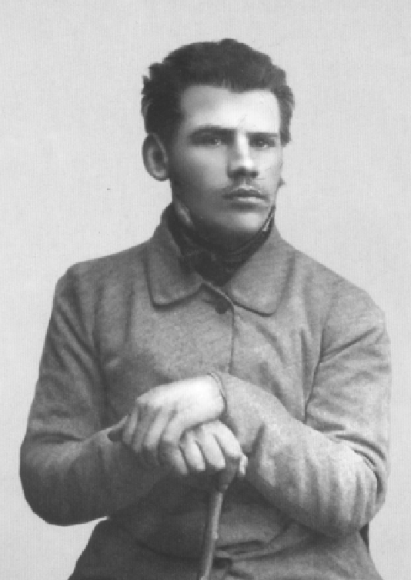

Promoting a Devil, Leo Tolstoy

Promoting a Devil, The Imp And The Crust

Translated by Louise and Aylmer Maude 1906

A POOR PEASANT set out early one morning to plough, taking with him for his breakfast a crust of bread. He got his plough ready, wrapped the bread in his coat, put it under a bush, and set to work. After a while when his horse was tired and he was hungry, the peasant fixed the plough, let the horse loose to graze and went to get his coat and his breakfast.

He lifted the coat, but the bread was gone! He looked and looked, turned the coat over, shook it out — but the bread was gone. The peasant could not make this out at all.

‘That’s strange,’ thought he; ‘I saw no one, but all the same some one has been here and has taken the bread!’

It was an imp who had stolen the bread while the peasant was ploughing, and at that moment he was sitting behind the bush, waiting to hear the peasant swear and call on the Devil.

The peasant was sorry to lose his breakfast, but ‘It can’t be helped,’ said he. ‘After all, I shan’t die of hunger! No doubt whoever took the bread needed it. May it do him good!’

And he went to the well, had a drink of water, and rested a bit. Then he caught his horse, harnessed it, and began ploughing again.

The imp was crestfallen at not having made the peasant sin, and he went to report what had happened to the Devil, his master.

He came to the Devil and told how he had taken the peasant’s bread, and how the peasant instead of cursing had said, ‘May it do him good!’

The Devil was angry, and replied: ‘If the man got the better of you, it was your own fault — you don’t understand your business! If the peasants, and their wives after them, take to that sort of thing, it will be all up with us. The matter can’t be left like that! Go back at once,’ said he, ‘and put things right. If in three years you don’t get the better of that peasant, I’ll have you ducked in holy water!’

The imp was frightened. He scampered back to earth, thinking how he could redeem his fault. He thought and thought, and at last hit upon a good plan.

He turned himself into a labouring man, and went and took service with the poor peasant. The first year he advised the peasant to sow corn in a marshy place. The peasant took his advice, and sowed in the marsh. The year turned out a very dry one, and the crops of the other peasants were all scorched by the sun, but the poor peasant’s corn grew thick and tall and full-eared. Not only had he grain enough to last him for the whole year, but he had much left over besides.

The next year the imp advised the peasant to sow on the hill; and it turned out a wet summer. Other people’s corn was beaten down and rotted and the ears did not fill; but the peasant’s crop, up on the hill, was a fine one. He had more grain left over than before, so that he did not know what to do with it all.

Then the imp showed the peasant how he could mash the grain and distil spirit from it; and the peasant made strong drink, and began to drink it himself and to give it to his friends.

So the imp went to the Devil, his master, and boasted that he had made up for his failure. The Devil said that he would come and see for himself how the case stood.

He came to the peasant’s house, and saw that the peasant had invited his well-to-do neighbours and was treating them to drink. His wife was offering the drink to the guests, and as she handed it round she tumbled against the table and spilt a glassful.

The peasant was angry, and scolded his wife: ‘What do you mean, you slut? Do you think it’s ditchwater, you cripple, that you must go pouring good stuff like that over the floor?’

The imp nudged the Devil, his master, with his elbow: ‘See,’ said he, ‘that’s the man who did not grudge his last crust!’

The peasant, still railing at his wife, began to carry the drink round himself. Just then a poor peasant returning from work came in uninvited. He greeted the company, sat down, and saw that they were drinking. Tired with his day’s work he felt that he too would like a drop. He sat and sat, and his mouth kept watering, but the host instead of offering him any only muttered: ‘I can’t find drink for every one who comes along.’

This pleased the Devil; but the imp chuckled and said, ‘Wait a bit, there’s more to come yet!’

The rich peasants drank, and their host drank too. And they began to make false, oily speeches to one another.

The Devil listened and listened, and praised the imp.

‘If,’ said he, ‘the drink makes them so foxy that they begin to cheat each other, they will soon all be in our hands.’

‘Wait for what’s coming,’ said the imp. ‘Let them have another glass all round. Now they are like foxes, wagging their tails and trying to get round one another; but presently you will see them like savage wolves.’

The peasants had another glass each, and their talk became wilder and rougher. Instead of oily speeches they began to abuse and snarl at one another. Soon they took to fighting, and punched one another’s noses. And the host joined in the fight, and he too got well beaten.

The Devil looked on and was much pleased at all this. ‘This is first-rate!’ said he.

But the imp replied: ‘Wait a bit — the best is yet to come. Wait till they have had a third glass. Now they are raging like wolves, but let them have one more glass, and they will be like swine.’

The peasants had their third glass, and became quite like brutes. They muttered and shouted, not knowing why, and not listening to one another.

Then the Party began to break up. Some went alone, some in twos, and some in threes, all staggering down the street. The host went out to speed his guests, but he fell on his nose into a puddle, smeared himself from top to toe, and lay there grunting like a hog.

This pleased the Devil still more.

‘Well,’ said he, ‘you have hit on a first-rate drink, and have quite made up for your blunder about the bread. But now tell me how this drink is made. You must first have put in fox’s blood: that was what made the peasants sly as foxes. Then, I suppose, you added wolf’s blood: that is what made them fierce like wolves. And you must have finished off with swine’s blood, to make them behave like swine.’

‘No,’ said the imp, ‘that was not the way I did it. All I did was to see that the peasant had more corn than he needed. The blood of the beasts is always in man; but as long as he has only enough corn for his needs, it is kept in bounds. While that was the case, the peasant did not grudge his last crust. But when he had corn left over, he looked for ways of getting pleasure out of it. And I showed him a pleasure — drinking! And when he began to turn God’s good gifts into spirits for his own pleasure — the fox’s, wolf’s and swine’s blood in him all came out. If only he goes on drinking, he will always be a beast!’

The Devil praised the imp, forgave him for his former blunder, and advanced him to a post of high honour.

The End