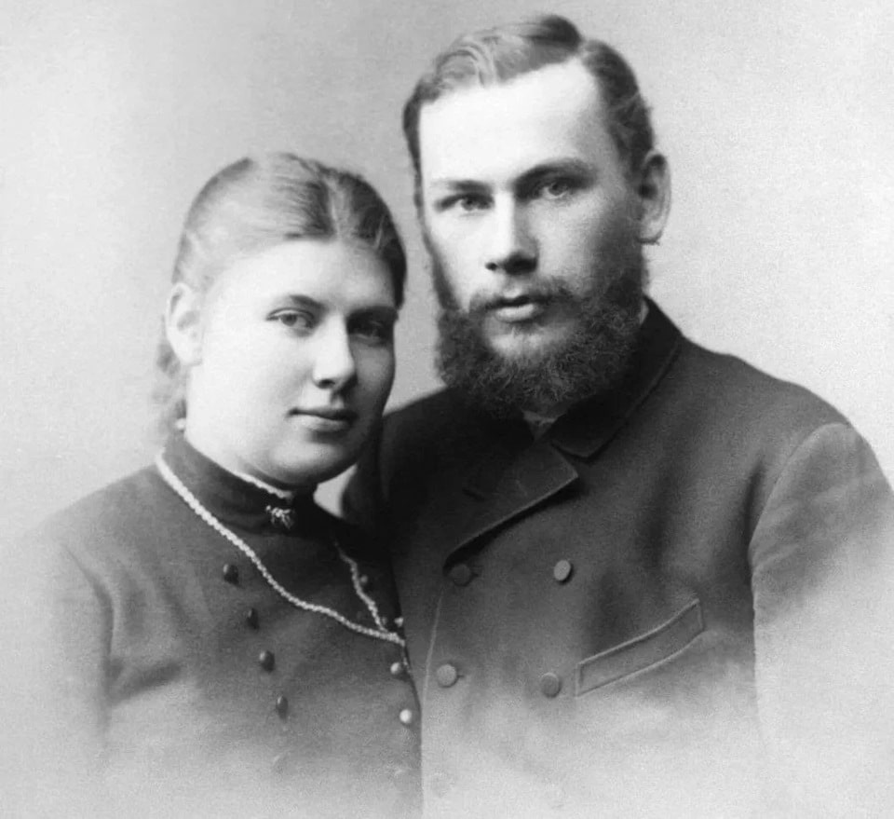

Scenes From Common life, Leo Tolstoy

Scenes From Common life

Chapter I

WILLOW

ONE Easter a peasant went to see whether the frost was out of the ground.

He went to his vegetable garden and poked into the ground with a stake. The soil was soft.

The peasant went into the forest. In the woods the catkins on a young willow were already beginning to swell. And the peasant said to himself :

“ Let me plant young willows around my garden; they will grow and make a hedge.”

He took his ax, cut down a dozen young sprouts, trimmed down the butts into points, and planted them in the ground.

All the willow sticks put forth sprouts and green foliage above; and below, underground, they sent out similar sprouts in place of roots, and some of them took hold of the earth and strengthened themselves; but others did not take hold of the earth with their roots, and these died and toppled over.

When autumn came, the peasant was delighted with his willows; six of them had taken root. The next spring some sheep girdled four of them, and thus only two were left.

The following spring, sheep girdled these also. One died away entirely, but the other took new lease of life, sent down deeper roots, and became a tree. Every spring the bees hummed on in the branches. Oftentimes they would swarm there, and the peasants would gather them into hives.

Peasants and their wives often came to lunch and nap under the tree, and their children climbed up its trunk and broke off its twigs.

. The peasant the one who had set out the slip had died long ago, and still the willow grew.

His eldest son twice trimmed off its branches and used them for fuel.

And still the willow grew. They cut the branches all round and made a cone of it, and when spring came, it still again put forth new branches, though they were small, but twice as many as before, like the mane of a colt.

And the eldest son ceased to be master of the house, and the village was removed to another place, but still the willow grew in the bare field.

Other peasants came and cut it down, and still it grew. The lightning struck the tree; it sent out fresh branches from the sides, and still it grew and bloomed.

One peasant wanted to cut it down to a block, and actually felled it; but it was badly rotted. The tree fell over and held only by one side, but still it kept growing, and every year the bees flew to it to gather pollen from its flowers.

Once, early in the spring, the children gathered to-gether to tend the horses under the tree.

They thought that it was rather cold, and they began to make a fire, and they collected stubble, mugwort, and twigs. One boy climbed the willow and broke off branches. They piled all their tinder in the hollow of the willow and set it on fire.

The willow began to hiss; the sap in its wood boiled, the smoke poured forth, and then it began to blaze; all the inside turned black. The young sprouts crumpled up; the blossoms wilted.

The children drove their horses home. The burned willow remained alone in the field. A black crow flew up to it, perched on it, and cried :

“ So the old poker is dead; it was time long ago ! “

Chapter II

GRAY HARE

A GRAY hare lived during the winter near a village. When night came, he would prick up one ear and listen, then he would prick up the other, jerk his whiskers, snuff, and sit up on his hind legs.

Then he would give one leap, two leaps, through the deep snow, and sit up again, on his hind legs and look all around.

On all sides nothing was to be seen except snow. The snow lay in billows and glittered white as sugar. Above the hare was frosty vapor, and through this vapor glis-tened the big bright stars.

The hare was obliged to make a long circuit across the highway to reach his favorite granary. On the highway he could hear the creaking of sledges, the whinnying of horses, the groaning of the seats in the sledges.

Once more the hare paused near the road. The peas-ants were walking alongside of their sledges, with their kaftan collars turned up. Their faces were scarcely visible. Their beards, their mustaches, their eyebrows, were white. Steam came from their mouths and noses.

Their horses were covered with sweat, and the sweat grew white with hoar-frost. The horses strained on their collars, plunged into the hollows and came up out of them again. The peasants urged them along and lashed them with their knouts. Two old men were walking side by side, and one was telling the other how a horse had been stolen from him.

As soon as the teams had passed, the hare crossed the road, and leaped unconcernedly toward the threshing-floor. A little dog belonging to the teams caught sight of the hare. He began to bark, and darted after him.

The hare made for the threshing-floor, across the snowdrifts; but the depth of the snow impeded the hare, and even the dog, after a dozen leaps, sank deep in the snow and gave up the chase.

The hare also stopped, sat up on his hind legs, and then proceeded at his leisure toward the threshing-floor.

On the way across the field he fell in with two other hares. They were nibbling and playing. The gray hare joined his mates, helped them clear away the icy snow, ate a few seeds of winter wheat, and then went on his way.

In the village it was all quiet; the fires were out; the only sound on the street was an infant crying in a cottage, and the framework of the houses creaking under the frost.

The hare hastened to the threshing-floor, and there he found some of his mates. He played with them on the well-swept floor, ate some oats from the tub on which they had already begun, mounted the snow-covered roof into the granary, and then went through the hedge back to his hole.

In the east the dawn was already beginning to redden, the stars dwindled, and the frosty vapor grew thicker over the face of the earth. In the neighboring village the women woke up and went out after water; the peas-ants began carrying fodder from the granaries; children were shouting and crying; along the highway more and more teams passed by, and the peasants talked in louder tones.

The hare leaped across the road, went to his old hole, selected a place a little higher up, dug away the snow, curled up in the depths of his new hole, stretched his ears along his back, and went to sleep with eyes wide open.

Chapter III

FOUNDLING

A POOR woman had a daughter, Masha. Masha one morning, in going after water, saw something lying on the door-step, wrapped up in rags.

Masha set down her pail and undid the rags. When she had opened the bundle, there came forth a cry from out the rags, ua! ua! ua !

Masha bent over and saw that it was a pretty little baby. He was crying lustily, ua! ua! ua! Masha took him up in her arms and carried him into the house, and tried to give him some milk with a spoon.

The mother said :

“ What have you brought in ? “

Masha said :

“ A baby; I found it at our door.”

The mother said :

“ We are so poor, how can we get food for another child ? I am going to the police and tell them to take it away.”

Masha wept, and said :

“ Matushka, he will not eat much; do keep him ! Just see what pretty little dimpled hands and fingers he has.”

The mother looked, and she had compassion on the child. She decided to keep him. Masha fed him and swaddled him, and she sang cradle songs to him when she put him to sleep.

Chapter IV

PEASANT AND THE CUCUMBERS

ONCE upon a time a peasant went to steal some cu-cumbers of a gardener. He crept down among the cucumbers, and said to himself :

“ Let me just get away with a bag of cucumbers; then I will sell them. With the money I will buy me a hen. The hen will lay some eggs, and will hatch them out, and I shall have a lot of chickens. I will feed up the chickens, and sell them, and buy a shoat a nice little pig.

In time she will farrow, and I shall have a litter of pigs. I will sell the little pigs and buy a mare; the mare will foal, and I shall have a colt. I will raise the colt and sell it; then I will buy a house and start a garden; I will have a garden and raise cucumbers; but [ won’t let them be stolen, I will keep a strict watch. I will hire watchmen, and will station them among the cucumbers, and often I, myself, will come unexpectedly among them, and I will shout, ‘ Hollo, there! keep a closer watch.’ “

As these words came into his head he shouted them at the top of his voice. The guards heard him, ran out, and belabored him with their sticks.

Chapter V

FIRE

IT was harvest-time, and the men and women 1 had gone out to work.

Only the very old and the very young stayed in the village.

A grandmother and three of her grandchildren were left in one cottage. 2 The grandmother kindled a fire in the oven, and lay down for a nap. The flies lighted on her and annoyed her with their biting. She covered up her head with a towel and went to sleep.

One of the grandchildren, Masha, she was three years old, opened the oven, shoveled out some of the coals into a dish, and ran out into the entry. Now in the entry lay some sheaves. 3 The women had been preparing these sheaves for bands.

Masha brought the coals, emptied them under the sheaves, and began to blow. When the straw took fire, she was delighted; she ran into the sitting-room, and seized her little brother, Kiriushka, he was eighteen months old, and was only just beginning to walk, and she said, “ Look, Kiliuska ! see what a nice fire I have started ! “

The sheaves were already flaming and cracking.

When Masha saw the entry full of smoke, she was frightened and hastened back into the hut. Kiriushka stumbled on the threshold and bumped his nose, and set up a cry. His sister dragged him into the room, and both of them hid under the bench. The grandmother heard nothing, as she was asleep.

The oldest brother, Vanya, he was eight, was in the street. When he saw that smoke was pouring from the entry, he ran indoors, bounded through the smoke into the hut, and tried to waken the grandmother; but the grandmother, who was only half awake, was dazed, and, forgetting all about the children, leaped up and ran about the village after help.

Meantime Masha was crouching under the bench; but the little one cried because he had hurt his nose so badly. Vanya heard him crying, looked under the bench, and called to Masha, “ Run quick ! you will be burnt up ! “

Masha ran to the entry; but it was impossible for her to pass, on account of the smoke and fire.

She came back. Then Vanya opened the window and told her to crawl out. When she had crawled out, Vanya seized his little brother and tried to drag him along.

But the little fellow was heavy and would not let his brother help him. He screamed, and struck Vanya. Twice Vanya fell while he was dragging him to the window; and by this time the door of the hut was on fire,

Vanya thrust the baby boy’s head up to the window, and tried to push him through, but the little fellow, who was very much frightened, clung with his hands, and would not let go. Then Vanya cried to Masha, “ Pull him by the head ! “ and he himself pushed from behind. And thus they dragged him through the window out-of-doors.

Chapter VI

TREASURE TROVE

AN old woman and her granddaughter lived in a village. They were very poor and had nothing to eat. Easter Sunday came. The people were full of rejoicing. All made their purchases for the great feast, but the old woman and her granddaughter had nothing to make merry with. They shed tears, and began to pray God to help them.

Then the old woman remembered that long ago, in the time of the Frenchman^ the peasants used to hide their money in the ground. And the old woman said to her granddaughter :

“ Granddaughter, take your shovel and go over to the site of the old village, ask God’s help, and dig into the ground; perhaps God will send us something.”

And the granddaughter said to herself: “It is impos-sible that I should find anything. Still, I will do as grandma 2 bade me.”

She took the shovel and went. After she had dug a hole, she began to think :

“ I have dug long enough; I am going home now.”

She was just going to take out the shovel when she heard it knock against something. She leaned over, and saw a large jug. She shook it; something jingled. She threw down her shovel, and ran to her grandma, crying, “ Babushka, I have found a treasure !”

“They opened the jug and found it full of silver coins. And the grandmother and granddaughter were able to have an Easter feast, and they bought a cow, and thanked God because He had heard their prayer.

Chapter VII

BIRD

IT was Serozha’s birthday, and he received many different gifts, peg-tops and hobby-horses and pictures. But Serozha’s uncle gave him a gift which he prized above all the rest : it was a trap for snaring birds. The trap was constructed in such a way that a board was fitted on the frame and shut down upon the top. If seed were scattered on the board, and it was put out in the yard, the little bird would fly down, hop upon the board, the board would give way, and the trap would shut with a clap.

Serozha was delighted and he ran to his mother to show her the trap.

His mother said :

“ It is not a good plaything. What do you want to do with birds ? Why do you want to torture them ? “

“ I am going to put them in a cage. They will sing, and I will feed them.”

Serozha got some seed, scattered it on the board, and set the trap in the garden. And he stood by and expected the birds to fly down. But the birds were afraid of him, and did not come near the cage. Serozha ran in to get something to eat, and left the cage.

After dinner he went to look at it; the cage had shut, and in it a little bird was beating against the bars.

Serozha was delighted, took up the bird, and carried it into the house.

“ Mamma, I have caught a bird; I think it is a night-ingale; and how its heart beats ! “

His mother said it was a canary.

“ Be careful ! don’t hurt it; you would better let it

go.”

“ No; I am going to give it something to eat and drink.”

Serozha put the canary in a cage, and for two days gave him seed and water and cleaned the cage. But on the third day he forgot all about the canary, and did not change the water.

And his mother said :

“ See here : you have forgotten your bird; you would better let it go.”

“ No; I will not forget it again; I will immediately give it fresh water and clean its cage.”

Serozha thrust his hand into the cage and .began to clean it, but the little bird was frightened and fluttered. After Serozha had cleaned the cage, he went to get some water. His mother perceived that he had for-gotten to shut the cage door, and she called after him :

“ Serozha, shut up your cage, else your bird will fly out and hurt itself.”

She had hardly spoken these words, when the bird found the door, was delighted, spread its wings, and flew around the room toward the window. But it did not see the glass, and struck against it and fell back on the window-sill. Serozha came running in, picked up the bird, and put it back in the cage. The bird was still alive, but it lay on its breast, with its wings spread out, and breathed heavily. Serozha looked and looked, and began to cry :

“ Mamma, what can I do now ? “

“You can do nothing now.”

.Serozha did not leave the cage all day, but gazed at the canary, and all the time the bird lay on its breast and breathed hard and fast.

When Serozha went to bed, the bird was dead. Sero-zha could not get to sleep for a long time; every time that he shut his eyes he seemed to see the bird still lying and sighing.

In the morning, when Serozha went to his cage, he saw the bird lying on his back, with his legs crossed, and all stiff.

After that Serozha never again tried to snare birds.

Chapter VIII

HOW UNCLE SEMYON TOLD ABOUT HIS ADVENTURE IN THE WOODS

ONE time in winter I had gone into the woods after timber. I had cut down three trees, and lopped off the limbs, and was hewing them, when I looked up and saw that it was getting late; that it was time to go home. But the weather was bad; it was snowing and blowing. I said to myself :

“ The night is coming on, and you don’t know the way.”

I whipped up the horse and drove on; still there was no sign of outlet. Forest all around.

I thought how thin my shuba was; I was in danger of freezing to death.

I still pushed on; it grew dark, and I was entirely off the road.

I was just going to unyoke the sled and protect myself under it, when I heard not far away the jingle of bells. I went in the direction of the bells, and saw a troika of roan horses, their manes tied with ribbons ! their bells were jingling, and two young men were in the sleigh.

“Good evening, brothers.”

“ Good evening, peasant.”

“ Where is the road, brothers ? “

“ Here we are right on the road.”

I went to them, and I saw that strangely enough the road was unbroken, all drifted over.

“ Follow us,” said they, and they whipped up their horses.

My wretched mare could not keep up with them. I began to shout :

“ Hold on, brothers ! “

They waited for me, laughing.

“Get in with us,” said they; “it will be easier for your horse without a load.”

“ Thank you,” said I.

I cLmbed into their sledge. It was handsome well lined. As soon as I sat down, how they spurred on the horses ! “ Now then, my darlings / “

The roan horses dashed away, making the snow fly in clouds.

What a wonderful thing ! It grew lighter and lighter, and the road became as glare as ice, and we flew so fast that it took away my breath, and the twigs lashed my face. It began to be painful.

I looked ahead; there was a steep mountain, a very steep mountain, and at the foot of the mountain a ravine. The roans were flying straight for the ravine.

I was frightened, and cried :

“Heavens and earth! slow up, you, slow up; you will kill us ! “

But the men only laughed, and urged on the horses the more. I saw there was no saving us; the ravine was under our very runners. But I saw a bough right over my head.

“ Well,” I said to myself, “you may go over alone.”

I stood up and seized the bough, and there I hung !

As I caught it I shouted :

“ Hold on ! “ And then I heard women shouting :

“ Uncle Semyon ! what is the matter ? Start up the fire, you women ! Something is wrong with Uncle Semyon ! he is screaming ! Stir up the fire ! “

I woke up, and there I was in my cottage, clinging to the loft, and screaming at the top of my voice. And all that I had seen had been a dream !

Chapter IX

COW

widow Mary a lived with her mother and six children. Their means of life were small. But they used their last money in the purchase of a red cow, so as to have milk for the children. The eldest children pastured Brownie 1 in the field, and gave her slops at home.

One-time while the mother was away from home, the oldest son, Misha, in climbing on the shelf after bread, knocked over a tumbler and broke it.

Misha was afraid that his mother would chide him. So he gathered up the large pieces of broken glass, carried them into the yard, and buried them in the dung-heap, but the little pieces he threw into the basin. The mother missed the glass, and made in-quiries; but Misha said nothing, and so the matter rested.

On the next day, after dinner, when the mother went to give Brownie the swill from the basin, she found that Brownie was ailing and would not eat her food. They tried to give her medicine, and they called the babka. 2 The babka said that the cow would not live; it was best to slaughter her for beef.

They called a peasant and proceeded to slaughter the cow. The children heard Brownie lowing in the yard; they all climbed upon the oven and began to weep.

After they had slaughtered Brownie, they took off the hide and cut the carcass in pieces, and there, in the throat, they found a piece of glass. And so they knew that her death was caused by her swallowing the glass in the slops.

When Misha heard this he began to weep bitterly, and confessed to his mother that he broke the glass. The mother said nothing, but also wept. Then she said :

“ We have killed our Brownie, and have nothing to get another cow with. How will the little ones live without milk ? “

Misha kept howling louder and louder, and would not come down from the oven when they ate the jelly made from the cow’s head. Every time when he went to sleep, he saw in his dreams how Uncle Vasili brought the red cow by the horns, Brownie, with her wide eyes and beautiful neck.

From that time the children had no more milk. Only on holidays they had milk, for then Marya asked her neighbor for a mug of it.

It happened that the lady of that estate needed a child’s nurse. And the grandmother said to the daughter :

“ Let me go; I will take the place as nurse, and maybe God will let you get along with the children alone. And if God spares me, I can earn enough in a year to buy a cow.”

Thus they did. The grandmother went to the lady; but it grew still more hard for Marya and the children. The children lived a whole year without having milk. They had nothing but kisel jelly and tiuria l to eat and they grew thin and pale.

After the year was over, the grandmother came home, bringing twenty rubles.

“ Well, daughter,” says she, “ now we will buy a cow.”

Marya was delighted; all the children were delighted. Marya and the grandmother went to market to buy their cow. They asked a neighbor to stay with the children, and they asked another neighbor, Uncle Zakhar, to go with them and help them to select the cow.

After saying their prayers they went to town. In the afternoon the children kept running into the street to see if they could see the cow. They amused them-selves guessing what kind of a cow she would be red or black. They kept telling one another how they would feed her. All day long they waited and waited. They walked a verst to meet the cow, but as it was already growing dark, they turned back.

Suddenly they saw coming along the road a cart, and in it sat their grandmother, and beside the hind wheel walked a brindle cow tied by the horn, and their mother was walking behind urging her on with a dry stick.

The children ran to them and began to examine the cow. They brought bread and grass and tried to feed her. The mother went into the cottage, changed her clothes, and went out with her towel and milk-pail. She sat down under the cow and began to wipe the udder. The Lord be praised ! The cow gave milk, and the children stood around and watched the milk straining into the pail, and listened to its sound under the mother’s fingers. When the mother had milked the pail half full, she carried it down cellar, and each of the children had a mug for supper.

Chapter X

FILIPOK

ONCE there was a little boy whose name was Filipp. All the children were going to school. Filipp took his hat and wanted to go too.

But his mother said to him :

“ Where are you going, Filipok ? “

“ To school.”

“ You are too small; you can’t go,” and his mother kept him at home.

The children went off to school. Their father had gone early in the morning to the woods; the mother was engaged in her daily work.

Filipok and his grandmother were left in the cottage, on the oven. Filipok began to feel lonely; his grand-mother was asleep, and he began to search for his hat. When he could not find his own, he took an old one, made of sheepskin, and started for school.

School was kept at the village church. When Filipp walked along his own street, 1 the dogs did not meddle with him, for they knew him; but when he reached the street in the next estate, a black dog 2 came bounding out and barking, and behind this dog came another still bigger, named Wolfie, 3 and Filipp started to run, the dogs after him.

Filipok began to cry; then he stubbed his toe and fell. A peasant came out and called off the dogs, and asked :

“ Where are you going all sole alone, you little rascal? “

Filipok made no answer, pulled up his skirt, and started to run with all his might. He ran to the school. There was no one on the steps, but in school the voices of the children could be heard in a confused murmur.

Filipp was now filled with fear :

“ Suppose the teacher should drive me away ? “

And he began to consider what he should do. If he should go back, the dogs might bite him; but if he went into school, he was afraid of the teacher.

A peasant woman passed the school, with a pail, and she said :

“ All the rest are studying, and what are you standing there for?”

So Filipok went into school. In the entry he took off his cap and opened the door. The room was full of children. All were talking at once, and the teacher, in a red scarf, was walking up and down in the midst of them.

“ Who are you ? “ he demanded of Filipok.

Filipok clutched his cap and said nothing.

“Who are you?”

Filipok said never a word.

“Are you dumb?”

Filipok was so scared that he could not speak.

“Well, then, go home if you can’t speak.”

Now Filipok would have been glad to say something, but his throat was all parched with terror.

He looked at the teacher and burst into tears.

Then the teacher felt sorry for him. He caressed his head, and inquired of the children who the little fellow was.

“This is Filipok, Kostiushka’s l brother; he has been wanting for a long time to go to school, but his mother would not let him, and he must have run away to school.”

“ Well, sit down on the bench next your brother, and I will ask your mother to let you come to school.”

The teacher began to teach Filipok his letters; but

Filipok already knew them, and could even read a little. “ Very well; spell your name, then.” Filipok said, “ Khve-i, khvi le-i, li peok, pok.” Everybody laughed.

“Bravo!” said the teacher; “who taught you to read?” Filipok summoned courage, and said : “ Kostiushka. I am mischievous. I learned them

all at once. I am terribly smart! “ The teacher laughed, and asked : “ And do you know your prayer ? “ Filipok said yes, and began to repeat the Ave Maria:

but he did not get every word quite correct. The teacher interrupted him, and said : “You must not boast. I will teach you.” After this Filipok began to go to school regularly with the children.

The End