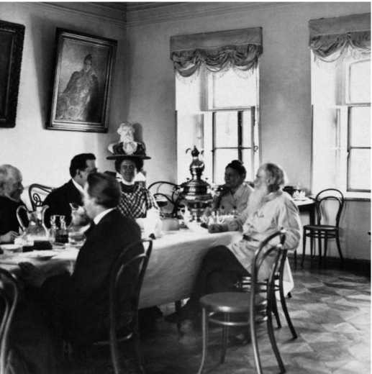

Stories From Botany, Leo Tolstoy

Stories From Botany

Translated by Nathan Haskell Dole 1888

Chapter I

MY APPLE TREES

I SET OUT two hundred young apple trees, and for three years, in the spring and autumn, I dug around them, and when winter came, I wrapped them around with straw as a protection against rabbits.

On the fourth year, when the snow had gone, I went out to examine my apple trees. They had grown dur-ing the winter, their bark was smooth and full of sap, the branches were all perfect, and on all the extremities of the twigs were the buds of flowers, as round as little peas.

Here and there, where the buds had already burst, the edges of the petals could be seen.

I knew that all the buds would become flowers and fruit, and I was full of gladness as I watched my apple trees.

But when I came to strip off the straw from the first tree, I noticed that at its foot, just below the level of the soil, the bark of the tree had been nibbled around, down to the rind, just like a white ring.

The mice had done it.

I stripped the next tree, and on the next tree it was just the same. Out of two hundred apple trees not one was untouched. I smeared the injured places with pitch and wax; but as soon as the apple trees bloomed, the flowers immediately fell to the ground. Little leaves came out, but they faded and dried up. The bark grew rough and black.

Out of my two hundred trees only nine were saved.

The bark of these nine apple trees had not been en-tirely girdled, but in the white rings there was left a band of bark. At the juncture of these bands with the bark warts grew; but though the trees were badly in-jured, still they survived. All the rest were lost, save that below the girdled place little sprouts came up; but they were wild.

The bark on trees is the same as the veins in man; the blood flows through a man’s veins, and through the bark the sap flows over the tree and provides it with branches, leaves, and flowers. The whole inside of a tree may be removed, as often happens with old willows, and if only the bark is alive, the tree will live; but if the bark is destroyed, the tree is destroyed. If a man’s veins are cut, the man dies : in the first place, because the blood runs out of them; and in the second place, because then the blood cannot be distributed over the body.

And in the same way the birch tree perishes when children make a hole in it to drink the sap; all the sap runs out.

And in the same way my apple trees perished be-cause the mice entirely girdled the bark so that there was no way for the sap from the roots to reach the branches, the leaves, and the blossoms.

Chapter II

OLD POPLAR

OUR park had been neglected for five years. I en-gaged workmen with axes and shovels, and I myself began to work with them in my park. We cut down and lopped off dead and wild growths and superfluous thickets and trees.

More abundantly and luxuriantly than anything else had grown the poplar and bird cherry. The poplar starts from roots, and it is impossible to pull it up; but you have to cut the roots out of the ground.

Behind the pond stood a monstrous poplar, two spans in circumference. On all sides of it was a field, and this field was overgrown with young poplar shoots. I ordered the men to cut them down : I wanted to make the place more cheerful; but, above all, I wanted to make it easier for the old poplar, because I thought that all these young trees came from it and robbed it of sap.

As we were cutting down the young poplars, I some-times felt a pang of regret to see the roots full of sap hacked in pieces underground. Sometimes four of us tried to pull up the roots of some young poplar that had been cut down, and found it impossible. It would re-sist with all its might, and would not die. I said to myself :

“ Evidently it ought to live, if it clings so stoutly to life.”

But it was essential to cut them down; and I per-sisted in having them destroyed. But afterward, when it was too late, I learned that I ought not to have de-stroyed them.

I supposed that the saplings drew the sap from the old poplar, but it proved to be quite the reverse. By the time I had cut them down, the old poplar was also beginning to die. When it put forth leaves, I saw that one of its halves it grew in two great branches was bare, and that same summer it dried up. It had been long dying, and was conscious of it, and had been giving its life to its shoots.

That was the reason that they had grown so rapidly, and I, who had wished to help it, had killed all its children.

Chapter III

BIRD CHERRY TREE

A BIRD cherry l had taken root on the path through the hazelnut grove, and was beginning to choke off the hazel bushes.

For some time I queried whether to cut it or not to cut it; I felt sorry to do so. This bird cherry did not grow in a clump, but in a tree more than five inches l in diam-eter, and twenty-eight feet high, full of branches, bushy, and wholly covered with bright, white, fragrant blos-soms. The perfume from it was wafted a long distance.

I certainly should not have cut it down, but one of the workmen I had given him orders before to cut down every bird cherry began to fell it in my absence. When I came he had already cut halfway into it, and the sap was dripping down under the ax as he let it fall into the gash.

“ There ‘s no help for it,” I said to myself; “ evidently it is its fate.”

So I myself took the ax, and began to help the peasant cut it down.

It is delightful to work at all sorts of work; it is delightful even to cut wood. It is delightful to sink the ax deep in the wood, with a slanting stroke, and then to cut it in straight, and thus to advance deeper and deeper into the tree.

I entirely forgot about the bird cherry tree, and thought only about getting it cut down as quickly as possible.

When I got out of breath, I laid down the ax, and the peasant and I leaned against the tree, and tried to push it over. We pushed hard; the tree shook its foliage and sprinkled us with drops of dew, and strewed all around the white, fragrant petals of its blossoms.

At this instant something shrieked; there was a sharp, crackling sound in the center of the tree, and the tree began to fall.

It broke off near the gash, and, slowly wavering, toppled over on the grass, with all its leaves and blossoms. The branches and blossoms trembled for a moment after it fell, and then grew motionless.

“ Ekh ! what a splendid piece ! “ said the peasant; “it’s a real shame ! “

As for me, I felt so sorry that I hastened off to look after other work.

1 Three vershoks, 5.25 inches.

Chapter IV

HOW TREES WALK

ONCE we were clearing an overgrown path on the hillside, near the pond. We had cut down many briers, willows, and poplars, and at last we came to a bird cherry.

It was growing on the path itself, and it was so old and thick that it seemed as if it must have been there at least ten years. And yet I knew that only five years before the park had been cleared.

I could not understand how such a mature cherry tree could have sprung up there.

We cut it down and went on. A little farther away, in another thicket, there was another bird cherry tree like the first, only even more dense.

I examined its root, and found that it sprang from under an old linden. The linden had been smothering it with its shade, and the cherry had run under the ground for a distance of a dozen feet, 1 with a straight stem; and when it came out into the light, it had raised its head and begun to flourish.

I cut it up by the root, and was amazed to see how light-colored and rotten the root was. After I had cut it off, the peasants and I tried to pull up the tree; but in spite of all our best efforts we could not stir it; it seemed to be fastened to the ground.

I said :

“ Look and see if we have not failed to cut it entirely off.”

One of the workmen crawled down under it, and cried :

“Yes, there ‘s another root; there it is under the path.”

I went to him, and found that this was the case.

The cherry tree, in order not to be choked off by the linden, had crept from under the linden to the path, seven feet from its original root. Then the root which I had cut off was rotten and dried up, but the new one was alive. It had evidently felt that it would not live under the linden, had stretched itself out, had taken hold of the soil with its branch, had made a root out of the branch, and then abandoned the old root.

Then I began to understand how the first bird cherry had grown up in the path. It had evidently done the same thing, but had succeeded in so thoroughly ridding itself of its old root that I could not find it.

The end