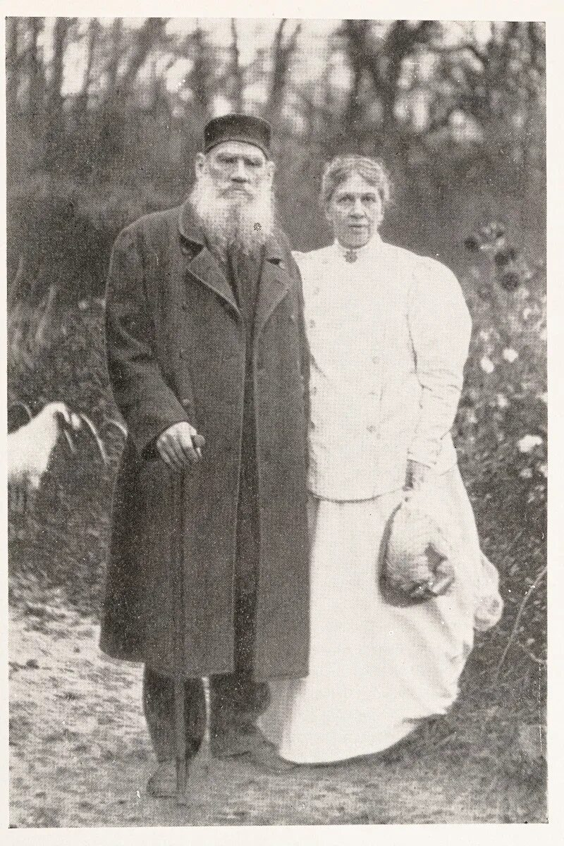

Stories From The New Speller, Leo Tolstoy

Stories From The New Speller

Translated by Nathan Haskell Dole 1888

I. THE WOLF AND THE KIDS

A GO AT was going to the field after provender, and she shut up her Kids in the barn, with injunctions

not to let any one in. Said she :

“ But when you hear my voice then open the door.” A Wolf overheard, crept up to the barn, and sang

after the manner of the Goat :

“ Little children, open the door; your mother has

come with some food for you.”

The Kids peered out of the window, and said :

“ The voice is our mamma’s, but the legs are those of

a wolf. We cannot let you in.”

II. THE FARMER’S WIFE AND THE CAT

A FARMER’S wife was annoyed by mice eating up the tallow in her cellar. She shut the cat into the cellar, so that the cat might catch the mice.

But the cat ate up, not only the tallow, but the milk and the meat also.

III. THE CROW AND THE EAGLE

sheep went out to pasture.

Suddenly an Eagle appeared, swooped down from the sky, caught a little lamb with its claws, and bore him away.

A Crow saw it, and felt also an inclination to dine on meat. She said :

“ That was not a very bright performance. Now I am going to do it, but in better style. The Eagle was stupid; he carried off a little lamb, but I am going to take that fat ram yonder.”

The Crow buried her claws deep in the ram’s fleece, and tried to fly off with him; but all in vain. And she was not able to extricate her claws from the wool.

The shepherd came along, freed the ram from the Crow’s claws, and killed the Crow, and flung it away.

IV. THE MOUSE AND THE FROG

A MOUSE went to visit a Frog. The Frog met the Mouse on the bank, and urged him to visit his chamber under the water.

The Mouse climbed down to the water’s edge, took a taste of it, and then climbed back again.

“Never,” said he, “will I make visits to people of alien race.”

V. THE VAINGLORIOUS COCKEREL

Two Cockerels fought on a dungheap.

One Cockerel was the stronger : he vanquished the other and drove him from the dungheap.

All the Hens gathered around the Cockerel, and began to laud him. The Cockerel wanted his strength and glory to be known in the next yard. He flew on top of the barn, flapped his wings, and crowed in a loud voice :

“ Look at me, all of you. I am a victorious Cockerel. No other Cockerel in the world has such strength as I.”

The Cockerel had not finished his paean, when an Eagle killed him, seized him in his claws, and carried him to his nest.

VI. THE ASS AND THE LION

ONCE upon a time a Lion went out to hunt, and he took with him an Ass. And he said to him :

“ Ass, now you go into the woods, and roar as loud as you can; you have a capacious throat. The prey that run away from your roaring will fall into my clutches.”

And so he did. The Ass brayed, and the timid creatures of the wood fled in all directions, and the Lion caught them.

After the hunting was over, the Lion said to the Ass :

“ Now I will praise you. You roared splendidly.”

And since that time the Ass is always braying, and always expects to be praised.

VII. THE FOOL AND HIS KNIFE

A FOOL had an excellent knife.

With this knife the fool tried to cut a nail. The knife would not cut the nail.

Then the fool said :

“ My knife is mean,” and he tried to cut some soft kisel jelly with his knife. Wherever the knife went through the jelly the liquid closed together again.

The fool said, “ Miserable knife ! it won’t cut kisel, either,” and he threw away his good knife.

VIII. THE BOY DRIVER

A PEASANT was returning from market with his son Vanka. 1 The peasant went to sleep in his cart, and Vanka held the reins and cracked the whip. They happened to meet another team. Vanka shouted :

“ Turn out to the right ! I shall run over you ! “ .

And the peasant with the team said :

“ It is not a big cricket, but it chirps so as to be heard ! “

IX. LIFE DULL WITHOUT SONG

IN the upper Part of a house lived a rich barin, and on the floor below lived a poor tailor. The tailor was always singing songs at his work, and prevented the barin from sleeping.

The barin gave the tailor a purse full of money not to sing. The tailor became rich, and took good care of his money, and refrained from singing.

But it grew tiresome to him; he took the money and returned it to the barin, saying :

“ Take back your money and let me sing my songs again, or I shall die of melancholy.”

X. THE SQUIRREL AND THE WOLF

A SQUIRREL was leaping from limb to limb, and fell directly upon a sleeping Wolf. The Wolf jumped up, and was going to devour him. But the Squirrel begged the Wolf to let him go. .

The Wolf said :-^

“ All right; I will let you go on condition that you tell me why it is that you squirrels are always so happy. I am always melancholy; but I see you playing and leaping all the time in the trees.”

The Squirrel said :

“ Let me go first, and then I will tell you; but now I am afraid of you.”

The Wolf let him go, and the Squirrel leaped up into a tree, and from there it said :

“ You are melancholy because you are bad. Wicked-ness consumes your heart. But we are happy because we are good, and do no one any harm.”

XI. UNCLE MITYA’S HORSE

UNCLE MITYA had a very fine bay horse.

Some thieves heard about the bay horse, and laid their plans to steal it. They came after it was dark, and crept into the yard.

Now it happened that a peasant who had a bear with him came to spend the night at Uncle Mitya’s. Uncle Mitya took the peasant into the cottage, let out the bay horse into the yard, and put the bear into the inclosure where the bay horse was.

The thieves came in the dark into the inclosure, and began to grope around. The bear got on his hind legs, and seized one of the thieves, who was so frightened that he bawled with all his might.

Uncle Mitya came out and caught the thieves.

XII. THE BOOK

Two men together found a book in the street, and began to dispute as to the ownership of it.

A third happened along, and asked :

“ Which of you can read ? “

“ Neither of us.”

“ Then why do you want the book ? Your quarrel reminds me of two bald men who fought for possession of a comb, when neither had any hair on his head.”

XIII. THE WOLF AND THE FOX

A WOLF was running from the dogs, and wanted to hide in a cleft. But a Fox was lying in the cleft; she showed her teeth at the Wolf, and said :

“ You cannot come in here; this is my place.”

The Wolf did not stop to dispute the matter, but merely said :

“If the dogs were not so near, I would teach you whose place it is; but now the right is on your side.”

XIV. THE PEASANT AND HIS HORSE

SOME soldiers made a foray into hostile territory. A peasant ran out into the field where his horse was, and tried to catch it. But the horse would not come to the peasant.

And the peasant said to him :-

“ Stupid, if you don’t let me catch you, the enemy will carry you off.”

The Horse asked :

“ What would the enemy do with me ? “

The peasant replied :

“ Of course they would make you carry burdens.”

And the Horse rejoined :

“ Well, don’t I carry burdens for you ? So then it is all the same to me whether I work for you or your enemies.”

XV. THE EAGLE AND THE SOW

AN Eagle built a nest on a tree, and hatched out some eaglets. And a wild Sow brought her litter under the tree.

The Eagle used to fly off after her prey, and bring it back to her young. And the Sow rooted around the tree and hunted in the woods, and when night came she would bring her young something to eat.

And the Eagle and the Sow lived in neighborly fashion.

And a Grimalkin laid his plans to destroy the eaglets and the little sucking pigs. He went to the Eagle, and said :

“ Eagle, you had better not fly very far away. Be-ware of the Sow; she is planning an evil design. She is going to undermine the roots of the tree. You see she is rooting all the time.”

Then the Grimalkin went to the Sow and said :

“ Sow, you have not a good neighbor. Last evening I heard the Eagle saying to her eaglets : ‘ My dear little eaglets, I am going to treat you to a nice little pig. Just as soon as the Sow is gone, I will bring you a little young sucking pig.’ ‘

From that time the Eagle ceased to fly out after prey, and the Sow did not go any more into the forest. The eaglets and the young pigs perished of starvation, and Grimalkin feasted on them.

XVI. THE LOAD

AFTER the French had left Moscow, two peasants went out to search for treasures. One was wise, the other stupid.

They went together to the burnt Part of the city, and found some scorched wool. . They said, “ That will be useful at home.”

They gathered up as much as they could carry, and started home with it.

On the way they saw lying in the street a lot of cloth. The wise peasant threw down the wool, seized as much of the cloth as he could carry, and put it on his shoulders. The stupid one said :

“ Why throw away the wool ? It is nicely tied up, and nicely fastened on.” And so he did not take any of the cloth.

They went farther, and saw lying in the street some ready-made clothes that had been thrown away. The wise peasant unloaded the cloth, picked up the clothes, and put them on his shoulders. The stupid one said :

“ Why should I throw away the wool ? It is nicely tied up and securely fastened on my back.”

They went on their way, and saw silver plate scattered about. The wise peasant threw down the clothes, and gathered up as much of the silver as he could, and started off with it; but the stupid one did not give up his wool, because it was nicely tied up and securely tied on.

Going still farther, they saw gold lying on the road. The wise peasant threw down his silver and picked up the gold; but the stupid one said :

“ What is the good of taking off the wool ? It is nicely tied up and securely fastened to my back.”

And they went home. On the way a rain set in, and the wool became water-soaked, so that the stupid man had to throw it away, and thus reached home empty-handed; but the wise peasant kept his gold and became rich.

XVII. THE BIG OVEN

ONCE upon a time a man had a big house, and in the house there was a big oven; but this man’s family was small only himself and his wife.

When winter came, the man tried to keep his oven going; and in one month he burnt up all his firewood. He had nothing to feed the fire, and it was cold.

Then the man began to break up his fences, and use the boards for fuel. When he had burnt up all of his fences, the house, now without any protection against the wind, was colder than ever, and still they had no firewood.

Then the man began to tear down the ceiling of his house, and burn that in the oven.

A neighbor noticed that he was tearing down his ceiling, and said to him :

“ Why, neighbor, have you lost your mind ? pulling down your ceiling in winter. You and your wife will freeze to death!”

But the man said :

“ No, brother; you see I am pulling down my ceiling so as to have something to heat my oven with. We have such a curious one; the more I heat it up, the colder we are ! “

The neighbor laughed, and said :

“Well, then, after you have burnt up your ceiling, then you will be tearing down your house. You won’t have anywhere to live; only the oven will be left, and even that will be cold ! “

“Well, that is my misfortune,” said the man. “All my neighbors have firewood enough for all winter; but I have already burnt up my fences and the ceiling of my house, and have nothing left.”

The neighbor replied :

“ All you need is to have your oven rebuilt”

But the man said :

“ I know well that you are jealous of my house and my oven because they are larger than yours, and so you advise me to rebuild it.”

And he turned a deaf ear to his neighbor’s advice, and burnt up his ceiling, and burnt up his whole house, and had to go and live with strangers.

The End