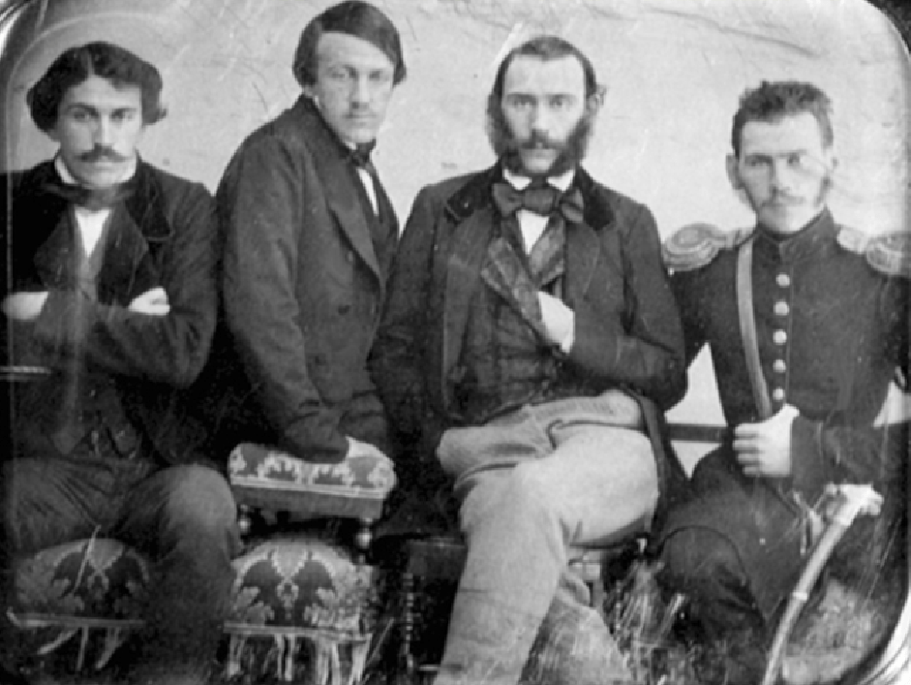

Tales From Zoology, Leo Tolstoy

Tales From Zoology

Translated by Nathan Haskell Dole 1888

Chapter I

OWL AND THE HARE

IT was growing dark. The owls began to fly in the forest, over the ravine, in search of their prey.

A big gray hare was bounding over the field, and began to smooth his fur.

An old owl, as she sat on the bough, was watching the gray hare; and a young owl said, “ Why don’t you pounce down on the hare ? “

The old one replied :

“ I am not strong enough. The hare is large. If you should clutch him, he would carry you off into the thicket.”

But the young owl said :

“ Why, I could hold him with one claw, and with the other I could cling to the tree.”

And the young owl swooped down on the hare, clutched his back with his claw in such a way that all the nails sank into the fur, and he was going to cling to the tree with the other claw; and he said to him-self :

“ He will not escape.”

But the hare darted himself away, and pulled the owl in two. One claw remained in the tree; the other in the hare’s back.

The next year a sportsman killed this hare, and was surprised to find on his back the talons of a full-grown owl.

Chapter II

HOW WOLVES TEACH THEIR CUBS

I WAS riding along the road, when I heard some one shouting behind me. It was a young shepherd. He was running across a field, and pointing at something.

I looked, and saw two wolves running across the field. One was full grown; the other was a cub. The cub had on his back a lamb which had just been killed, and he had the leg in his mouth.

The old wolf was running behind.

As soon as I saw the wolves, I joined the shepherd, and we started in pursuit, setting up a shout.

When they heard our shout, some peasants started out also in pursuit, with their dogs.

.As soon as the old wolf caught sight of the dogs and the men, he ran to the young one, snatched the lamb from him, jerked it over his own back, and both wolves increased their pace and were soon lost from view.

Then the lad began to relate how it had happened. The big wolf had sprung out from the ravine, seized the lamb, killed it, and carried it off. The cub came to meet him, and threw himself on the lamb. The old wolf allowed the young wolf to carry the lamb, but kept running a short distance behind.

But as soon as there was danger, the old one ceased giving the lesson, and seized the lamb for himself.

Chapter III

HARES AND WOLVES

HARES feed at night on the bark of trees; field-hares, on seeds and grass; barn-hares, on grains of wheat on the threshing-floors.

In the night-time hares leave on the snow a deep, noticeable trail. Men and dogs and foxes and crows and eagles delight in hunting hares.

If a hare went in a straight line without doubling, then in the morning there would be no trouble in fol-lowing his trail and catching him; but God has endowed the hare with timidity, and this timidity is his salvation.

At night the hare runs over the fields and woods with-out fear and leaves a straight track; but as soon as morning comes, and his foes awake, then the hare begins to listen, now for the barking of dogs, now for the creaking of sledges, now for the voices of peasants, now for the noise of wolves in the woods, and so he leaps first to one side and then to the other.

He darts ahead, and something frightens him, and so he doubles on his track. Then he hears something else, and with all his might he leaps to one side and makes away from his former track. Again something startles him, and the hare turns back and again jumps to one side. When it is daylight, he is in his hole.

In the morning, when the sportsmen begin to track the hare, they become confused in this maze of double tracks and long leaps, and they marvel at the hare’s shrewdness.

But the hare had no thought of being shrewd : he was merely afraid of everything.

Chapter IV

SCENT

A MAN sees with his eyes, hears with his ears, smells with his nose, tastes with his tongue, and feels with his fingers. Some men have more serviceable eyes. Some men have less serviceable eyes than others. One man has keen sense of hearing, another is deaf. One man has a more delicate sense of smell than another, and he perceives an odor from a long distance, while another will not notice the stench from a bad egg. One person recognizes an object by touching it, while another can do nothing of the sort, and is unable to distinguish wood from paper by the touch. One no sooner puts a substance into his mouth than he tells it is sweet, while another swallows it and cannot make out whether it is sweet or bitter.

In the same way wild animals have various senses in various degrees of power. But all wild animals have a keener scent than man has. When a man wants to tell what an object is, he examines it, he listens when it makes a noise, sometimes he smells of it and tastes it; but more than all, if a man wants to be sure what an object is, he must feel of it.

But in the case of almost all wild animals, their chief dependence is on smelling the object. The horse, the wolf, the dog, the cow, the bear, do not recognize sub-stances until they test them by smelling.

When a horse is afraid of anything, it snorts; in other words, it clears its nose so as to smell better, and its fear does not disappear until it has scented the object. A dog will often follow its master by its scent, and when it sees its master it is afraid, it does not recognize him, and it keeps on barking until it smells him, and recognizes that what seemed terrible to his eyes is really his master. Cattle see other cattle killed, they hear other cattle bellow in the abattoir, and yet they have no comprehension of what is taking place. But if the cow or the ox happens to find a place where the blood of cattle has been shed and catches the scent of it, then the creature understands, begins to low, kicks, and resists being driven from the place.

An old man had a sick wife; he himself went to milk the cow. The cow lowed; she knew it was not her mistress, and she would not give any milk. The man’s wife 1 told him to wear her cloak and put her kerchief on his head; and when he did so the cow let herself be milked. But when the old man threw off these garments, the cow smelt him and again held back her milk.

Hounds when they track a wild animal often run, not on the trail itself, but at one side, even as far as twenty paces.

When an inexperienced huntsman wants to set his dog on the trail of an animal, and touches the dog’s nose to the trail itself, the dog always goes to one side. The trail smells so strong to the dog that it cannot make the proper distinctions by the trail itself, and cannot tell whether the animal was running one way or the other. It goes to one side and then only it tells by its sense of smell in which direction the scent increases, and so runs after the animal.

It does what we do when any one speaks too loudly in our ear : we move away, and then at a proper dis-tance we distinguish what is said. Or when we are looking at any object which is too near us, we hold it farther from our eyes, and then we look at it.

Dogs recognize one another and communicate with one another by means of smells.

Still more delicate is the sense of smell in insects. The bee flies straight to the flower which it needs. The worm crawls to its leaf. The bug, the flea, the gnat, smell a man distant a hundred thousand times its own length away.

If the atoms emanating from substances and penetrat-ing our nostrils are minute, how infinitesimal must be the Particles which affect the smellers of insects !

Chapter V

TOUCH AND SIGHT

TWIST the index finger with the middle finger and place between these fingers intertwined a small ball in such a way that it touches both, and then shut your eyes. It will seem to you that you are holding two balls. Open your eyes and you will see that it is only one. Your fingers have deceived you, and your eyes have corrected the impression.

Look best of all a little sidewise at a good, clear mirror, it will seem to you that it is a window or a door, and that there is something behind it. Touch it with your fingers and you will assure yourself that it is a mirror. Your eyes deceived you, but your fingers cor-rected the impression.

Chapter VI

SILKWORM

IN my garden there were some old mulberry trees. They had been set out long ago by my grandfather.

One autumn I was given a quantity 1 of silkworm eggs, and advised to raise the worms and make silk.

These eggs were dark gray and so small that in my zolotnik I counted five thousand eight hundred and thirty-five of them. They were smaller than the heads of the smallest pins. They were perfectly inert; only, when they were crushed, they made a crackling sound.

I heaped them up on my table and had forgotten all about them.

But when spring came, I went one day out into my garden and noticed that the mulberry buds were swelling, and were even in leaf where the sun got to them. Then I remembered about my silkworm eggs, and as soon as I went into the house I began to ex-amine them and scatter them over a wider surface.

The larger Part of them were no longer of a dark gray as before, but some had turned into a light gray color, while others were still brighter, with milky shades. The next morning I went early to look at the eggs, and saw that the worms had already crept out of some of them, and that others were swollen and filled up. They had evidently become conscious in their shells that their nutriment was ready for them.

The little worms were black and hairy, and so small that it was difficult to see them. I examined them with a magnifying glass, and could see that in the egg they lay curled up in little rings, and when they emerged they straightened themselves out.

I went out into the garden to my mulberry tree, gath-ered three handf uls of leaves, and laid them by themselves on the table, and went to make a place for them, as I had been told to do.

While I was getting ready the paper, the worms per-ceived the presence of the leaves on the table, and crawled over to them. I moved the leaves away and tried to attract the worms along, and they, just like dogs attracted by a piece of meat, crept in pursuit of the leaves over the table-cloth, across the pencils, pen-knives, and papers.

Then I cut out a sheet of paper and riddled it with holes made with a knife. I spread the leaves on the paper and laid the paper with the leaves over the worms. The worms crept through the holes; they all mounted on the leaves and immediately set to work feeding.

In the same way I laid a paper covered with leaves over the other worms, and they likewise, as soon as they were hatched, immediately crept through the holes and began to feed.

All the worms on each sheet of paper gathered together and ate the leaves, beginning at the edge. Then, when they had stripped them clean, they began to crawl over the paper in search of new food. Then I would spread over them fresh sheets of perforated paper covered with mulberry leaves, and they would crawl through to the new food.

They lay in my room on a shelf, and when there were no leaves, they would crawl over the shelf, reach-ing the very edge; but they never fell to the floor, although they were blind.

As soon as a worm would come to the abyss, before letting himself down, he would put out of his mouth a little thread and fasten it to the edge, then let himself down, hang suspended, make investigations, and if it pleased him to let himself down, he would let him-self down; but if he wanted to return, then he would pull himself back by means of his web.

During all the twenty-four hours of the day the worms did nothing else but feed; and it was necessary to give them mulberry leaves in greater and greater quantities. When fresh leaves were brought, and they were crawling over them, then there would be a rustling sound, like the noise of rain on foliage. This was made by them as they began to eat.

In this way the old worms lived five days. By this time they had grown enormously, and would eat ten times as much as at first.

I knew that on the fifth day it was time for them to roll themselves up, and I was on the watch for this to begin. In the evening of the fifth day one of the old worms stretched himself out on the paper and ceased to eat or to move.

During the next twenty-four hours I watched him for a long time. I knew that the worms shed their skins a number of times, when they have grown so large that their shells are too small for them, and then they put on new ones.

One of my companions took turns with me in watch-ing the process. In the evening he cried :

“ Come; he is beginning to undress ! “

I went over to the shelf, and was just in time to see that this worm had fastened his old shell to the paper and had made a rent near his mouth, was thrusting out his head, and was struggling and twisting so as to get out; but his old shirt would not let him go.

I looked at him for a long time struggling there and unable to extricate himself, and I felt a desire to help him.

I tried to pick him out by means of my finger-nail, but instantly saw that I had done a foolish thing. A sort of liquid gushed over my finger-nail, and the worm died.

I thought that it was his blood; but then I saw that the worm had under his skin a watery juice for the pur-pose of facilitating the process of slipping out of the shirt. My finger-nail had evidently disturbed the forma-tion of the new shirt, for the worm, though he was loosened, speedily perished.

I did not touch any of the others, and in the same way they all came out of their shirts. A few of them, however, died; but all of them, after a long and pain-ful struggle, at last emerged from their old shirts.

After they had moulted, the worms began to eat more voraciously than ever, and I had to bring them still more mulberry leaves. In the course of four days they went to sleep again, and again went through the change of skin.

Then they ate still more leaves, and they measured as much as an eighth of a vershok x in length.

Then at the end of six days they again went to sleep, and once more the transformation from old shells into new ones took place, and they began to be very large and fat, and we had really considerable trouble to keep them supplied with leaves.

On the ninth day the old worms entirely ceased to feed, and they went crawling up on the shelf and the supports. I caught some of them and gave them fresh leaves, but they turned their heads away from the leaves and crawled off again.

I then recollected that the silkworms, when they are about to spin their cocoons, 2 absolutely cease to feed, and go to climbing.

I put them back, and began to watch what they would do.

Some of the old ones crawled up on the ceiling, took up positions aPart, each by himself, crawled around a little, and then began to fasten a web in various directions.

I watched one in Particular. He went into a corner, extended a half-dozen threads at a distance of a vershok from him in every direction; then he hung himself to them, doubled himself almost in two, like a horseshoe, and began to move his head round and round, and to send out a silken web in such a way that the web began to whip itself around him.

By evening he was, as it were, in a mist of his own weaving. He could be scarcely seen, and on the next day he was entirely invisible in his cocoon. He was entirely enwrapped in silk, and yet he still kept spin-ning. At the end of three days he ceased to spin, and died.

Afterward I learned how long a thread he had spun in those three days. If the whole cocoon be unwound, it will sometimes give a thread more than a verst 1 in length, and rarely less; and it is easy to reckon how many times the worm has to turn his head during these three days to spin such a thread; it will be not less than three hundred thousand times. In other words, he turns his head round without ceasing once every second for seventy-two hours. We noticed also after this labor was finished, when we took a few of the cocoons and cut them open, that the worms were perfectly dry and white as wax.

I was aware that from these cocoons, with their dry, white, wax-like insides, butterflies would come forth; but as I looked at them, I could not believe it. Still, on the twentieth day, I began to watch what would happen to those that I had left.

I knew that on the twentieth day the change would take place. As yet nothing was to be seen, and I even began to think that there was some mistake about it, when suddenly I noticed that the end of one of the cocoons had grown dark and moist. I was even in-clined to believe that it was spoiled, and was inclined to throw it away.

But then I thought, “ May it not be the beginning of the change ? “ And so I kept watching it to see what would happen.

And, in fact, from the moist spot something moved. For a long time I could not make out what it was. But then something appeared like a head with feelers.

( The feelers moved. Then I perceived that a leg was thrust through the hole, then another, and the leg was clinging hold and trying to get loose from the cocoon. Something came out farther and farther, and at last I perceived a moist butterfly.

When all its six legs were freed, the tail followed; when it was entirely out, it sat there. When the butter-fly became dry, it was white; it spread its wings, flew up, circled around, and lighted on the window-pane.

At the end of two days the butterfly laid its eggs on the window-sill, and fastened them together. The eggs were yellowish in color. Twenty-five butterflies laid their eggs : I collected five thousand of them.

The next year I raised still more silkworms, and spun off still more silk.

The End