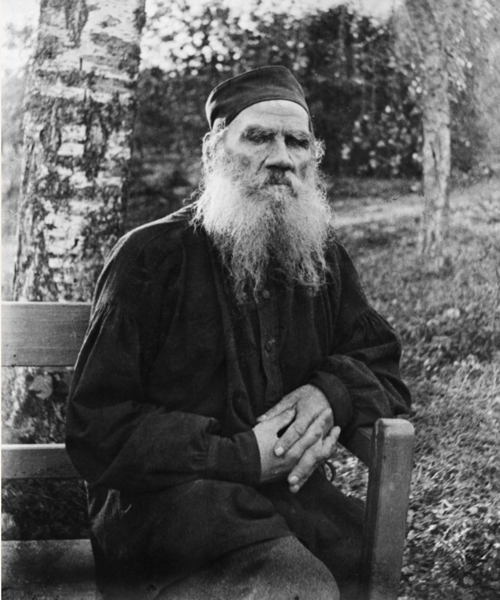

The Cause of it All, Leo Tolstoy

The Cause of it All

CHARACTERS

AKULÍNA. An old woman of seventy, brisk, dignified, old-fashioned.

MICHAEL. Her son, thirty-five years old, passionate, self-satisfied, vain and strong.

MARTHA. Her daughter-in-law, a grumbler, speaks much and rapidly.

PARÁSHKA. Ten years old, daughter of Martha and Michael.

TARÁS. The village elder's assistant, speaks slowly and gives himself airs.

A TRAMP. Forty years old, restless, thin, speaks impressively; when drunk is particularly free and easy.

IGNÁT. Forty years old, a buffoon, merry and stupid.

ACT I

Autumn. A peasant's hut, with a small room partitioned off. Akulína sits spinning; Martha the housewife is kneading bread; little Paráshka is rocking a cradle.

MARTHA. Oh dear, my heart feels heavy! I know it means trouble; there's nothing to keep him there. It will again be like the other day, when he went to town to sell the firewood and drank nearly half of it. And he blames me for everything.

AKULÍNA. Why look for trouble? It is still early, and the town is a long way off. For the present ...

MARTHA. What do you mean by early? Akímych is back already. He started after Michael but Michael's not back yet! It's worry worry all day long; that's all the pleasure one gets.

AKULÍNA. Akímych took his load straight to a customer; but our man took his to sell at the market.

MARTHA. If he were alone I shouldn't worry, but Ignát is with him; and when he's with that lousy hound (God forgive me!), he's sure to get drunk. Early and late one toils and moils. Everything is on our shoulders! If one only got anything by it! But no! hustling about all day long is all the pleasure one gets.

Door opens and Tarás enters with a ragged Tramp.

TARÁS. Good day to you! I've brought a man who wants a night's lodging.[1]

[1] It is customary for the village authorities to quarter tramps on each peasant household in a village in turn, or in such order as appears convenient.

TRAMP [bows] My respects to you.

MARTHA. Why do you bring them to us so often? We put up a tramp last Wednesday night; you always bring them to us. You should make Stepanída put them up; there are no children there. It's more than I can do to look after my own family, and you always bring these people to us.

TARÁS. Everyone in turn has to put them up.

MARTHA. It's all very well to say "everyone in turn," but I have children, and besides, the master is not at home to-day.

TARÁS. Never mind, let the fellow sleep here to-night; he'll not wear out the place he lies on.

AKULÍNA [to Tramp] Come in and sit down, and be our guest.

TRAMP. I tender my gratitude. I should like a bite of something, if possible.

MARTHA. You haven't had time to look round, and want to eat already. Didn't you beg anything in the village?

TRAMP [sighs] I'm not in the habit of begging because of my position, and having no producks of my own ...

Akulína rises, goes to the table, takes a loaf of bread, cuts a slice, and gives it to the Tramp.

TRAMP [taking the bread] Merci.[2] [Sits down on the bench and eats greedily].

[2] The tramp, who has had some acquaintance with educated Revolutionaries, tries to introduce foreign words, or words not generally used by workmen, into his talk. In this instance he used the French word merci instead of the plain "thank you."

TARÁS. And where is Michael?

MARTHA. Why, he took hay to the town. It's time he was back, but he's not here. Something must have happened.

TARÁS. Why, what should happen?

MARTHA. What indeed? Not anything good; it's only bad one has to expect. As soon as he's out of the house he forgets all about us! I expect he'll come back tipsy!

AKULÍNA [sitting down to spin, points at Martha and says to Tarás] It's not in her to be quiet. As I always say, we women must find something to grumble about.

MARTHA. If he were alone I should not be afraid, but he went with Ignát.

TARÁS [smiling] Ah well, Ignát Ivánovich certainly is fond of a drop of vódka.

AKULÍNA. Doesn't he know what Ignát is like! Ignát is one man, and our Michael's another.

MARTHA. It's all very well for you to talk, mother; but I'm sick of his drinking. While he is sober it would be a sin to complain of him, but when he's drunk, you know what he is like. One can't say a word; everything is wrong.

TARÁS. Yes, but look at you women too; a man has a drink. Well, he swaggers about a bit, and sleeps it off, and everything goes on all right; but then the likes of you keep on nagging at him.

MARTHA. When he's drunk there's no pleasing him, do what you will.

TARÁS. But you should understand that we can't help having a drop now and then. Your woman's business is at home, but the likes of us must have a drop when we're on business, or for company's sake. Well, so one drinks, and where is the harm?

MARTHA. You may talk, but it's hard on us women. Oh, how hard it is! If one harnessed you men to our work just for a week, you would sing a different tune. Kneading, cooking, baking, spinning, weaving, and the cattle to look after, and all the rest of it, and the brats to keep washed and clothed and fed; it's all on our shoulders, and if anything is the least bit not to his fancy, there you are, especially when he's drunk. Oh dear, what a life ours is!

TRAMP [chewing] That's quite correct. It's the cause of it all; I mean all the catastrophes of life proceed from alcoholic liquors.

TARÁS. It seems to have bowled you over too!

TRAMP. No, not exactly that, though I have suffered from that too. The career of my life might have been different but for the drink.

TARÁS. Now, to my thinking, if you drink reasonably, there's no manner of harm in it.

TRAMP. But I say that it is so strong that it may completely ruin a man.

MARTHA. That's what I say: you worry and do your best, and the only comfort you get is to be scolded and beaten like a dog.

TRAMP. And that's not all. There are some people, persons I mean, that are quite deprived of their reason through it and commit entirely inappropriate actions. While he does not drink, give him anything you like and he won't take what is not his; but when drunk, he grabs whatever comes handy. Many a time one gets beaten and put in prison. As long as I don't drink, all goes honestly and honourably, but as soon as I drink, I mean as soon as that same person drinks, he at once begins grabbing whatever comes his way.

AKULÍNA. And I think it's all in oneself.

TRAMP. Of course it's in oneself as long as one is well, but this is a kind of disease.

TARÁS. A nice kind of disease. A good hiding would soon cure that disease. Well, goodbye for the present. [Exit].

MARTHA [wipes her hands and turns to go].

AKULÍNA [sees that the Tramp has finished his bread] Martha, I say, Martha! Cut him another piece.

MARTHA. Bother him, I must get the samovár to boil. [Exit].

Akulína rises, goes to the table, cuts a chunk of bread and gives it to the Tramp.

TRAMP. Merci, I have acquired a great appetite.

AKULÍNA. Are you a workman?

TRAMP. Who? I? I was a mechanic.

AKULÍNA. And what wages did you get?

TRAMP. I used to get fifty, and even seventy roubles, a month.

AKULÍNA. That's a good lot! Then how have you come down so low?

TRAMP. Come down! I'm not the only one. I've come down because the times are such that it is impossible for an honest man to live.

MARTHA [brings in the samovár] Oh Lord! it's certain sure he'll come home drunk. I feel it in my heart.

AKULÍNA. I'm afraid he must really have gone on the spree.

MARTHA. There it is. One struggles and struggles and kneads and bakes and cooks and spins and weaves and tends the cattle; everything on one's own shoulders. [The baby in the cradle cries] Paráshka, rock the boy. Oh dear, what a life it is for us women. And when he is drunk, nothing is right!... If one only says a word he doesn't like ...

AKULÍNA [making the tea] And this is the last of the tea. Did you tell him to get some?

MARTHA. Of course. He said he would, but he'll have forgotten all about his home!... [She puts the samovár on the table].

The Tramp moves away.

AKULÍNA. Why do you leave the table? We are going to drink tea.

TRAMP. I tender my gratitude for the hearty hospitality. [Throws away the cheap cigar[3] he was smoking and comes to the table].

[3] The "cigar" will have probably consisted of some bad tobacco rolled up in a bit of newspaper.

MARTHA. And what sort do you belong to? Peasants, or some other?

TRAMP. Well, I'm not of the peasant class, nor of the aristocracy. I'm of the double-edged class.

MARTHA. What's that? [hands him a cup of tea].

TRAMP. Merci. Why this; that my father was a Polish Count, and besides him I had many others; and I also had two mothers. In general my biography presents many difficulties.

MARTHA. Have another cup? Well, did you get any learning?

TRAMP. My learning has also been very uncircumstantial. Not my mother, but my godmother apprenticed me to a blacksmith. That blacksmith was my first perdagogue; and his perdagogy consisted in this--that he did not beat his anvil as often as he beat my unfortunate head. Nevertheless, however much he hit me, he could not deprive me of talent. Then I went to a locksmith's, and there I was appreciated, and became foreman. I made acquaintance with educated people, and belonged to a political faction. I was able to master intellectual literature; and my life might have been elevated for I possessed immense talent.

AKULÍNA. Of course.

TRAMP. But here came an upset. The despotic yoke oppressing the life of the people! I got into prison; I mean, I suffered the incarceration of freedom.

MARTHA. What for?

TRAMP. For our rights.

MARTHA. What rights?

TRAMP. What rights? Why the rights that the bourgeois should not feast continually, and that the labouring proletariat might reap the rewards of labour.

AKULÍNA. And get back the land, I suppose?

TRAMP. Well naturally. The Agromoric question too.

AKULÍNA. May God and the Holy Queen of Heaven grant it. We are that pressed for land. Well, and how are things now?

TRAMP. Now? I am off to Moscow. I shall go to an exploiter of labour. Can't be helped; I shall humble myself and say--give me what work you will, only take me.

AKULÍNA. Well, have some more tea.

TRAMP. Thank you; merci I mean.

Noise and talk in the passage outside.

AKULÍNA. Here's Michael, just in time for tea.

MARTHA [rises] Oh, my goodness, Ignát is with him! That means he's drunk.

Michael and Ignát stagger in.

IGNÁT. How are you all? [Crosses himself before the icon] Here we are, damn you, just in time for tea. We went to church, service was done; we went to dine, all eaten and gone; to the pub, we went in, just time to begin. Ha, ha, ha! You give us some tea and we'll give you some vódka. That's fair. [Laughs].

MICHAEL. Where has this swell come from? [Points to Tramp. Takes a bottle from the bosom of his coat and puts it on the table] Bring some cups.

AKULÍNA. Well, did you get on all right?

IGNÁT. Nothing could be better, damn you; drank, and had a spree, and have brought some home.

MICHAEL [fills the cups with vódka, hands one to his mother and then one to the Tramp] Drink, you too!

TRAMP [taking cup] I offer most heartfelt thanks. Your health. [Empties the cup].

IGNÁT. Fine fellow, how he swills, damn him! I should think hunger makes it run through all his veins. [Pours out some more].

TRAMP [drinks] I wish you success in all your undertakings.

AKULÍNA. Well, did you get a good price for the hay?

IGNÁT. Good or bad, we've drunk it all, damn you! Am I right, Michael?

MICHAEL. Why, of course. It's not made to be looked at! One must have some fun once in a hundred years.

MARTHA. What are you swaggering for? There's not much good in that. We've nothing to eat at home, and see what you're doing.

MICHAEL [threateningly] Martha!

MARTHA. Well, what of Martha? I know I'm Martha. Oh, it makes me sick to look at you.

MICHAEL. Martha, look!

MARTHA. There's nothing to see. I don't want to look.

MICHAEL. Pour out the vódka and serve it round to our visitors.

MARTHA. Faugh, you bleary-eyed hound. I don't want to speak to you.

MICHAEL. You don't? Ah, you baggage, what did you say?

MARTHA [rocks cradle. Paráshka is frightened and comes to her] What I said? I said I do not want to talk to you, that's all.

MICHAEL. Have you forgotten? [Jumps up from the table, strikes her on the head and knocks off her kerchief] One!

MARTHA. Oh! Oh! Oh! [Runs crying to the door].

MICHAEL. You'll not get away, you jade! [Rushes at her].

TRAMP [jumps up from the table and seizes his arm] You have no kind of complete right.

MICHAEL [stops and looks at Tramp with surprise] Is it long since you had a thrashing?

TRAMP. You have no complete right to subject the female sex to insults.

MICHAEL. Oh, you son of a bitch! Do you see this? [Shows his fist].

TRAMP. I will not allow exploitations to be performed on the female sex.

MICHAEL. I'll give you such an extolpation that you'll not know which end you stand on....

TRAMP. Go on, strike away! Why don't you? [Holds out his face].

MICHAEL [shrugs his shoulders and spreads out his arms] Suppose I really go for you?

TRAMP. I tell you, strike!

MICHAEL. Well, you are a rum chap, now I come to look at you. [Drops his arms and shakes his head].

IGNÁT [to Tramp] One sees at once that you're pretty sweet on the women, damn you!

TRAMP. I stand up for their rights.

MICHAEL [to Martha as, breathing heavily, he steps to the table] Well Martha, you must set a big candle before the saints for his sake. But for him, I'd have beaten you to a jelly.

MARTHA. What else can one expect of you. One worries all one's life, baking and cooking; and as soon as ...

MICHAEL. Now, have done, have done! [Offers vódka to the Tramp] Drink. [To his wife] And what are you slobbering for? Mayn't a fellow have his joke? There you are [gives her money], put it away. Here are two three-rouble notes and two twenty-copeck pieces.

MARTHA. And the tea and sugar I wanted?

MICHAEL [takes parcel from his pocket and hands it to his wife. Martha takes the money and the parcel and goes into the little room, silently arranging the kerchief on her head] What an unreasonable lot these women are. [He again offers vódka to the Tramp] There, drink.

TRAMP [declining it] Drink it yourself.

MICHAEL. Come now, don't fuss.

TRAMP [drinking] Success to you.

IGNÁT [to Tramp] You must have seen many a strange sight, I suppose. Oh, what a fine coat you've got! Latest fashion. Where did you get it from? [pointing to Tramp's tattered jacket]. Don't you mend it, it's fine as it is! It's getting on in years, I fancy. Well, it can't be helped. If I had one like it, the women would be sweet on me too! [To Martha] Ain't that true?

AKULÍNA. You should not, Ignát Iványch. Before seeing anything of him, why go and hold up a man to laughter?

TRAMP. It comes of his uneducatedness.

IGNÁT. I'm doing it friendly-like. Drink [offers vódka].

AKULÍNA. He says himself--it's the cause of all evil--and he's been in prison because of it.

MICHAEL. What were you in prison for?

TRAMP [very drunk] I've suffered for expropriation.

MICHAEL. What's that?

TRAMP. Why, this way. Came up to a fat paunch: "Give up your money, else here's a levolver."[4] He tries this way and that, but forks out 2,300 roubles.

[4] As usual he mispronounces his word and calls a "revolver" "a levolver."

AKULÍNA. Oh Lord!

TRAMP. We meant to dispose of it the proper way. Zembrikóf was our leader. Then those ravens swooped down on us. At once under arrest, and into prison.

IGNÁT. And took the money away?

TRAMP. Of course. Only they could not convict me. At the trial the procurator said these words to me: "You've stolen money" says he; and I answer him straight: "Thieves steal, but we have performed an expropriation for our Party." And he didn't know what to say. He tried this way and that, but couldn't answer me. "Lead him," says he, "to prison," that is--to the incarceration of free life.

IGNÁT. Clever dog! A regular brick! [Offering vódka] Drink, damn you.

AKULÍNA. Fie, how nastily you speak!

IGNÁT. I, Grannie? I don't mean it for abuse; it's a manner of speech of mine. Damn you, damn you!... Your good health, Grannie.

MARTHA [returns and stands at the table pouring out tea].

MICHAEL. That's right. Fancy taking offence! I say, it's thanks to him. [To Tramp] What do you think? [Embraces Martha] I cherish my old woman. See, how I cherish her. In a word, my old woman is first-rate. I would not change her for anybody.

IGNÁT. There, that's good. Grannie, drink! I stand treat.

TRAMP. What it means--the power of enershy! One was in a state of melancholy, and now there's nothing but pleasantness and friendly disposition. Grannie, I feel much love for you and for everybody. Brothers dear [sings revolutionary song].

MICHAEL. It has got right hold of him in his hunger.

ACT II

Same hut. Morning

Martha and Akulína. Michael is asleep

MARTHA [takes hatchet] I must go and chop some firewood.

AKULÍNA [with a pail] He'd have beaten you black and blue yesterday, had it not been for that fellow. I don't see him. Has he gone? I suppose he has. [Exit one after the other].

MICHAEL [climbs down from the top of the oven] Just look, the sun's already quite high. [Puts on his boots] She must have gone to fetch water with mother. How my head aches! I won't do it again; the devil take it! [Crosses himself before the icon, prays, and then washes his hands and face] I'll go and harness.

Enter Martha with firewood.

MARTHA. And yesterday's beggar? Has he gone?

MICHAEL. Must have gone. Can't see him.

MARTHA. Oh well, let him go. He seemed a clever chap though.

MICHAEL. He took your part!

MARTHA. What of that!

Michael puts on his coat.

MARTHA. And the tea and sugar? Did you put them away last night, eh?

MICHAEL. I thought you did.

Enter Akulína with a pail of water.

MARTHA [to Akulína] Mother, have you taken the parcel?

AKULÍNA. No, I know nothing about it. I haven't seen it.

MARTHA. Last night, I put it on the window-sill.

AKULÍNA. Yes, I saw it there.

MARTHA. Where can it be? [They look for it].

AKULÍNA. Dear me, what a shame!

Enter Neighbour.

NEIGHBOUR. Well Michael Tikhónych, are we to go for the wood?

MICHAEL. Yes, of course. I'm just going to harness; but you see we've lost something.

NEIGHBOUR. Dear me! What is it?

MARTHA. Why, you see, my old man brought a parcel from town yesterday, with tea and sugar in it, and I put it down here on the window-sill and didn't remember to put it away; and now it's gone.

MICHAEL. And we're committing the sin of suspecting a tramp who spent the night here.

NEIGHBOUR. What sort of tramp?

MARTHA. Well, he's rather thin and has no beard.

MICHAEL. His coat's all in rags.

NEIGHBOUR. Curly hair and rather hooked nose?

MICHAEL. Yes, yes!

NEIGHBOUR. I've just met him, and wondered why he was stepping out so fast.

MICHAEL. It must be him. Where was he?

NEIGHBOUR. I don't think he can have crossed the bridge yet.

MICHAEL [snatches up his cap and goes out quickly, followed by the Neighbour] I'll catch the knave. It's him.

MARTHA. Oh, what a shame, what a shame! It's surely him.

AKULÍNA. And suppose it's not. It happened once, some twenty years ago, that they accused a man of having stolen a horse. A crowd collected. One says: "I myself saw him catching it." Another says he saw him leading it. It was a big piebald horse, easily noticed. All the people began searching for it, and in the forest they found the lad. "It's you," they say. He protests and swears it was not him. They say: "What's the good of listening to him; the women said quite certainly it's him." Then he said something rude. George Lapúshkin (he's dead now) was a hot-tempered man. He dashed at him slap bang, and struck him on the mouth. "It was you," said he, and hit out at him. Then all the others fell on him and began beating him with sticks and fists till they killed him. And what do you think!.... Next day the real thief was found. The lad they killed had only gone into the forest to choose a tree to cut down.

MARTHA. Yes, of course, we may be sinning against him. He has come down very low, but seemed a good fellow.

AKULÍNA. Yes, he has sunk very low. One can't expect much from the likes of him.

MARTHA. They're shouting. I expect they're bringing him back.

Enter Michael, Neighbour, an old man and a lad, pushing the Tramp before them.

MICHAEL [with the parcel in his hands, excitedly to his wife] It was found on him. [To Tramp] You thief! You dog!

AKULÍNA [to Martha] It's him, poor soul. See how he hangs his head.

MARTHA. It seems it was himself he spoke about yesterday that grabs anything that's handy when he's had some drink.

TRAMP. I'm not a thief; I'm an expropriator. I am a worker and must live. You can't understand it. Do what you like with me.

NEIGHBOUR. Take him to the village Elder or straight to the police!

TRAMP. I tell you, do whatever you like. I am not afraid, and am ready to suffer for my convictions. If you were educated you would understand.

MARTHA [to her husband] Suppose we let him go, in God's name. We've got the parcel back. Let him go and let's not commit another sin.

MICHAEL [repeating] "Another sin!" Taken to teaching? One wouldn't know what to do without you, eh?

MARTHA. Why not let him go?

MICHAEL. "Let him go!" One knows what to do without you, you fool. "Let him go!" Go he may, but he must hear a word or two so that he should feel. [To Tramp] Well then, listen, you sir, to what I have to say to you. Though you are in a very low state, still you have done very wrong--very wrong. Another man would have caved your ribs in, and have taken you to the police; but I will only say this. You've done wrong, as wrong as may be; only you are in a very bad way and I don't want to hurt you. [Pauses. Everyone is silent. Then he continues solemnly] Go, and God be with you, and do not do it again. [Looks at his wife] And you want to teach me!

NEIGHBOUR. You shouldn't, Michael; oh, you should not. You're encouraging that sort of thing.

MICHAEL [the parcel still in his hand] Whether I should or not is my business. [To his wife] And you tried to teach me! [Stops, looks at the parcel, then at his wife, and gives it to the Tramp with decision] Take it, you can drink it on the way. [To wife] And you wanted to teach me! [To Tramp] Go, you've been told to go. Then go, and no palavering.

TRAMP [takes parcel. Silence] You think I don't understand. [His voice trembles] I fully understand. Had you beaten me like a dog, it would have felt less hard. Don't I understand what I am? I am a rascal, a degenerate, I mean. Forgive me for the Lord's sake. [Sobs, throws the parcel on the table, and goes out hurriedly].

MARTHA. A good thing he didn't take the tea, or we should have had none to drink.

MICHAEL [to wife] And you wanted to teach me!

NEIGHBOUR. How he cried, poor soul.

AKULÍNA. He too was a man.

The End