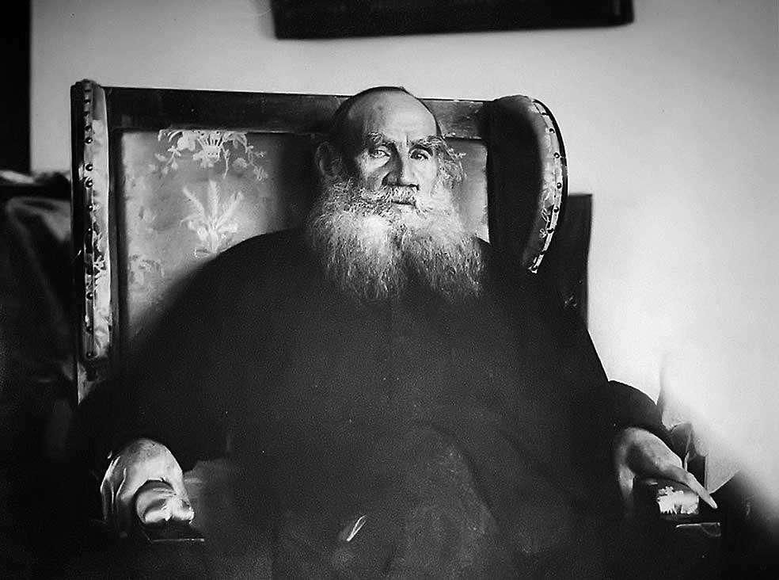

The Coffee-House Of Surat, Leo Tolstoy

The Coffee-House Of Surat

Translated by Louise and Aylmer Maude 1906

IN THE TOWN of Surat, in India, was a coffee-house where many travellers and foreigners from all Parts of the world met and conversed.

One day a learned Persian theologian visited this coffee-house. He was a man who had spent his life studying the nature of the Deity, and reading and writing books upon the subject. He had thought, read, and written so much about God, that eventually he lost his wits, became quite confused, and ceased even to believe in the existence of a God. The Shah, hearing of this, had banished him from Persia.

After having argued all his life about the First Cause, this unfortunate theologian had ended by quite perplexing himself, and instead of understanding that he had lost his own reason, he began to think that there was no higher Reason controlling the universe.

This man had an African slave who followed him everywhere. When the theologian entered the coffee-house, the slave remained outside, near the door, sitting on a stone in the glare of the sun, and driving away the flies that buzzed around him. The Persian having settled down on a divan in the coffee-house, ordered himself a cup of opium. When he had drunk it and the opium had begun to quicken the workings of his brain, he addressed his slave through the open door:

“Tell me, wretched slave,” said he, “do you think there is a God, or not?”

“Of course there is,” said the slave, and immediately drew from under his girdle a small idol of wood.

“There,” said he, “that is the God who has guarded me from the day of my birth. Every one in our country worships the fetish tree, from the wood of which this God was made.”

This conversation between the theologian and his slave was listened to with surprise by the other guests in the coffee-house. They were astonished at the master’s question, and yet more so at the slave’s reply.

One of them, a Brahmin, on hearing the words spoken by the slave, turned to him and said:

“Miserable fool! Is it possible you believe that God can be carried under a man’s girdle? There is one God — Brahma, and he is greater than the whole world, for he created it. Brahma is the One, the mighty God, and in His honour are built the temples on the Ganges’ banks, where his true priests, the Brahmins, worship him. They know the true God, and none but they. A thousand score of years have passed, and yet through revolution after revolution these priests have held their sway, because Brahma, the one true God, has protected them.”

So spoke the Brahmin, thinking to convince every one; but a Jewish broker who was present replied to him, and said:

“No! the temple of the true God is not in India. Neither does God protect the Brahmin caste. The true God is not the God of the Brahmins, but of Abraham, Isaac, and Jacob. None does He protect but His chosen people, the Israelites. From the commencement of the world, our nation has been beloved of Him, and ours alone. If we are now scattered over the whole earth, it is but to try us; for God has promised that He will one day gather His people together in Jerusalem. Then, with the Temple of Jerusalem — the wonder of the ancient world — restored to its splendor, shall Israel be established a ruler over all nations.”

So spoke the Jew, and burst into tears. He wished to say more, but an Italian missionary who was there interrupted him.

“What you are saying is untrue,” said he to the Jew. “You attribute injustice to God. He cannot love your nation above the rest. Nay rather, even if it be true that of old He favored the Israelites, it is now nineteen hundred years since they angered Him, and caused Him to destroy their nation and scatter them over the earth, so that their faith makes no converts and has died out except here and there. God shows preference to no nation, but calls all who wish to be saved to the bosom of the Catholic Church of Rome, the one outside whose borders no salvation can be found.”

So spoke the Italian. But a Protestant minister, who happened to be present, growing pale, turned to the Catholic missionary and exclaimed:

“How can you say that salvation belongs to your religion? Those only will be saved, who serve God according to the Gospel, in spirit and in truth, as bidden by the word of Christ.”

Then a Turk, an office-holder in the custom-house at Surat, who was sitting in the coffee-house smoking a pipe, turned with an air of superiority to both the Christians.

“Your belief in your Roman religion is vain,” said he. “It was superseded twelve hundred years ago by the true faith: that of Mohammed! You cannot but observe how the true Mohammed faith continues to spread both in Europe and Asia, and even in the enlightened country of China. You say yourselves that God has rejected the Jews; and, as a proof, you quote the fact that the Jews are humiliated and their faith does not spread. Confess then the truth of Mohammedanism, for it is triumphant and spreads far and wide. None will be saved but the followers of Mohammed, God’s latest prophet; and of them, only the followers of Omar, and not of Ali, for the latter are false to the faith.”

To this the Persian theologian, who was of the sect of Ali, wished to reply; but by this time a great dispute had arisen among all the strangers of different faiths and creeds present. There were Abyssinian Christians, Llamas from Thibet, Ismailians and Fireworshippers. They all argued about the nature of God, and how He should be worshipped. Each of them asserted that in his country alone was the true God known and rightly worshipped.

Every one argued and shouted, except a Chinaman, a student of Confucius, who sat quietly in one corner of the coffee-house, not joining in the dispute. He sat there drinking tea and listening to what the others said, but did not speak himself.

The Turk noticed him sitting there, and appealed to him, saying:

“You can confirm what I say, my good Chinaman. You hold your peace, but if you spoke I know you would uphold my opinion. Traders from your country, who come to me for assistance, tell me that though many religions have been introduced into China, you Chinese consider Mohammedanism the best of all, and adopt it willingly. Confirm, then, my words, and tell us your opinion of the true God and of His prophet.”

“Yes, yes,” said the rest, turning to the Chinaman, “let us hear what you think on the subject.”

The Chinaman, the student of Confucius, closed his eyes, and thought a while. Then he opened them again, and drawing his hands out of the wide sleeves of his garment, and folding them on his breast, he spoke as follows, in a calm and quiet voice.

“Sirs, it seems to me that it is chiefly pride that prevents men agreeing with one another on matters of faith. If you care to listen to me, I will tell you a story which will explain this by an example.”

“I came here from China on an English steamer which had been round the world. We stopped for fresh water, and landed on the east coast of the island of Sumatra. It was midday, and some of us, having landed, sat in the shade of some cocoanut palms by the seashore, not far from a native village. We were a Party of men of different nationalities.”

“As we sat there, a blind man approached us. We learned afterwards that he had gone blind from gazing too long and too persistently at the sun, trying to find out what it is, in order to seize its light.”

“He strove a long time to accomplish this, constantly looking at the sun; but the only result was that his eyes were injured by its brightness, and he became blind.”

“Then he said to himself:”

“The light of the sun is not a liquid; for if it were a liquid it would be possible to pour it from one vessel into another, and it would be moved, like water, by the wind. Neither is it fire; for if it were fire, water would extinguish it. Neither is light a spirit, for it is seen by the eye; nor is it matter, for it cannot be moved. Therefore, as the light of the sun is neither liquid, nor fire, nor spirit, nor matter, it is — nothing!”

“So he argued, and, as a result of always looking at the sun and always thinking about it, he lost both his sight and his reason. And when he went quite blind, he became fully convinced that the sun did not exist.”

“With this blind man came a slave, who after placing his master in the shade of a cocoanut tree, picked up a cocoanut from the ground, and began making it into a night-light. He twisted a wick from the fibre of the cocoanut: squeezed oil from the nut in the shell, and soaked the wick in it.”

“As the slave sat doing this, the blind man sighed and said to him:”

“Well, slave, was I not right when I told you there is no sun? Do you not see how dark it is? Yet people say there is a sun. . . . But if so, what is it?”

“I do not know what the sun is,” said the slave. “That is no business of mine. But I know what light is. Here I have made a night-light, by the help of which I can serve you and find anything I want in the hut.”

And the slave picked up the cocoanut shell, saying:

“This is my sun.”

A lame man with crutches, who was sitting near by, heard these words, and laughed:

“You have evidently been blind all your life,” said he to the blind man, “not to know what the sun is. I will tell you what it is. The sun is a ball of fire, which rises every morning out of the sea and goes down again among the mountains of our island each evening. We have all seen this, and if you had had your eyesight you too would have seen it.”

A fisherman, who had been listening to the conversation said:

“It is plain enough that you have never been beyond your own island. If you were not lame, and if you had been out as I have in a fishing-boat, you would know that the sun does not set among the mountains of our island, but as it rises from the ocean every morning so it sets again in the sea every night. What I am telling you is true, for I see it every day with my own eyes.”

Then an Indian who was of our Party, interrupted him by saying:

“I am astonished that a reasonable man should talk such nonsense. How can a ball of fire possibly descend into the water and not be extinguished? The sun is not a ball of fire at all, it is the Deity named Deva, who rides for ever in a chariot round the golden mountain, Meru. Sometimes the evil serpents Ragu and Ketu attack Deva and swallow him: and then the earth is dark. But our priests pray that the Deity may be released, and then he is set free. Only such ignorant men as you, who have never been beyond their own island, can imagine that the sun shines for their country alone.”

Then the master of an Egyptian vessel, who was present, spoke in his turn.

“No,” said he, “you also are wrong. The sun is not a Deity, and does not move only round India and its golden mountain. I have sailed much on the Black Sea, and along the coasts of Arabia, and have been to Madagascar and to the Philippines. The sun lights the whole earth, and not India alone. It does not circle round one mountain, but rises far in the East, beyond the Isles of Japan, and sets far, far away in the West, beyond the islands of England. That is why the Japanese call their country ‘Nippon,’ that is, ‘the birth of the sun.’ I know this well, for I have myself seen much, and heard more from my grandfather, who sailed to the very ends of the sea.”

He would have gone on, but an English sailor from our ship interrupted him.

“There is no country,” he said “where people know so much about the sun’s movements as in England. The sun, as every one in England knows, rises nowhere and sets nowhere. It is always moving round the earth. We can be sure of this for we have just been round the world ourselves, and nowhere knocked up against the sun. Wherever we went, the sun showed itself in the morning and hid itself at night, just as it does here.”

And the Englishman took a stick and, drawing circles on the sand, tried to explain how the sun moves in the heavens and goes round the world. But he was unable to explain it clearly, and pointing to the ship’s pilot said:

“This man knows more about it than I do. He can explain it properly.”

The pilot, who was an intelligent man, had listened in silence to the talk till he was asked to speak. Now every one turned to him, and he said:

“You are all misleading one another, and are yourselves deceived. The sun does not go round the earth, but the earth goes round the sun, revolving as it goes, and turning towards the sun in the course of each twenty-four hours, not only Japan, and the Philippines, and Sumatra where we now are, but Africa, and Europe, and America, and many lands besides.

The sun does not shine for some one mountain, or for some one island, or for some one sea, nor even for one earth alone, but for other planets as well as our earth. If you would only look up at the heavens, instead of at the ground beneath your own feet, you might all understand this, and would then no longer suppose that the sun shines for you, or for your country alone.”

Thus spoke the wise pilot, who had voyaged much about the world, and had gazed much upon the heavens above.

“So on matters of faith,” continued the Chinaman, the student of Confucius, “it is pride that causes error and discord among men. As with the sun, so it is with God. Each man wants to have a special God of his own, or at least a special God for his native land. Each nation wishes to confine in its own temples Him, whom the world cannot contain.

“Can any temple compare with that which God Himself has built to unite all men in one faith and one religion?

“All human temples are built on the model of this temple, which is God’s own world. Every temple has its fonts, its vaulted roof, its lamps, its pictures or sculptures, its inscriptions, its books of the law, its offerings, its altars and its priests. But in what temple is there such a font as the ocean; such a vault as that of the heavens; such lamps as the sun, moon, and stars; or any figures to be compared with living, loving, mutually-helpful men?

Where are there any records of God’s goodness so easy to understand as the blessings which God has strewn abroad for man’s happiness? Where is there any book of the law so clear to each man as that written in his heart? What sacrifices equal the self-denials which loving men and women make for one another? And what altar can be compared with the heart of a good man, on which God Himself accepts the sacrifice?

“The higher a man’s conception of God, the better will he know Him. And the better he knows God, the nearer will he draw to Him, imitating His goodness, His mercy, and His love of man.

“Therefore, let him who sees the sun’s whole light filling the world, refrain from blaming or despising the superstitious man, who in his own idol sees one ray of that same light. Let him not despise even the unbeliever who is blind and cannot see the sun at all.”

So spoke the Chinaman, the student of Confucius; and all who were present in the coffee-house were silent, and disputed no more as to whose faith was the best.

The End