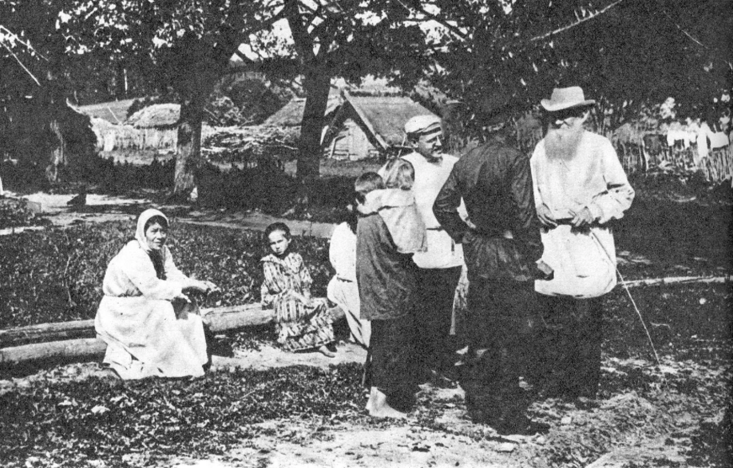

The Empty Drum, Leo Tolstoy

The Empty Drum

Translated by Louise and Aylmer Maude 1906

EMELYÁN WAS A labourer and worked for a master. Crossing the meadows one day on his way to work, he nearly trod on a frog that jumped right in front of him, but he just managed to avoid it. Suddenly he heard some one calling to him from behind.

Emelyán looked round and saw a lovely lassie, who said to him: ‘Why don’t you get married, Emelyán?’

‘How can I marry, my lass?’ said he. ‘I have but the clothes I stand up in, nothing more, and no one would have me for a husband.’

‘Take me for a wife,’ said she.

Emelyán liked the maid. ‘I should be glad to,’ said he, ‘but where and how could we live?’

‘Why trouble about that?’ said the girl. ‘One only has to work more and sleep less, and one can clothe and feed oneself anywhere.’

‘Very well then, let us marry,’ said Emelyán. ‘Where shall we go to?’

‘Let us go to town.’

So Emelyán and the lass went to town, and she took him to a small hut on the very edge of the town, and they married and began housekeeping.

One day the King, driving through the town, passed by Emelyán’s hut. Emelyán’s wife came out to see the King. The King noticed her and was quite surprised.

‘Where did such a beauty come from?’ said he and stopping his carriage he called Emelyán’s wife and asked her: ‘Who are you?’

‘The peasant Emelyán’s wife,’ said she.

‘Why did you, who are such a beauty, marry a peasant?’ said the King. ‘You ought to be a queen!’

‘Thank you for your kind words,’ said she, ‘but a peasant husband is good enough for me.’

The King talked to her awhile and then drove on. He returned to the palace, but could not get Emelyán’s wife out of his head. All night he did not sleep, but kept thinking how to get her for himself. He could think of no way of doing it, so he called his servants and told them they must find a way.

The King’s servants said: ‘Command Emelyán to come to the palace to work, and we will work him so hard that he will die. His wife will be left a widow, and then you can take her for yourself.’

The King followed their advice. He sent an order that Emelyán should come to the palace as a workman and that he should live at the palace, and his wife with him.

The messengers came to Emelyán and gave him the King’s message. His wife said, ‘Go, Emelyán; work all day, but come back home at night.’

So Emelyán went, and when he got to the palace the King’s steward asked him, ‘Why have you come alone, without your wife?’

‘Why should I drag her about?’ said Emelyán. ‘She has a house to live in.’

At the King’s palace they gave Emelyán work enough for two. He began the job not hoping to finish it; but when evening came, lo and behold! it was all done. The steward saw that it was finished, and set him four times as much for next day.

Emelyán went home. Everything there was swept and tidy; the oven was heated, his supper was cooked and ready, and his wife sat by the table sewing and waiting for his return. She greeted him, laid the table, gave him to eat and drink, and then began to ask him about his work.

‘Ah!’ said he, ‘it’s a bad business: they give me tasks beyond my strength, and want to kill me with work.’

‘Don’t fret about the work,’ said she, ‘don’t look either before or behind to see how much you have done or how much there is left to do; only keep on working and all will be right.’

So Emelyán lay down and slept. Next morning he went to work again and worked without once looking round. And, lo and behold! by the evening it was all done, and before dark he came home for the night.

Again and again they increased Emelyán’s work, but he always got through it in good time and went back to his hut to sleep. A week passed, and the King’s servants saw they could not crush him with rough work so they tried giving him work that required skill. But this, also, was of no avail. Carpentering, and masonry, and roofing, whatever they set him to do, Emelyán had it ready in time, and went home to his wife at night. So a second week passed.

Then the King called his servants and said: ‘Am I to feed you for nothing? Two weeks have gone, and I don’t see that you have done anything. You were going to tire Emelyán out with work, but I see from my windows how he goes home every evening — singing cheerfully! Do you mean to make a fool of me?’

The King’s servants began to excuse themselves. ‘We tried our best to wear him out with rough work,’ they said, ‘but nothing was too hard for him; he cleared it all off as though he had swept it away with a broom. There was no tiring him out. Then we set him to tasks needing skill, which we did not think he was clever enough to do, but he managed them all. No matter what one sets him, he does it all, no one knows how.

Either he or his wife must know some spell that helps them. We ourselves are sick of him, and wish to find a task he cannot master. We have now thought of setting him to build a cathedral in a single day. Send for Emelyán, and order him to build a cathedral in front of the palace in a single day. Then, if he does not do it, let his head be cut off for disobedience.’

The King sent for Emelyán. ‘Listen to my command,’ said he: ‘build me a new cathedral on the square in front of my palace, and have it ready by to-morrow evening. If you have it ready I will reward you, but if not I will have your head cut off.’

When Emelyán heard the King’s command he turned away and went home. ‘My end is near,’ thought he. And coming to his wife, he said: ‘Get ready, wife we must fly from here, or I shall be lost by no fault of my own.’

‘What has frightened you so?’ said she, ‘and why should we run away?’

‘How can I help being frightened? The King has ordered me, to-morrow, in a single day, to build him a cathedral. If I fail he will cut my head off. There is only one thing to be done: we must fly while there is yet time.’

But his wife would not hear of it. ‘The King has many soldiers,’ said she. ‘They would catch us anywhere. We cannot escape from him, but must obey him as long as strength holds out.’

‘How can I obey him when the task is beyond my strength?’

‘Eh, goodman, don’t be downhearted. Eat your supper now, and go to sleep. Rise early in the morning and all will get done.’

So Emelyán lay down and slept. His wife roused him early next day. ‘Go quickly,’ said she, ‘and finish the cathedral. Here are nails and a hammer; there is still enough work there for a day.’

Emelyán went into the town, reached the palace square, and there stood a large cathedral not quite finished. Emelyán set to work to do what was needed, and by the evening all was ready.

When the King awoke he looked out from his palace, and saw the cathedral, and Emelyán going about driving in nails here and there. And the King was not pleased to have the cathedral — he was annoyed at not being able to condemn Emelyán and take his wife. Again he called his servants. ‘Emelyán has done this task also,’ said the King, ‘and there is no excuse for putting him to death. Even this work was not too hard for him. You must find a more cunning plan, or I will cut off your heads as well as his.’

So his servants planned that Emelyán should be ordered to make a river round the palace, with ships sailing on it. And the King sent for Emelyán and set him this new task.

‘If,’ said he, ‘you could build a cathedral in one night, you can also do this. To-morrow all must be ready. If not, I will have your head off.’

Emelyán was more downcast than before, and returned to his wife sad at heart.

‘Why are you so sad?’ said his wife. ‘Has the King set you a fresh task?’

Emelyán told her about it. ‘We must fly,’ said he.

But his wife replied: ‘There is no escaping the soldiers; they will catch us wherever we go. There is nothing for it but to obey.’

‘How can I do it?’ groaned Emelyán.

‘Eh! eh! goodman,’ said she, ‘don’t be downhearted. Eat your supper now, and go to sleep. Rise early, and all will get done in good time.’

So Emelyán lay down and slept. In the morning his wife woke him. ‘Go,’ said she ‘to the palace — all is ready. Only, near the wharf in front of the palace, there is a mound left; take a spade and level it.

When the King awoke he saw a river where there had not been one; ships were sailing up and down, and Emelyán was levelling a mound with a spade. The King wondered, but was pleased neither with the river nor with the ships, so vexed was he at not being able to condemn Emelyán. ‘There is no task,’ thought he, ‘that he cannot manage. What is to be done?’ And he called his servants and again asked their advice.

‘Find some task,’ said he, ‘which Emelyán cannot compass. For whatever we plan he fulfils, and I cannot take his wife from him.’

The King’s servants thought and thought, and at last devised a plan. They came to the King and said: ‘Send for Emelyán and say to him: “Go to there, don’t know where,” and bring back “that, don’t know what.” Then he will not be able to escape you. No matter where he goes, you can say that he has not gone to the right place, and no matter what he brings, you can say it is not the right thing. Then you can have him beheaded and can take his wife.’

The King was pleased. ‘That is well thought of,’ said he. So the King sent for Emelyán and said to him: ‘Go to “there, don’t know where,” and bring back “that, don’t know what.” If you fail to bring it, I will have you beheaded.’

Emelyán returned to his wife and told her what the King had said. His wife became thoughtful.

‘Well,’ said she, ‘they have taught the King how to catch you. Now we must act warily.’ So she sat and thought, and at last said to her husband: ‘You must go far, to our Grandam — the old peasant woman, the mother of soldiers — and you must ask her aid. If she helps you to anything, go straight to the palace with it, I shall be there: I cannot escape them now. They will take me by force, but it will not be for long. If you do everything as Grandam directs, you will soon save me.’

So the wife got her husband ready for the journey. She gave him a wallet, and also a spindle. ‘Give her this,’ said she. ‘By this token she will know that you are my husband.’ And his wife showed him his road.

Emelyán set off. He left the town behind, and came to where some soldiers were being drilled. Emelyán stood and watched them. After drill the soldiers sat down to rest. Then Emelyán went up to them and asked: ‘Do you know, brothers, the way to “there, don’t know where?” and how I can get “that, don’t know what?”’

The soldiers listened to him with surprise. ‘Who sent you on this errand?’ said they

‘The King,’ said he.

‘We ourselves,’ said they, ‘from the day we became soldiers, go we “don’t know where,” and never yet have we got there; and we seek we “don’t know what,” and cannot find it. We cannot help you.’

Emelyán sat a while with the soldiers and then went on again. He trudged many a mile, and at last came to a wood. In the wood was a hut, and in the hut sat an old, old woman, the mother of peasant soldiers, spinning flax and weeping. And as she spun she did not put her fingers to her mouth to wet them with spittle, but to her eyes to wet them with tears. When the old woman saw Emelyán she cried out at him: ‘Why have you come here?’ Then Emelyán gave her the spindle, and said his wife had sent it.

The old woman softened at once, and began to question him. And Emelyán told her his whole life: how he married the lass; how they went to live in the town; how he had worked, and what he had done at the palace; how he built the cathedral, and made a river with ships on it, and how the King had now told him to go to ‘there, don’t know where, and bring back ‘that, don’t know what.’

The Grandam listened to the end, and ceased weeping. She muttered to herself: ‘The time has surely come,’ and said to him: ‘All right, my lad. Sit down now, and I will give you something to eat.’

Emelyán ate, and then the Grandam told him what to do. ‘Here,’ said she, ‘is a ball of thread; roll it before you, and follow where it goes. You must go far till you come right to the sea. When you get there you will see a great city. Enter the city and ask for a night’s lodging at the furthest house. There look out for what you are seeking.’

‘How shall I know it when I see it, Granny?’ said he.

‘When you see something men obey more than father or mother, that is it. Seize that, and take it to the King. When you bring it to the King, he will say it is not right, and you must answer: “If it is not the right thing it must be smashed,” and you must beat it, and carry it to the river, break it in pieces, and throw it into the water. Then you will get your wife back and my tears will be dried.’

Emelyán bade farewell to the Grandam and began rolling his ball before him. It rolled and rolled until at last it reached the sea. By the sea stood a great city, and at the further end of the city was a big house. There Emelyán begged for a night’s lodging, and was granted it. He lay down to sleep, and in the morning awoke and heard a father rousing his son to go and cut wood for the fire. But the son did not obey. ‘It is too early,’ said he, ‘there is time enough.’ Then Emelyán heard the mother say, ‘Go, my son, your father’s bones ache; would you have him go himself? It is time to be up!’

But the son only murmured some words and fell asleep again. Hardly was he asleep when something thundered and rattled in the street. Up jumped the son and quickly putting on his clothes ran out into the street. Up jumped Emelyán, too, and ran after him to see what it was that a son obeys more than father or mother. What he saw was a man walking along the street carrying, tied to his stomach, a thing which he beat with sticks, and that it was that rattled and thundered so, and that the son had obeyed. Emelyán ran up and had a look at it. He saw it was round, like a small tub, with a skin stretched over both ends, and he asked what it was called.

He was told, ‘A drum.’

‘And is it empty?’

‘Yes, it is empty.’

Emelyán was surprised. He asked them to give the thing to him, but they would not. So Emelyán left off asking, and followed the drummer. All day he followed, and when the drummer at last lay down to sleep, Emelyán snatched the drum from him and ran away with it.

He ran and ran, till at last he got back to his own town. He went to see his wife, but she was not at home. The day after he went away, the King had taken her. So Emelyán went to the palace, and sent in a message to the King: ‘He has returned who went to “there, don’t know where,” and he has brought with him “that, don’t know what.”’

They told the King, and the King said he was to come again next day.

But Emelyán said, ‘Tell the King I am here to-day, and have brought what the King wanted. Let him come out to me, or I will go in to him!’

The King came out. ‘Where have you been?’ said he.

Emelyán told him.

‘That’s not the right place,’ said the King. ‘What have you brought?’

Emelyán pointed to the drum, but the King did not look at it.

‘That is not it.’

‘If it is not the right thing,’ said Emelyán, ‘it must be smashed, and may the devil take it!’

And Emelyán left the palace, carrying the drum and beating it. And as he beat it all the King’s army ran out to follow Emelyán, and they saluted him and waited his commands.

The King, from his window, began to shout at his army telling them not to follow Emelyán. They did not listen to what he said, but all followed Emelyán.

When the King saw that, he gave orders that Emelyán’s wife should be taken back to him, and he sent to ask Emelyán to give him the drum.

‘It can’t be done,’ said Emelyán. ‘I was told to smash it and to throw the splinters into the river.’

So Emelyán went down to the river carrying the drum, and the soldiers followed him. When he reached the river bank Emelyán smashed the drum to splinters, and threw the splinters into the stream. And then all the soldiers ran away.

Emelyán took his wife and went home with her. And after that the King ceased to trouble him; and so they lived happily ever after.

The End