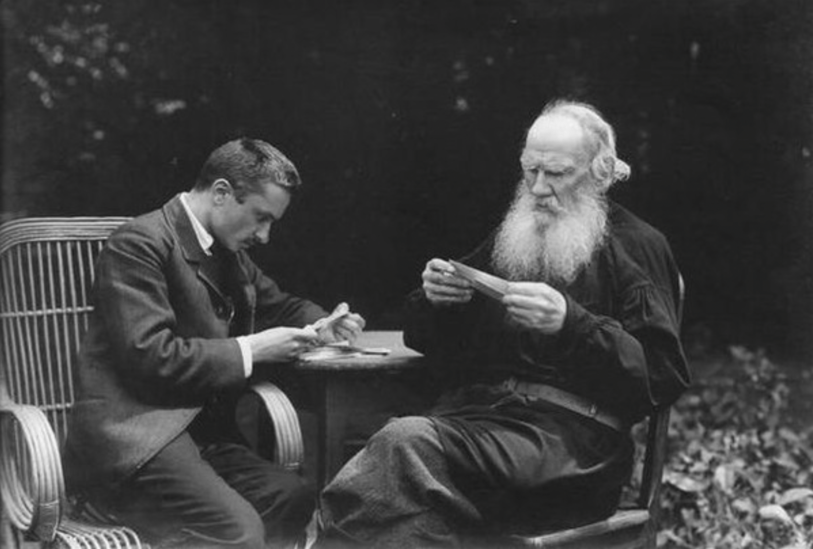

The Great Bear, Leo Tolstoy

The Great Bear

Translated Rochelle S. Townsend 1916

A LONG, LONG time ago there was a big drought on the earth. All the rivers dried up and the streams and wells, and the trees withered and the bushes and grass, and men and beasts died of thirst.

One night a little girl went out with a pitcher to find some water for her sick mother. She wandered and wandered everywhere, but could find no water, and she grew so tired that she lay down on the grass and fell asleep. When she awoke and took up the pitcher she nearly upset the water it contained.

The pitcher was full of clear, fresh water. The little girl was glad and was about to put it to her lips, but she remembered her mother and ran home with the pitcher as fast as she could. She hurried so much that she did not notice a little dog in her path; she stumbled over it and dropped the pitcher. The dog whined pitifully; the little girl seized the pitcher.

She thought the water would have been upset, but the pitcher stood upright and the water was there as before. She poured a little into the palm of her hand and the dog lapped it and was comforted. When the little girl again took up the pitcher, it had turned from common wood to silver. She took the pitcher home and gave it to her mother.

The mother said, “ I shall die just the same; you had better drink it,’ : and she handed the pitcher to the child. In that moment the pitcher turned from silver to gold. The little girl could no longer contain herself and was about to put the pitcher to her lips, when the door opened and a stranger entered who begged for a drink.

The little girl swallowed her saliva and gave the pitcher to him. And suddenly seven large diamonds sprang out of the pitcher and a stream of clear, fresh water flowed from it. And the seven diamonds began to rise, and they rose higher and higher till they reached the sky and became the Great Bear.

The End