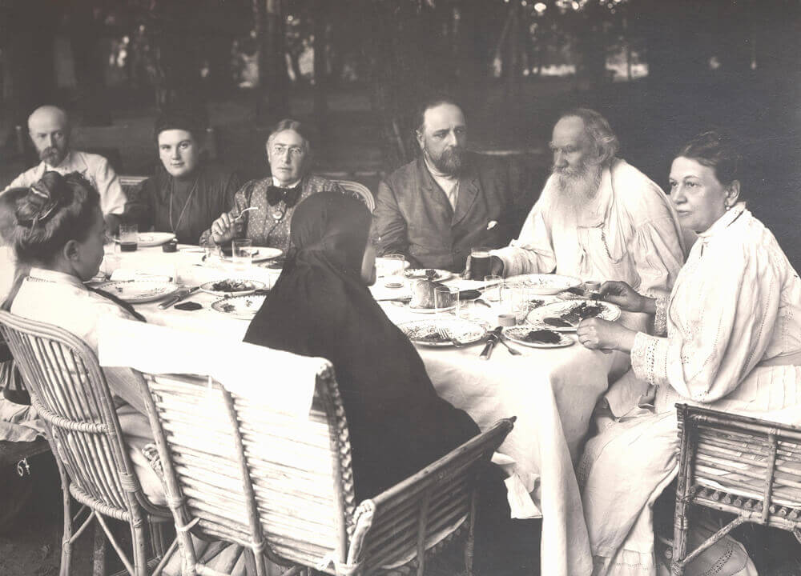

The Repentant Sinner, Leo Tolstoy

The Repentant Sinner

Translated by Louise and Aylmer Maude 1906

AND HE SAID unto Jesus, Lord, remember me when thou comest into thy Kingdom. And Jesus said unto him, Verily I say unto thee, Today shalt thou be with me in paradise.’-Luke xxiii. 42, 43.

THERE was once a man who lived for seventy years in the world, and lived in sin all that time. He fell ill but even then did not repent. Only at the last moment, as he was dying, he wept and said:

‘Lord! forgive me, as Thou forgavest the thief upon the cross.’

And as he said these words, his soul left his body. And the soul of the sinner, feeling love towards God and faith in His mercy, went to the gates of heaven and knocked, praying to be let into the heavenly kingdom.

Then a voice spoke from within the gate:

‘What man is it that knocks at the gates of Paradise and what deeds did he do during his life?’

And the voice of the Accuser replied, recounting all the man’s evil deeds, and not a single good one.

And the voice from within the gates answered:

‘Sinners cannot enter into the kingdom of heaven. Go hence!’

Then the man said:

‘Lord, I hear thy voice, but cannot see thy face, nor do I know thy name.’

The voice answered:

‘I am Peter, the Apostle.’

And the sinner replied:

‘Have pity on me, Apostle Peter! Remember man’s weakness, and God’s mercy. Wert not thou a disciple of Christ? Didst not thou hear his teaching from his own lips, and hadst thou not his example before thee? Remember then how, when he sorrowed and was grieved in spirit, and three times asked thee to keep awake and pray, thou didst sleep, because thine eyes were heavy, and three times he found thee sleeping. So it was with me. Remember, also, how thou didst promise to be faithful unto death, and yet didst thrice deny him, when he was taken before Caiaphas. So it was with me. And remember, too, how when the cock crowed thou didst go out and didst weep bitterly. So it is with me. Thou canst not refuse to let me in.’

And the voice behind the gates was silent.

Then the sinner stood a little while, and again began to knock, and to ask to be let into the kingdom of heaven.

And he heard another voice behind the gates, which said:

‘Who is this man, and how did he live on earth?’

And the voice of the Accuser again repeated all the sinner’s evil deeds, and not a single good one.

And the voice from behind the gates replied:

‘Go hence! Such sinners cannot live with us in Paradise.’ Then the sinner said:

‘Lord, I hear thy voice, but I see thee not, nor do I know thy name.’

And the voice answered:

‘I am David; king and prophet.’

The sinner did not despair, nor did he leave the gates of Paradise, but said:

Have pity on me, King David! Remember man’s weakness, and God’s mercy. God loved thee and exalted thee among men. Thou hadst all: a kingdom, and honour, and riches, and wives, and children; but thou sawest from thy house-top the wife of a poor man, and sin entered into thee, and thou tookest the wife of Uriah, and didst slay him with the sword of the Ammonites. Thou, a rich man, didst take from the poor man his one ewe lamb, and didst kill him. I have done likewise. Remember, then, how thou didst repent, and how thou saidst, “I acknowledge my transgressions: my sin is ever before me?” I have done the same. Thou canst not refuse to let me in.’

And the voice from within the gates was silent.

The sinner having stood a little while, began knocking again, and asking to be let into the kingdom of heaven. And a third voice was heard within the gates, saying:

‘Who is this man, and how has he spent his life on earth?’

And the voice of the Accuser replied for the third time, recounting the sinner’s evil deeds, and not mentioning one good deed.

And the voice within the gates said:

‘DePart hence! Sinners cannot enter into the kingdom of heaven.’

And the sinner said:

‘Thy voice I hear, but thy face I see not, neither do I know thy name.’

Then the voice replied:

‘I am John the Divine, the beloved disciple of Christ.’

And the sinner rejoiced and said:

‘Now surely I shall be allowed to enter. Peter and David must let me in, because they know man’s weakness and God’s mercy; and thou wilt let me in, because thou lovest much. Was it not thou, John the Divine who wrote that God is Love, and that he who loves not, knows not God? And in thine old age didst thou not say unto men: “Brethren, love one another.” How, then, canst thou look on me with hatred, and drive me away? Either thou must renounce what thou hast said, or loving me, must let me enter the kingdom of heaven.’

And the gates of Paradise opened, and John embraced the repentant sinner and took him into the kingdom of heaven.

The End