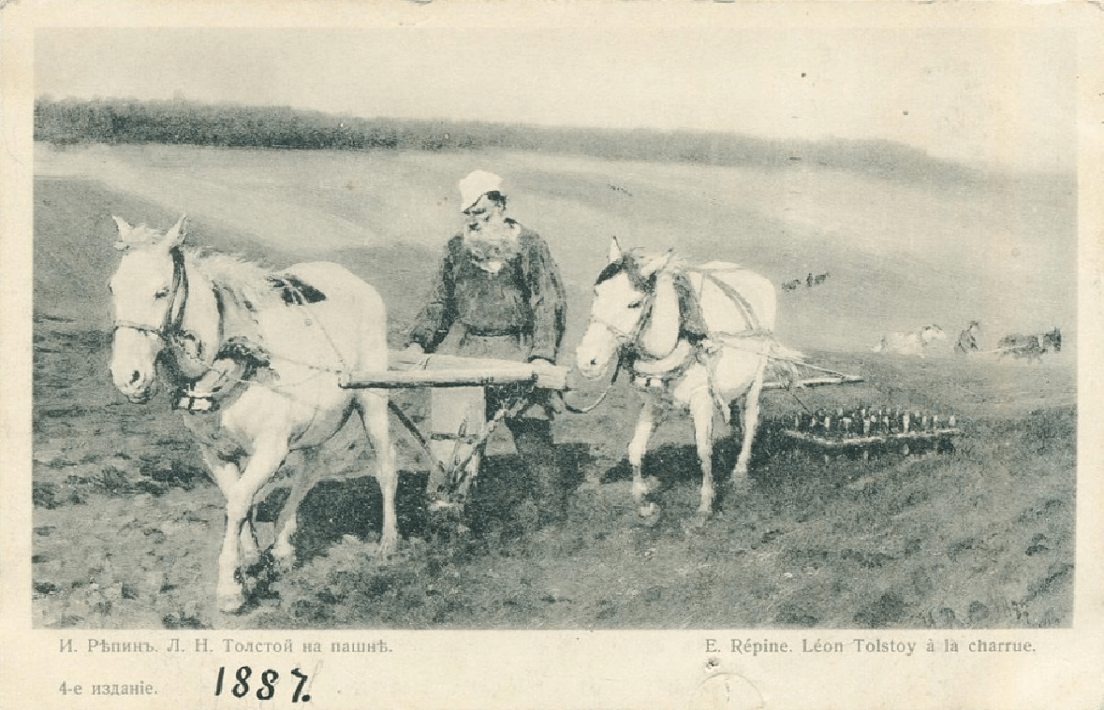

The Three Hermits, Leo Tolstoy

The Three Hermits

Translated by Louise and Aylmer Maude 1906

‘AND IN PRAYING use not vain repetitions, as the Gentiles do: for they think that they shall be heard for their much speaking. Be not therefore like unto them: for your Father knoweth what things ye have need of, before ye ask Him.’ — Matt. vi. 7, 8.

A BISHOP was sailing from Archangel to the Solovétsk Monastery; and on the same vessel were a number of pilgrims on their way to visit the shrines at that place. The voyage was a smooth one. The wind favourable, and the weather fair. The pilgrims lay on deck, eating, or sat in groups talking to one another. The Bishop, too, came on deck, and as he was pacing up and down, he noticed a group of men standing near the prow and listening to a fisherman who was pointing to the sea and telling them something.

The Bishop stopped, and looked in the direction in which the man was pointing. He could see nothing however, but the sea glistening in the sunshine. He drew nearer to listen, but when the man saw him, he took off his cap and was silent. The rest of the people also took off their caps, and bowed.

‘Do not let me disturb you, friends,’ said the Bishop. ‘I came to hear what this good man was saying.’

‘The fisherman was telling us about the hermits,’ replied one, a tradesman, rather bolder than the rest.

‘What hermits?’ asked the Bishop, going to the side of the vessel and seating himself on a box. ‘Tell me about them. I should like to hear. What were you pointing at?’

‘Why, that little island you can just see over there,’ answered the man, pointing to a spot ahead and a little to the right. ‘That is the island where the hermits live for the salvation of their souls.’

‘Where is the island?’ asked the Bishop. ‘I see nothing.’

‘There, in the distance, if you will please look along my hand. Do you see that little cloud? Below it and a bit to the left, there is just a faint streak. That is the island.’

The Bishop looked carefully, but his unaccustomed eyes could make out nothing but the water shimmering in the sun.

‘I cannot see it,’ he said. ‘But who are the hermits that live there?’

‘They are holy men,’ answered the fisherman. ‘I had long heard tell of them, but never chanced to see them myself till the year before last.’

And the fisherman related how once, when he was out fishing, he had been stranded at night upon that island, not knowing where he was. In the morning, as he wandered about the island, he came across an earth hut, and met an old man standing near it. Presently two others came out, and after having fed him, and dried his things, they helped him mend his boat.

‘And what are they like?’ asked the Bishop.

‘One is a small man and his back is bent. He wears a priest’s cassock and is very old; he must be more than a hundred, I should say. He is so old that the white of his beard is taking a greenish tinge, but he is always smiling, and his face is as bright as an angel’s from heaven. The second is taller, but he also is very old.

He wears tattered, peasant coat. His beard is broad, and of a yellowish grey colour. He is a strong man. Before I had time to help him, he turned my boat over as if it were only a pail. He too, is kindly and cheerful. The third is tall, and has a beard as white as snow and reaching to his knees. He is stern, with over-hanging eyebrows; and he wears nothing but a mat tied round his waist.’

‘And did they speak to you?’ asked the Bishop.

‘For the most Part they did everything in silence and spoke but little even to one another. One of them would just give a glance, and the others would understand him. I asked the tallest whether they had lived there long. He frowned, and muttered something as if he were angry; but the oldest one took his hand and smiled, and then the tall one was quiet. The oldest one only said: “Have mercy upon us,” and smiled.’

While the fisherman was talking, the ship had drawn nearer to the island.

‘There, now you can see it plainly, if your Grace will please to look,’ said the tradesman, pointing with his hand.

The Bishop looked, and now he really saw a dark streak — which was the island. Having looked at it a while, he left the prow of the vessel, and going to the stern, asked the helmsman:

‘What island is that?’

‘That one,’ replied the man, ‘has no name. There are many such in this sea.’

‘Is it true that there are hermits who live there for the salvation of their souls?’

‘So it is said, your Grace, but I don’t know if it’s true. Fishermen say they have seen them; but of course they may only be spinning yarns.’

‘I should like to land on the island and see these men,’ said the Bishop. ‘How could I manage it?’

‘The ship cannot get close to the island,’ replied the helmsman, ‘but you might be rowed there in a boat. You had better speak to the captain.’

The captain was sent for and came.

‘I should like to see these hermits,’ said the Bishop. ‘Could I not be rowed ashore?’

The captain tried to dissuade him.

‘Of course it could be done,’ said he, ‘but we should lose much time. And if I might venture to say so to your Grace, the old men are not worth your pains. I have heard say that they are foolish old fellows, who understand nothing, and never speak a word, any more than the fish in the sea.’

‘I wish to see them,’ said the Bishop, ‘and I will pay you for your trouble and loss of time. Please let me have a boat.’

There was no help for it; so the order was given. The sailors trimmed the sails, the steersman put up the helm, and the ship’s course was set for the island. A chair was placed at the prow for the Bishop, and he sat there, looking ahead. The passengers all collected at the prow, and gazed at the island. Those who had the sharpest eyes could presently make out the rocks on it, and then a mud hut was seen. At last one man saw the hermits themselves. The captain brought a telescope and, after looking through it, handed it to the Bishop.

‘It’s right enough. There are three men standing on the shore. There, a little to the right of that big rock.’

The Bishop took the telescope, got it into position, and he saw the three men: a tall one, a shorter one, and one very small and bent, standing on the shore and holding each other by the hand.

The captain turned to the Bishop.

‘The vessel can get no nearer in than this, your Grace. If you wish to go ashore, we must ask you to go in the boat, while we anchor here.’

The cable was quickly let out, the anchor cast, and the sails furled. There was a jerk, and the vessel shook. Then a boat having been lowered, the oarsmen jumped in, and the Bishop descended the ladder and took his seat. The men pulled at their oars, and the boat moved rapidly towards the island. When they came within a stone’s throw they saw three old men: a tall one with only a mat tied round his waist: a shorter one in a tattered peasant coat, and a very old one bent with age and wearing an old cassock — all three standing hand in hand.

The oarsmen pulled in to the shore, and held on with the boathook while the Bishop got out.

The old men bowed to him, and he gave them his benediction, at which they bowed still lower. Then the Bishop began to speak to them.

‘I have heard,’ he said, ‘that you, godly men, live here saving your own souls, and praying to our Lord Christ for your fellow men. I, an unworthy servant of Christ, am called, by God’s mercy, to keep and teach His flock. I wished to see you, servants of God, and to do what I can to teach you, also.’

The old men looked at each other smiling, but remained silent.

‘Tell me,’ said the Bishop, ‘what you are doing to save your souls, and how you serve God on this island.’

The second hermit sighed, and looked at the oldest, the very ancient one. The latter smiled, and said:

‘We do not know how to serve God. We only serve and support ourselves, servant of God.’

‘But how do you pray to God?’ asked the Bishop.

‘We pray in this way,’ replied the hermit. ‘Three are ye, three are we, have mercy upon us.’

And when the old man said this, all three raised their eyes to heaven, and repeated:

‘Three are ye, three are we, have mercy upon us!’

The Bishop smiled.

‘You have evidently heard something about the Holy Trinity,’ said he. ‘But you do not pray aright. You have won my affection, godly men. I see you wish to please the Lord, but you do not know how to serve Him. That is not the way to pray; but listen to me, and I will teach you. I will teach you, not a way of my own, but the way in which God in the Holy Scriptures has commanded all men to pray to Him.’

And the Bishop began explaining to the hermits how God had revealed Himself to men; telling them of God the Father, and God the Son, and God the Holy Ghost.

‘God the Son came down on earth,’ said he, ‘to save men, and this is how He taught us all to pray. Listen and repeat after me: “Our Father.”’

And the first old man repeated after him, ‘Our Father,’ and the second said, ‘Our Father,’ and the third said, ‘Our Father.’

‘Which art in heaven,’ continued the Bishop.

The first hermit repeated, ‘Which art in heaven,’ but the second blundered over the words, and the tall hermit could not say them properly. His hair had grown over his mouth so that he could not speak plainly. The very old hermit, having no teeth, also mumbled indistinctly.

The Bishop repeated the words again, and the old men repeated them after him. The Bishop sat down on a stone, and the old men stood before him, watching his mouth, and repeating the words as he uttered them. And all day long the Bishop laboured, saying a word twenty, thirty, a hundred times over, and the old men repeated it after him. They blundered, and he corrected them, and made them begin again.

The Bishop did not leave off till he had taught them the whole of the Lord’s prayer so that they could not only repeat it after him, but could say it by themselves. The middle one was the first to know it, and to repeat the whole of it alone. The Bishop made him say it again and again, and at last the others could say it too.

It was getting dark, and the moon was appearing over the water, before the Bishop rose to return to the vessel. When he took leave of the old men, they all bowed down to the ground before him. He raised them, and kissed each of them, telling them to pray as he had taught them. Then he got into the boat and returned to the ship.

And as he sat in the boat and was rowed to the ship he could hear the three voices of the hermits loudly repeating the Lord’s prayer. As the boat drew near the vessel their voices could no longer be heard, but they could still be seen in the moonlight, standing as he had left them on the shore, the shortest in the middle, the tallest on the right, the middle one on the left.

As soon as the Bishop had reached the vessel and got on board, the anchor was weighed and the sails unfurled. The wind filled them, and the ship sailed away, and the Bishop took a seat in the stern and watched the island they had left. For a time he could still see the hermits, but presently they disappeared from sight, though the island was still visible. At last it too vanished, and only the sea was to be seen, rippling in the moonlight.

The pilgrims lay down to sleep, and all was quiet on deck. The Bishop did not wish to sleep, but sat alone at the stern, gazing at the sea where the island was no longer visible, and thinking of the good old men. He thought how pleased they had been to learn the Lord’s prayer; and he thanked God for having sent him to teach and help such godly men.

So the Bishop sat, thinking, and gazing at the sea where the island had disappeared. And the moonlight flickered before his eyes, sparkling, now here, now there, upon the waves. Suddenly he saw something white and shining, on the bright path which the moon cast across the sea. Was it a seagull, or the little gleaming sail of some small boat? The Bishop fixed his eyes on it, wondering.

‘It must be a boat sailing after us,’ thought he ‘but it is overtaking us very rapidly. It was far, far away a minute ago, but now it is much nearer. It cannot be a boat, for I can see no sail; but whatever it may be, it is following us, and catching us up.’

And he could not make out what it was. Not a boat, nor a bird, nor a fish! It was too large for a man, and besides a man could not be out there in the midst of the sea. The Bishop rose, and said to the helmsman:

‘Look there, what is that, my friend? What is it?’ the Bishop repeated, though he could now see plainly what it was — the three hermits running upon the water, all gleaming white, their grey beards shining, and approaching the ship as quickly as though it were not morning.

The steersman looked and let go the helm in terror.

‘Oh Lord! The hermits are running after us on the water as though it were dry land!’

The passengers hearing him, jumped up, and crowded to the stern. They saw the hermits coming along hand in hand, and the two outer ones beckoning the ship to stop. All three were gliding along upon the water without moving their feet. Before the ship could be stopped, the hermits had reached it, and raising their heads, all three as with one voice, began to say:

‘We have forgotten your teaching, servant of God. As long as we kept repeating it we remembered, but when we stopped saying it for a time, a word dropped out, and now it has all gone to pieces. We can remember nothing of it. Teach us again.’

The Bishop crossed himself, and leaning over the ship’s side, said:

‘Your own prayer will reach the Lord, men of God. It is not for me to teach you. Pray for us sinners.

And the Bishop bowed low before the old men; and they turned and went back across the sea. And a light shone until daybreak on the spot where they were lost to sight.

The End