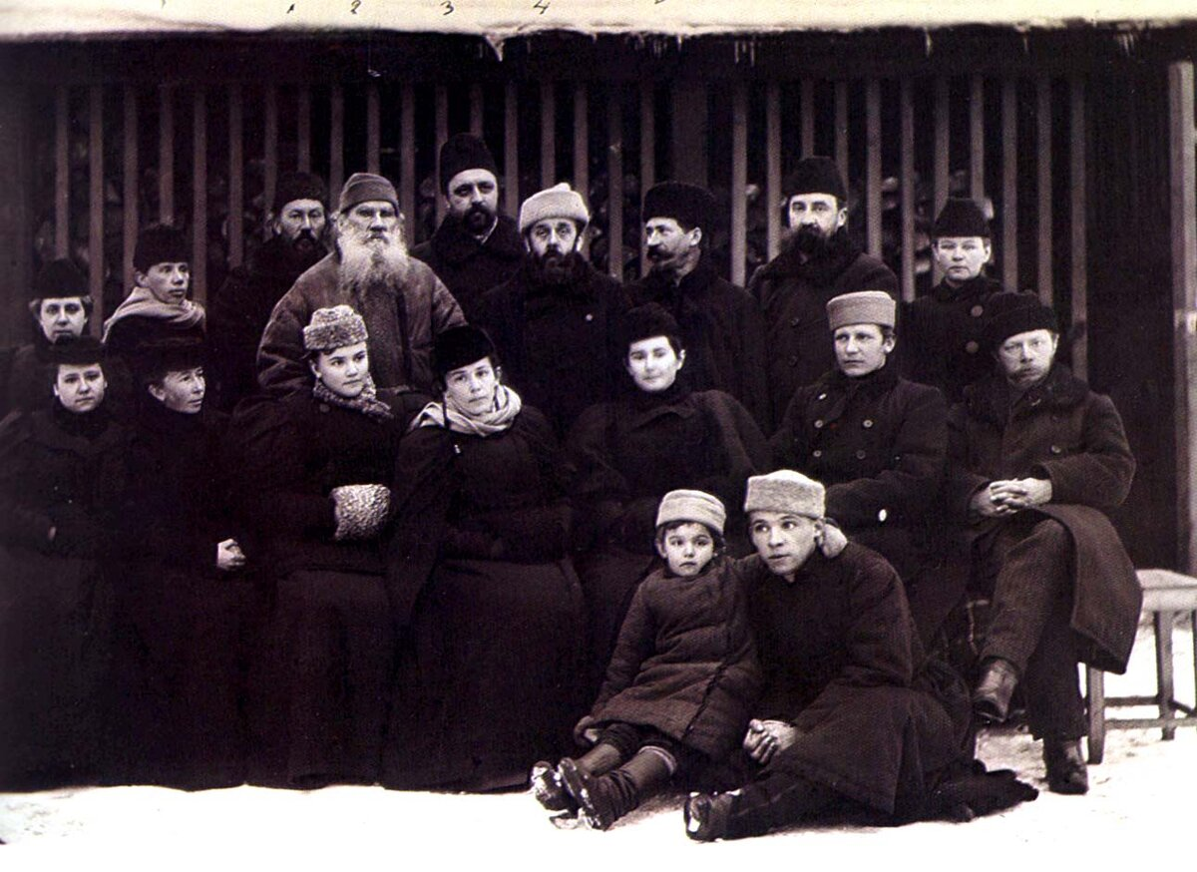

Three Parables, Leo Tolstoy

Three Parables

Translated by Nathan Haskell Dole 1895

PARABLE THE FIRST

A WEED had spread over a beautiful meadow. And in order to get rid of it the tenants of the meadow mowed it, but the weed only increased in consequence. And now the kind, wise master came to visit the tenants of the meadow, and among the other good counsels which he gave them, he told them they ought not to mow the weed, since that only made it grow the more luxuriantly, but that they must pull it up by the roots.

But either because the tenants of the meadow did not, amongst the other prescriptions of the good master, take heed of his advice not to mow down the weed, but to pull it up, or because they did not understand him, or because, according to their calculations, it seemed foolish to obey, the result was that his advice not to mow the weed but to pull it up was not followed, just as if he had never proffered it, and the men went on mowing the weed and spreading it.

And although, during the succeeding years, there were men that reminded the tenants of the meadow of the advice of the kind, wise master, they did not heed them, and continued to do as before, so that mowing of the weed as soon as it began to appear became not only a custom but even a sacred tradition, and the meadow grew more and more infested. And the matter went so far that the meadow grew nothing but weeds, and men lamented this and invented all kinds of means to correct the evil; but the only one they did not use was that which had long ago been prescribed by their kind, wise master.

And now, as time went on, it occurred to one man who saw the wretched condition into which the meadow had fallen, and who found among the master’s forgotten prescriptions the rule not to mow the weed, but to pull it up by the root it occurred to the man, I say, to remind the tenants of the meadow that they were acting foolishly, and that their folly had long ago been pointed out by the kind, wise master.

But what do you think instead of putting credence in the correctness of this man’s recollections, and in case they proved to be reliable ceasing to mow the weed, and in case he were mistaken proving to him the incorrectness of his recollections, or stigmatizing the good, wise master’s recommendations as impracticable and not obligatory upon them, the tenants of the meadow did nothing’ of the sort; but they took exception to this man’s recollections and began to abuse him.

Some called him a conceited fool who imagined that he was the only one to understand the master’s regulations; others called him a malicious false interpreter and slanderer; still others, forgetting that he was not giving them his own opinions, but was only reminding them of the prescriptions of the wise master whom they all revered, called him a dangerous man because he wished to pull up the weed and deprive them of their meadow. “ He says we ought not to mow the meadow,” said they, purposely suppressing the fact that the man did not say that it was not necessary to destroy the weed, but said that they should pull it up by the roots instead of mowing it, “but if we do not destroy the weed, then it will spread and wholly ruin our meadow. And why was the meadow granted to us if we must train the weed in it ? “

And the general impression that this man was either a fool or a false interpreter, or had the purpose of injuring the people, became so deeply grounded that every one cast reproaches and ridicule upon him. And however earnestly he asseverated that he not only did not desire to spread the weed, but on the contrary considered that the destruction of the weed was one of the chief duties of the agriculturist, just as it was meant by the good, wise master whose words he merely repeated, still they would not listen to him because they had definitely made up their minds that he was either a conceited fool misinterpreting the good, wise master’s words, or a villain trying to induce men not to destroy the weeds but to protect and spread them more widely.

The same thing took place in my own case when I pointed out the injunction of the evangelical teaching about the non-resistance of evil by violence. This rule was laid down by Christ and after Him in all times by all His true disciples.

But either because they did not notice this rule, or because they did not understand it, or because its fulfilment seemed to them too difficult, as time went the more completely this rule was forgotten, the farther the manner of men’s lives deParted from this rule; and finally it came to the pass to which it has now come that this rule has already begun to seem to people something new, strange, unheard-of, and even foolish. And I, also, have the same experience as the man had who reminded men of the good, wise master’s prescription to refrain from mowing the weed, but to pull it up by the roots.

As the tenants of the meadow purposely shut their eyes to the fact that the counsel was not to give up destroying the weed, but to destroy it by a different method, and said, “ We will not listen to this man, he is a fool; he forbids us to mow down the weeds and tells us to pull them up “ so in reply to my reminder that according to Christ’s teaching in order to annihilate evil we must not employ violence against it, but must destroy it from the root with love, men said : “ We will not listen to him, he is a fool; he advises not to oppose evil to evil so that evil may overwhelm us.”

I said that, according to Christ’s teaching, evil cannot be eradicated by evil; that all resistance of evil by violence only intensifies the evil, that according to Christ’s teaching evil is eradicated by good. Bless them that curse you, pray for them that abuse you, do good to them that hate you, love your enemies, and you will have no enemies!

I said that, according to Christ’s teaching, the whole life of man is a battle with evil, a resistance of evil by reason and love, but that out of all the methods of resisting evil Christ excepted only the one unreasonable method of resisting evil with violence, which is equivalent to fighting evil with evil.

And I was misunderstood as saying that Christ taught that we must not resist evil. And all those whose lives were based on violence, and to whom in consequence violence was dear, were glad to take such a misconstruction of my words, and at the same time of Christ’s words, and it was avowed that the teaching of non-resistance of evil was incredible, stupid, godless, and dangerous. And men calmly continue under the guise of destroying evil to make it more widely spread.

PARABLE THE SECOND

MEN were trafficking in flour, butter, milk, and all kinds of food-stuffs. And as each one was desirous of receiving the greatest profit and becoming rich as soon as possible, all these men got more and more into the habit of adulterating their goods with cheap and injurious mixtures : with the flour they mixed bran and lime, they put oleomargarin into their butter, they put water and chalk into their milk. And until these goods reached the consumers all went well : the wholesale traders sold them to the retailers, and the retailers distributed them in small quantities.

There were many stores and shops, and the wares, it seemed, went off very rapidly. And the tradesmen were satisfied. But the city consumers, those that did not raise their own produce and were therefore obliged to buy it, found it very harmful and disagreeable. The flour was bad, the butter and milk were bad, but as there were no other wares except those adulterated to be had in the city markets, the city consumers continued to buy them, and they complained because the food tasted bad and was unwholesome; they blamed themselves, and ascribed it to the wretched way in which the food was prepared. Meantime the tradespeople continued more and more flagrantly to adulterate their food-stuffs with cheap foreign ingredients. Thus passed a sufficiently long time. The city people were all suffering, and no one had the resolution to express his dissatisfaction.

And it happened that a housekeeper who had always given her family food and drink of her own make came to the city. This woman had spent her whole life in the preparation of food, and though she was not a famous cook, still she knew very well how to bake bread and to cook good dinners.

This woman bought various articles in the city and began to bake and cook. Her loaves did not rise, but fell. Her cakes, owing to the oleomargarin butter, seemed tasteless. She set her milk, but there was no cream. The housekeeper instantly came to the conclusion that her purchases were poor. She examined them, and her surmises were confirmed. She found lime in the flour, oleomargarin in the butter, chalk in the milk. Finding that all the materials she had bought were adulterated, the housekeeper went to the bazaars and began in a loud voice to accuse the tradesmen, and to demand that they should either stock their shops with good, nutritious, unadulterated articles, or else cease to trade, and shut up shop.

But the tradesmen paid no attention to the housekeeper, but told her that their goods were first class, that the whole city had been buying of them for so many years, and that they even had medals, and they showed her their medals on their signs. But the housekeeper did not give in.

“I don’t need any medals,” said she, “but wholesome food, so that I and my children may not have stomach troubles from it.”

“Apparently, my good woman, you have never seen genuine flour and butter,” said the tradesmen, showing her the white, pure-looking flour in varnished bins, the wretched imitation of butter lying in neat dishes, and the white fluid in glittering transparent jars.

“Of course I know them,” replied the housekeeper, “ because all my life long I have had to do with them, and I have cooked with them and have eaten them, I and my children. Your goods are adulterated. Here is the proof of it,” said she, displaying the spoilt bread, the oleomargarin in the cakes, and the sediment in the milk. “ You ought to throw all this stuff of yours into the river or burn it, and get unadulterated goods instead.”

And the woman, standing in front of the shops, kept incessantly crying her one message to the purchasers who came by, and the purchasers began to be troubled.

Then perceiving that this audacious housekeeper was likely to injure their wares, the tradesmen said to the purchasers :

“ Look here, gentlemen, what a lunatic this woman is ! She wants people to perish of starvation. She insists on our burning up and destroying all our provisions. What would you have to eat if we should heed her and refuse to sell you our goods ? Do not listen to her, she is a coarse countrywoman, and she is no judge of provisions, and it is nothing but envy which makes her attack us. She is poor, and wants every one else to be as poor as she is.”

Thus spoke the tradesmen to the gathering throng, purposely blinking the fact that the woman wanted, not that all provisions should be destroyed, but that good ones should be substituted for bad.

And thereupon the throng fell upon the woman and began to beat her. And though she assured them all that she had no wish to destroy the food-stuffs, that, on the contrary, she had all her life been occupied in feeding others and herself, but that she only wanted that those men that took upon themselves the feeding of the people should not poison them with deleterious adulterations pretending to be edible. Though she pleaded her cause eloquently, they refused to hear her because their minds were made up that she wanted to deprive people of the food which they needed.

The same thing has happened to me in regard to the art and science of our day.

All my life long I have been fed on this food, and to the best of my ability I have attempted to feed others on it. And as this for me is a food and not an object of traffic or luxury, I know beyond a question when food is food and when it is only a counterfeit. And now when I made trial of the food which in our time began to be offered for sale in the intellectual bazaar under the guise of art and science, and attempted to feed those dear to me with it, I discovered that a large Part of this food was not genuine.

And when I declared that the art and the science on sale in the intellectual bazaar are margarined or at least contain great mixtures of what is foreign to true art and true science, and that I know this because the produce I have bought in the intellectual bazaar has been proved to be, not merely disadvantageous to me and those near and dear to me, but positively deleterious, then I was hooted at and abused, and it was insinuated that I did this because I was untrained and could not properly treat of such lofty objects.

When I began to show that the dealers themselves in these intellectual wares were all the time charging one another of cheating, when I called to mind that in all times under the name of art and science much that was bad and harmful was offered to men, and that consequently in our time also the same danger was threatening, that this was no joke, that the poison for the soul was many times more dangerous than a poison for the body, and that therefore these spiritual products ought to be examined with the greatest attention when they are offered to us. in the form of food, and everything counterfeit and deleterious ought to be rejected, when I began to say this, no one, no one, not a single man in a single article or book made reply to these arguments, but from all the shops there was a chorus of cries against me as against the woman : “ He is a fool ! He wants to destroy art and science which we live by ! Beware of him and do not heed him ! Hear us, hear us ! We have the very latest foreign wares ! “

PARABLE THE THIRD

TRAVELERS were making a journey. And they happened to lose their way, so that they found themselves proceeding, not on a smooth road, but across a bog, among clumps of bushes, briers, and fallen trees, which blocked their progress, and even to move grew more and more difficult.

Then the travelers divided into two Parties; one decided not to stop, but to keep going in the direction that they had been going, assuring themselves and the others that they had not wandered from the right road, and were sure to reach their journey’s end.

The other Party decided that, as the direction in which they were now going was evidently not the right one otherwise they would long ago have reached the journey’s end it was necessary to find the road, and in order to find it, it was requisite that without delay they should move as rapidly as possible in all directions.

All the travelers were divided between these two opinions : some decided to keep going straight ahead, the others decided to make trials in all directions; but there was one man who, without sharing either opinion, declared that before continuing in the direction in which they had been going, or beginning to move rapidly in all directions, hoping that by this means they might find the right way, it was necessary first of all to pause and deliberate on their situation, and then after due deliberation to decide on one thing or the other.

But the travelers were so excited by the disturbance, were so alarmed at their situation, they were so desirous of flattering themselves with the hope that they had not lost their way, but had only temporarily wandered from the road, and would soon find it again, and, above all, they had such a desire to forget their terror by moving about, that this opinion was met with universal indignation, with reproaches, and with the ridicule of those of both Parties.

“ It is the advice of weakness, cowardice, sloth,” they said.

“ It is a fine way to reach the end of our journey, sitting down and not moving from the place ! “ cried others.

“ For this are we men, and for this is strength given us, to struggle and labor, conquering obstacles, and not pusillanimously giving in to them,” exclaimed still others.

And in spite of what was said by the man that differed from the rest, “ how if we proceeded in a wrong direction without changing it, we should never attain our goal, but go farther from it, and how we should never attain it either if we kept flying from one direction to another, and how the only means of attaining our goal was by taking observation from the sun or the stars and thus finding what direction we must take to reach it, and having chosen it to stick to it and how to do this it was necessary first of all to halt, and to halt not for the purpose of stopping, but to find the right way and then unfalteringly to go in it, and how for either case it was necessary to stop and consider” in spite of all this argument, they refused to heed him.

And the first division of the travelers went off in the direction in which they had been going, and the second division kept changing their course; but neither division succeeded in attaining their journey’s end, but up to the present time, moreover, they have not yet escaped from the bushes and the briers, but are still lost.

Exactly the same thing happened to me when I attempted to express my doubts as to whether the road which we have taken through the dark forest of the labor question and through the all-swallowing bog of the endless armament of the nations is exactly the right route by which we ought to go, that it is very possible that we have lost our way, and that, therefore, it might be well for us for a time to stop moving in that direction which is evidently wrong, and first of all to consider, by means of the universal and eternal laws of truth revealed to us, what the direction is by which we intend to go.

No one replied to this, not a person said, “ We are not mistaken in our direction and we are not gone astray; we are sure of this for this reason and for that.”

Not a person said, “ Possibly we are mistaken, but we have an infallible means of correcting our error without ceasing to move.”

No one said either the one thing or the other. But all were indignant, took offense, and hastened to quench my solitary voice with a simultaneous outburst.

“ We are so indolent and backward ! And this is the advice of indolence, sluggishness, inefficiency ! “

Some even went so far as to add :

“ It ‘s all nonsense ! Don’t listen to him. Follow us.”

And they shouted like those that reckon that salvation is to be found in unchangedly traveling a once selected road, whatever it may have been; like those also that expect to find salvation in flying about in all directions.

“Why wait? Why consider? Push forward! Everything will come out of itself ! “

Men have lost their way and are suffering in consequence. It would seem that the first main application of energy which should be put forth ought to be directed, not to the confirmation of the movement that has seduced us into the false position where we are, but to the cessation of it. It would seem clear that as soon as we stopped we might, in a measure, comprehend our situation, and discover the direction in which we ought to go in order to attain true happiness, not for one man, not for one class of men, but that general good of humanity toward which all men are striving and every human heart by itself.

But how is it ? Men invent everything possible, but do not hit upon the one thing that might prove their salvation, or if it did not do that, might at least ameliorate their condition; I mean, that they should pause for a moment and not go on increasing their misfortunes by their fallacious activity. Men are conscious of the wretchedness of their condition, and are doing all they can to avoid it, but the one thing that would assuredly ameliorate it they are unwilling to do, and the advice given them to do it, more than anything else, rouses their indignation.

If there were any possibility of doubting the fact that we have gone astray, then this treatment of the advice to “ think it over “ proves more distinctly than anything else how hopelessly astray we have gone and how great is our despair.

The End