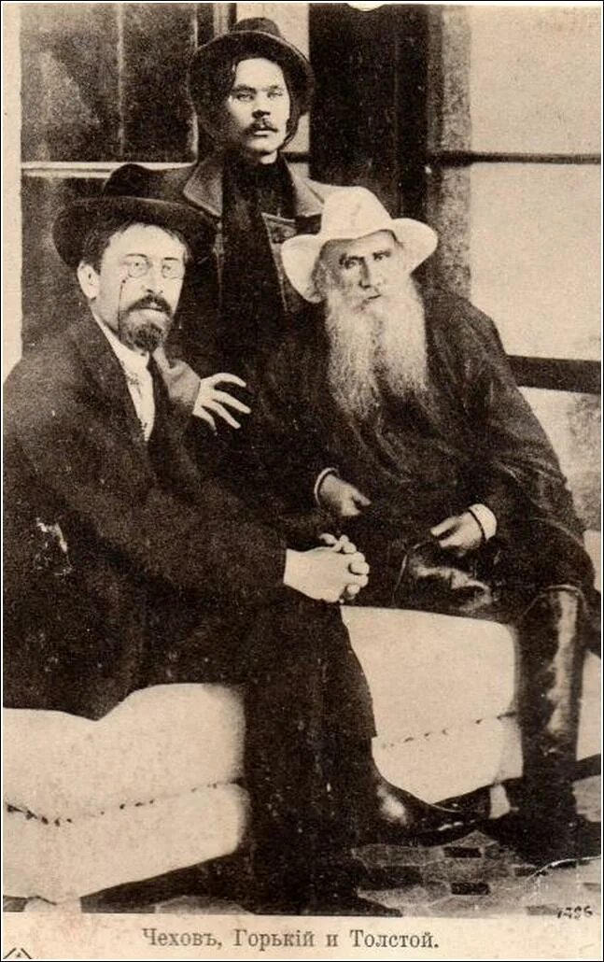

Too Dear! Leo Tolstoy

Too Dear!

Translated by Louise and Aylmer Maude 1906

Tolstoy’s adaptation of a story originally told by Guy de Maupassant

NEAR the borders of France and Italy, on the shore of the Mediterranean Sea, lies a tiny little kingdom called Monaco. Many a small country town can boast more inhabitants than this kingdom, for there are only about seven thousand of them all told, and if all the land in the kingdom were divided there would not be an acre for each inhabitant. But in this toy kingdom there is a real kinglet; and he has a palace, and courtiers, and ministers, and a bishop, and generals, and an army.

It is not a large army, only sixty men in all, but still it is an army. There were also taxes in this kingdom as elsewhere: a tax on tobacco, and on wine and spirits and a poll-tax. But though the people there drink and smoke as people do in other countries, there are so few of them that the King would have been hard put to it to feed his courtiers and officials and to keep himself, if he had not found a new and special source of revenue.

This special revenue comes from a gaming house, where people play roulette. People play, and whether they win or lose the keeper always gets a percentage on the turnover; and out of his profits he pays a large sum to the King. The reason he pays so much is that it is the only such gambling establishment left in Europe. Some of the little German Sovereigns used to keep gaming houses of the same kind, but some years ago they were forbidden to do so. The reason they were stopped was because these gaming houses did so much harm.

A man would come and try his luck, then he would risk all he had and lose it, then he would even risk money that did not belong to him and lose that too, and then, in despair, he would drown or shoot himself. So the Germans forbade their rulers to make money in this way; but there was no one to stop the King of Monaco, and he remained with a monopoly of the business.

So now every one who wants to gamble goes to Monaco. Whether they win or lose, the King gains by it. ‘You can’t earn stone palaces by honest labour,’ as the proverb says; and the Kinglet of Monaco knows it is a dirty business, but what is he to do? He has to live; and to draw a revenue from drink and from tobacco is also not a nice thing. So he lives and reigns, and rakes in the money, and holds his court with all the ceremony of a real king.

He has his coronation, his levees; he rewards, sentences, and pardons, and he also has his reviews, councils, laws, and courts of justice: just like other kings, only all on a smaller scale.

Now it happened a few years ago that a murder was committed in this toy King’s domains. The people of that kingdom are peaceable, and such a thing had not happened before. The judges assembled with much ceremony and tried the case in the most judicial manner. There were judges, and prosecutors, and jurymen, and barristers. They argued and judged, and at last they condemned the criminal to have his head cut off as the law directs. So far so good. Next they submitted the sentence to the King. The King read the sentence and confirmed it. ‘If the fellow must be executed, execute him.’

There was only one hitch in the matter; and that was that they had neither a guillotine for cutting heads off, nor an executioner. The Ministers considered the matter, and decided to address an inquiry to the French Government, asking whether the French could not lend them a machine and an expert to cut off the criminal’s head; and if so, would the French kindly inform them what the cost would be. The letter was sent.

A week later the reply came: a machine and an expert could be supplied, and the cost would be 16,000 francs. This was laid before the King. He thought it over. Sixteen thousand francs! ‘The wretch is not worth the money,’ said he. ‘Can’t it be done, somehow, cheaper? Why 16,000 francs is more than two francs a head on the whole population. The people won’t stand it, and it may cause a riot!’

So a Council was called to consider what could be done; and it was decided to send a similar inquiry to the King of Italy. The French Government is republican, and has no proper respect for kings; but the King of Italy was a brother monarch, and might be induced to do the thing cheaper. So the letter was written, and a prompt reply was received.

The Italian Government wrote that they would have pleasure in supplying both a machine and an expert; and the whole cost would be 12,000 francs, including travelling expenses. This was cheaper, but still it seemed too much. The rascal was really not worth the money. It would still mean nearly two francs more per head on the taxes. Another Council was called. They discussed and considered how it could be done with less expense. Could not one of the soldiers perhaps be got to do it in a rough and homely fashion? The General was called and was asked: ‘Can’t you find us a soldier who would cut the man’s head off?

In war they don’t mind killing people. In fact, that is what they are trained for.’ So the General talked it over with the soldiers to see whether one of them would not undertake the job. But none of the soldiers would do it. ‘No,’ they said, ‘we don’t know how to do it; it is not a thing we have been taught.’

What was to be done? Again the Ministers considered and reconsidered. They assembled a Commission, and a Committee, and a Sub-Committee, and at last they decided that the best thing would be to alter the death sentence to one of imprisonment for life. This would enable the King to show his mercy, and it would come cheaper.

The King agreed to this, and so the matter was arranged. The only hitch now was that there was no suitable prison for a man sentenced for life. There was a small lock-up where people were sometimes kept temporarily, but there was no strong prison fit for permanent use. However, they managed to find a place that would do, and they put the young fellow there and placed a guard over him. The guard had to watch the criminal, and had also to fetch his food from the palace kitchen.

The prisoner remained there month after month till a year had passed. But when a year had passed, the Kinglet, looking over the account of his income and expenditure one day, noticed a new item of expenditure. This was for the keep of the criminal; nor was it a small item either. There was a special guard, and there was also the man’s food. It came to more than 600 francs a year. And the worst of it was that the fellow was still young and healthy, and might live for fifty years. When one came to reckon it up, the matter was serious. It would never do. So the King summoned his Ministers and said to them:

‘You must find some cheaper way of dealing with this rascal. The present plan is too expensive.’ And the Ministers met and considered and reconsidered, till one of them said: ‘Gentlemen, in my opinion we must dismiss the guard.’

‘But then,’ rejoined another Minister, ‘the fellow will run away.’ ‘Well,’ said the first speaker, ‘let him run away, and be hanged to him!’ So they reported the result of their deliberations to the Kinglet, and he agreed with them. The guard was dismissed, and they waited to see what would happen.

All that happened was that at dinner-time the criminal came out, and, not finding his guard, he went to the King’s kitchen to fetch his own dinner. He took what was given him, returned to the prison, shut the door on himself, and stayed inside. Next day the same thing occurred. He went for his food at the proper time; but as for running away, he did not show the least sign of it! What was to be done? They considered the matter again.

‘We shall have to tell him straight out,’ said they ‘that we do not want to keep him.’ So the Minister of Justice had him brought before him.

‘Why do you not run away?’ said the Minister. ‘There is no guard to keep you. You can go where you like, and the King will not mind.’

‘I daresay the King would not mind,’ replied the man, ‘but I have nowhere to go. What can I do? You have ruined my character by your sentence, and people will turn their backs on me. Besides, I have got out of the way of working. You have treated me badly. It is not fair.

In the first place, when once you sentenced me to death you ought to have executed me; but you did not do it. That is one thing. I did not complain about that. Then you sentenced me to imprisonment for life and put a guard to bring me my food; but after a time you took him away again and I had to fetch my own food. Again I did not complain. But now you actually want me to go away! I can’t agree to that. You may do as you like, but I won’t go away!’

What was to be done? Once more the Council was summoned. What course could they adopt? The man would not go. They reflected and considered. The only way to get rid of him was to offer him a pension. And so they reported to the King. ‘There is nothing else for it,’ said they; ‘we must get rid of him somehow.’ The sum fixed was 600 francs, and this was announced to the prisoner.

‘Well,’ said he, ‘I don’t mind, so long as you undertake to pay it regularly. On that condition I am willing to go.’

So the matter was settled. He received one-third of his annuity in advance, and left the King’s dominions. It was only a quarter of an hour by rail; and he emigrated, and settled just across the frontier, where he bought a bit of land, started market-gardening, and now lives comfortably.

He always goes at the proper time to draw his pension. Having received it, he goes to the gaming tables, stakes two or three francs, sometimes wins and sometimes loses, and then returns home. He lives peaceably and well.

It is a good thing that he did not commit his crime in a country where they do not grudge expense to cut a man’s head off, or to keeping him in prison for life.

The end