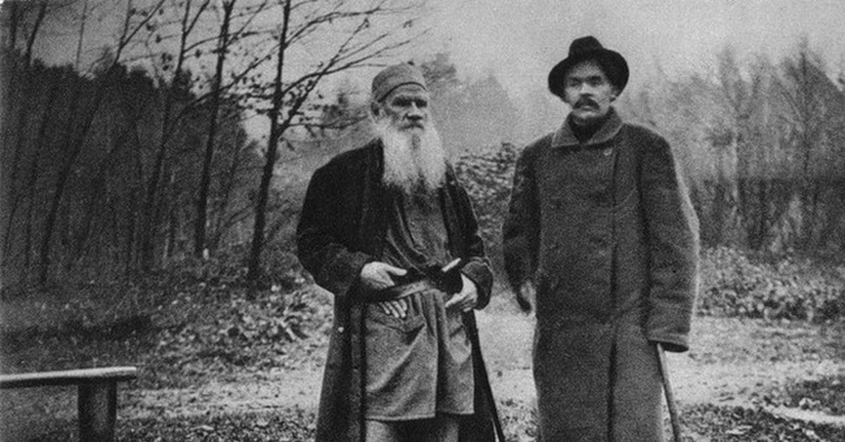

Work, Death, And Sickness, Leo Tolstoy

Work, Death, And Sickness

Translated by Louise and Aylmer Maude 1906

THIS IS A legend current among the South American Indians.

God, say they, at first made men so that they had no need to work: they needed neither houses, nor clothes, nor food, and they all lived till they were a hundred, and did not know what illness was.

When, after some time, God looked to see how people were living, he saw that instead of being happy in their life, they had quarrelled with one another, and, each caring for himself, had brought matters to such a pass that far from enjoying life, they cursed it.

Then God said to himself: ‘This comes of their living separately, each for himself.’ And to change this state of things, God so arranged matters that it became impossible for people to live without working. To avoid suffering from cold and hunger, they were now obliged to build dwellings, and to dig the ground, and to grow and gather fruits and grain.

‘Work will bring them together,’ thought God.

‘They cannot make their tools, prepare and transport their timber, build their houses, sow and gather their harvests, spin and weave, and make their clothes, each one alone by himself.’

‘It will make them understand that the more heartily they work together, the more they will have and the better they will live; and this will unite them.’

Time passed on, and again God came to see how men were living, and whether they were now happy.

But he found them living worse than before. They worked together (that they could not help doing), but not all together, being broken up into little groups. And each group tried to snatch work from other groups, and they hindered one another, wasting time and strength in their struggles, so that things went ill with them all.

Having seen that this, too, was not well, God decided so as to arrange things that man should not know the time of his death, but might die at any moment; and he announced this to them.

‘Knowing that each of them may die at any moment,’ thought God, ‘they will not, by grasping at gains that may last so short a time, spoil the hours of life allotted to them.’

But it turned out otherwise. When God returned to see how people were living, he saw that their life was as bad as ever.

Those who were strongest, availing themselves of the fact that men might die at any time, subdued those who were weaker, killing some and threatening others with death. And it came about that the strongest and their descendants did no work, and suffered from the weariness of idleness, while those who were weaker had to work beyond their strength, and suffered from lack of rest. Each set of men feared and hated the other. And the life of man became yet more unhappy.

Having seen all this, God, to mend matters, decided to make use of one last means; he sent all kinds of sickness among men. God thought that when all men were exposed to sickness they would understand that those who are well should have pity on those who are sick, and should help them, that when they themselves fall ill those who are well might in turn help them.

And again God went away, but when He came back to see how men lived now that they were subject to sicknesses, he saw that their life was worse even than before. The very sickness that in God’s purpose should have united men, had divided them more than ever.

Those men who were strong enough to make others work, forced them also to wait on them in times of sickness; but they did not, in their turn, look after others who were ill. And those who were forced to work for others and to look after them when sick, were so worn with work that they had no time to look after their own sick, but left them without attendance. That the sight of sick folk might not disturb the pleasures of the wealthy, houses were arranged in which these poor people suffered and died, far from those whose sympathy might have cheered them, and in the arms of hired people who nursed them without compassion, or even with disgust.

Moreover, people considered many of the illnesses infectious, and, fearing to catch them, not only avoided the sick, but even separated themselves from those who attended the sick.

Then God said to Himself: ‘If even this means will not bring men to understand wherein their happiness lies, let them be taught by suffering.’ And God left men to themselves.

And, left to themselves, men lived long before they understood that they all ought to, and might be, happy. Only in the very latest times have a few of them begun to understand that work ought not to be a bugbear to some and like galley-slavery for others, but should be a common and happy occupation, uniting all men.

They have begun to understand that with death constantly threatening each of us, the only reasonable business of every man is to spend the years, months, hours, and minutes, allotted him — in unity and love. They have begun to understand that sickness, far from dividing men, should, on the contrary, give opportunity for loving union with one another.

The End