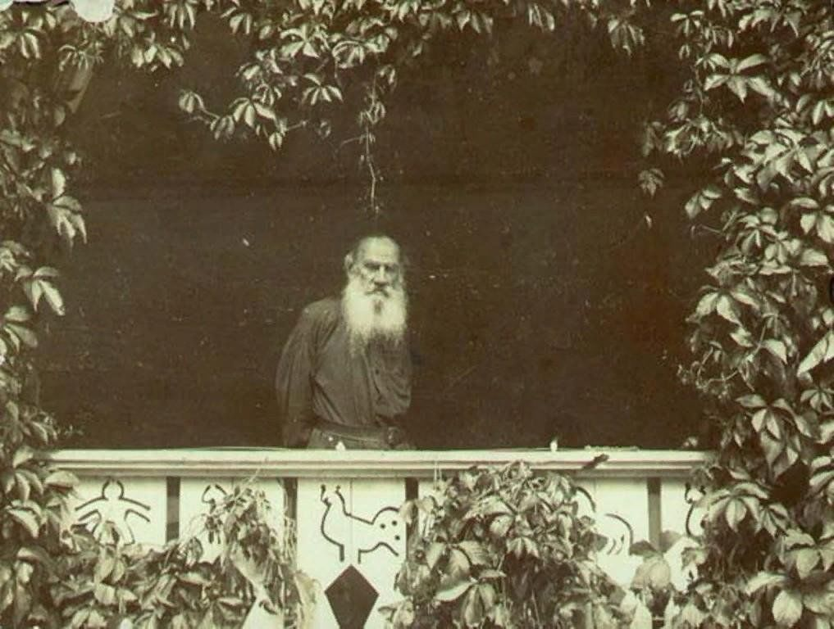

Yermak, The Conqueror Of Siberia, Leo Tolstoy

Yermak, The Conqueror Of Siberia

AT THE TIME of the Tsar Ivan the Terrible, 1 the Strogonofs were rich merchants, and lived in Perm, on the river Kama.

They had heard that on the river Kama, for a hundred and forty versts around, there was rich land; the soil had not been plowed for a century; the black forest for a century had not been felled. In the forests were many wild animals, and along the river were lakes full of fish, and no one lived in this land except wandering Tartars.

So the Strogonofs wrote a letter to the Tsar :

“ Grant us this land, and we ourselves will found cities, and we will gather men together and establish them, and we will not allow the Tartars to pass through it.”

The Tsar consented, and granted them the land. The Strogonofs sent out agents to collect people. And there came to them many people who were out of work. The Strogonofs assigned lands and forest to all who came, gave cattle to each, and agreed not to tax them during their lives, and only required of them that if it were necessary they should go to fight the Tartars.

Thus this land was settled with a Russian population.

Twenty years passed. The Strogonof merchants grew richer and richer, and this territory of one hun-dred and forty versts became too small for them. They wanted still more land. Now there were lofty moun-tains a hundred versts distant, the Urals, and they heard that beyond these Urals was excellent land. The ruler

1 loann Vasilyevitch “ Groznui,” 1530-1584.

of this land, which was boundless, was a petty Siberian prince named Kuchum.

In former times Kuchum had given his allegiance to the Russian Tsar, but since then he had revolted, and he was threatening to destroy the Strogonof colonies.

And again the Strogonof s wrote to the Tsar :

“ You granted us land, and we have brought it under your sway; now the thievish little Tsar 1 Kuchum has revolted from you, and he wants to take this land away and destroy us. Bid us take the territory that lies beyond the Ural Mountains; we will conquer Kuchum and bring all his land under your sway.”

The Tsar consented, and replied :

“ If you have the power, get possession of Kuchum’s land. But do not take many men away from Russia.”

As soon as the Strogonofs received this missive from the Tsar they sent their agents to collect still more people. And they gave them orders above all to get Cossacks from the Volga and the Don.

Now at this time there were many Cossacks wander-ing along the Volga and the Don. They formed bands numbering two hundred, three hundred, or six hundred men, elected their atamans, or leaders, and sailed up and down in bateaux, seizing and plundering merchant boats, and wintering in a stronghold on the banks.

The Strogonofs’ agents came to the Volga and began to make inquiries:

“ Who are the most famous Cossacks here ? “

And it was said in reply :

“ There are many Cossacks. And they make life unendurable. There is Mishka the Circassian, 2 there is Sarui-Azman....but there is no one uglier than Yermak Timofeftch, the ataman. He has an army of a thousand men, and not only the people and the mer-chants fear him, but even the Tsar’s army dares not engage with him.”

And the agents went to the ataman Yermak and tried to persuade him to take service with the Strogonofs.

1 Tsarek.

2 Cherkashenin; Mishka is the diminutive of Mikhail Michael.

Yermak received the agents, listened to their words, and agreed to come with his army about the time of the Assumption.

At the time of the Feast of the Assumption six hun-dred Cossacks, with their ataman Yermak, the son of Timofe’f, came to the Strogonofs. At first Strogonof sent them out against the neighboring Tartars. The Cossacks defeated them. Then when there was nothing further to do, the Cossacks began to wander about and pillage. Strogonof summoned Yermak, and said :

“ I am not going to keep you any longer, if you act so lawlessly.”

And Yermak replied :

“ I myself am sorry. But it is not so easy to manage my men; they are wild fellows. Give us something to do.”

And Strogonof said :

“ Go beyond the Urals, and fight with Kuchum and master his land. Even the Tsar will reward you.”

And he read to Yermak the Tsar’s missive, and Yermak was delighted; he called together his Cossacks, and said :

“ You scandalize me before the master here. You are always up to some lawlessness. If you don’t behave, he will dismiss you, and then where will you go ? On the Volga the Tsar has a great army; they will take you prisoners, and it will go hard with you on account of the deeds that you have done. But if you find it dull here, we must find some work for you to do.”

And he showed them the Tsar’s missive permitting Strogonof to conquer the land beyond the Urals. The Cossacks talked it over and agreed to go.

Yermak returned to Strogonof, and the two began to consult together how best to make the expedition.

They decided how many bateaux would be needed, how much grain, powder, lead; how many cattle, fire-arms; how many Tartar prisoners for interpreters; how many German gunsmiths.

Strogonof said to himself :

“ Though this is going to cost me dear, still I must give him all he asks, or otherwise they will settle down here and ruin me.”

So Strogonof agreed, got everything together, and fitted out Yermak and his Cossacks.

On the tenth of September, Yermak and his Cossacks started to row up the river Chusovaya in thirty-two bateaux, each bateau carrying a score of men.

For four days they rowed up-stream and entered the Silver River. 1 This was as far as they could go by boat.

They made inquiries of the interpreters, and learned that they would be obliged to go from that point over the mountains, two hundred versts by land, and then they would come to other rivers.

The Cossacks disembarked here; they built a city and unloaded all their belongings, and they threw aside their bateaux, and constructed carts, loaded them up, and set out on their journey across the mountains. The whole region was forest, and no one lived there.

For ten days they went across the country, and reached the Zharovnya River. There again they halted, and set to work to build bateaux. After they were built they started on their voyage down the river. They sailed down for five days, and reached regions still more delightful, fields, forests, lakes. And there was abundance of fish and game, and the game was not afraid of them.

They sailed down one day more, and sailed into the Tura River.

There on the Tura River they began to fall in with inhabitants, and saw Tartar towns.

Yermak sent some Cossacks to investigate one town, bidding them find out what kind of a town it was, and whether it had many defenders.

Twenty men went on this expedition; they threw all the Tartars into a panic, and captured the whole town, and captured all their cattle. Some of the Tartars they killed, and some they took as prisoners.

Yermak, through an interpreter, asked the Tartars

1 The Serebrannaya.

what people they were, and under whose sway they lived.

The Tartars replied that they belonged to the Tsardom of Siberia, and their Tsar was Kuchum.

Yermak let the Tartars go, except three of the most intelligent, whom he retained to act as guides.

They sailed farther. The farther they sailed, the bigger grew the river all the time, and the country grew better and better.

And they kept encountering more and more people. But the inhabitants were not powerful, and the Cossacks captured all the towns along the river.

In one town they made a great number of Tartars prisoners, and one person of authority, an old Tartar.

They began to ask the Tartar who he was. And he said : “I am Tauzik, and I am a servant of my Tsar Kuchum, and I am his head man in this city.”

Yermak proceeded to ask Tauzik about his Tsar. “Was his city of Sibir far distant? Had Kuchum a large army ? had he great wealth ? “

Tauzik told him all about it.

“ Kuchum is the very first Tsar in all the world. His city of Sibir is the biggest city in the world. In this city,” said he, “there are as many men and cattle as there are stars in the sky. The Tsar Kuchum’s army is beyond number; all the other tsars banded together could not vanquish him.”

And Yermak said :

“ We Russians have come here to vanquish your Tsar Kuchum, and to take his city, and to bring him under the sway of the Russian Tsar. And we have a great army. Those who have come with me are only the vanguard, but those who follow us in bateaux are be-yond number, and they all have guns. And our guns will shoot through a tree, and are not like your bows and arrows. Just look here ! “

And Yermak shot at a tree and split it, and the Cos-sacks from all sides began to fire off their guns.

Tauzik fell on his knees with fright, and Yermak said to him :

“ Now do you hasten to your Tsar Kuchum and tell him what you have seen. Let him submit to us; but if he does not submit, then we will bring him to destruction.”

And he let Tauzik go.

The Cossacks sailed farther. They entered into the great river Tobol, and all the time they were drawing nearer and nearer to the city of Sibir. They came to the moutn of the little river Babasan, and behold ! on the bank stands a town, and around the town are many Tartars.

An interpreter was sent to the Tartars to inquire who those men were. The interpreter came back with the answer :

“ This army has been collected by Kuchum. And the general who commands the army is Kuchum’s own son-in-law, Mametkul. He sent me, and commanded me to say to you, ‘ Go back, or else he will cut you in pieces.’ “

Yermak collected his Cossacks, went on shore, and began to fire at the Tartars. As soon as the Tartars heard the noise of the firing they fled. The Cossacks set out in pursuit of them, and some they killed, and some they captured. Mametkul himself barely escaped.

The Cossacks sailed farther. They came out upon a broad, swift river, the Irtuish. They sailed down this river a whole day; and they arrived at a handsome town, and there they stopped.

The Cossacks marched against the town. As soon as they reached it, the Tartars began to shoot arrows at them, and they wounded three Cossacks.

Yermak sent his interpreter to say to the Tartars :

“.Give up your city, or else we will cut you in pieces.”

The interpreter returned, saying :

“ Here lives Kuchum’s servant, Atik Murza Kachara. He has a great army, and he declares that he will not surrender the town.”

Yermak gathered his Cossacks, and said :

“ Now, boys, if we do not take this town, the Tartars will hold us back and will not let us pass. And, there-fore, the more speedily we inspire them with fear, the better it will be for us. All of you come on ! Fling yourselves on them all at once ! “

And thus they did.

There were many Tartars there, and brave fellows ! As the Cossacks rushed forward, the Tartars began to shoot with their bows. They overwhelmed the Cossacks with their arrows. Some of them they killed, and others they wounded. And the Cossacks were filled with fury, and rushed against the Tartars, and all whom they fell upon they killed.

In this town the Cossacks found many treasures, cattle, rugs, many furs, and much mead. After they had buried the dead and rested, they took their plunder and went on.

They had not sailed very far when, behold ! on the bank there stood something like a city, and there was an army that seemed to stretch as far as the eye could see; and the whole army was surrounded by a ditch, and the ditch was protected by a palisade.

The Cossacks came to a pause. They began to feel dubious. Yermak called a council.

“ Well, boys, what shall be done ? “

The Cossacks were disheartened. Some said :

“ We must sail by.” Others said :

“We must go back.”

And they grew desperate, and blamed Yermak, saying :

“ Why did you bring us hither ? Already they have killed so many of us, and wounded still more, and here we shall all perish.”

And they began to shed tears.

And Yermak said to his sub-ataman, Ivan Koltso :

“ Well, now, Vanya, what do you think about it ? “

And Koltso replied :

“What do I think about it? If we are not killed to-day, then we shall be to-morrow, and if not to-morrow, then we shall die ingloriously in our beds. My advice is, leap on shore and make straight for the Tartars and God will decide.”

And Yermak exclaimed :

“AY! brave fellow, Vanya ! That is what we must do! Ekh! you boys! You aren’t Cossacks, but old women! Of course it was to catch sturgeon and to scare Tartar women; simply for that that I brought you hither. Don’t you yourselves see ? If we go back we shall be killed ! If we row by, we shall be killed ! If we stay here, we shall be killed ! Where, then, shall we betake ourselves ? First labor, then rest !

Boys, you are like a healthy mare that my father had. When she was going downhill she would draw, and on level ground she would draw; but when it came to going up-hill, she would balk and back and try to find something easier. Then my father took a stake, beat her and beat her with the stake. And the mare jumped around, and kicked and tipped over the cart. Then father took her out of the thills and put her through the mill. Now, if she had pulled, she would not have got the thrashing. So it is with you, boys. There ‘s only one thing left for us, to go straight for the Tartars.” ....

The Cossacks laughed, and said :

“ It is plain that you are wiser than we are, Timo-fei’tch. We fools have no right to give advice. Take us wherever you wish. We can’t die twice, but we must die once.”

And Yermak said :

“ Now listen, boys. This is the way that we must do it. They have n’t yet seen the whole of us. We will divide ourselves into three bands. Those in the middle will march straight at them, and the other two divisions will make a flank movement to the right and left. Now when the middle division begins to engage them, they will think that we are all there they will come out. And then we will give it to them from the flanks. That ‘s the way, boys. And if we beat these, there will be nothing left to fear. We shall be tsars ourselves.”

That was the way that they did.

As soon as the middle division went forward under Yermak, the Tartars began to yell and rushed out.

Then the wings joined battle, the right under Ivan Koltso, the left under the ataman Meshcheryak.

The Tartars were panic-stricken, and took to their heels. The Cossacks slaughtered them. And no one at all dared to oppose Yermak any longer. And thus they made their entrance into the very city of Sibir. And there Yermak took up his abode exactly as if he had been Tsar.

The neighboring princes l began to come to Yermak with salutations, and the Tartars came back and began to settle down in Sibir. Kuchum and his son-in-law, however, dared not make a direct attack on Yermak, but wandered round and round, and laid their plans to capture him.

In the spring, at the time for the freshets, some Tar-tars came to Yermak, saying :

“ Mametkul is coming against you again, and he has collected a great army, and is now on the Vagaya River.”

Yermak hastened over rivers, swamps, streams, and forests, crept up with his Cossacks, fell on Mametkul, and killed many of the Tartars, and took Mametkul him-self prisoner and brought him back to Sibir. And now there remained few Tartars who were not subdued, and that summer Yermak marched against those that would not submit, and_ on the Irtuish and on the Obi rivers Yermak brought so much land under subjection that you could not go around it in two months.

After he had conquered all this land, he sent a mes-senger to the Strogonof s with a letter, in which he said :

“ I have taken Kuchum’s city, and have Mametkul in captivity, and I have brought all the people round about under my sway. But it has cost me many Cossacks. Send us people, so that we may be more lively. And the wealth in this land is limitless in extent.”

And he sent also costly furs, foxskins and martens and sable.

After this two years passed. Yermak still held Sibir,

1 Tsar’ki, petty tsar; it is a moot question whether the word tsar is de-rived from the Latin Caesar, or whether Coesar may not itself be an Oriental title of similar derivation. The spelling of “ czar “ is not Russian.

but no reinforcements arrived from Russia, and Yermak’s Russian forces were growing small.

One time the Tartar Kachara sent a messenger to Yermak, saying :

“We have submitted to your sway, but the Nogai are harassing us; let some of your braves come to our aid. We will conquer the Nogai’ together. And we give you our oath that we will do no manner of harm to your braves.”

Yermak had faith in their oath, and he sent to them Ivan Koltso with forty men. As soon as these forty men came to them, the Tartars fell on them and killed them; and this still further reduced the Cossacks.

Another time some Bukhara traders sent word to Yermak that they were on their way with merchandise which they wished to give him in his city of Sibir, but that Kuchum and his army were in their way, and would not let them pass.

Yermak took fifty men and went out to clear the road for the Bukharians. But when he reached the Irtuish River he did not find any merchants. So they prepared to bivouac there.

The night was dark and rainy.

No sooner had the Cossacks lain down for the night, than the Tartars rushed in from every side, threw themselves on the sleeping Cossacks, and began to hew them down. Yer-mak leaped up and began to fight. He was wounded in the arm by a knife. Then he ran to the river and threw himself into it the Tartars after him. He was already in the water. But he was never seen again, and his body was never found, and no one knows how he died.

The End