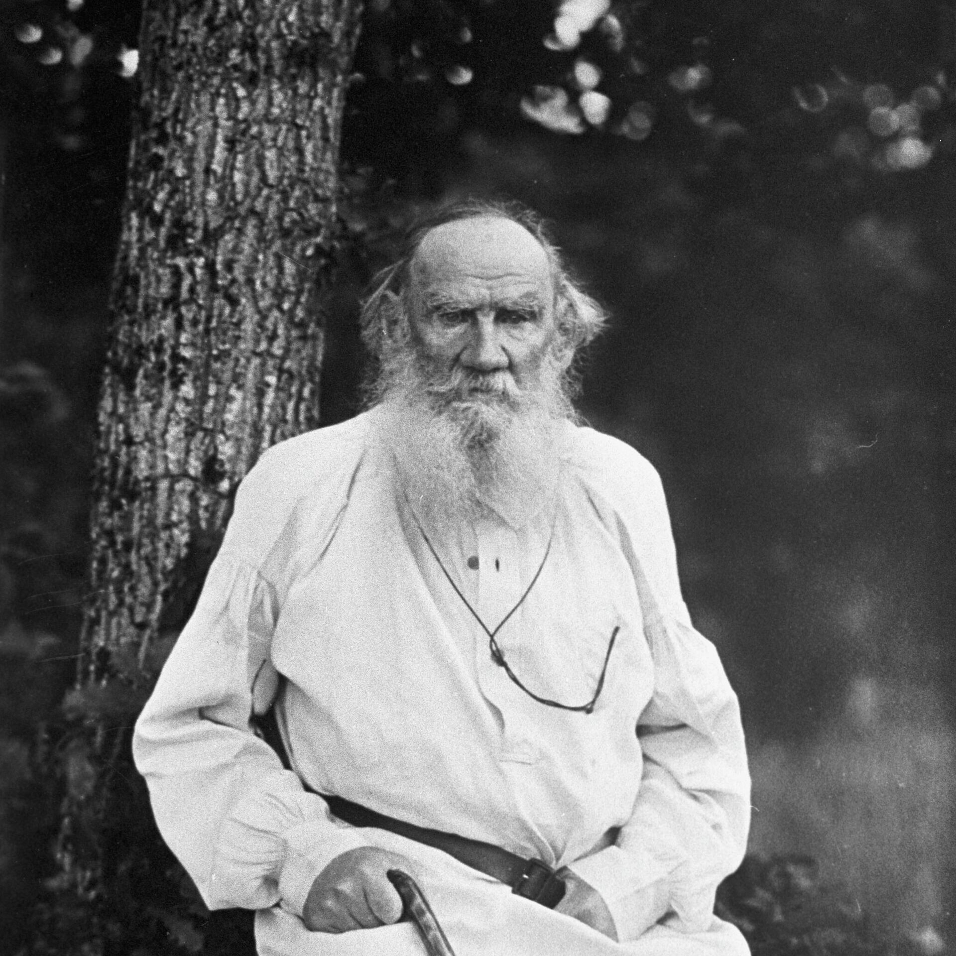

Moscow Census, Leo Tolstoy

Moscow Census

ARTICLE ON THE CENSUS IN MOSCOW.

Translated by Isabel F. Hapgood 1887

The object of a census is scientific. A census is a sociological investigation. And the object of the science of sociology is the happiness of the people. This science and its methods differ sharply from all other sciences.

Its peculiarity lies in this, that sociological investigations are not conducted by learned men in their cabinets, observatories and laboratories, but by two thousand people from the community. A second peculiarity is this, that the investigations of other sciences are not conducted on living people, but here living people are the subjects. A third peculiarity is, that the aim of every other science is simply knowledge, while here it is the good of the people. One man may investigate a nebula, but for the investigation of Moscow, two thousand persons are necessary.

The object of the study of nebulæ is merely that we may know about nebulæ; the object of the study of inhabitants is that sociological laws may be deduced, and that, on the foundation of these laws, a better life for the people may be established. It makes no difference to the nebula whether it is studied or not, and it has waited long, and is ready to wait a great while longer; but it is not a matter of indifference to the inhabitants of Moscow, especially to those unfortunates who constitute the most interesting subjects of the science of sociology.

The census-taker enters a night lodging-house; in the basement he finds a man dying of hunger, and he politely inquires his profession, his name, his native place, the character of his occupation, and after a little hesitation as to whether he is to be entered in the list as alive, he writes him in and goes his way.

And thus will the two thousand young men proceed. This is not as it should be.

Science does its work, and the community, summoned in the persons of these two thousand young men to aid science, must do its work. A statistician drawing his deductions from figures may feel indifferent towards people, but we census-takers, who see these people and who have no scientific prepossessions, cannot conduct ourselves towards them in an inhuman manner. Science fulfils its task, and its work is for its objects and in the distant future, both useful and necessary to us. For men of science, we can calmly say, that in 1882 there were so many beggars, so many prostitutes, and so many uncared-for children.

Science may say this with composure and with pride, because it knows that the confirmation of this fact conduces to the elucidation of the laws of sociology, and that the elucidation of the laws of sociology leads to a better constitution of society. But what if we, the unscientific people, say: “You are perishing in vice, you are dying of hunger, you are pining away, and killing each other; so do not grieve about this; when you shall have all perished, and hundreds of thousands more like you, then, possibly, science may be able to arrange everything in an excellent manner.” For men of science, the census has its interest; and for us also, it possesses an interest of a wholly different significance. The interest and significance of the census for the community lie in this, that it furnishes it with a mirror into which, willy nilly, the whole community, and each one of us, gaze.

The figures and deductions will be the mirror. It is possible to refrain from reading them, as it is possible to turn away from the looking-glass. It is possible to glance cursorily at both figures and mirror, and it is also possible to scrutinize them narrowly. To go about in connection with the census as thousands of people are now about to do, is to scrutinize one’s self closely in the mirror.

What does this census, that is about to be made, mean for us people of Moscow, who are not men of science? It means two things. In the first place, this, that we may learn with certainty, that among us tens of thousands who live in ease, there dwell tens of thousands of people who lack bread, clothing and shelter; in the second place, this, that our brothers and sons will go and view this and will calmly set down according to the schedules, how many have died of hunger and cold.

And both these things are very bad.

All cry out upon the instability of our social organization, about the exceptional situation, about revolutionary tendencies. Where lies the root of all this? To what do the revolutionists point? To poverty, to inequality in the distribution of wealth. To what do the conservatives point? To the decline in moral principle. If the opinion of the revolutionists is correct, what must be done? Poverty and the inequality of wealth must be lessened. How is this to be effected? The rich must share with the poor.

If the opinion of the conservatives is correct, that the whole evil arises from the decline in moral principle, what can be more immoral and vicious than the consciously indifferent survey of popular sufferings, with the sole object of cataloguing them? What must be done? To the census we must add the work of affectionate intercourse of the idle and cultivated rich, with the oppressed and unenlightened poor.

Science will do its work, let us perform ours also. Let us do this. In the first place, let all of us who are occupied with the census, superintendents and census-takers, make it perfectly clear to ourselves what we are to investigate and why. It is the people, and the object is that they may be happy. Whatever may be one’s view of life, every one will agree that there is nothing more important than human life, and that there is no more weighty task than to remove the obstacles to the development of this life, and to assist it.

This idea, that the relations of men to poverty are at the foundation of all popular suffering, is expressed in the Gospels with striking harshness, but at the same time, with decision and clearness for all.

“He who has clothed the naked, fed the hungry, visited the prisoner, that man has clothed Me, fed Me, visited Me,” that is, has done the deed for that which is the most important thing in the world.

However a man may look upon things, every one knows that this is more important than all else on earth.

And this must not be forgotten, and we must not permit any other consideration to veil from us the most weighty fact of our existence. Let us inscribe, and reckon, but let us not forget that if we encounter a man who is hungry and without clothes, it is of more moment to succor him than to make all possible investigations, than to discover all possible sciences. Perish the whole census if we may but feed an old woman.

The census will be longer and more difficult, but we cannot pass by people in the poorer quarters and merely note them down without taking any heed of them and without endeavoring, according to the measure of our strength and moral sensitiveness, to aid them. This in the first place. In the second, this is what must be done: All of us, who are to take part in the census, must refrain from irritation because we are annoyed; let us understand that this census is very useful for us; that if this is not cure, it is at least an effort to study the disease, for which we should be thankful; that we must seize this occasion, and, in connection with it, we must seek to recover our health, in some small degree.

Let all of us, then, who are connected with the census, endeavor to take advantage of this solitary opportunity in ten years to purify ourselves somewhat; let us not strive against, but assist the census, and assist it especially in this sense, that it may not have merely the harsh character of the investigation of a hopelessly sick person, but may have the character of healing and restoration to health. For the occasion is unique: eighty energetic, cultivated men, having under their orders two thousand young men of the same stamp, are to make their way over the whole of Moscow, and not leave a single man in Moscow with whom they have not entered into personal relations.

All the wounds of society, the wounds of poverty, of vice, of ignorance — all will be laid bare. Is there not something re-assuring in this? The census-takers will go about Moscow, they will set down in their lists, without distinction, those insolent with prosperity, the satisfied, the calm, those who are on the way to ruin, and those who are ruined, and the curtain will fall. The census-takers, our sons and brothers, these young men will behold all this. They will say: “Yes, our life is very terrible and incurable,” and with this admission they will live on like the rest of us, awaiting a remedy for the evil from this or that extraneous force. But those who are perishing will go on dying, in their ruin, and those on the road to ruin will continue in their course.

No, let us rather grasp the idea that science has its task, and that we, on the occasion of this census, have our task, and let us not allow the curtain once lifted to be dropped, but let us profit by the opportunity in order to remove the immense evil of the separation existing between us and the poor, and to establish intercourse and the work of redressing the evil of unhappiness and ignorance, and our still greater misfortune, — the indifference and aimlessness of our life.

I already hear the customary remark: “All this is very fine, these are sounding phrases; but do you tell us what to do and how to do it?” Before I say what is to be done, it is indispensable that I should say what is not to be done. It is indispensable, first of all, in my opinion, in order that something practical may come of this activity, that no society should be formed, that there should be no publicity, that there should be no collection of money by balls, bazaars or theatres; that there should be no announcement that Prince A. has contributed one thousand rubles, and the honorable citizen B. three thousand; that there shall be no collection, no calling to account, no writing up, — most of all, no writing up, so that there may not be the least shadow of any institution, either governmental or philanthropic.

But in my opinion, this is what should be done instantly: Firstly, All those who agree with me should go to the directors, and ask for their shares the poorest sections, the poorest dwellings; and in company with the census-takers, twenty-three, twenty-four or twenty-five in number, they should go to these quarters, enter into relations with the people who are in need of assistance, and labor for them.

Secondly: We should direct the attention of the superintendents and census-takers to the inhabitants in need of assistance, and work for them personally, and point them out to those who wish to work over them. But I am asked: What do you mean by working over them? I reply; Doing good to people. The words “doing good” are usually understood to mean, giving money. But, in my opinion, doing good and giving money are not only not the same thing, but two different and generally opposite things. Money, in itself, is evil.

And therefore he who gives money gives evil. This error of thinking that the giving of money means doing good, arose from the fact, that generally, when a man does good, he frees himself from evil, and from money among other evils.

And therefore, to give money is only a sign that a man is beginning to rid himself of evil. To do good, signifies to do that which is good for man. But, in order to know what is good for man, it is necessary to be on humane, i.e., on friendly terms with him. And therefore, in order to do good, it is not money that is necessary, but, first of all, a capacity for detaching ourselves, for a time at least, from the conditions of our own life. It is necessary that we should not be afraid to soil our boots and clothing, that we should not fear lice and bedbugs, that we should not fear typhus fever, diphtheria, and small-pox.

It is necessary that we should be in a condition to seat ourselves by the bunk of a tatterdemalion and converse earnestly with him in such a manner, that he may feel that the man who is talking with him respects and loves him, and is not putting on airs and admiring himself. And in order that this may be so, it is necessary that a man should find the meaning of life outside himself. This is what is requisite in order that good should be done, and this is what it is difficult to find.

When the idea of assisting through the medium of the census occurred to me, I discussed the matter with divers of the wealthy, and I saw how glad the rich were of this opportunity of decently getting rid of their money, that extraneous sin which they cherish in their hearts. “Take three hundred — five hundred rubles, if you like,” they said to me, “but I cannot go into those dens myself.”

There was no lack of money. Remember Zaccheus, the chief of the Publicans in the Gospel. Remember how he, because he was small of stature, climbed into a tree to see Christ, and how when Christ announced that he was going to his house, having understood but one thing, that the Master did not approve of riches, he leaped headlong from the tree, ran home and arranged his feast.

And how, as soon as Christ entered, Zaccheus instantly declared that he gave the half of his goods to the poor, and if he had wronged any man, to him he would restore fourfold. And remember how all of us, when we read the Gospel, set but little store on this Zaccheus, and involuntarily look with scorn on this half of his goods, and fourfold restitution. And our feeling is correct. Zaccheus, according to his lights, performed a great deed. He had not even begun to do good. He had only begun in some small measure to purify himself from evil, and so Christ told him.

He merely said to him: “To-day is salvation come nigh unto this house.”

What if the Moscow Zaccheuses were to do the same that he did? Assuredly, more than one milliard could be collected. Well, and what of that? Nothing. There would be still greater sin if we were to think of distributing this money among the poor. Money is not needed. What is needed is self-sacrificing action; what is needed are people who would like to do good, not by giving extraneous sin-money, but by giving their own labor, themselves, their lives. Where are such people to be found? Here they are, walking about Moscow. They are the student enumerators. I have seen how they write out their charts. The student writes in the night lodging-house, by the bedside of a sick man. “What is your disease?”— “Small-pox.” And the student does not make a wry face, but proceeds with his writing. And this he does for the sake of some doubtful science. What would he do if he were doing it for the sake of his own undoubted good and the good of others?

When children, in merry mood, feel a desire to laugh, they never think of devising some reason for laughter, but they laugh without any reason, because they are gay; and thus these charming youths sacrifice themselves. They have not, as yet, contrived to devise any means of sacrificing themselves, but they devote their attention, their labor, their lives, in order to write out a chart, from which something does or does not appear. What would it be if this labor were something really worth their while? There is and there always will be labor of this sort, which is worthy of the devotion of a whole life, whatever the man’s life may be. This labor is the loving intercourse of man with man, and the breaking-down of the barriers which men have erected between themselves, so that the enjoyment of the rich man may not be disturbed by the wild howls of the men who are reverting to beasts, and by the groans of helpless hunger, cold and disease.

This census will place before the eyes of us well-to-do and so-called cultivated people, all the poverty and oppression which is lurking in every corner of Moscow. Two thousand of our brothers, who stand on the highest rung of the ladder, will come face to face with thousands of people who stand on the lowest round of society. Let us not miss this opportunity of communion. Let us, through these two thousand men, preserve this communion, and let us make use of it to free ourselves from the aimlessness and the deformity of our lives, and to free the condemned from that indigence and misery which do not allow the sensitive people in our ranks to enjoy our good fortune in peace.

This is what I propose: (1) That all our directors and enumerators should join to their business of the census a task of assistance, — of work in the interest of the good of these people, who, in our opinion, are in need of assistance, and with whom we shall come in contact; (2) That all of us, directors and enumerators, not by appointment of the committee of the City Council, but by the appointment of our own hearts, shall remain in our posts, — that is, in our relations to the inhabitants of the town who are in need of assistance, — and that, at the conclusion of the work of the census, we shall continue our work of aid.

If I have succeeded in any degree in expressing what I feel, I am sure that the only impossibility will be getting the directors and enumerators to abandon this, and that others will present themselves in the places of those who leave; (3) That we should collect all those inhabitants of Moscow, who feel themselves fit to work for the needy, into sections, and begin our activity now, in accordance with the hints of the census-takers and directors, and afterwards carry it on; (4) That all who, on account of age, weakness, or other causes, cannot give their personal labor among the needy, shall intrust the task to their young, strong, and willing relatives. (Good consists not in the giving of money, it consists in the loving intercourse of men. This alone is needed.)

Whatever may be the outcome of this, any thing will be better than the present state of things.

Then let the final act of our enumerators and directors be to distribute a hundred twenty-kopek pieces to those who have no food; and this will be not a little, not so much because the hungry will have food, but because the directors and enumerators will conduct themselves in a humane manner towards a hundred poor people.

How are we to compute the possible results which will accrue to the balance of public morality from the fact that, instead of the sentiments of irritation, anger, and envy which we arouse by reckoning the hungry, we shall awaken in a hundred instances a sentiment of good, which will be communicated to a second and a third, and an endless wave which will thus be set in motion and flow between men? And this is a great deal. Let those of the two thousand enumerators who have never comprehended this before, come to understand that, when going about among the poor, it is impossible to say, “This is very interesting;” that a man should not express himself with regard to another man’s wretchedness by interest only; and this will be a good thing.

Then let assistance be rendered to all those unfortunates, of whom there are not so many as I at first supposed in Moscow, who can easily be helped by money alone to a great extent. Then let those laborers who have come to Moscow and have eaten their very clothing from their backs, and who cannot return to the country, be despatched to their homes; let the abandoned orphans receive supervision; let feeble old men and indigent old women, who subsist on the charity of their companions, be released from their half-famished and dying condition. (And this is very possible. There are not very many of them.) And this will also be a very, very great deal accomplished. But why not think and hope that more and yet more will be done?

Why not expect that that real task will be partially carried out, or at least begun, which is effected, not by money, but by labor; that weak drunkards who have lost their health, unlucky thieves, and prostitutes who are still capable of reformation, should be saved? All evil may not be exterminated, but there will arise some understanding of it, and the contest with it will not be police methods, but by inward modes, — by the brotherly intercourse of the men who perceive the evil, with the men who do not perceive it because they are a part of it.

No matter what may be accomplished, it will be a great deal. But why not hope that every thing will be accomplished? Why not hope that we shall accomplish thus much, that there shall not exist in Moscow a single person in want of clothing, a single hungry person, a single human being sold for money, nor a single individual oppressed by the judgment of man, who shall not know that there is fraternal aid for him? It is not surprising that this should not be so, but it is surprising that this should exist side by side with our superfluous leisure and wealth, and that we can live on composedly, knowing that these things are so. Let us forget that in great cities and in London, there is a proletariat, and let us not say that so it must needs be.

It need not be this, and it should not, for this is contrary to our reason and our heart, and it cannot be if we are living people. Why not hope that we shall come to understand that there is not a single duty incumbent upon us, not to mention personal duty, for ourselves, nor our family, nor social, nor governmental, nor scientific, which is more weighty than this?

Why not think that we shall at last come to apprehend this? Only because to do so would be too great a happiness. Why not hope that some the people will wake up, and will comprehend that every thing else is a delusion, but that this is the only work in life?

And why should not this “some time” be now, and in Moscow? Why not hope that the same thing may happen in society and humanity which suddenly takes place in a diseased organism, when the moment of convalescence suddenly sets in? The organism is diseased this means, that the cells cease to perform their mysterious functions; some die, others become infected, others still remain in perfect condition, and work on by themselves. But all of a sudden the moment comes when every living cell enters upon an independent and healthy activity: it crowds out the dead cells, encloses the infected ones in a living wall, it communicates life to that which was lifeless; and the body is restored, and lives with new life.

Why should we not think and expect that the cells of our society will acquire fresh life and re-invigorate the organism? We know not in what the power of the cells consists, but we do know that our life is in our own power. We can show forth the light that is in us, or we may extinguish it.

Let one man approach the Lyapinsky house in the dusk, when a thousand persons, naked and hungry, are waiting in the bitter cold for admission, and let that one man attempt to help, and his heart will ache till it bleeds, and he will flee thence with despair and anger against men; but let a thousand men approach that other thousand with a desire to help, and the task will prove easy and delightful. Let the mechanicians invent a machine for lifting the weight that is crushing us — that is a good thing; but until they shall have invented it, let us bear down upon the people, like fools, like muzhiki, like peasants, like Christians, and see whether we cannot raise them.

And now, brothers, all together, and away it goes!

The End