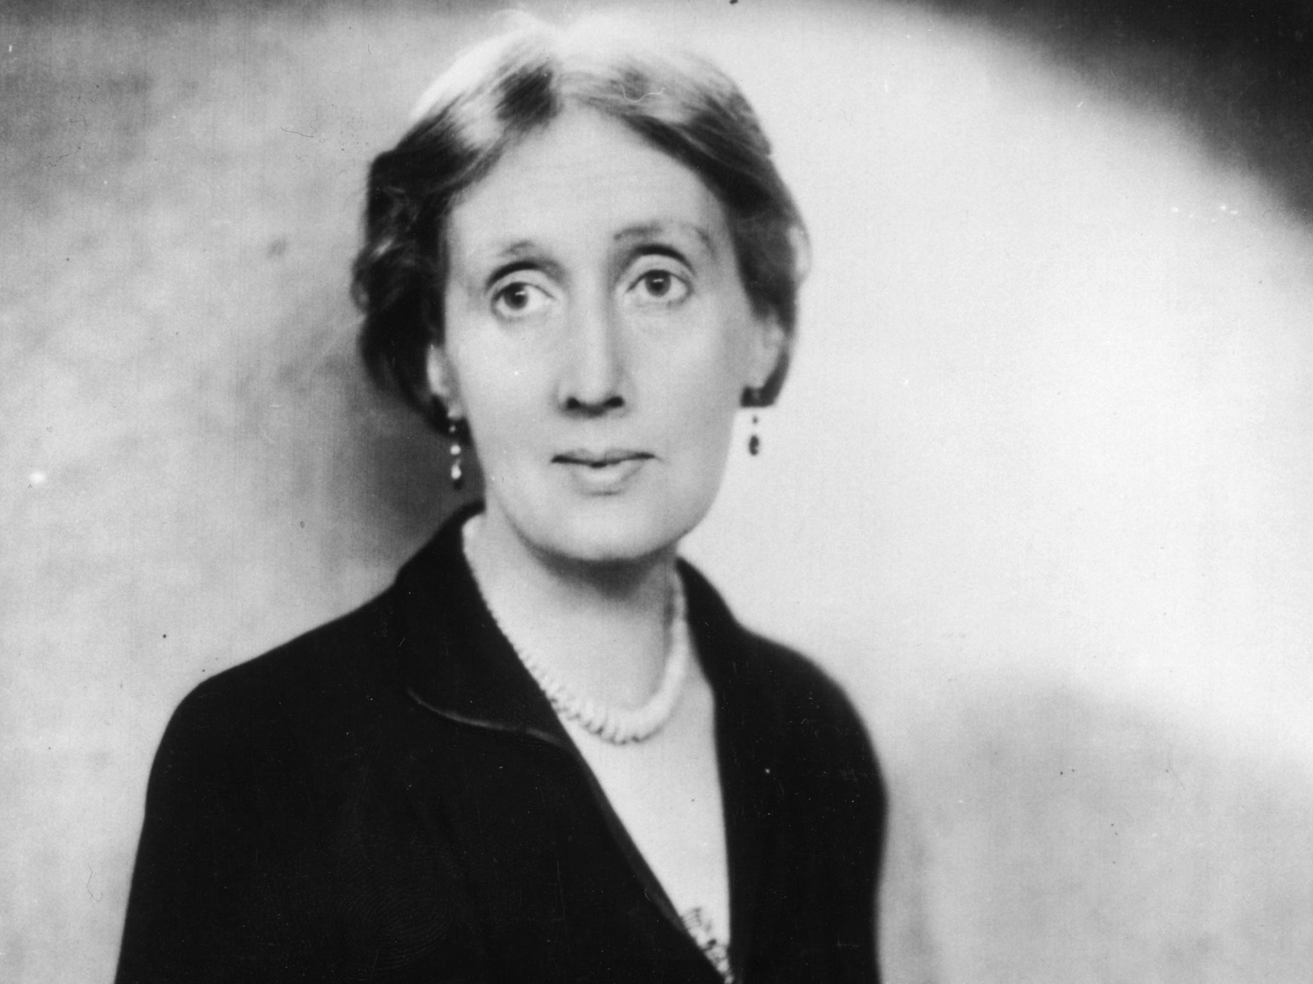

Three Essays on Dostoyevsky by Virginia Woolf

Contents

Dostoevsky the Father

More Dostoevsky

Dostoevsky in Cranford

Dostoevsky the Father

It would be a mistake to read this book as if it were a biography. Mlle Dostoevsky expressly calls it a study, and to this the reader must add that it is a study by a daughter. The letters, the facts, the testimonies of friends, even to a great extent the dates which support the orthodox biography are here absent or are introduced as they happen to suit the writer’s purpose.

And what is a daughter’s purpose in writing a study of her father? We need not judge her very severely if she wishes us to see him as she saw him - upright, affectionate, infallible, or, if he had his failings, she is to be excused if she represents them as the foibles of greatness. He was extravagant perhaps. He gambled sometimes. There were seasons when, misled by the wiles of women, he strayed from the paths of virtue.

We can make allowance for these filial euphemisms; and if we come to feel, as this book makes us feel, that the daughter was fond as well as proud of her father, that is a real addition to our knowledge. At the same time we should have listened more sympathetically if Mile Dostoevsky had suppressed her version of the quarrel between Dostoevsky and Turgenev. To make out that your father is a hero is one thing; to insist that his enemies are villains is another.

Yet she must have it that all the blame was on Turgenev’s side; that he was jealous, a snob, ‘even more cruel and malicious than the others’. She neglects the testimony supplied by Turgenev’s own works, and, what is more serious, makes no mention of the evidence on the other side which must be known to her. The effect is naturally to make the reader scrutinize Dostoevsky’s character more closely than he would otherwise have done.

He asks himself inevitably what there was in the man to cause this shrill and excited partisanship on the part of his daughter. The search for an answer among the baffling yet illuminating materials which Mlle Dostoevsky supplies is the true interest of this book.

If we were to be guided by her we should base our inquiry upon the fact that Dostoevsky was of Lithuanian descent on his father’s side. Mlle Dostoevsky has read Gobineau, and shows a perverse ingenuity and considerable industry in attributing almost every mental and moral characteristic to race heredity. Dostoevsky was a Lithuanian and thus loved purity; he was a Lithuanian and thus paid his brother’s debts; he was a Lithuanian and thus wrote bad Russian; he was a Lithuanian and thus a devout Catholic. When he complained that he had a strange and evil character he did not realize that it was neither strange nor evil, but simply Lithuanian.

As Dostoevsky himself never attached much importance to his descent, we may be allowed to follow his example. We shall not come much closer to him by pursuing that track. But Mlle Dostoevsky increases our knowledge by more indirect methods. A clever little girl cannot run about her father’s house without picking up many things which she is not expected to know. She knows whether the cook is grumbling; which of the guests bores her parents; whether her father is in a good temper, or whether there has been some mysterious grown-up catastrophe.

Considering that Aimée was very young when her father died, she could scarcely be expected to observe anything of much greater importance than this. But then she is a Russian. She has that apparently involuntary candour which must make family life so disconcerting in Russia. Her father’s greatness subdues her to a dutiful attitude, which, if reverent, is also a little colourless. But no one else has that power over her. ‘Her self-esteem was always excessive, almost morbid; a trifle would offend her, and she easily fell a victim to those who flattered her.’ Thus she describes her mother, and her mother is still alive.

As for her uncles and aunts, her step-brother, her father’s first wife, his mistress, she is completely outspoken about them all and - were it not that she qualifies her blame by detecting strains of Slav, Norman, Ukrainian, Negro, Mongol, and Swedish blood - equally severe.

That, indeed, is her contribution to our knowledge of Dostoevsky. No doubt she exaggerates; but there can also be no doubt that her bitterness is the legacy of old family quarrels - sordid, degrading, patched-up, but bursting out afresh and pursuing Dostoevsky to the verge of his death-chamber. The pages seem to ring with scoldings and complainings and recriminations; with demands for more money and with replies that all the money has been spent. Such, or something like it, we conclude, was the atmosphere in which Dostoevsky wrote his books.

His father was a doctor who had to resign his appointment owing to drunkenness; and it was on account of his drunken savagery that his serfs smothered him one day beneath the cushions of his carriage as he was driving on his estate. The disease was inherited by his children. Two of Dostoevsky’s brothers were drunkards; his sister was miserly to the verge of insanity, and was also murdered for her money. Her son was ‘so stupid that his folly verged on idiocy.

My uncle An drey’s son, a young and brilliant savant, died of creeping paralysis. The whole Dostoevsky family suffered from neurasthenia.’ And to the family eccentricity one must add what appears to the English reader the national eccentricity - the likelihood, that is to say, that if Dostoevsky escapes death on the scaffold and survives imprisonment in Siberia he will marry a wife who has a handsome young tutor for her lover, and will take for his mistress a girl who arrives at his bedside at seven in the morning brandishing an enormous knife with which she proposes to kill a Frenchman.

Dostoevsky dissuades her, and off they go to Wiesbaden where ‘my father played roulette with passionate absorption, was delighted when he won, and experienced a despair hardly less delicious when he lost’. It is all violent and extreme, later, even, when Dostoevsky was happily married, there was still a worthless stepson who expected to be supported; still the brothers’ debts to pay; still the sisters trying to make mischief between him and his wife; and then the rich aunt Kumanin must needs die and leave her property to stir up the last flames of hatred among the embittered relations. ‘Dostoevsky lost patience and, refusing to continue the painful discussion, left the table before the meal was finished.’ Three days later he was dead. One thinks of Farringford flourishing not so very far away. One wonders what Matthew Arnold, who deplored the irregularities of the Shelley set, would have said to this one.

And yet, has it anything to do with Dostoevsky? One feels rather as if one had been admitted to the kitchen where the cook is smashing the china, or to the drawing-room where the relations are gossiping in corners, while Dostoevsky sits upstairs alone in his study. He had, it is clear, an extraordinary power of absenting his mind from his body.

The money troubles alone, one would think, were enough to drive him distracted. On the contrary, it was his wife who worried, and it was Dostoevsky, says his daughter, who remained serene, saying, ‘in tones of conviction, “We shall never be without money.” ‘ We catch sight of his body plainly enough, but it is rather as if we passed him taking his afternoon walk, always at four o’clock, always along the same road, so absorbed in his own thoughts that ‘he never recognized the acquaintance he met on the way’. They travelled in Italy, visited the galleries, strolled in the Boboli gardens, and ‘the roses blooming there struck their Northern imaginations’.

But after working at The Idiot’ all the morning how much did he see of the roses in the afternoon? It is the waste of his day that is gathered up and given us in place of his life. But now and then, when Mlle Dostoevsky forgets the political rancours of the moment and the complex effect of the Norman strain upon the Lithuanian temperament, she opens the study door and lets us see her father as she saw him. He could not write if he had a spot of candle-grease on his coat.

He liked dried figs and kept a box of them in a cupboard from which he helped his children. He liked eau-de-Cologne to wash with. He liked little girls to wear pale green. He would dance with them and read aloud Dickens and Scott. But he never spoke to them about his own childhood. She thinks that he dreaded discovering signs of his father’s vices in himself; and she believes that he ‘wished intensely to be like others’. At any rate, it was the greatest pleasure of her day to be allowed to breakfast with him and to talk to him about books. And then it is all over. There is her father laid out in his evening dress in his coffin; a painter is sketching him; grand dukes and peasants crowd the staircase; while she and her brother distribute flowers to unknown people and enjoy very much the drive to the cemetery.

More Dostoevsky

Each time that Mrs Garnett adds another red volume to her admirable translations of the works of Dostoevsky we feel a little better able to measure what the existence of this great genius who is beginning to permeate our lives so curiously means to us. His books are now to be found on the shelves of the humblest English libraries; they have become an indestructible part of the furniture of our rooms, as they belong for good to the furniture of our minds.

The latest addition to Mrs Garnett’s translation, The Eternal Husband’, including also The Double’ and ‘The Gentle Spirit’, is not one of the greatest of his works, although it was produced in what may be held to be the greatest period of his genius, between The Idiot’ and The Possessed’. If one had never read anything else by Dostoevsky, one might lay the book down with a feeling that the man who wrote it was bound to write a very great novel some day; but with a feeling also that something strange and important had happened. This strangeness and this sense that something important has happened persist, however, although we are familiar with his books and have had time to arrange the impression that they make on us.

Of all great writers there is, so it seems to us, none quite so surprising, or so bewildering, as Dostoevsky. And although ‘The Eternal Husband’ is nothing more than a long short story which we need not compare with the great novels, it too has this extraordinary power; nor while we are reading it can we liberate ourselves sufficiently to feel certain that in this or that respect there is a failure of power, or insight, or craftsmanship; nor does it occur to us to compare it with other works either by the same writer or by other writers. It is very difficult to analyse the impression it has made even when we have finished it.

It is the story of one Velchaninov, who, many years before the story opens, has seduced the wife of a certain Pavel Pavlovitch in the town of T — . Velchaninov has almost forgotten her and is living in Petersburg. But now as he walks about Petersburg he is constantly running into a man who wears a crêpe hat-band and reminds him of someone he cannot put a name to.

At last, after repeated meetings which bring him to a state bordering on delirium, Velchaninov is visited at two o’clock in the morning by the stranger, who explains that he is the husband of Velchaninov’s old love, and that she is dead. When Velchaninov visits him the next day he finds him maltreating a little girl, who is, he instantly perceives, his own child.

He manages to take her away from Pavel, who is a drunkard and in every way disreputable, and give her lodging with friends, but almost immediately she dies. After her death Pavel announces that he is engaged to marry a girl of sixteen, but when, as he insists, Velchaninov visits her, she confides to him that she detests Pavel and is already engaged to a youth of nineteen. Between them they contrive to pack Pavel off to the country; and he turns up finally at the end of the story as the husband of a provincial beauty, and the lady, of course, has a lover.

These, at least, are the little bits of cork which mark a circle upon the top of the waves while the net drags the floor of the sea and encloses stranger monsters than have ever been brought to the light of day before. The substance of the book is made out of the relationship between Velchaninov and Pavel.

Pavel is a type of what Velchaninov calls ‘the eternal husband’. ‘Such a man is born and grows up only to be a husband, and, having married, is promptly transformed into a supplement of his wife, even when he happens to have an unmistakable character of his own ... [Pavel] could only as long as his wife was alive have remained all that he used to be, but, as it was, he was only a fraction of a whole, suddenly cut off and set free, that is something wonderful and unique.’

One of the peculiarities of the eternal husband is that he is always half in love with the lovers of his wife, and at the same time wishes to kill them. Impelled by this mixture of almost amorous affection and hatred, he cannot keep away from Velchaninov, in whom he breeds a kind of reflection of his own sensations of attraction and repulsion. He can never bring himself to make any direct charge against Velchaninov; and Velchaninov is never able to confess or to deny his misconduct.

Sometimes, from the stealthy way in which he approaches, Velchaninov feels certain that he has an impulse to kill him; but then he insists upon kissing him and cries out, ‘So, you understand, you’re the one friend left me now!’ One night when Velchaninov is ill and Pavel has shown the most enthusiastic devotion Velchaninov wakes from a nightmare to find Pavel standing over him and attempting to murder him with a razor. Pavel is easily mastered and slinks away shamefaced in the morning. But did he mean to murder him, Velchaninov muses, or did he want it without knowing that he wanted it?

But did he love me yesterday when he declared his feeling and said ‘Let us settle our account’? Yes, it was from hatred that he loved me; that’s the strongest of all loves ... It would be interesting to know by what I impressed him. Perhaps by my clean gloves and my knowing how to put them on ... He comes here ‘to embrace me and weep’, as he expressed it in the most abject way - that is, he came here to murder me and thought he came ‘to embrace me and to weep’. But who knows?

If I had wept with him, perhaps, really, he would have forgiven me, for he had a terrible longing to forgive me! ... Ough! wasn’t he pleased, too, when he made me kiss him! Only he didn’t know then whether he would end by embracing me or murdering me ... The most monstrous monster is the monster with noble feelings ... But it was not your fault, Pavel Pavlovitch, it was not your fault: you’re a monster, so everything about you is bound to be monstrous, your dreams and your hopes.

Perhaps this quotation may give some idea of the labyrinth of the soul through which we have to grope our way. But being only a quotation it makes the different thoughts appear too much isolated; for in the context Velchaninov, as he broods over the blood-stained razor, passes over his involved and crowded train of thought without a single hitch, just, in fact, as we ourselves are conscious of thinking when some startling fact has dropped into the pool of our consciousness.

From the crowd of objects pressing upon our attention we select now this one, now that one, weaving them inconsequently into our thought; the associations of a word perhaps make another loop in the line, from which we spring back again to a different section of our main thought, and the whole process seems both inevitable and perfectly lucid. But if we try to construct our mental processes later, we find that the links between one thought and another are submerged. The chain is sunk out of sight and only the leading points emerge to mark the course.

Alone among writers Dostoevsky has the power of reconstructing these most swift and complicated states of mind, of re-thinking the whole train of thought in all its speed, now as it flashes into light, now as it lapses into darkness; for he is able to follow not only the vivid streak of achieved thought but to suggest the dim and populous underworld of the mind’s consciousness where desires and impulses are moving blindly beneath the sod. Just as we awaken ourselves from a trance of this kind by striking a chair or a table to assure ourselves of an external reality, so Dostoevsky suddenly makes us behold, for an instant, the face of his hero, or some object in the room.

This is the exact opposite of the method adopted, perforce, by most of our novelists. They reproduce all the external appearances - tricks of manner, landscape, dress, and the effect of the hero upon his friends - but very rarely, and only for an instant, penetrate to the tumult of thought which rages within his own mind. But the whole fabric of a book by Dostoevsky is made out of such material. To him a child or a beggar is as full of violent and subtle emotions as a poet or a sophisticated woman of the world; and it is from the intricate maze of their emotions that Dostoevsky constructs his version of life.

In reading him, therefore, we are often bewildered because we find ourselves observing men and women from a different point of view from that to which we are accustomed. We have to get rid of the old tune which runs so persistently in our ears, and to realize how little of our humanity is expressed in that old tune. Again and again we are thrown off the scent in following Dostoevsky’s psychology; we constantly find ourselves wondering whether we recognize the feeling that he shows us, and we realize constantly and with a start of surprise that we have met it before in ourselves, or in some moment of intuition have suspected it in others.

But we have never spoken of it, and that is why we are surprised. Intuition is the term which we should apply to Dostoevsky’s genius at its best. When he is fully possessed by it he is able to read the most inscrutable writing at the depths of the darkest souls; but when it deserts him the whole of his amazing machinery seems to spin fruitlessly in the air. In the present volume, The Double’, with all its brilliancy and astonishing ingenuity, is an example of this kind of elaborate failure; ‘The Gentle Spirit’, on the other hand, is written from start to finish with a power which for the time being turns everything we can put beside it into the palest commonplace.

Dostoevsky in Cranford

It is amusing sometimes to freshen one’s notion of a great, and thus semi-mythical, character by transplanting him in imagination to one’s own age, shore, or country village. How, one asks, would Dostoevsky have behaved himself upon the vicarage lawn? In ‘Uncle’s Dream’, the longest story in Mrs Garnett’s new volume, he enables one to fancy him in those incongruous surroundings. Mordasov bears at any rate a superficial resemblance to Cranford.

All the ladies in that small country town spend their time in drinking tea and talking scandal. A newcomer, such as Prince K., is instantly torn to pieces like a fish tossed to a circle of frenzied and ravenous seagulls. Mordasov cannot be altogether like Cranford, then.

No such figure of speech could be used with propriety to describe the demure activities and bright-eyed curiosities of the English circle of ladies. After sending our imaginary Dostoevsky, therefore, pacing up and down the lawn, there can be no doubt that he suddenly stamps his foot, exclaims something unintelligible, and rushes off in despair. ‘The instinct of provincial newsmongers sometimes approaches the miraculous ...

They know you by heart, they know even what you don’t know about yourself. The provincial ought, one would think, by his very nature to be a psychologist and a specialist in human nature. That is why I have been sometimes genuinely amazed at meeting in the provinces not psychologists and specialists in human nature, but a very great number of asses. But that is aside; that is a superfluous reflection.’ His patience is already exhausted; it is idle to expect that he will linger in the High-street or hang in a rapture of observation round the draper’s shop. The delightful shades and subdeties of English provincial life are lost upon him.

But Mordasov is a very different place from Cranford. The ladies do not confine themselves to tea, as their condition after dinner sometimes testifies. Their tongues wag with a fury that is rather that of the open market-place than of the closed drawing-room. Though they indulge in petty vices such as listening at keyholes and stealing the sugar when the hostess is out of the room, they act with the brazen boldness of viragos.

One would be alarmed to find oneself left alone with one of them. Nevertheless, in his big rough way, Dostoevsky is neither savagely contemptuous nor sadly compassionate; he is genuinely amused by the spectacle of Mordasov. It roused, as human life so seldom did, his sense of comedy. He tries even to adapt his dialogue to the little humours of a gossiping conversation.

‘Call that a dance! I’ve danced myself, the shawl dance, at the breaking-up party at Madame Jamis’s select boarding-school - and it really was a distinguished performance. I was applauded by senators! The daughters of princes and counts were educated there! ... Only fancy’ [she runs on, as if she were imitating the patter of Miss Bates] ‘chocolate was handed round to everyone, but not offered to me, and they did not say a word to me all the time... The tub of a woman, I’ll pay her out!’

But Dostoevsky cannot keep to that tripping measure for long. The language becomes abusive, and the temper violent. His comedy has far more in common with the comedy of Wycherly than with the comedy of Jane Austen. It rapidly runs to seed, and becomes a helter-skelter, extravagant farce. The restraint and aloofness of the great comic writers are impossible to him. It is probable, for one reason, that he could not allow himself the time. ‘Uncle’s Dream’, ‘The Crocodile’, and ‘An Unpleasant Predicament’ read as if they were the improvisations of a gigantic talent reeling off its wild imaginations at breathless speed. They have the diffuseness of a mind too tired to concentrate, and too fully charged to stop short. Slack and un girt as it is, it tumbles out rubbish and splendour pell-mell.

Yet we are perpetually conscious that, if Dostoevsky fails to keep within the proper limits, it is because the fervour of his genius goads him across the boundary. Because of his sympathy his laughter passes beyond merriment into a strange violent amusement which is not merry at all. He is incapable, even when his story is hampered by the digression, of passing by anything so important and lovable as a man or a woman without stopping to consider their case and explain it.

Thus at one moment it occurs to him that there must be a reason why an unfortunate clerk could not afford to pay for a bottle of wine. Immediately, as if recalling a story which is known to him down to its most minute detail, he describes how the clerk had been born and brought up; it is then necessary to bring in the career of his brutal father-in-law, and that leads him to describe the peculiarities of the five unfortunate women whom the father-in-law bullies.

In short, once you are alive, there is no end to the complexity of your connections, and sorrow and misery are so rubbed into the texture of life that the more you examine it the more cloudy and confused it becomes. Perhaps it is because we know so little about the family history of the ladies of Cranford that we can put the book down with a smile. Still, we need not underrate the value of comedy because Dostoevsky makes the perfection of the English product appear to be the result of leaving out all the most important things. It is the old, unnecessary quarrel between the inch of smooth ivory and the six feet of canvas with its strong coarse grains.

The End