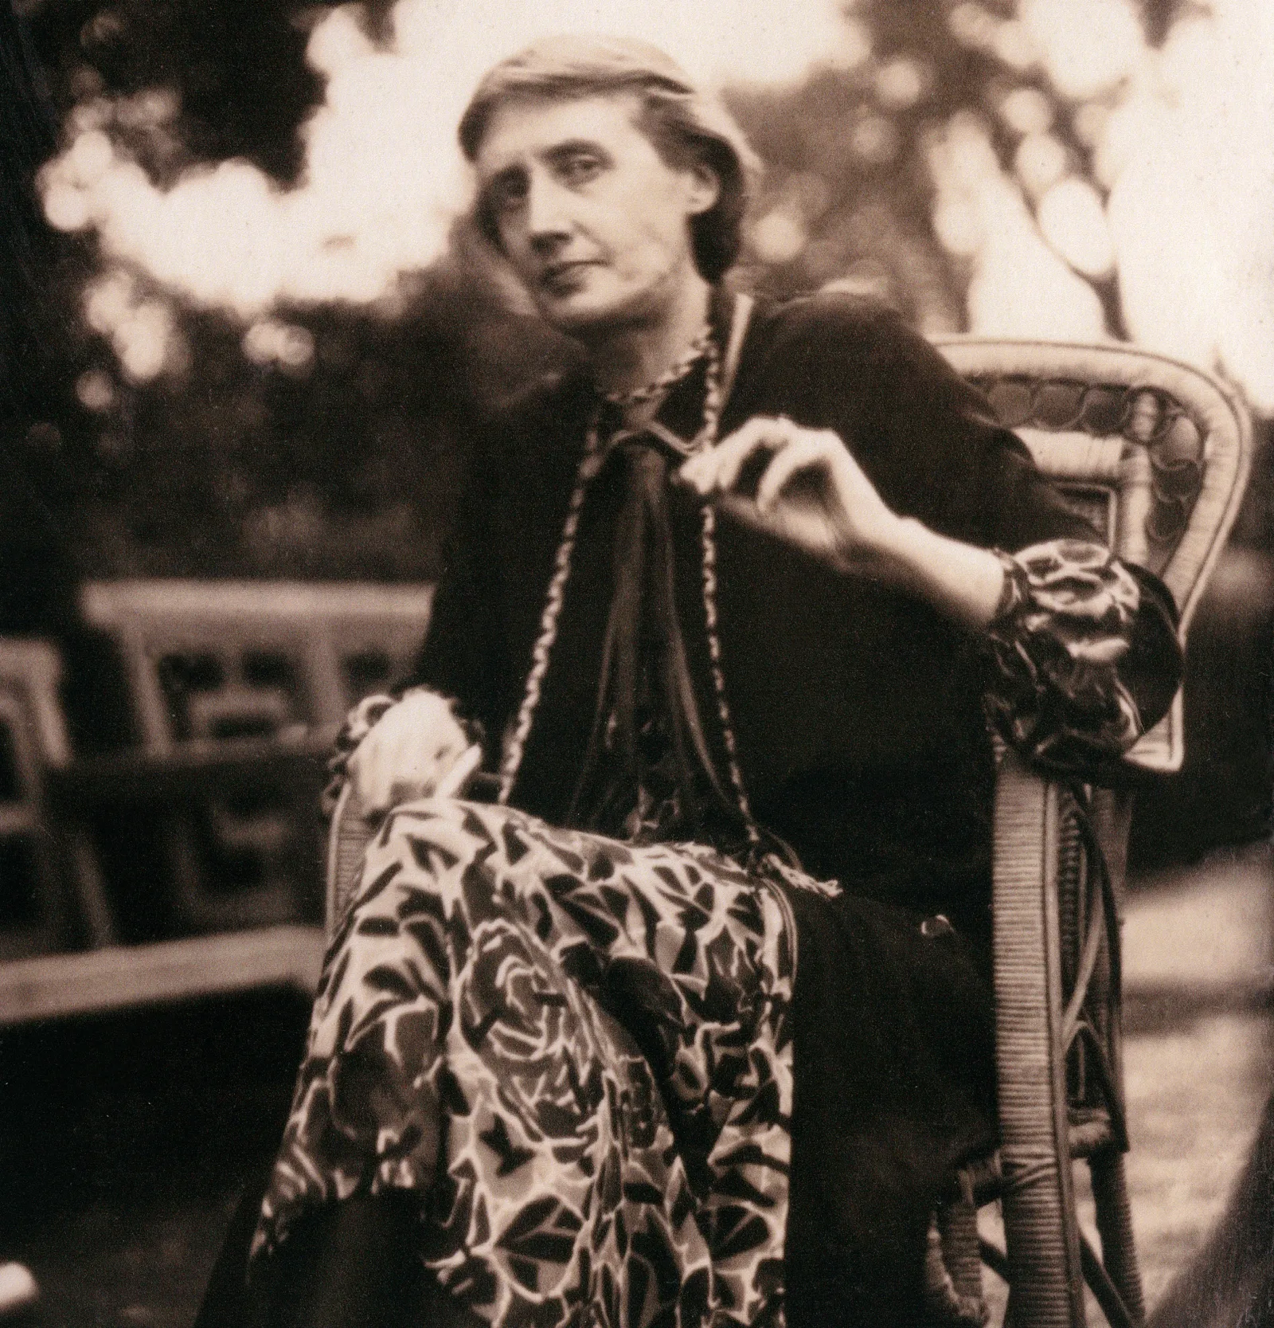

The Russian Point of View, Virginia Woolf

The Russian Point of View by Virginia Woolf

The famous novelist and literary critic Virginia Woolf published this essay on Russian literature, examining Tolstoy’s contribution, in a London periodical in 1912.

Virginia Woolf

The Russian Point of View

DOUBTFUL AS WE frequently are whether either the French or the Americans, who have so much in common with us, can yet understand English literature, we must admit graver doubts whether, for all their enthusiasm, the English can understand Russian literature. Debate might protract itself indefinitely as to what we mean by “understand”. Instances will occur to everybody of American writers in particular who have written with the highest discrimination of our literature and of ourselves; who have lived a lifetime among us, and finally have taken legal steps to become subjects of King George.

For all that, have they understood us, have they not remained to the end of their days foreigners? Could any one believe that the novels of Henry James were written by a man who had grown up in the society which he describes, or that his criticism of English writers was written by a man who had read Shakespeare without any sense of the Atlantic Ocean and two or three hundred years on the far side of it separating his civilisation from ours? A special acuteness and detachment, a sharp angle of vision the foreigner will often achieve; but not that absence of self-consciousness, that ease and fellowship and sense of common values which make for intimacy, and sanity, and the quick give and take of familiar intercourse.

Not only have we all this to separate us from Russian literature, but a much more serious barrier — the difference of language. Of all those who feasted upon Tolstoi, Dostoevsky, and Tchekov during the past twenty years, not more than one or two perhaps have been able to read them in Russian. Our estimate of their qualities has been formed by critics who have never read a word of Russian, or seen Russia, or even heard the language spoken by natives; who have had to depend, blindly and implicitly, upon the work of translators.

What we are saying amounts to this, then, that we have judged a whole literature stripped of its style. When you have changed every word in a sentence from Russian to English, have thereby altered the sense a little, the sound, weight, and accent of the words in relation to each other completely, nothing remains except a crude and coarsened version of the sense.

Thus treated, the great Russian writers are like men deprived by an earthquake or a railway accident not only of all their clothes, but also of something subtler and more important — their manners, the idiosyncrasies of their characters. What remains is, as the English have proved by the fanaticism of their admiration, something very powerful and very impressive, but it is difficult to feel sure, in view of these mutilations, how far we can trust ourselves not to impute, to distort, to read into them an emphasis which is false.

They have lost their clothes, we say, in some terrible catastrophe, for some such figure as that describes the simplicity, the humanity, startled out of all effort to hide and disguise its instincts, which Russian literature, whether it is due to translation or to some more profound cause, makes upon us.

We find these qualities steeping it through, as obvious in the lesser writers as in the greater. “Learn to make yourselves akin to people. I would even like to add: make yourself indispensable to them. But let this sympathy be not with the mind — for it is easy with the mind — but with the heart, with love towards them.” “From the Russian”, one would say instantly, where-ever one chanced on that quotation.

The simplicity, the absence of effort, the assumption that in a world bursting with misery the chief call upon us is to understand our fellow-sufferers, “and not with the mind — for it is easy with the mind — but with the heart” — this is the cloud which broods above the whole of Russian literature, which lures us from our own parched brilliancy and scorched thoroughfares to expand in its shade — and of course with disastrous results. We become awkward and self-conscious; denying our own qualities, we write with an affectation of goodness and simplicity which is nauseating in the extreme. We cannot say “Brother” with simple conviction. There is a story by Mr. Galsworthy in which one of the characters so addresses another (they are both in the depths of misfortune).

Immediately everything becomes strained and affected. The English equivalent for “Brother” is “Mate” — a very different word, with something sardonic in it, an indefinable suggestion of humour. Met though they are in the depths of misfortune the two Englishmen who thus accost each other will, we are sure, find a job, make their fortunes, spend the last years of their lives in luxury, and leave a sum of money to prevent poor devils from calling each other “Brother” on the Embankment. But it is common suffering, rather than common happiness, effort, or desire that produces the sense of brotherhood. It is the “deep sadness” which Dr. Hagberg Wright finds typical of the Russian people that creates their literature.

A generalisation of this kind will, of course, even if it has some degree of truth when applied to the body of literature, be changed profoundly when a writer of genius sets to work on it. At once other questions arise. It is seen that an “attitude” is not simple; it is highly complex. Men reft of their coats and their manners, stunned by a railway accident, say hard things, harsh things, unpleasant things, difficult things, even if they say them with the abandonment and simplicity which catastrophe has bred in them.

Our first impressions of Tchekov are not of simplicity but of bewilderment. What is the point of it, and why does he make a story out of this? we ask as we read story after story. A man falls in love with a married woman, and they part and meet, and in the end are left talking about their position and by what means they can be free from “this intolerable bondage”.

“‘How? How?’ he asked, clutching his head. . . . And it seemed as though in a little while the solution would be found and then a new and splendid life would begin.” That is the end. A postman drives a student to the station and all the way the student tries to make the postman talk, but he remains silent. Suddenly the postman says unexpectedly, “It’s against the regulations to take any one with the post”. And he walks up and down the platform with a look of anger on his face. “With whom was he angry? Was it with people, with poverty, with the autumn nights?” Again, that story ends.

But is it the end, we ask? We have rather the feeling that we have overrun our signals; or it is as if a tune had stopped short without the expected chords to close it. These stories are inconclusive, we say, and proceed to frame a criticism based upon the assumption that stories ought to conclude in a way that we recognise. In so doing, we raise the question of our own fitness as readers.

Where the tune is familiar and the end emphatic — lovers united, villains discomfited, intrigues exposed — as it is in most Victorian fiction, we can scarcely go wrong, but where the tune is unfamiliar and the end a note of interrogation or merely the information that they went on talking, as it is in Tchekov, we need a very daring and alert sense of literature to make us hear the tune, and in particular those last notes which complete the harmony. Probably we have to read a great many stories before we feel, and the feeling is essential to our satisfaction, that we hold the parts together, and that Tchekov was not merely rambling disconnectedly, but struck now this note, now that with intention, in order to complete his meaning.

We have to cast about in order to discover where the emphasis in these strange stories rightly comes. Tchekov’s own words give us a lead in the right direction. “. . . such a conversation as this between us”, he says, “would have been unthinkable for our parents. At night they did not talk, but slept sound; we, our generation, sleep badly, are restless, but talk a great deal, and are always trying to settle whether we are right or not.” Our literature of social satire and psychological finesse both sprang from that restless sleep, that incessant talking; but after all, there is an enormous difference between Tchekov and Henry James, between Tchekov and Bernard Shaw.

Obviously — but where does it arise? Tchekov, too, is aware of the evils and injustices of the social state; the condition of the peasants appals him, but the reformer’s zeal is not his — that is not the signal for us to stop. The mind interests him enormously; he is a most subtle and delicate analyst of human relations. But again, no; the end is not there. Is it that he is primarily interested not in the soul’s relation with other souls, but with the soul’s relation to health — with the soul’s relation to goodness? These stories are always showing us some affectation, pose, insincerity. Some woman has got into a false relation; some man has been perverted by the inhumanity of his circumstances. The soul is ill; the soul is cured; the soul is not cured. Those are the emphatic points in his stories.

Once the eye is used to these shades, half the “conclusions” of fiction fade into thin air; they show like transparences with a light behind them — gaudy, glaring, superficial. The general tidying up of the last chapter, the marriage, the death, the statement of values so sonorously trumpeted forth, so heavily underlined, become of the most rudimentary kind. Nothing is solved, we feel; nothing is rightly held together. On the other hand, the method which at first seemed so casual, inconclusive, and occupied with trifles, now appears the result of an exquisitely original and fastidious taste, choosing boldly, arranging infallibly, and controlled by an honesty for which we can find no match save among the Russians themselves.

There may be no answer to these questions, but at the same time let us never manipulate the evidence so as to produce something fitting, decorous, agreeable to our vanity. This may not be the way to catch the ear of the public; after all, they are used to louder music, fiercer measures; but as the tune sounded so he has written it. In consequence, as we read these little stories about nothing at all, the horizon widens; the soul gains an astonishing sense of freedom.

In reading Tchekov we find ourselves repeating the word “soul” again and again. It sprinkles his pages. Old drunkards use it freely; “. . . you are high up in the service, beyond all reach, but haven’t real soul, my dear boy . . . there’s no strength in it”. Indeed, it is the soul that is the chief character in Russian fiction. Delicate and subtle in Tchekov, subject to an infinite number of humours and distempers, it is of greater depth and volume in Dostoevsky; it is liable to violent diseases and raging fevers, but still the predominant concern. Perhaps that is why it needs so great an effort on the part of an English reader to read The Brothers Karamazov or The Possessed a second time. The “soul” is alien to him. It is even antipathetic.

It has little sense of humour and no sense of comedy. It is formless. It has slight connection with the intellect. It is confused, diffuse, tumultuous, incapable, it seems, of submitting to the control of logic or the discipline of poetry. The novels of Dostoevsky are seething whirlpools, gyrating sandstorms, waterspouts which hiss and boil and suck us in. They are composed purely and wholly of the stuff of the soul.

Against our wills we are drawn in, whirled round, blinded, suffocated, and at the same time filled with a giddy rapture. Out of Shakespeare there is no more exciting reading. We open the door and find ourselves in a room full of Russian generals, the tutors of Russian generals, their step-daughters and cousins, and crowds of miscellaneous people who are all talking at the tops of their voices about their most private affairs.

But where are we? Surely it is the part of a novelist to inform us whether we are in an hotel, a flat, or hired lodging. Nobody thinks of explaining. We are souls, tortured, unhappy souls, whose only business it is to talk, to reveal, to confess, to draw up at whatever rending of flesh and nerve those crabbed sins which crawl on the sand at the bottom of us.

But, as we listen, our confusion slowly settles. A rope is flung to us; we catch hold of a soliloquy; holding on by the skin of our teeth, we are rushed through the water; feverishly, wildly, we rush on and on, now submerged, now in a moment of vision understanding more than we have ever understood before, and receiving such revelations as we are wont to get only from the press of life at its fullest. As we fly we pick it all up — the names of the people, their relationships, that they are staying in an hotel at Roulettenburg, that Polina is involved in an intrigue with the Marquis de Grieux — but what unimportant matters these are compared with the soul! It is the soul that matters, its passion, its tumult, its astonishing medley of beauty and vileness.

And if our voices suddenly rise into shrieks of laughter, or if we are shaken by the most violent sobbing, what more natural? — it hardly calls for remark. The pace at which we are living is so tremendous that sparks must rush off our wheels as we fly.

Moreover, when the speed is thus increased and the elements of the soul are seen, not separately in scenes of humour or scenes of passion as our slower English minds conceive them, but streaked, involved, inextricably confused, a new panorama of the human mind is revealed. The old divisions melt into each other. Men are at the same time villains and saints; their acts are at once beautiful and despicable. We love and we hate at the same time. There is none of that precise division between good and bad to which we are used. Often those for whom we feel most affection are the greatest criminals, and the most abject sinners move us to the strongest admiration as well as love.

Dashed to the crest of the waves, bumped and battered on the stones at the bottom, it is difficult for an English reader to feel at ease. The process to which he is accustomed in his own literature is reversed. If we wished to tell the story of a General’s love affair (and we should find it very difficult in the first place not to laugh at a General), we should begin with his house; we should solidify his surroundings.

Only when all was ready should we attempt to deal with the General himself. Moreover, it is not the samovar but the teapot that rules in England; time is limited; space crowded; the influence of other points of view, of other books, even of other ages, makes itself felt. Society is sorted out into lower, middle, and upper classes, each with its own traditions, its own manners, and, to some extent, its own language. Whether he wishes it or not, there is a constant pressure upon an English novelist to recognise these barriers, and, in consequence, order is imposed on him and some kind of form; he is inclined to satire rather than to compassion, to scrutiny of society rather than understanding of individuals themselves.

No such restraints were laid on Dostoevsky. It is all the same to him whether you are noble or simple, a tramp or a great lady. Whoever you are, you are the vessel of this perplexed liquid, this cloudy, yeasty, precious stuff, the soul. The soul is not restrained by barriers.

It overflows, it floods, it mingles with the souls of others. The simple story of a bank clerk who could not pay for a bottle of wine spreads, before we know what is happening, into the lives of his father-in-law and the five mistresses whom his father-in-law treated abominably, and the postman’s life, and the charwoman’s, and the Princesses’ who lodged in the same block of flats; for nothing is outside Dostoevsky’s province; and when he is tired, he does not stop, he goes on. He cannot restrain himself. Out it tumbles upon us, hot, scalding, mixed, marvellous, terrible, oppressive — the human soul.

There remains the greatest of all novelists — for what else can we call the author of War and Peace? Shall we find Tolstoi, too, alien, difficult, a foreigner? Is there some oddity in his angle of vision which, at any rate until we have become disciples and so lost our bearings, keeps us at arm’s length in suspicion and bewilderment? From his first words we can be sure of one thing at any rate — here is a man who sees what we see, who proceeds, too, as we are accustomed to proceed, not from the inside outwards, but from the outside inwards. Here is a world in which the postman’s knock is heard at eight o’clock, and people go to bed between ten and eleven.

Here is a man, too, who is no savage, no child of nature; he is educated; he has had every sort of experience. He is one of those born aristocrats who have used their privileges to the full. He is metropolitan, not suburban. His senses, his intellect, are acute, powerful, and well nourished.

There is something proud and superb in the attack of such a mind and such a body upon life. Nothing seems to escape him. Nothing glances off him unrecorded. Nobody, therefore, can so convey the excitement of sport, the beauty of horses, and all the fierce desirability of the world to the senses of a strong young man. Every twig, every feather sticks to his magnet.

He notices the blue or red of a child’s frock; the way a horse shifts its tail; the sound of a cough; the action of a man trying to put his hands into pockets that have been sewn up. And what his infallible eye reports of a cough or a trick of the hands his infallible brain refers to something hidden in the character, so that we know his people, not only by the way they love and their views on politics and the immortality of the soul, but also by the way they sneeze and choke.

Even in a translation we feel that we have been set on a mountain-top and had a telescope put into our hands. Everything is astonishingly clear and absolutely sharp. Then, suddenly, just as we are exulting, breathing deep, feeling at once braced and purified, some detail — perhaps the head of a man — comes at us out of the picture in an alarming way, as if extruded by the very intensity of its life. “Suddenly a strange thing happened to me: first I ceased to see what was around me; then his face seemed to vanish till only the eyes were left, shining over against mine; next the eyes seemed to be in my own head, and then all became confused — I could see nothing and was forced to shut my eyes, in order to break loose from the feeling of pleasure and fear which his gaze was producing in me. . . .”

Again and again we share Masha’s feelings in Family Happiness. One shuts one’s eyes to escape the feeling of pleasure and fear. Often it is pleasure that is uppermost. In this very story there are two descriptions, one of a girl walking in a garden at night with her lover, one of a newly married couple prancing down their drawing-room, which so convey the feeling of intense happiness that we shut the book to feel it better. But always there is an element of fear which makes us, like Masha, wish to escape from the gaze which Tolstoi fixes on us.

Is it the sense, which in real life might harass us, that such happiness as he describes is too intense to last, that we are on the edge of disaster? Or is it not that the very intensity of our pleasure is somehow questionable and forces us to ask, with Pozdnyshev in the Kreutzer Sonata, “But why live?” Life dominates Tolstoi as the soul dominates Dostoevsky.

There is always at the centre of all the brilliant and flashing petals of the flower this scorpion, “Why live?” There is always at the centre of the book some Olenin, or Pierre, or Levin who gathers into himself all experience, turns the world round between his fingers, and never ceases to ask, even as he enjoys it, what is the meaning of it, and what should be our aims. It is not the priest who shatters our desires most effectively; it is the man who has known them, and loved them himself. When he derides them, the world indeed turns to dust and ashes beneath our feet. Thus fear mingles with our pleasure, and of the three great Russian writers, it is Tolstoi who most enthralls us and most repels.

But the mind takes its bias from the place of its birth, and no doubt, when it strikes upon a literature so alien as the Russian, flies off at a tangent far from the truth.

The End